M.H Saboo Siddik College of Engg.
Sem: VI Class: T.E Comp Duration: 1 hr Subject: DDBS

Q.1 Explain in brief. (Each of two marks)
1. XML Applications
2. XML DTD
3. Xpath
4. Derived Fragmentation
5. Allocation of Fragments

Q.2 Answer the following questions. (Each of five marks).
1. Design question for XML Schema, DTD and XML Document.
2. What is the difference between structured, semi structured, and unstructured data? What about self describing data?
3. Compare XML DTD with XML Schema.
4. 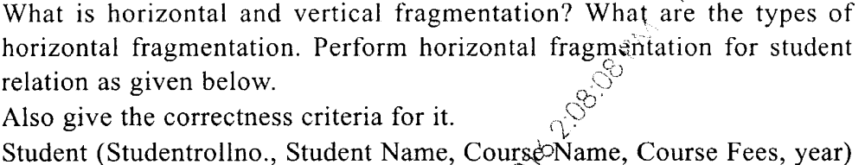

5. 