CONTRAST

1. Arizona Department of Transportation
2. <https://www.azdot.gov/>
3. 
4. It is apparent by the colors used in this site that it is using contrast with its colors. The site is predominately made up of cool colors (blue, green, purple); however, in different sections it also uses warm colors. Although not captured from the mobile screen shot, when one visits the site on the computer the will also see the predominant use of cool colors, but in the bottom left page the viewer will also see the intentional contrast of warm colors (yellow, orange, and red).

REPETITION

1. Arizona Game and Fish Department
2. <https://www.azgfd.com/>

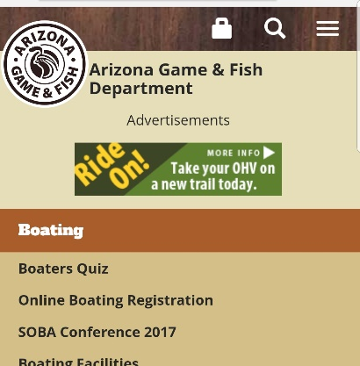

1. From the screenshot up above the viewer can see the top of the webpage, which has an Arizona Game and Fish Logo on the top left, and an empty header of the page with a brownish color. If the viewer were to visit the website they would have the option of being able to click on various sections of the website. Each section repeats the design at the top of the page with the logo and the empty brownish bar for the header. This is an example of repetition.

ALIGNMENT

1. Arizona Game and Fish Department
2. <https://www.azgfd.com/>

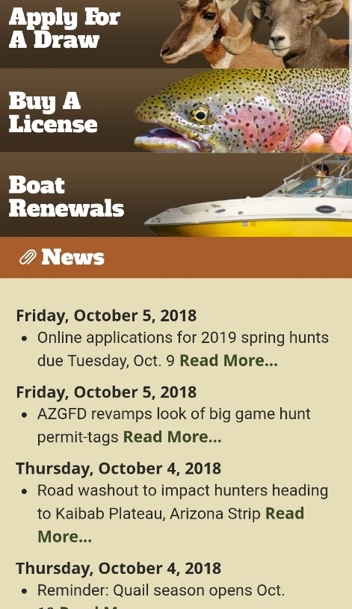

1. For alignment I used the same website that I used for repetition. On the front of the website the viewer can see how the website aligns the text by justifying it to the left. The act of justifying to the left makes sense as English is read from left to right and the website is written in English (it would be interesting to see how Hebrew websites or languages that read from right to left are generally justified). Also note how at the top of the screenshot the main sections that the user can click on to see more have the language aligned to the left while pictures that represent the content of the sections are aligned to the right.

PROXIMITY

1. Arizona State Library
2. <https://azlibrary.gov/>

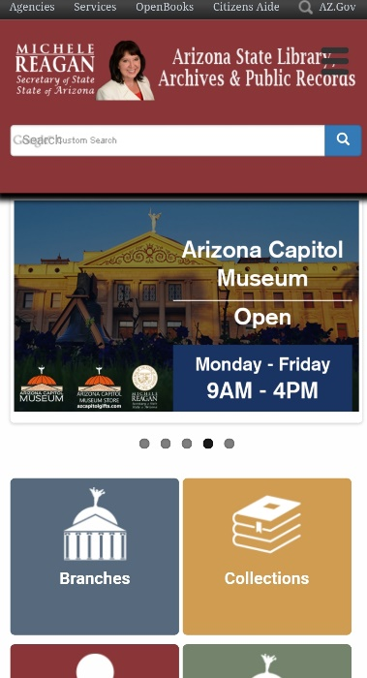

1. In this website the user can see the use of proximity particularly with respect to the use of whitespace. The website uses whitespace and proximity to design several logos that represent the content of the different sections. Also, the main picture of the website changes. You can’t see it in this, by the designers also use white space in one of the main pictures to create an image of the state of Arizona.