**Site Name:** The site name will be weathergoodorbad.com. As the domain name suggests, the site will provide up-to-date weather information for three towns.

**Site Purpose:** The purpose of this site is to keep the inhabitants of Preston, Soda Springs, and Fish Haven aware of current and expected weather. This objective will be achieved by designing a site that;

* Simple and easy for the user to navigate;
* Contains standard headers;
* Contains a navigation menu that is intuitive and easy to follow;
* Includes maps of affected areas;
* Includes current weather stories;
* Has pages specific to each town to address each town’s respective weather condition;
* Maintains images that help illustrate the weather condition for each town; and
* Supports responsive design techniques allowing for delivery of the site and its content on all classes of devices: personal computer, tablet, and smartphone.

**Target Audience:**

* Who: The inhabitants of Preston, Soda Springs, and Fish Haven, and others who may be planning a visit to these cities.
* Age: 12 and up
* Technology: Anyone who knows how to browse the internet or navigate through an internet website.
* Income: Not applicable. The site is simply targeting people who would like to know and understand the weather where they live. This could be relevant to people with various levels of income.
* Motivation: Provide a service to the above-mentioned communities and to give back to the world that has so generously blessed the web-designer of this site.

**Site Map:**

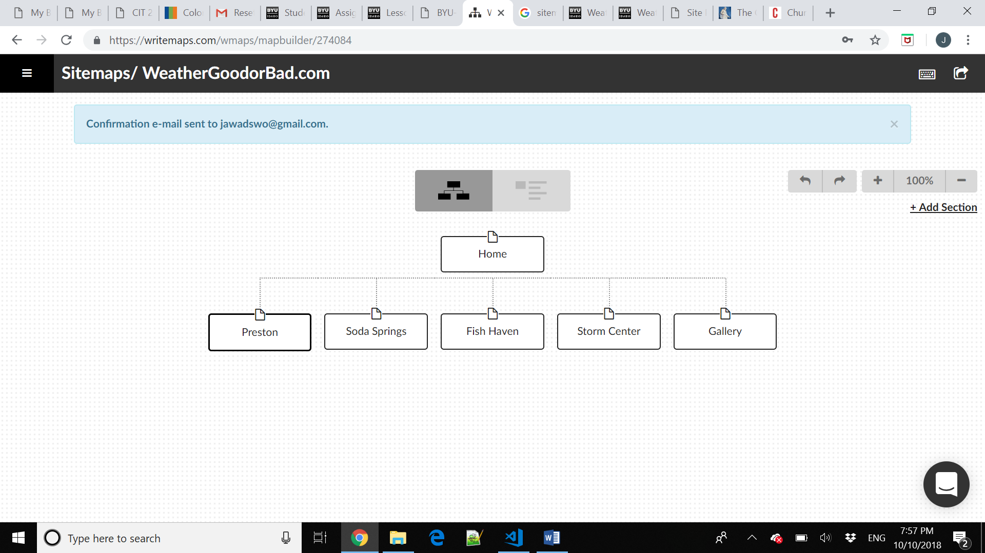

Home: The home page will contain a current weather story with corresponding image and information sections for all three towns.

Town Pages: These will each contain weather conditions and other town information or relevant articles/content.

Strom Center: Will include discussion of latest breaking storms.

Gallery: Will include weather photos.

**Color Scheme:**

The color scheme will consist primarily of cool colors and will be made up for the most part by different shades of the following colors;

Dominant Color: Green

Secondary Colors: Blue and Purple

Other: Black

Typography:

|  |  |  |  |  |
| --- | --- | --- | --- | --- |
| Site Header | Times New Roman | 40 px | ##80ff80 | SAMPLE |
| Primary Navigation | Calibri | 30 px | #df80ff | SAMPLE |
| Paragraph text | Calibri | 16 px | #8080ff | SAMPLE |

Please note that the color scheme and typography may have changes and tweaks as the project progresses. The samples above are simply to provide a starting point. Potentially the sites colors could change as the seasons change (i.e. warm colors for the fall and more neutral colors for the winter).

**Wireframe Sketch:**

