API HANDS-ON Document

1. **AirLineRest** 
   1. **Retrieve all airlines**

http method : GET

Return Type : Application/Json

url : <http://localhost:8080/airlinesWebApp/rs/airline/allAirLines>

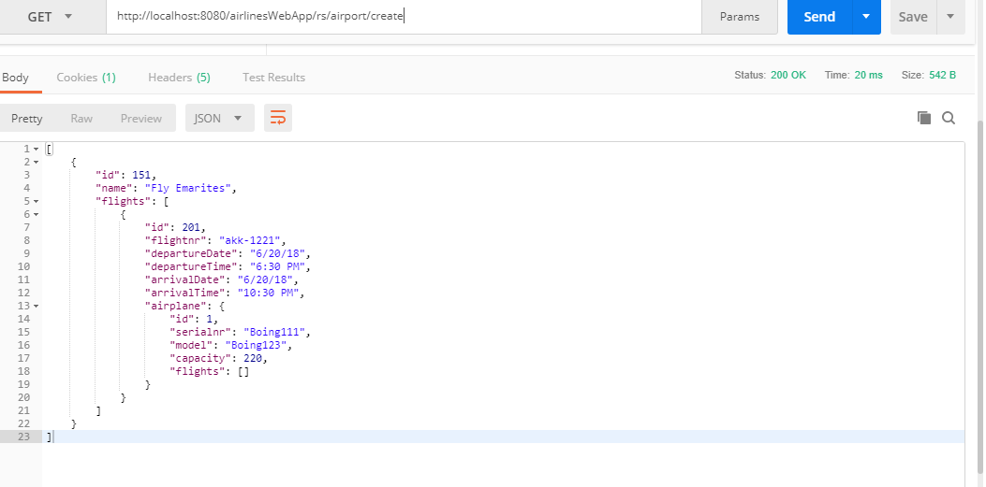

* 1. **Create airline ( owns the flight creation as well)**

http method : POST

Return Type : Application/Json

URL: <http://localhost:8080/airlinesWebApp/rs/airline/create>

Request Body :

{

"airlineName" : "Qatar Airways",

"flightCreationDetails":[

{

"flightnr" : "akk-1221",

"departureDate" : "6-20-2018",

"departureTime" : "13:12:30",

"arrivalDate" : "6-20-2018",

"arrivalTime" : "17:10:30",

"originName": "OHARE",

"destinationName": "JFK",

"serialNumberAirPlane": "xis-123"

}

]

}

* 1. **Retrieve single airline**

Http Method : GET

Return Type : Application/Json

Pass the id of the airline in the url

url : <http://localhost:8080/airlinesWebApp/rs/airline/getAirLine/151>

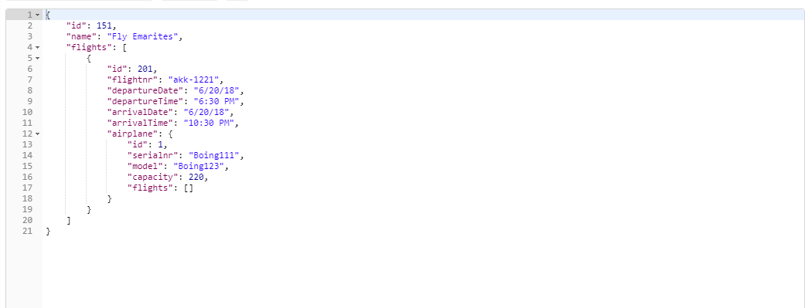

* 1. **Delete single air Line**

Http Method: DELETE

Return Type: Application/Json

Pass the id of the object you want to delete in the url

url : <http://localhost:8080/airlinesWebApp/rs/airline/7701>

* 1. **Get airline by name**

Http Method : GET

Return Type: Application/Json

Pass the name of the airline within the url like so

URL : <http://localhost:8080/airlinesWebApp/rs/airline/getByName/abca>

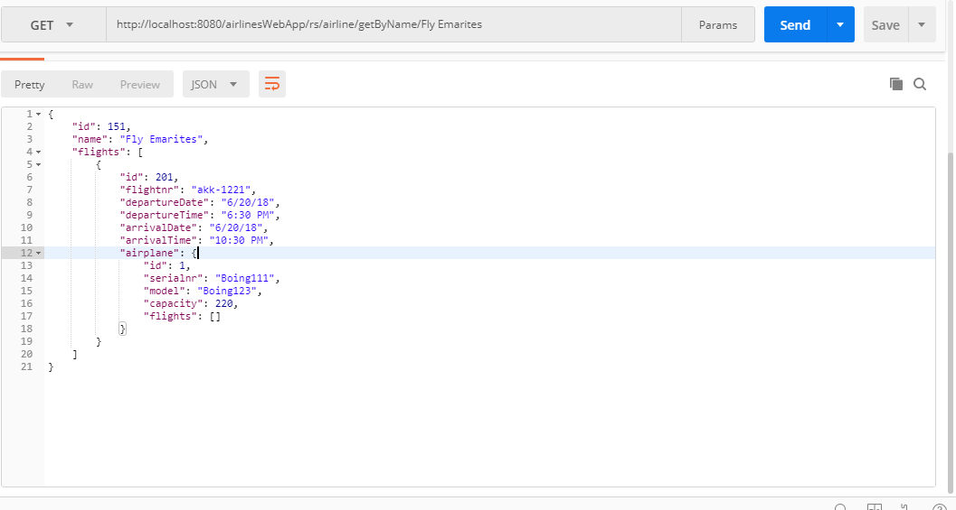

* 1. **Update AirLine**

Http Method : PUT

Return Type: Application/Json

Consume Type : Application/Json

Url : <http://localhost:8080/airlinesWebApp/rs/airline/update>

Same as create but add the id of the airline

* 1. **Get By Flight**

Http Method : Post

Return Type: Application/Json

Consume Type : Application/Json

Pass flight id in the body

Url : <http://localhost:8080/airlinesWebApp/rs/airline/findbByFlight>

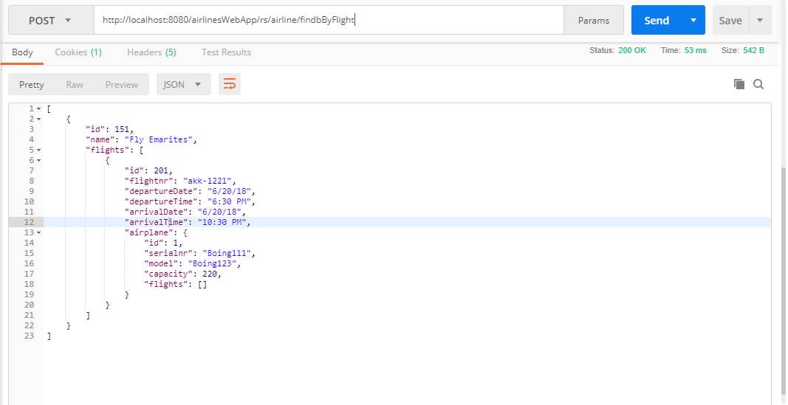

1. **AirPlaneRest**
   1. **Retrieve all airplanes**

Http Method : GET

Return Type : Application/Json

URL : <http://localhost:8080/airlinesWebApp/rs/airPlane/allAirPlanes>

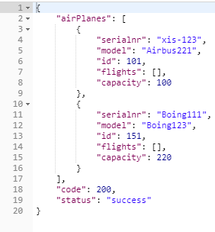

* 1. **Create new Airplane**

Http Method : POST

Return Type : Application/Json

URL: <http://localhost:8080/airlinesWebApp/rs/airPlane/create>

Post body :

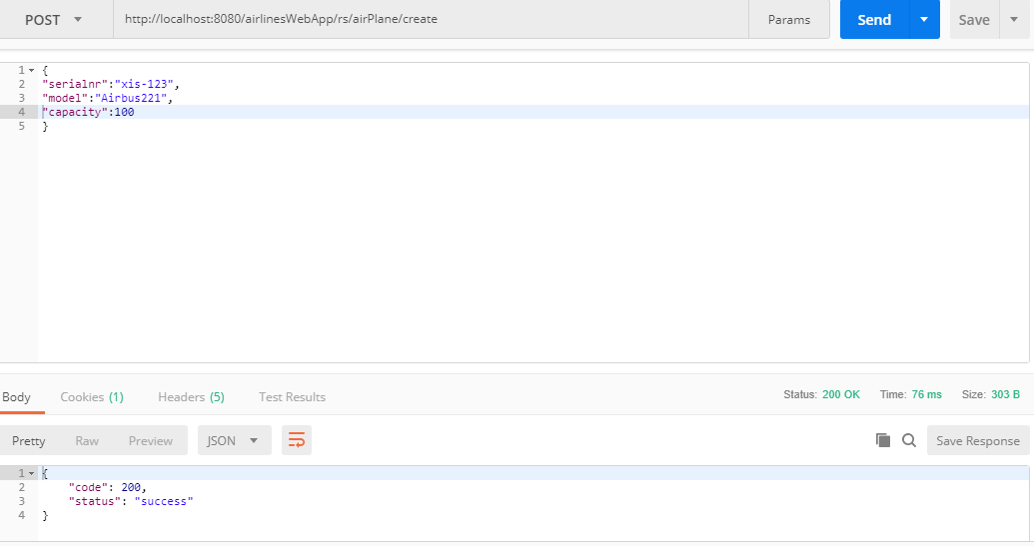

* 1. **Find specific airplane by id**

Http Method : GET

Return Type : Application/Json

Pass the id in the url

URL : <http://localhost:8080/airlinesWebApp/rs/airPlane/find/7151>

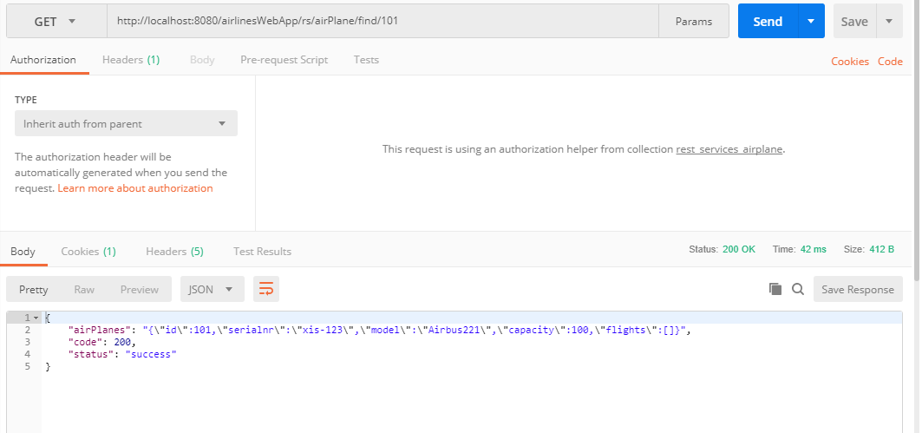

* 1. **Find Airplane By Serial Number**

Http Method : GET

Return Type : Application/ Json

Pass the serial number in the url

URL: <http://localhost:8080/airlinesWebApp/rs/airPlane/findBySrlnr/111>

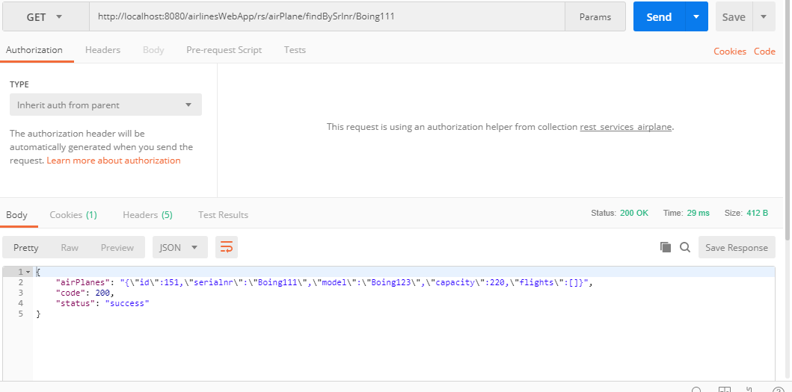

* 1. **Find Airplane By Model**

Http Method : GET

Return Type : Application/ Json

Pass the model number in the url

URL: <http://localhost:8080/airlinesWebApp/rs/airPlane/findByModel/AirBus123>

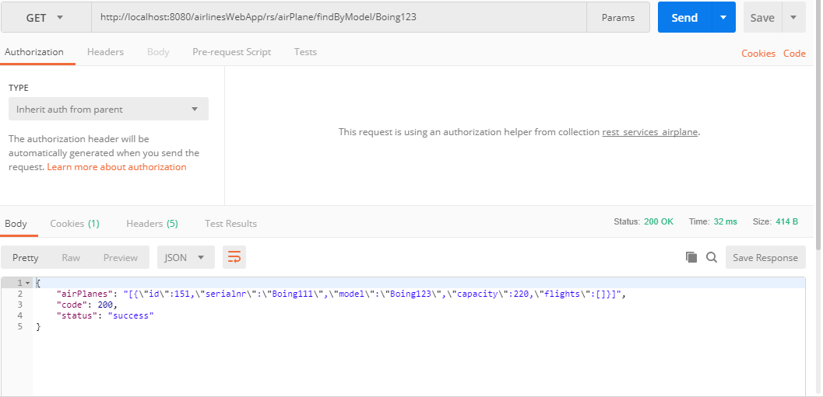

* 1. **Update Airplane**

Http Method : PUT

Return Type: Application/Json

Consume Type : Application/Json

Url : <http://localhost:8080/airlinesWebApp/rs/airPlane/update>

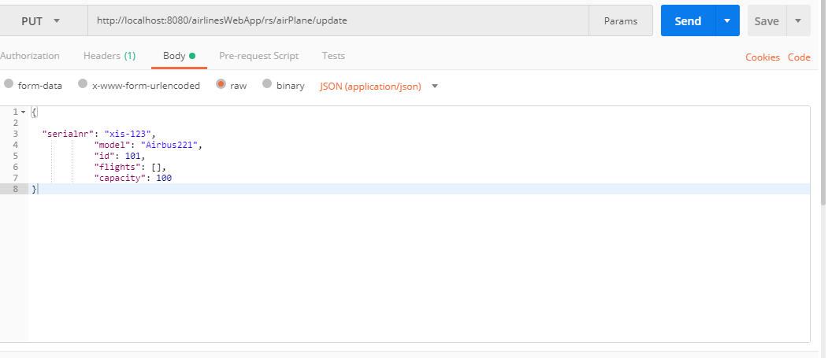

* 1. **Delete single Airplane**

Http Method: DELETE

Return Type: Application/Json

Pass the id of the object you want to delete in the url

url : <http://localhost:8080/airlinesWebApp/rs/airPlane/7451>

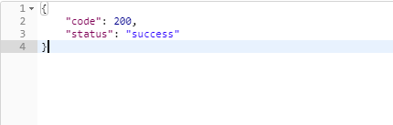

1. **Airport Rest**
   1. **Retrieve all airports**

Http Method : GET

Return Type : Application/Json

url : <http://localhost:8080/airlinesWebApp/rs/airport/allAirports>

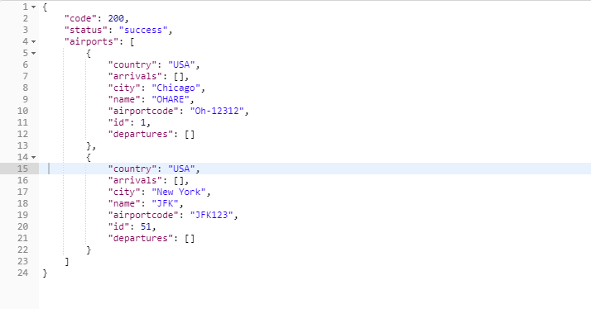

* 1. **Create new Airport**

Http Method : POST

Return Type : Application/Json

URL: <http://localhost:8080/airlinesWebApp/rs/airport/create>

Post body :

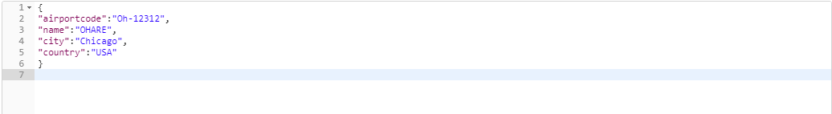

****Post response :

* 1. **Delete single Airport**

Http Method: DELETE

Return Type: Application/Json

Pass the id of the object you want to delete in the url

url : <http://localhost:8080/airlinesWebApp/rs/airport/delete/1>



* 1. **Update Airport**

Http Method : PUT

Return Type: Application/Json

Consume Type : Application/Json

Url : <http://localhost:8080/airlinesWebApp/rs/airport/update>

post body :

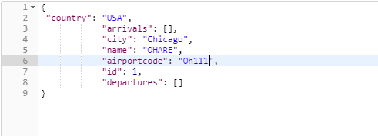

 Post response :

* 1. **Get Specific AirPort by Id**

http method : GET

Return Type : Application/Json

Pass the id in the url

url : <http://localhost:8080/airlinesWebApp/rs/airport/getAirport/1>

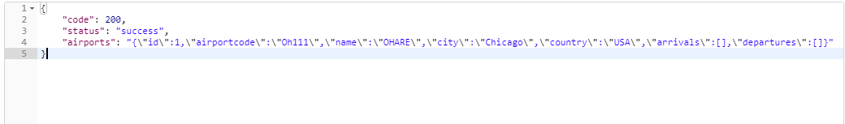

* 1. **Get Airport By Airport Code**

http method : GET

Return Type : Application/Json

Pass the airport code in the url

url : <http://localhost:8080/airlinesWebApp/rs/airport/findByCode/JFK123>

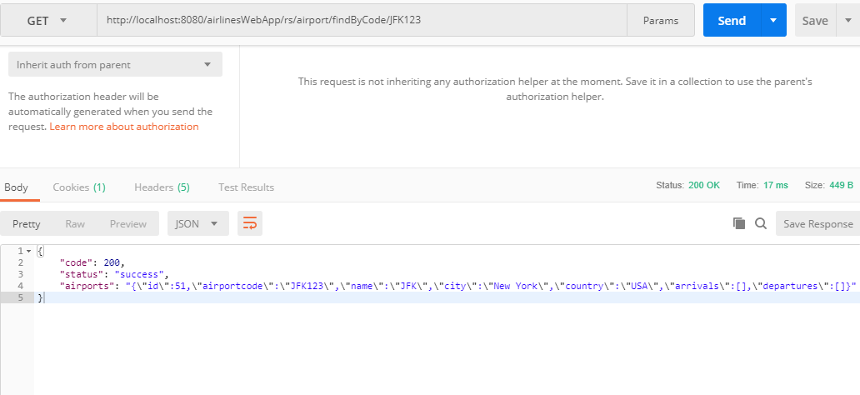

* 1. **Get Airport by Flight Arival**

http method : GET

Return Type : Application/Json

Pass the flight id in the url

url : <http://localhost:8080/airlinesWebApp/rs/airport/findByArrival/12332>

* 1. **Get Airport by Flight Departure**

http method : GET

Return Type : Application/Json

Pass the flight id in the url

url : <http://localhost:8080/airlinesWebApp/rs/airport/findByDeparture/12332>

* 1. **Get Airport by Country**

http method : GET

Return Type : Application/Json

Pass the flight country name in the url

url : <http://localhost:8080/airlinesWebApp/rs/airport/findByCountry/USA>

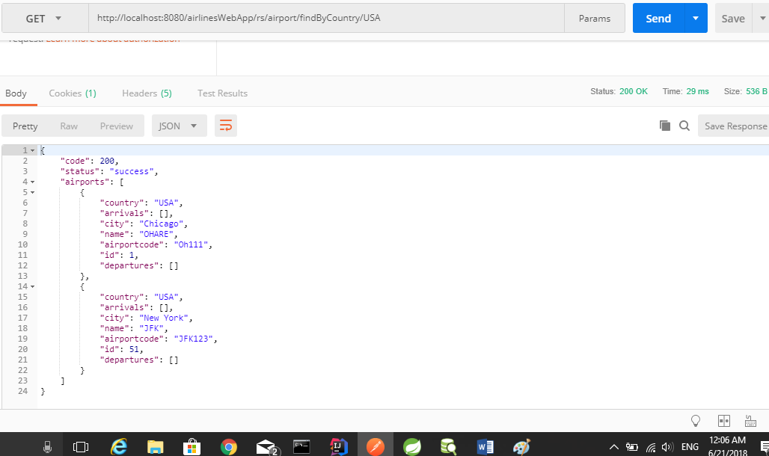

* 1. **Get Airport by name**

http method : GET

Return Type : Application/Json

Pass the flight airport name in the url

url : <http://localhost:8080/airlinesWebApp/rs/airport/findByName/JFK>

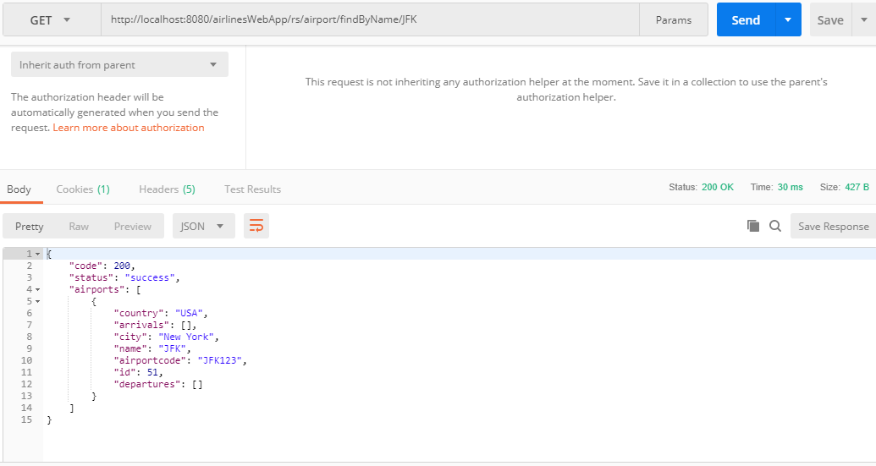

* 1. **Get Airport by city**

http method : GET

Return Type : Application/Json

Pass the flight city name in the url

url : <http://localhost:8080/airlinesWebApp/rs/airport/findByCity/Chicago>

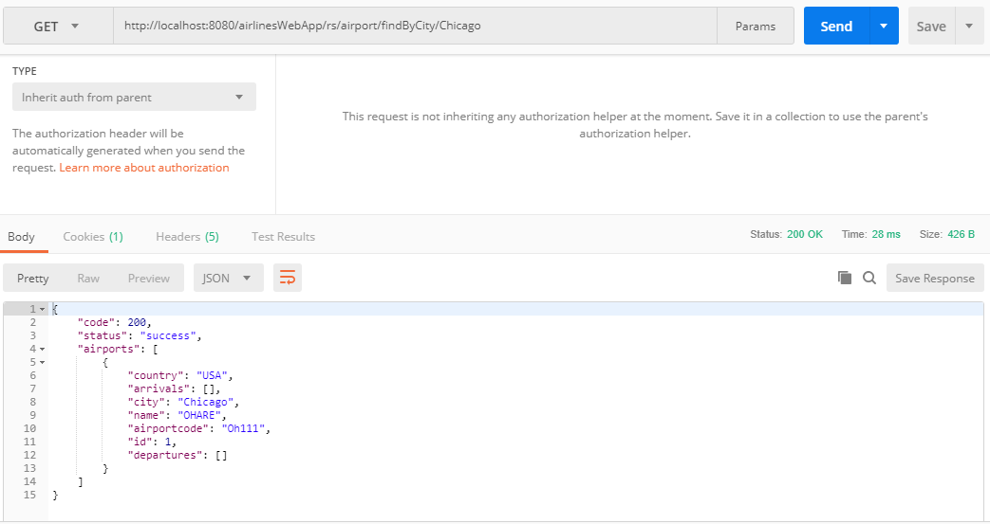

1. **Flight Rest**
   1. **Retrieve all flights**

http method : GET

Return Type : Application/Json

url : <http://localhost:8080/airlinesWebApp/rs/flight/allFlights>

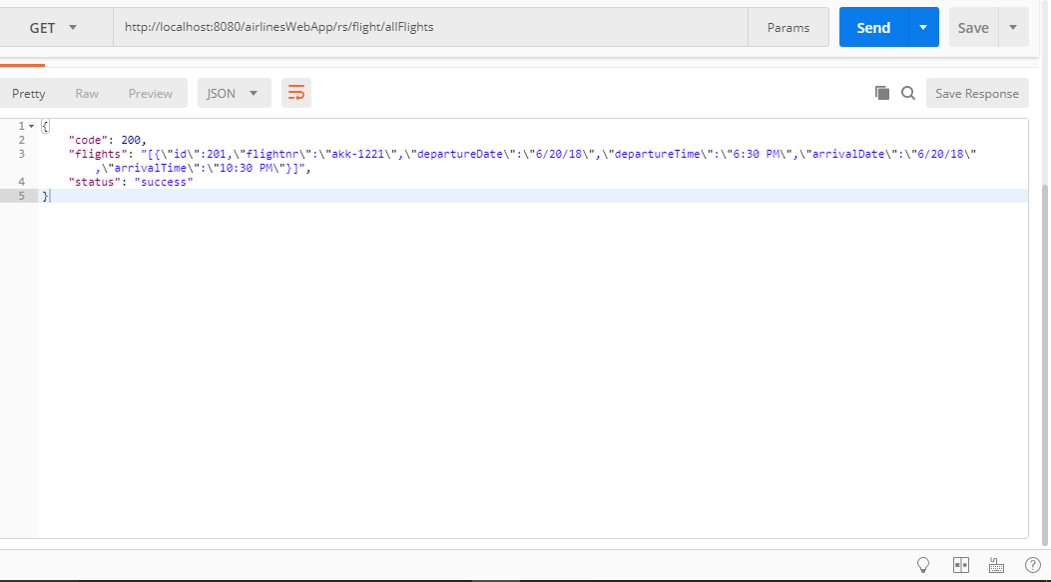

* 1. **Update Airplane**

Http Method : PUT

Return Type: Application/Json

Consume Type : Application/Json

Url : <http://localhost:8080/airlinesWebApp/rs/flight/update>

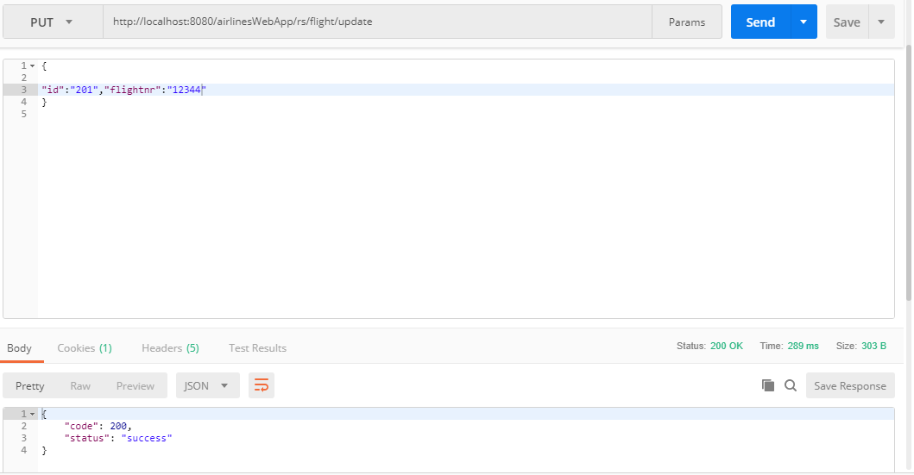

* 1. **Find flight**

http method : POST(pass flight id)

Return Type : Application/Json

Consume Tyoe : Application/ Json

url <http://localhost:8080/airlinesWebApp/rs/flight/getFlight>

post body :

{

"id":"201"

}

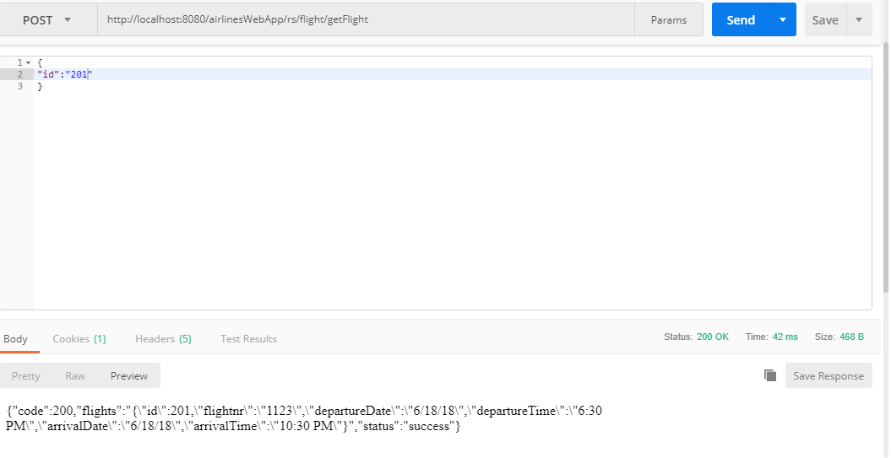

* 1. **Get flight by flight number**

http method : GET

Return Type : Application/Json

Pass the flight number in the url

url <http://localhost:8080/airlinesWebApp/rs/flight/getByNumber/1123>

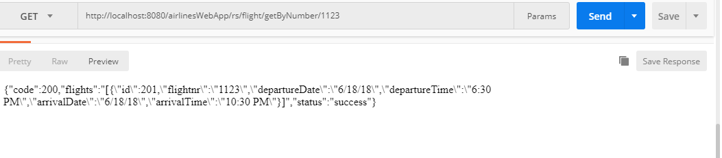

* 1. **Find flight by airline**

http method : POST(pass airline)

Return Type : Application/Json

Consume Tyoe : Application/ Json

URL : <http://localhost:8080/airlinesWebApp/rs/flight/findByAirline>

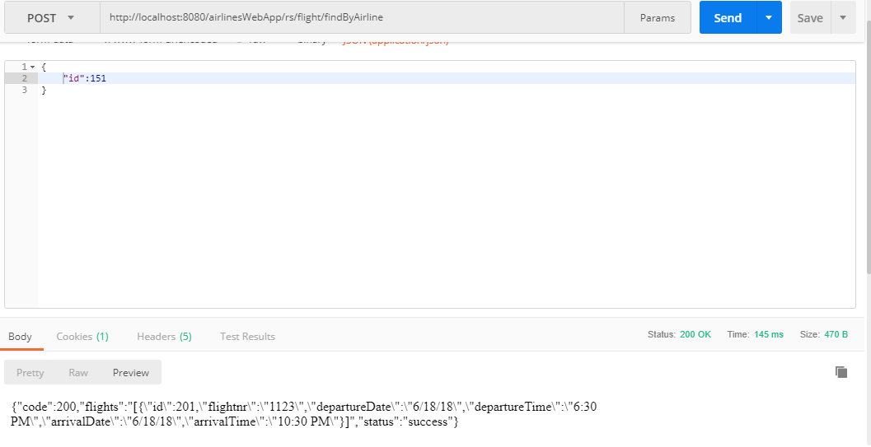

* 1. **Find flight by airport origin**

http method : POST(pass airport)

Return Type : Application/Json

Consume Tyoe : Application/ Json

URL : <http://localhost:8080/airlinesWebApp/rs/flight/findByOrigin>

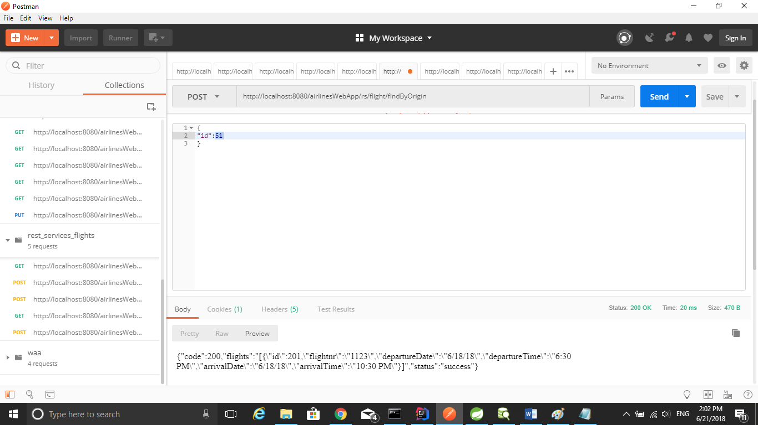

* 1. **Find flight by airport destination**

http method : POST(pass airport)

Return Type : Application/Json

Consume Tyoe : Application/ Json

URL : <http://localhost:8080/airlinesWebApp/rs/flight/findByDestination>

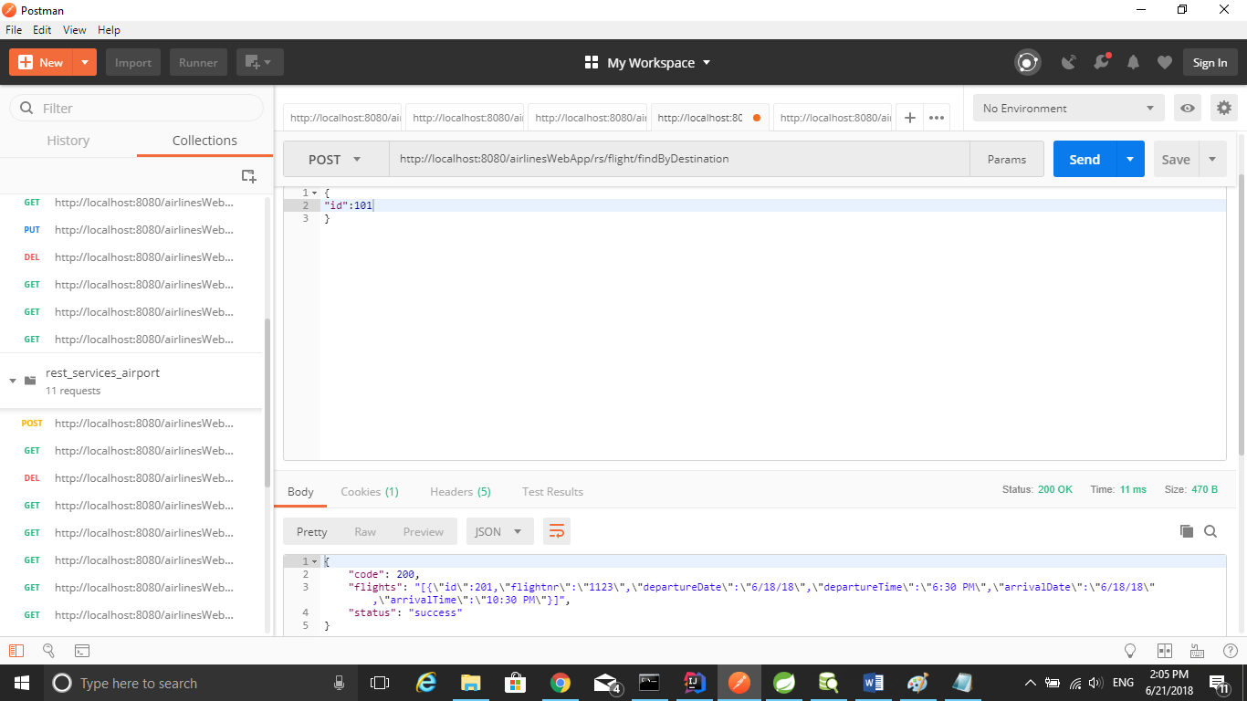

* 1. **Find flight by airplane**

http method : POST(pass airplane)

Return Type : Application/Json

Consume Tyoe : Application/ Json

URL : <http://localhost:8080/airlinesWebApp/rs/flight/findByAirplane>

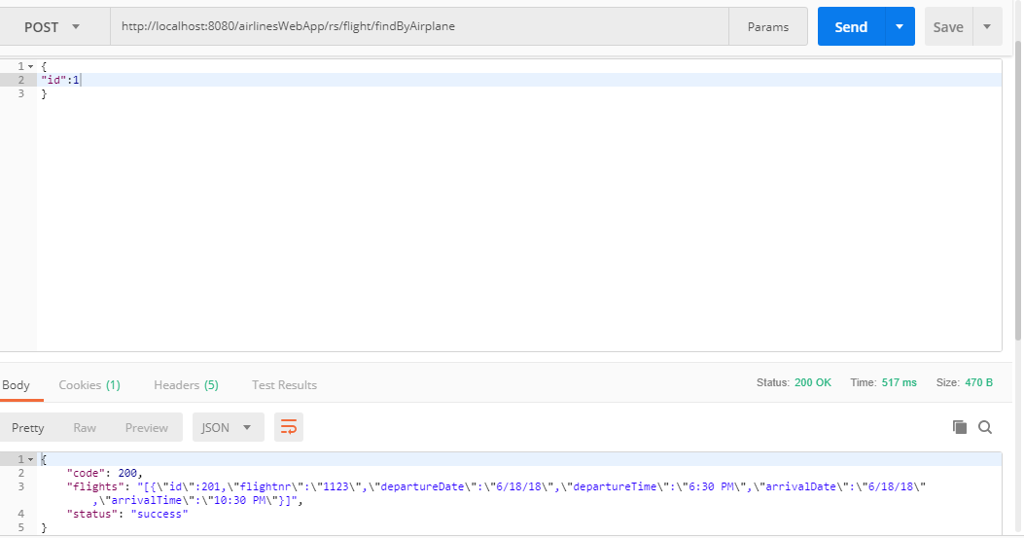

* 1. **Get flight by Arival Date**

http method : GET

Return Type : Application/Json

Pass the arival date in the url

url <http://localhost:8080/airlinesWebApp/rs/flight/findByArrival/6-18-18>

* 1. **Get flight by Departure Date**

http method : GET

Return Type : Application/Json

Pass the departure date in the url

url <http://localhost:8080/airlinesWebApp/rs/flight/findByDeparture/6-18-18>

* 1. **Find arrival between 2 dates**

http method : POST(pass date from, and date to)

Return Type : Application/Json

Consume Tyoe : Application/ Json

url <http://localhost:8080/airlinesWebApp/rs/flight/findByArrivalBetween>

post body :

{

"datetimeFromPara":"6-18-18",

"datetimeFromPara":"6-18-18"

}

* 1. **Find departure between 2 dates**

http method : POST(pass date from, and date to)

Return Type : Application/Json

Consume Tyoe : Application/ Json

url <http://localhost:8080/airlinesWebApp/rs/flight/findByDepartureBetween>

post body :

{

"datetimeFromPara":"6-18-18",

"datetimeFromPara":"6-18-18"

}