Group: Jake Waffle, Katy Phipps, Carey Stirling, and Ryan Spiekerman
Prof. Nina Peterson
CS-250
28 March 2012
Lab 4: Identifying the Parts
Dell Laptop:
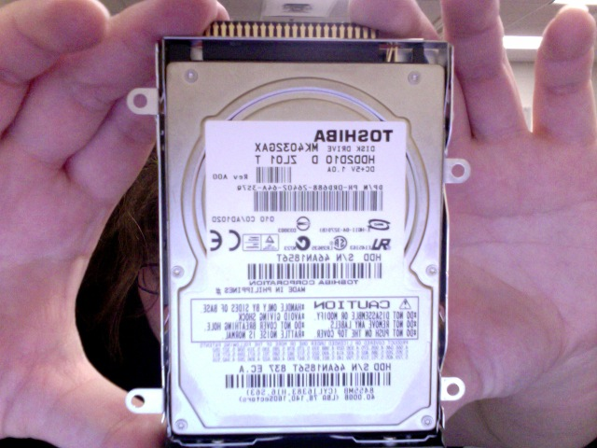
Toshiba:
40 GB Hard Drive
160 sectors
D/C 5 volt 1 Amp

-Connects to the system bus and acts as the main memory storage.

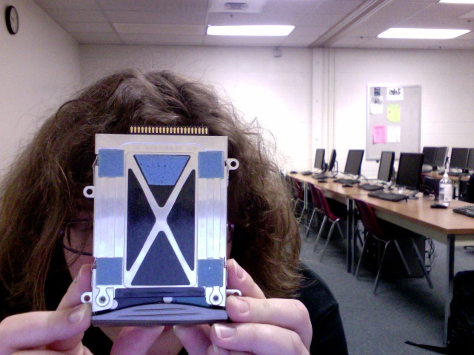
The back of the drive case

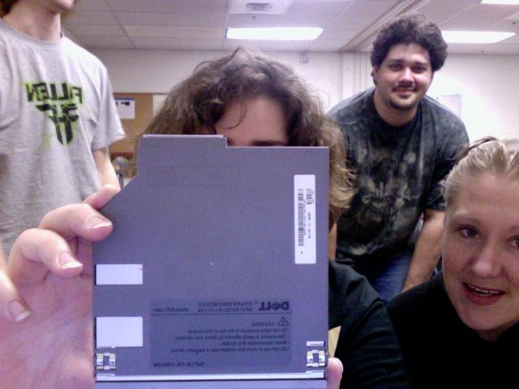
DELL:
-DVD+RW drive module.
-Input rating 5 volts 2.8 Amp direct current
-8x speed

-It possesses the capabilities of reading and writing to an optical storage device.

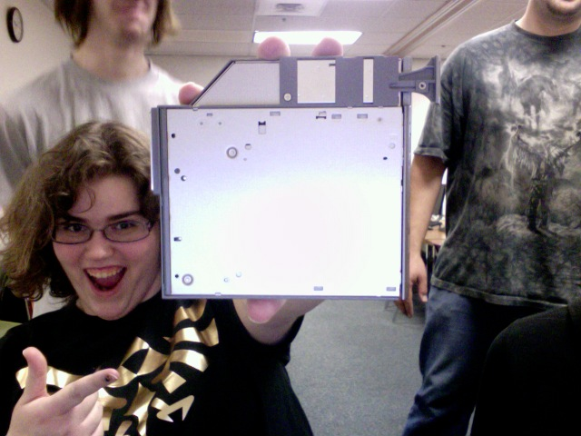
DVD Drive, back
-It cleverly
supports the enormous weight of the dvd drive.

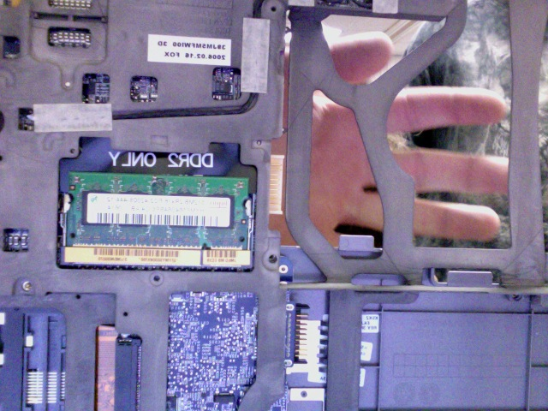
DDR2 SDRAM:
2 chips of 512MB each. It’s lead free.
-DDR2 stands for double data rate and -SDRAM stands for synchronous dynamic random-access memory
-DDR2's internal clock runs at half the speed of its predecessor, DDR.

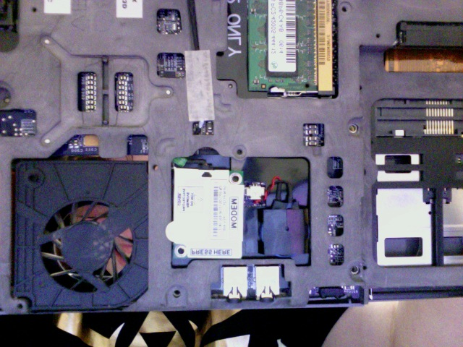
56k internal modem daughter card. It’s lead free.

-This card allows the laptop to access the internet in a wireless fashion.

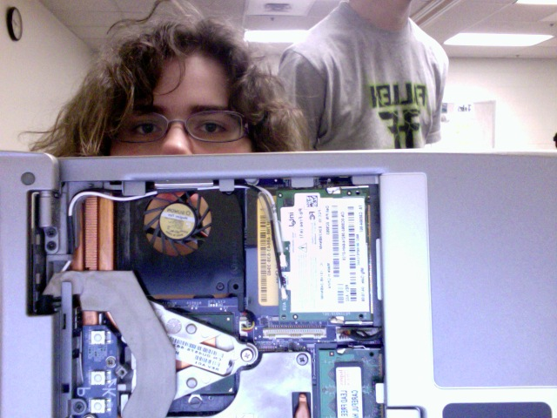
System Fan
D/C 5 volt 1.4 watts
-I believe this fan is to prevent overheating of computer components.

Other side of DDR2 SDRAM

Heat sink

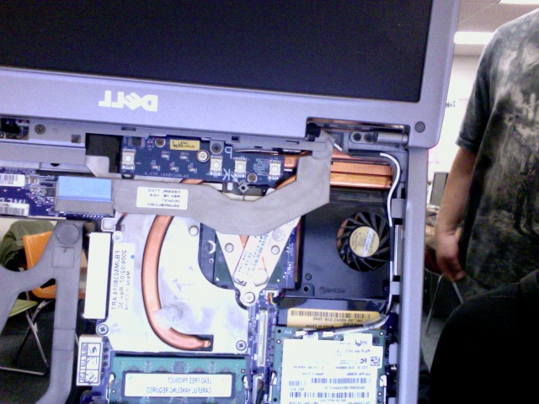
The heat sink is the orange thingy and its purpose is to cool the CPU.

Bezel Monitor, LCD display. 14.1 display

Gateway Computer:
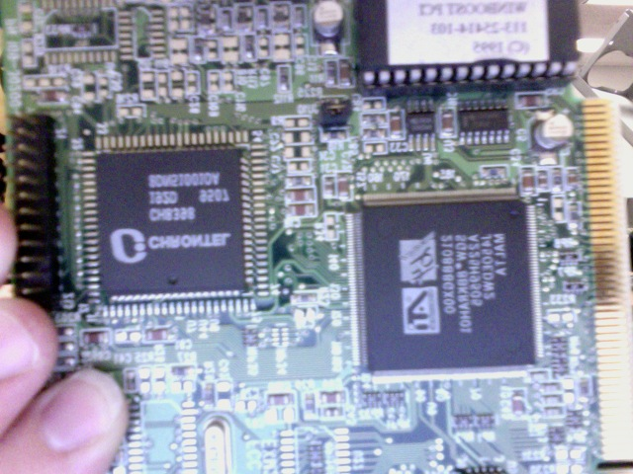
Gateway Desktop:
Sound card
-It deals with input and output of data in regards to audio devices. It is plugged into a PCI slot and therefore operates using the PCI bus for data transferal.

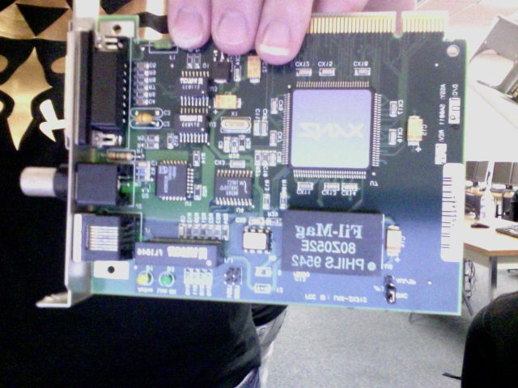
Alt. Audio/Video card

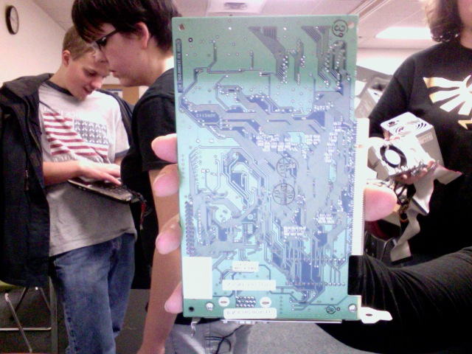
Networking card?

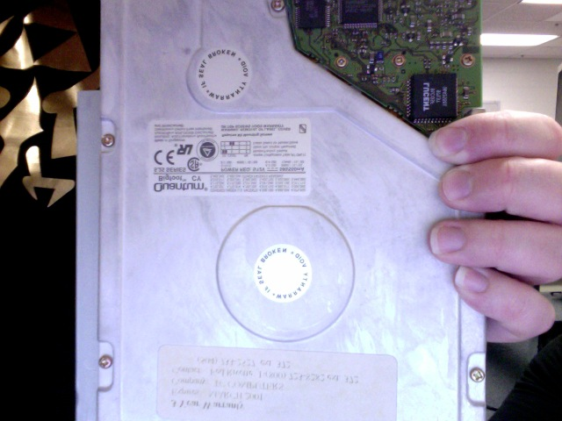
Hard drive
(yes, the room is upside down)
-2.1GB
-5/12 volts direct current 580/550mA
-This hard drive was made in 1997. So it is believed that it only contains one disk.
-And its purpose is to dynamically store data.

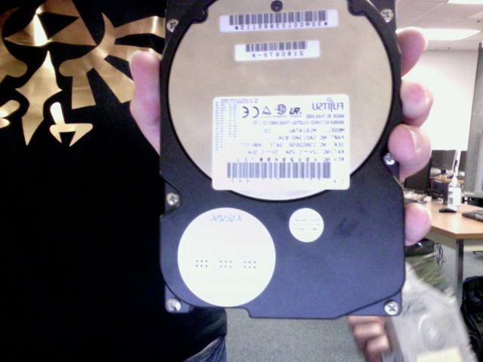
Hard Drive:
1.6GB 12volt D/C 0.29amps
-This is the other hard drive of the dell computer and it or the other one probably use the system bus to collaborate with other components like the CPU.

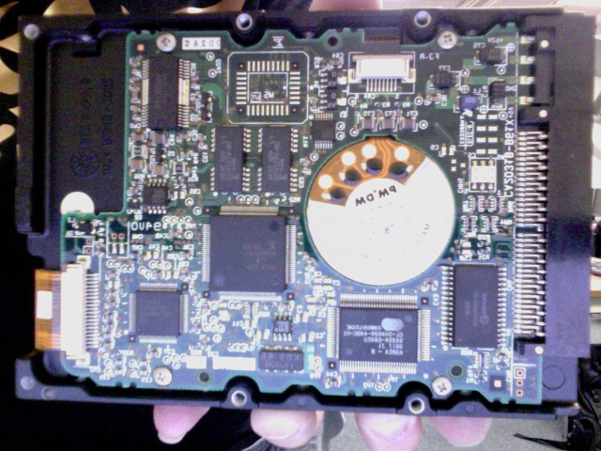
Hard Drive:
Underside

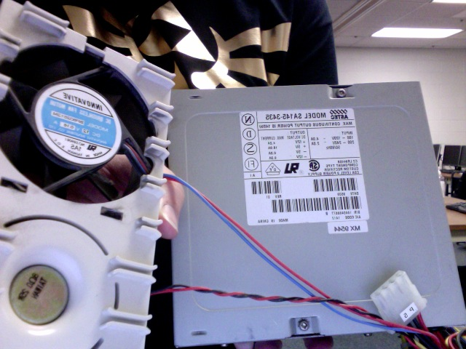
Power supply and cooling fan.
-To transfer electricity to the rest of the computer and prevent overheating is what these guys do.

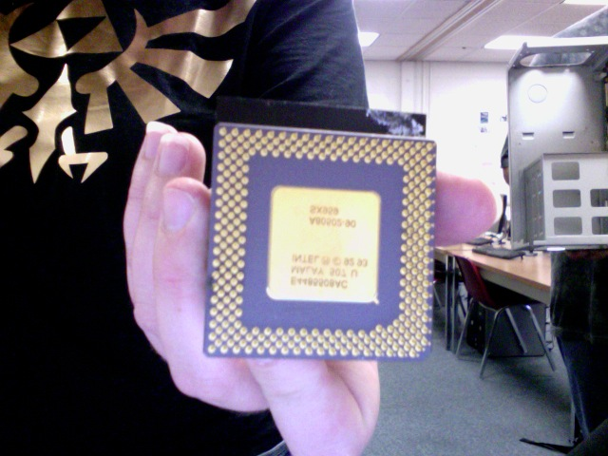
The Processor:
-Intel 92 93

-It contains Arithmetic Logic, Unit(ALU), Control Unit, registers and the interconnections.
-CPU deals with computing arithmetic and logical values with ALU. And it extracts and decodes instructions from memory using the Control Unit.

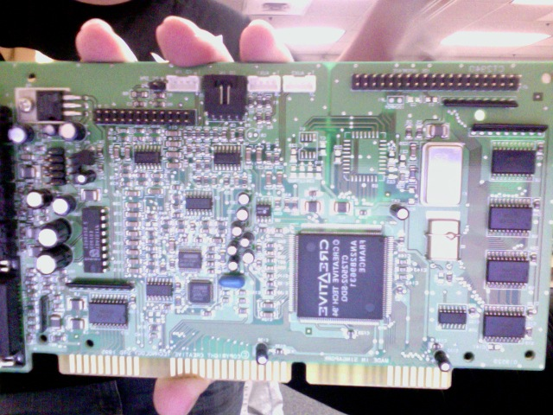
Sound blaster 16
Built-in SCSI adaptor, ATAPI IDE interface that connects to the cd-rom.
-Handles the input and output of audio devices.
-It can operate over the SCSI bus – an interface that is used for data transferal between devices and computers.

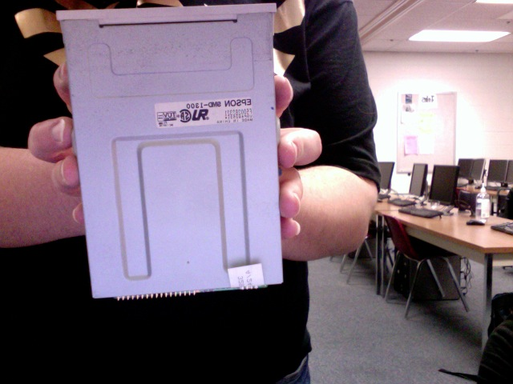
Epson:
Floppy disk drive
DC + 5volt 1amp
-It is used to read from a floppy disc – a magnetic storage device.

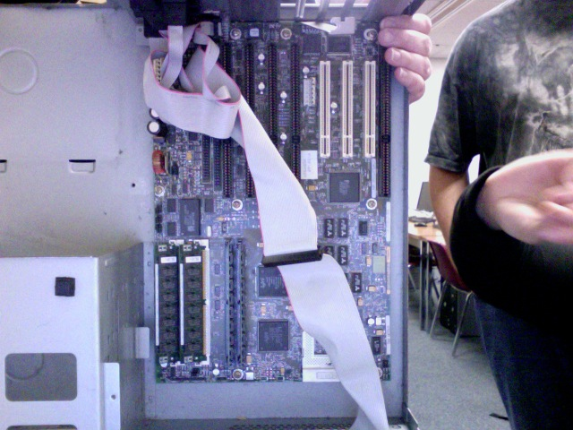
Inside case:
Motherboard
RAM sticks
PCI bus slots
IDE cable
BIOS chip

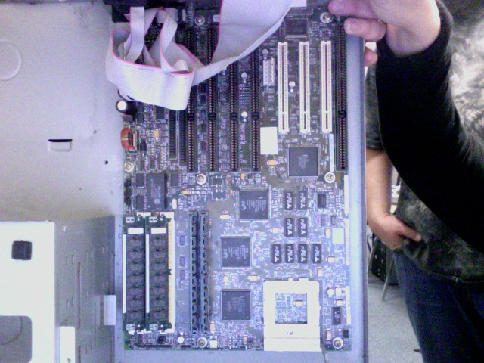
A little closer.

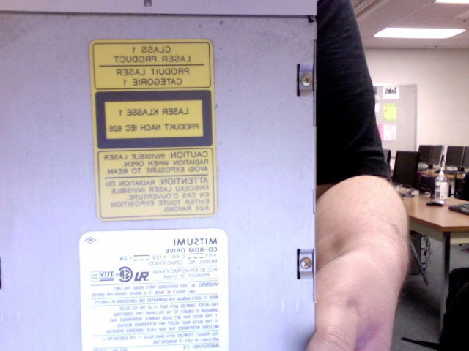
CD-ROM DRIVE! DC+ 5volt 0.4amp / +12volt 1.2amp, made by Mistumi

-This allows the computer to read memory from an optical storage device.
Server:
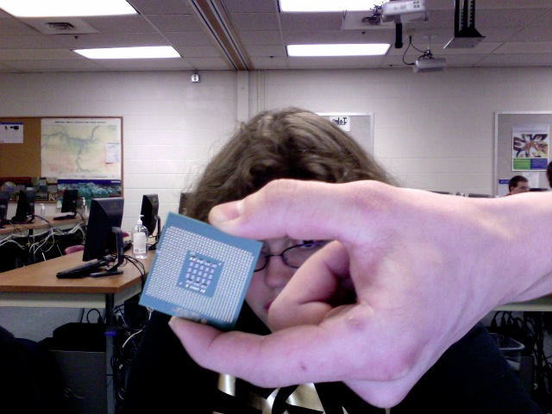
Server CPU.
It contains ALU, Control, registers and the interconnections.

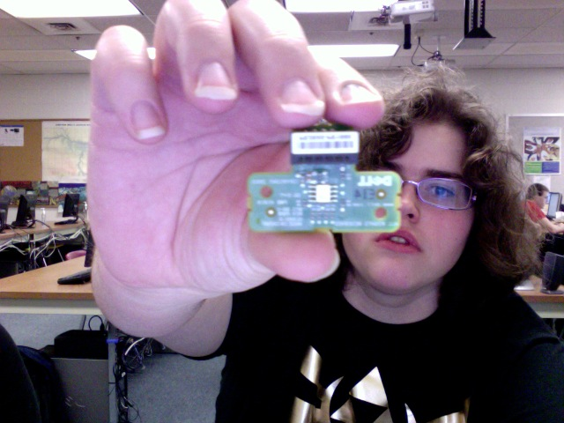
RAID key.

-This serves as a dedicated stick of RAM for the RAID.

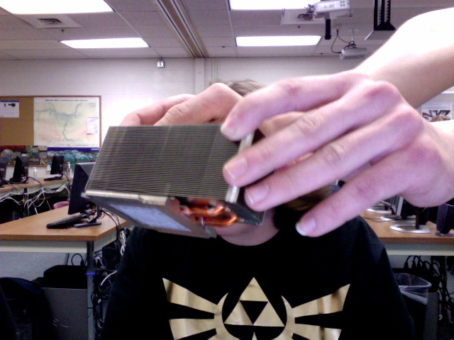
Heat sink.

-It cools the CPU by using a system similar to a radiator in that it takes heat away from the CPU and transfers it to a liquid.

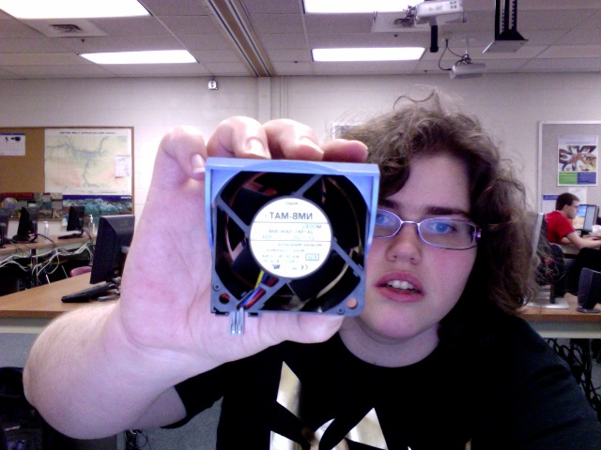
System fan.

-Overheating prevention mechanism.

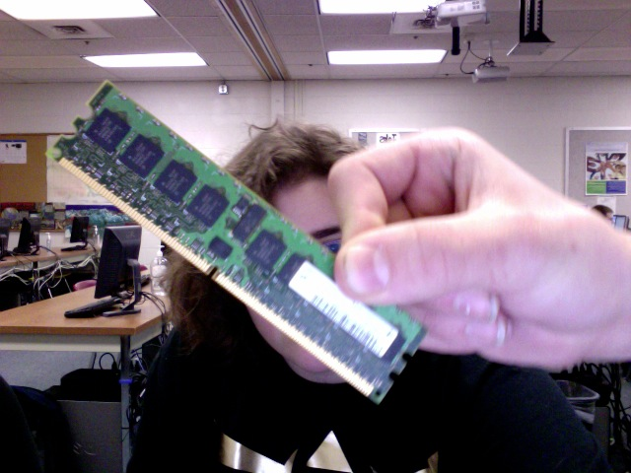
Server RAM.

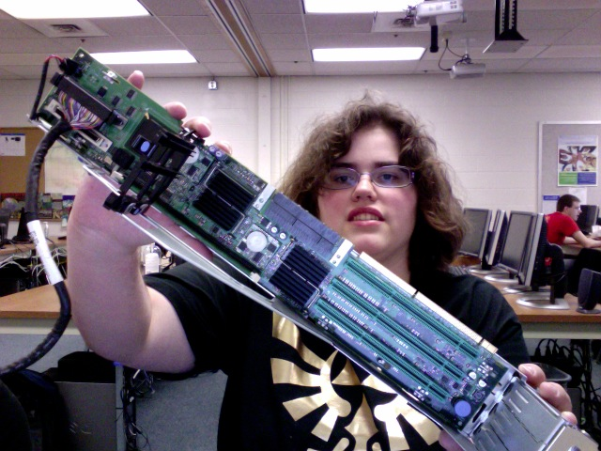
Disk array controller or the RAID controller
-This device manages the physical disk drives that are connected to the back-end side and presents them as logical units to the computer.

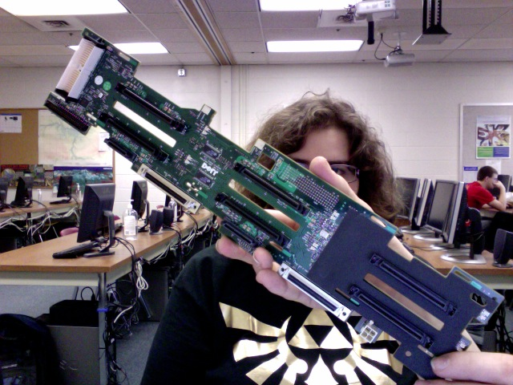
SCSI board

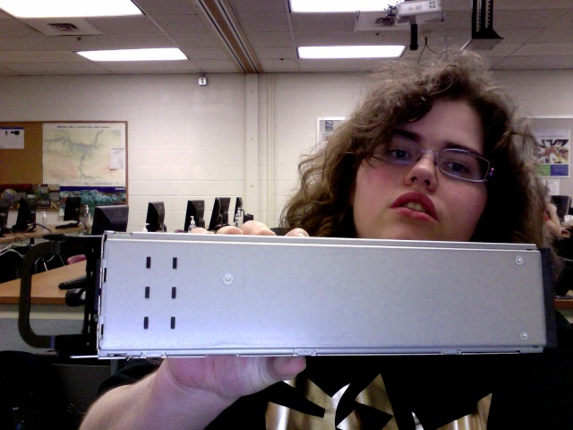
Power supply.

Dell Desktop:
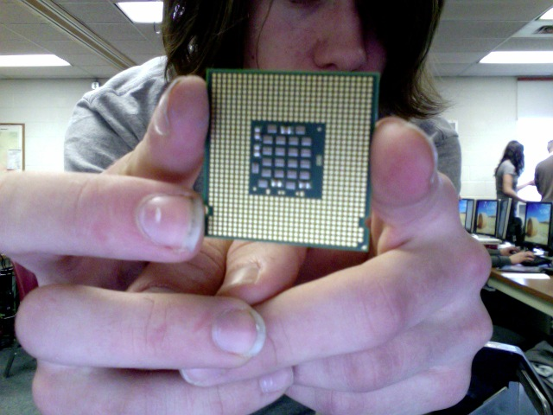
Dell CPU.
Intel Xeon Processor
3.2GHZ: 90 nm
1 MB integrated L2 cache.
800MHZ Bus speed

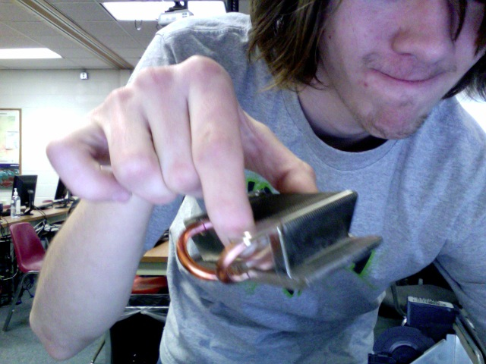
Heat sink is generic and unmarked.

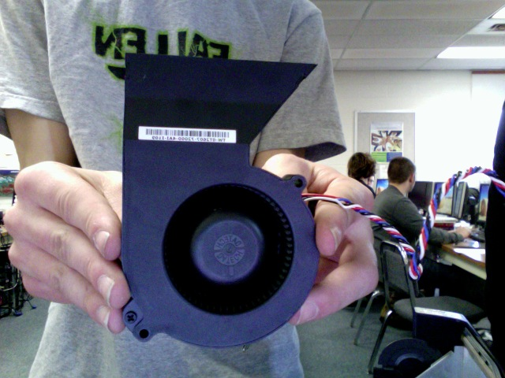
12 volt 2.6 Amp brushless D/C system fan.

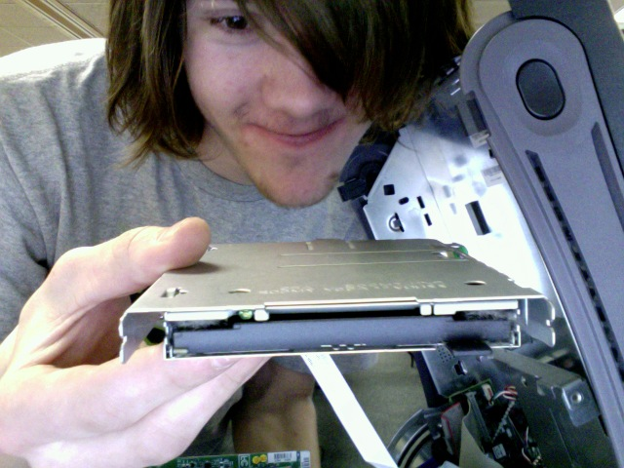
Dell Floppy Drive and case. Floppy drive has been discontinued. 5 volt direct current, 750mA.

