INDEX

* **1. INTRODUCING THE CONCEPT OF BAYMAX (PERSONAL HEALTH CARE ASSISTANT)**
* **2. WHAT ARE THE PROBLEMS THAT OUR PROJECT RESOLVE**
* **3.WHAT DO OUR PERSONAL HEALTH CARE ASSISTANT DO?**

**3.1 ILLNESS ANALYZER**

**3.2 HOW MACHINE LEARNING TAKES ITS PART IN THE**

**ILLNESS ANALYZER.**

* **4.ADDITIONAL FEATURES OF THE PROJECT**
* **5.CONCLUSION**

***INTRODUCING THE CONCEPT OF BAYMAX:***

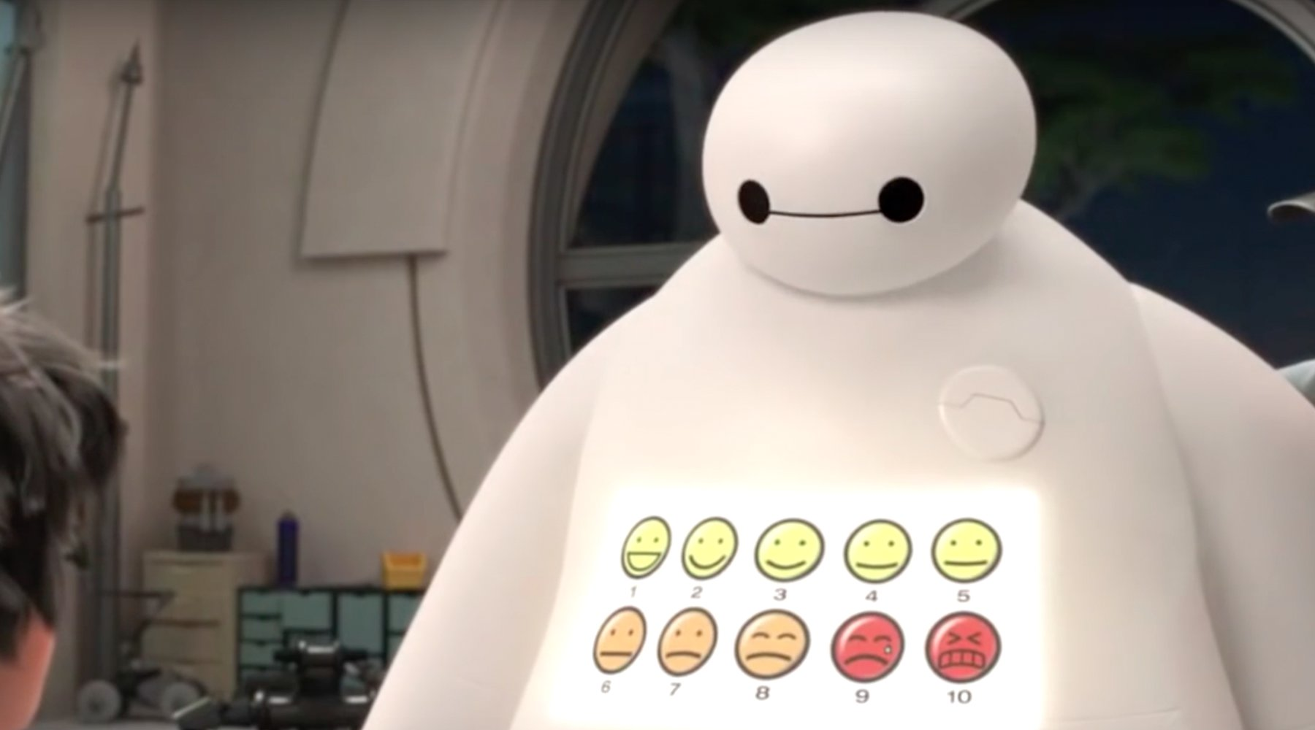

**The basic idea of our project is inspired from the fictional character baymax starring from the animated scifi movie big hero 6.**

**however our project doesn't essentially work the same as baymax but is well concerned about peoples basic health care. While we initially had the idea of working on making a “PERSONAL HEALTH CARE ASSISTANT” we had many ideas , but while linking it to the machine learning concepts our ideas became much complex to work, on so we got ourselves confined to work only on few ideas rather than all of them to maintain perfection of our project**

**WHAT ARE THE PROBLEMS THAT OUR PROJECT RESOLVE**

* **In this modern world the whole health and medical industries have completely became business minded and money driven private organizations.**
* **So a person of low economy have to face many hard consequences even to have basic first aid or health care .**
* **So to overcome this condition we collectively developed this project to provide basic first aid and medication with no cost and also a better analysis over the illnesses.**

**WHAT DO OUR PERSONAL HEALTH CARE ASSISTANT DO?**

* **ILLNESS ANALYZER**
* **It interacts with the user by generating some simple questions like name , age , gender etc(only to analyze their health conditions).**
* **Then it displays a set of options and sub options that contain different type of illness conditions for the user to choose.**
* **After choosing the suitable type of the illness user is suffering from the assistant suggests some perfect first aid and medication to ensure users fast recovery.**
* **And after the process is completed it asks the user to give a feedback on its assistance for the developers to keep a track of its behaviour .**
* **HOW MACHINE LEARNING TAKES ITS PART IN THE ILLNESS ANALYZER**
* **The data of each user is stored in individual data sets and traced back.**
* **And different types of analysis are carried out on all the users data collectively i.e., plotting graphs for different age groups vs different diseases or gender vs diseases, etc.**
* **All these analysis are used to predict many illness factors and situations and take precautions to avoid them on before hand.**
* **And all the analysis part of the users data is carried out using the single linear regression and multiple linear regression algorithms of machine learning.**

**ADDITIONAL FEATURES OF THE PROJECT**

* **we also included a python program that interacts with the user and asks for users basic details like name, age , height , weight, gender,etc and calculates their Body Mass Index(BMI) .**
* **And then sorts the user into one of the two categories over weight or underweight and guides them with a set of diet and workout tips for both over and under weight.**

**CONCLUSION**

**our whole team worked together to develop this project and tried our best to make it user friendly and error free. But if you find any flaws at anypart of the project just inform us and help us to fix them and we are always open to suggestions.**

**THANK YOU**