

Arduino-GSM Based Smart Power Monitoring and Control System

Objective

The objective of this project is to remotely control an INVT drive using a GSM module and Arduino based on incoming phone calls. When the user calls the GSM module:
- On the first call, the GSM module detects the ring, sends a signal to the Arduino, which activates the relay, turning ON the INVT drive.
- On the second call, the GSM module again detects the ring and sends a signal to the Arduino, which deactivates the relay, turning OFF the INVT drive.
- Additionally, a voltage sensor connected to the output of the INVT monitors the voltage.
- The Arduino sends two SMS messages to the user:
  - One confirming the ON/OFF action.
  - Another reporting the output voltage from the INVT drive.
This system provides a simple and effective way to control and monitor industrial equipment remotely using just a mobile phone without needing internet access.

Components Used

- Arduino Uno
- Gsm 800L
- Voltage Sensor
- Relay1Channel
- Buck convertor - 2
- Smbs for power supply
- 1 and 2 kilo ohm resistor
- bread board and jumper wires

Code

#include <SoftwareSerial.h>
SoftwareSerial sim800(3, 2); // SIM800L TX to pin 3, RX to pin 2
String incomingData = ""; // Store incoming serial data
String allowedNumber = "+919025676907"; // Allowed number // add your number
bool callAnswered = false; // Track call state
const int relayPin = 4; // Relay pin
const int voltagePin = A0; // Voltage sensor pin
bool relayState = false; // Relay is OFF
unsigned long lastCommandTime = 0; // Prevent command overlap

void setup() {
Serial.begin(9600); // Serial monitor
pinMode(relayPin, OUTPUT); // Relay pin
pinMode(voltagePin, INPUT); // Voltage sensor pin
digitalWrite(relayPin, HIGH); // Relay OFF (active-low)

Serial.println("Initializing...");
delay(10000); // Extended delay for SIM800L stability

// Start SIM800L
sim800.begin(9600);
Serial.println("Starting at 9600 baud...");

// Clear serial buffer
while (sim800.available()) sim800.read();
delay(1000);

// Initialize with retries
bool initialized = false;
for (int retry = 0; retry < 5 && !initialized; retry++) {
Serial.println("Initialization attempt " + String(retry + 1));

// Set baud rate
if (sendCommand("AT+IPR=9600", 5000, "OK")) {
Serial.println("Baud rate set to 9600");
delay(2000);

// Test basic communication
if (sendCommand("AT", 5000, "OK")) {
Serial.println("SIM800L responding");
delay(2000);

// Enable caller ID with retries
bool clipSet = false;
for (int clipRetry = 0; clipRetry < 3 && !clipSet; clipRetry++) {
if (sendCommand("AT+CLIP=1", 5000, "OK")) {
Serial.println("Caller ID enabled");
clipSet = true;
} else {
Serial.println("CLIP Retry " + String(clipRetry + 1) + ": AT+CLIP=1 failed");
delay(2000);
}
}
if (clipSet) {
// Set SMS text mode with retries
bool cmgfSet = false;
for (int cmgfRetry = 0; cmgfRetry < 3 && !cmgfSet; cmgfRetry++) {
if (sendCommand("AT+CMGF=1", 5000, "OK")) {
Serial.println("SMS text mode set");
cmgfSet = true;
} else {
Serial.println("CMGF Retry " + String(cmgfRetry + 1) + ": AT+CMGF=1 failed");
delay(2000);
}
}
if (cmgfSet) {
initialized = true;
}
}
} else {
Serial.println("AT command failed");
}
} else {
Serial.println("AT+IPR=9600 failed");
}
if (!initialized) {
Serial.println("Retrying after delay...");
delay(5000);
}
}

if (!initialized) {
Serial.println("Initialization failed after 5 retries. Check SIM800L, wiring, or power.");
while (1); // Remove for non-critical use
}

Serial.println("Ready to detect calls...");
}

void loop() {
if (sim800.available()) {
char c = sim800.read();
if (c >= 32 && c <= 126 || c == '\n' || c == '\r') {
Serial.write(c);
incomingData += c;
} else {
Serial.print("[Non-printable: 0x");
Serial.print(c, HEX);
Serial.print("]");
}

if (c == '\n') {
incomingData.trim();

if (incomingData.indexOf("RING") >= 0) {
Serial.println("Incoming call detected!");
callAnswered = false;
incomingData = "";
}

if (incomingData.indexOf("+CLIP:") >= 0) {
Serial.println("Raw CLIP: " + incomingData);
int startIndex = incomingData.indexOf("\"") + 1;
int endIndex = incomingData.indexOf("\"", startIndex);
if (endIndex < startIndex) {
endIndex = incomingData.indexOf(",", startIndex);
if (endIndex < startIndex) endIndex = incomingData.length();
}
String callerNumber = incomingData.substring(startIndex, endIndex);
Serial.println("Parsed Caller: " + callerNumber);

if (callerNumber == allowedNumber || callerNumber.indexOf("9025676907") >= 0) {
if (!callAnswered && millis() - lastCommandTime > 5000) {
if (sendCommand("ATA", 5000, "OK")) {
Serial.println("Call answered successfully.");
} else {
Serial.println("Failed to answer call.");
}
lastCommandTime = millis();
}

// Toggle relay
relayState = !relayState;
digitalWrite(relayPin, relayState ? LOW : HIGH);
Serial.println("Relay turned " + String(relayState ? "ON" : "OFF"));

// Send relay state SMS
String relayMessage = "Relay is " + String(relayState ? "ON" : "OFF");
if (sendSMS(allowedNumber, relayMessage)) {
Serial.println("Relay SMS sent successfully.");
} else {
Serial.println("Relay SMS failed.");
}

// Read voltage and send voltage SMS
float voltage = readVoltage();
Serial.println("Measured Voltage: " + String(voltage, 2) + "V");
String voltageMessage = "Voltage: " + String(voltage, 2) + "V";
if (sendSMS(allowedNumber, voltageMessage)) {
Serial.println("Voltage SMS sent successfully.");
} else {
Serial.println("Voltage SMS failed.");
}
} else {
Serial.println("Blocked number: " + callerNumber);
}

incomingData = "";
}

incomingData = "";
}
}
}

float readVoltage() {
int sensorValue = analogRead(voltagePin); // Read analog value (0-1023)
Serial.println("Raw Analog Value: " + String(sensorValue)); // Debug raw value
// Convert to voltage (assuming 0-25V sensor, 5V Arduino reference)
float voltage = sensorValue * (25.0 / 1023.0);
// Validate voltage
if (sensorValue <= 0 || voltage > 25.0) {
Serial.println("Warning: Invalid voltage reading - " + String(voltage, 2) + "V. Check sensor wiring.");
return 0.0; // Return 0.0 if reading is invalid
}
return voltage;
}

bool sendSMS(String number, String message) {
Serial.println("Sending SMS to: " + number + ", Message: " + message);

// Clear buffer before starting
while (sim800.available()) sim800.read();

// Check network registration
String netResponse = getCommandResponse("AT+CREG?", 5000);
Serial.println("Network Status: " + netResponse);
if (netResponse.indexOf("+CREG: 0,1") < 0 && netResponse.indexOf("+CREG: 0,5") < 0) {
Serial.println("SMS failed: Not registered on network.");
return false;
}

// Check signal strength (fixed AT+CSQ command)
String signalResponse = getCommandResponse("AT+CSQ", 5000);
Serial.println("Signal Strength: " + signalResponse);
if (signalResponse.indexOf("+CSQ: 0,0") >= 0) {
Serial.println("SMS failed: No signal.");
return false;
}

// Set SMS text mode with retries
bool cmgfSet = false;
for (int cmgfRetry = 0; cmgfRetry < 3 && !cmgfSet; cmgfRetry++) {
while (sim800.available()) sim800.read(); // Clear buffer
if (sendCommand("AT+CMGF=1", 5000, "OK")) {
Serial.println("SMS text mode set");
cmgfSet = true;
} else {
Serial.println("CMGF Retry " + String(cmgfRetry + 1) + ": AT+CMGF=1 failed");
delay(2000);
}
}
if (!cmgfSet) {
Serial.println("SMS failed: Could not set CMGF.");
return false;
}

// Send SMS with retries
bool smsSent = false;
for (int smsRetry = 0; smsRetry < 3 && !smsSent; smsRetry++) {
Serial.println("SMS attempt " + String(smsRetry + 1));
// Clear buffer
while (sim800.available()) sim800.read();
// Send AT+CMGS command
sim800.print("AT+CMGS=\"" + number + "\"\r");
delay(1000); // Increased delay for SIM800L to process
// Wait for prompt
String promptResponse = getCommandResponse("", 2000);
Serial.println("CMGS Prompt Response: " + promptResponse);
if (promptResponse.indexOf(">") >= 0) {
// Send message
sim800.print(message);
delay(500);
sim800.write(26); // CTRL+Z
// Wait for response
String response = getCommandResponse("", 10000); // Increased timeout
Serial.println("CMGS Response: " + response);
if (response.indexOf("+CMGS:") >= 0 || response.indexOf("OK") >= 0) {
Serial.println("SMS Sent: " + message);
smsSent = true;
} else {
Serial.println("AT+CMGS failed on attempt " + String(smsRetry + 1));
delay(2000);
}
} else {
Serial.println("No prompt received for AT+CMGS on attempt " + String(smsRetry + 1));
delay(2000);
}
}

return smsSent;
}

bool sendCommand(String cmd, int delayTime, String expectedResponse) {
// Clear buffer
while (sim800.available()) sim800.read();
Serial.println("Sending: " + cmd);
sim800.println(cmd);
String response = "";
unsigned long startTime = millis();
while (millis() - startTime < delayTime) {
if (sim800.available()) {
char c = sim800.read();
if (c >= 32 && c <= 126 || c == '\n' || c == '\r') {
response += c;
Serial.write(c);
} else {
Serial.print("[Non-printable: 0x");
Serial.print(c, HEX);
Serial.print("]");
}
}
}
Serial.println();
return response.indexOf(expectedResponse) >= 0;
}

String getCommandResponse(String cmd, int delayTime) {
if (cmd != "") {
// Clear buffer
while (sim800.available()) sim800.read();
Serial.println("Sending: " + cmd);
sim800.println(cmd);
}
String response = "";
unsigned long startTime = millis();
while (millis() - startTime < delayTime) {
if (sim800.available()) {
char c = sim800.read();
if (c >= 32 && c <= 126 || c == '\n' || c == '\r') {
response += c;
Serial.write(c);
} else {
Serial.print("[Non-printable: 0x");
Serial.print(c, HEX);
Serial.print("]");
}
}
}
return response;
}
output

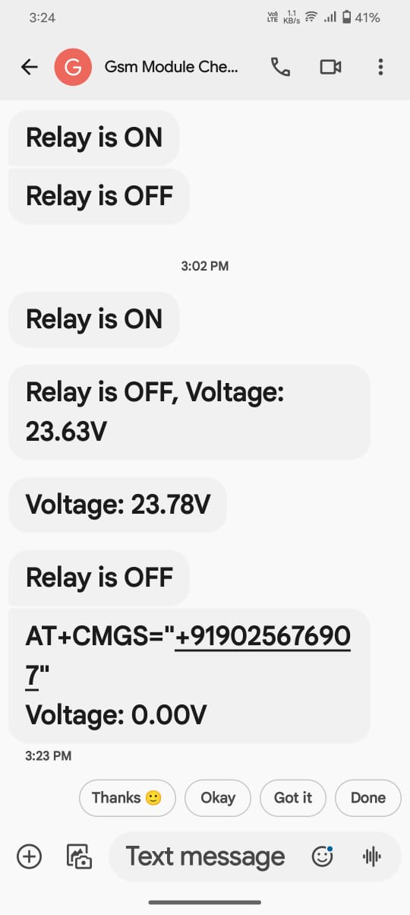

Use Cases

- Industrial motor control and monitoring.
- Smart energy meters with remote feedback.
- It only accepts one user to prevent unauthorised acces

Connection diagram

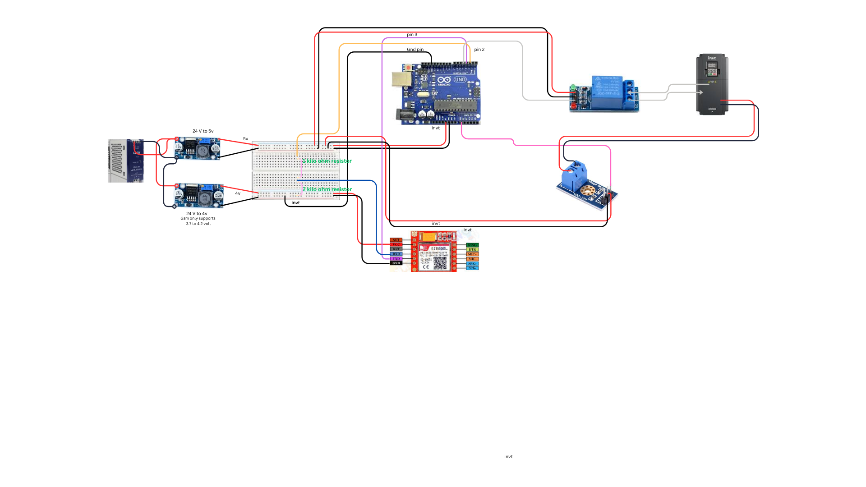

Supporting References

https://lastminuteengineers.com/sim800l-gsm-module-arduino-tutorial/

