STATE MACHINE

A state machine in C is a programming construct used to model systems that exhibit different behaviors based on their current state and incoming events. It provides a structured way to manage complex logic by defining distinct states and the transitions between them, triggered by specific events.

Key Components:
- States:
A finite set of well-defined conditions or modes the system can be in. These are often represented using an enum.
- Events:
External or internal occurrences that can trigger a change in state. Events can also be represented by an enum.
- Transitions:
Rules that define how the system moves from one state to another when a particular event occurs.
- Actions:
Operations or functions executed when entering a state, exiting a state, or during a transition.

Benefits:

- Improved Readability and Maintainability:
Clearly separates concerns and makes it easier to understand system behavior.
- Reduced Complexity:
Manages intricate logic by breaking it down into manageable states and transitions.
- Enhanced Testability:
Allows for systematic testing of each state and transition.
- Robustness:
Helps prevent unexpected behavior by explicitly defining all possible states and transitions.

Component | Description
State | Current mode/condition of the system
Event | Trigger that causes a state transition
Action | Code that runs during a transition
Transition | Rule: If state + event → new state

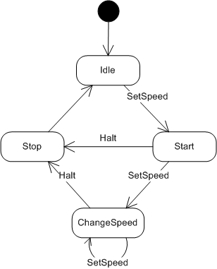

void processEvent(StateMachine* sm, const char* event) {
switch (sm->currentState) {
case IDLE:
if (strcmp(event, "send") == 0) {
sm->currentState = SENDING;
printf("Sending message...\n");
} else if (strcmp(event, "receive") == 0) {
sm->currentState = RECEIVING;
printf("Receiving message...\n");
}
break;

case SENDING:
sm->currentState = IDLE;
printf("Message sent. Back to idle.\n");
break;

case RECEIVING:
sm->currentState = IDLE;
printf("Message received. Back to idle.\n");
break;
}
}

