Zephyr RTOS Porting Report - BGM220P

Porting Zephyr RTOS to BGM220P (EFR32BG22 SoC)

Objective

To enable support for the Silicon Labs BGM220P module by creating a custom Zephyr board
configuration and successfully building the blinky_app using Zephyr RTOS

Silmplicity studio run:

I runned it simplicity studio on this board with basic led blink through to check the board is working properly or not through Bluetooth it is worked properly

Target Platform

• Board: Silicon Labs BGM220P
• SoC: EFR32BG22C224F512IM40
• Architecture: ARM Cortex-M33
• RTOS: Zephyr 4.2.0-rc1
• Toolchain: Zephyr SDK 0.17.2

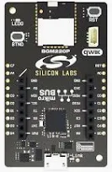

https://www.silabs.com/documents/public/data-sheets/bgm220p-datasheet.pdf

https://www.silabs.com/documents/public/reference-manuals/brd4311a-reference-manual.pdf

Board & Soc Setup:

Created custom board folder: zephyr/boards/arm/bgm220p

Created files :
- bgm220p.dts
- bgm220p_defconfig
- bgm220p.yaml
- Kconfig.board
- CmakeLists.txt

SOC Directory Structure

Setup under: zephyr/soc/arm/silabs/efr32bg22/
- Kconfig.soc
- Kconfig.series
- Kconfig.defconfig

Kconfig Integration (you did great here):

- ✅ Added source "soc/arm/silabs/Kconfig.series" in zephyr/soc/arm/Kconfig.series
- ✅ Added source "soc/arm/silabs/Kconfig.soc" in zephyr/soc/arm/Kconfig.soc
- ✅ Linked Kconfig.defconfig properly
- ✅ Defined all key symbols in efr32bg22/Kconfig.defconfig

zephyr/
├── boards/arm/bgm220p/
│ ├── bgm220p.dts
│ ├── bgm220p_defconfig
│ ├── bgm220p.yaml
│ ├── bgm220p-pinctrl.dtsi
│ ├── CMakeLists.txt
│ └── Kconfig.board
├── soc/arm/silabs/
│ ├── Kconfig.soc
| |------Kconfig.series
│ └── efr32bg22/
│ ├── Kconfig.series
│ ├── Kconfig.soc
│ └── Kconfig.defconfig

Code

((zephyr-env) ) jawahar@jawahar:~/zephyrproject/zephyr/soc/arm/silabs$ cat Kconfig.series
# SPDX-License-Identifier: Apache-2.0

config SOC_SERIES_EFR32BG22
bool "EFR32BG22 Series MCU"
select SOC_FAMILY_SILABS
select SOC_FAMILY_ARM
select ARCH_ARM
select CPU_CORTEX_M33
select ARM

source "soc/arm/silabs/efr32bg22/Kconfig.soc"

((zephyr-env) ) jawahar@jawahar:~/zephyrproject/zephyr/soc/arm/silabs$ cat Kconfig.soc
# SPDX-License-Identifier: Apache-2.0

menu "Silicon Labs EFR32 Series SoCs"

config SOC_SERIES_EFR32BG22
bool "EFR32BG22 Series MCU"
select SOC_FAMILY_SILABS
select CPU_CORTEX_M33
select ARM

source "soc/arm/silabs/efr32bg22/Kconfig.series"

source "soc/arm/silabs/efr32bg22/Kconfig.soc"

endmenu

((zephyr-env) ) jawahar@jawahar:~/zephyrproject/zephyr/soc/arm/silabs/efr32bg22$ ls
Kconfig.defconfig Kconfig.series Kconfig.soc
((zephyr-env) ) jawahar@jawahar:~/zephyrproject/zephyr/soc/arm/silabs/efr32bg22$ cat Kconfig.defconfig
if SOC_EFR32BG22C224F512IM40

config SOC
default "efr32bg22c224f512im40"

config SOC_SERIES
default "efr32bg22"

config ARCH
default "arm"

config ARM
def_bool y

config SOC_SERIES_EFR32BG22
def_bool y

config SOC_EFR32BG22C224F512IM40
def_bool y

config SERIAL
def_bool y

config CONSOLE
def_bool y

config UART_CONSOLE
def_bool y

config UART_GECKO
def_bool y

config GPIO
def_bool y

config MAIN_STACK_SIZE
int
default 2048

endif

((zephyr-env) ) jawahar@jawahar:~/zephyrproject/zephyr/soc/arm/silabs/efr32bg22$ cat Kconfig.series
# SPDX-License-Identifier: Apache-2.0

config SOC_SERIES_EFR32BG22
bool "EFR32BG22 Series MCU"
select SOC_FAMILY_SILABS
select SOC_FAMILY_ARM
select ARCH_ARM
select CPU_CORTEX_M33
select ARM
help
Enable support for Silicon Labs EFR32BG22 SoC series.

source "soc/arm/silabs/efr32bg22/Kconfig.soc"

((zephyr-env) ) jawahar@jawahar:~/zephyrproject/zephyr/soc/arm/silabs/efr32bg22$ cat Kconfig.soc
# SPDX-License-Identifier: Apache-2.0

config SOC_EFR32BG22C224F512IM40
bool "EFR32BG22C224F512IM40 MCU"
select SOC_SERIES_EFR32BG22
help
Enable support for the Silicon Labs EFR32BG22C224F512IM40 MCU

((zephyr-env) ) jawahar@jawahar:~/zephyrproject/zephyr/soc/arm/silabs/efr32bg22$

((zephyr-env) ) jawahar@jawahar:~/zephyrproject/my_led_app$ ls
build CMakeLists.txt Kconfig Kconfig.override prj.conf src
((zephyr-env) ) jawahar@jawahar:~/zephyrproject/my_led_app$ cat CMakeLists.txt
cmake_minimum_required(VERSION 3.20.0)
find_package(Zephyr REQUIRED HINTS $ENV{ZEPHYR_BASE})
project(my_led_app)

target_sources(app PRIVATE src/main.c)

((zephyr-env) ) jawahar@jawahar:~/zephyrproject/my_led_app$ cat Kconfig.override
CONFIG_MAIN_STACK_SIZE=2048

((zephyr-env) ) jawahar@jawahar:~/zephyrproject/my_led_app$ cat prj.conf
CONFIG_GPIO=y
CONFIG_SERIAL=y
CONFIG_CONSOLE=y
CONFIG_UART_CONSOLE=y
CONFIG_MAIN_STACK_SIZE=2048

((zephyr-env) ) jawahar@jawahar:~/zephyrproject/my_led_app$ cat Kconfig
# Kconfig.override for bgm220p to suppress Kconfig warnings

# Cache line sizes
config DCACHE_LINE_SIZE
int
default 32

config ICACHE_LINE_SIZE
int
default 32

# Interrupt-related symbols
config GEN_ISR_TABLES
bool
default n

config GEN_IRQ_VECTOR_TABLE
bool
default n

# Ambiq audio PDM buffer alignment
config PDM_AMBIQ_BUFFER_ALIGNMENT
int
default 32

# Flash MSPI cache size
config FLASH_MSPI_RANGE_HANDLE_CACHE_SIZE
int
default 0

# I2C idle gating
config SOC_IT51XXX_CPU_IDLE_GATING
bool
default n

# I2S Ambiq buffer alignment
config I2S_AMBIQ_BUFFER_ALIGNMENT
int
default 32

# MSPI Ambiq buffer location and alignment
config MSPI_AMBIQ_BUFF_RAM_LOCATION
hex
default 0x00000000

config MSPI_AMBIQ_BUFF_ALIGNMENT
int
default 32

# Undefined SOC Ambiq symbols
config SOC_AMBIQ_DCACHE_SIZE
int
default 0

config SOC_AMBIQ_DMA_BUFF_LOCATION
hex
default 0x00000000

config SOC_AMBIQ_DMA_BUFF_ALIGNMENT
int
default 32

((zephyr-env) ) jawahar@jawahar:~/zephyrproject/my_led_app$ cat src/main.c
#include <zephyr/kernel.h>
#include <zephyr/drivers/gpio.h>

#define LED_NODE DT_ALIAS(led0)

const struct gpio_dt_spec led = GPIO_DT_SPEC_GET(LED_NODE, gpios);

void main(void)
{
if (!device_is_ready(led.port)) {
return;
}

gpio_pin_configure_dt(&led, GPIO_OUTPUT_ACTIVE);

while (1) {
gpio_pin_toggle_dt(&led);
k_msleep(30000); // 30s delay
}
}

((zephyr-env) ) jawahar@jawahar:~/zephyrproject/my_led_app$

To Run:

west build -b bgm220p

Currently clearing Error

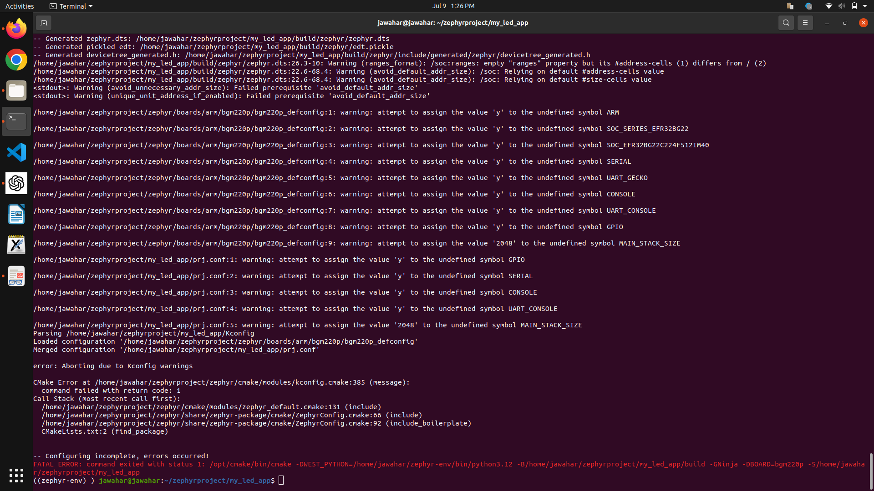

((zephyr-env) ) jawahar@jawahar:~/zephyrproject/my_led_app$ west build -b bgm220p
-- west build: generating a build system
Loading Zephyr default modules (Zephyr base).
-- Application: /home/jawahar/zephyrproject/my_led_app
-- CMake version: 3.20.0
-- Found Python3: /home/jawahar/zephyr-env/bin/python3.12 (found suitable version "3.12.11", minimum required is "3.10") found components: Interpreter
-- Cache files will be written to: /home/jawahar/.cache/zephyr
-- Zephyr version: 4.2.0-rc1 (/home/jawahar/zephyrproject/zephyr)
-- Found west (found suitable version "1.4.0", minimum required is "0.14.0")
-- Board: bgm220p
-- ZEPHYR_TOOLCHAIN_VARIANT not set, trying to locate Zephyr SDK
-- Found host-tools: zephyr 0.16.5 (/opt/zephyr-sdk)
-- Found toolchain: zephyr 0.16.5 (/opt/zephyr-sdk)
-- Found Dtc: /opt/zephyr-sdk/sysroots/x86_64-pokysdk-linux/usr/bin/dtc (found suitable version "1.6.0", minimum required is "1.4.6")
-- Found BOARD.dts: /home/jawahar/zephyrproject/zephyr/boards/arm/bgm220p/bgm220p.dts
-- Generated zephyr.dts: /home/jawahar/zephyrproject/my_led_app/build/zephyr/zephyr.dts
-- Generated pickled edt: /home/jawahar/zephyrproject/my_led_app/build/zephyr/edt.pickle
-- Generated devicetree_generated.h: /home/jawahar/zephyrproject/my_led_app/build/zephyr/include/generated/zephyr/devicetree_generated.h
/home/jawahar/zephyrproject/my_led_app/build/zephyr/zephyr.dts:26.3-10: Warning (ranges_format): /soc:ranges: empty "ranges" property but its #address-cells (1) differs from / (2)
/home/jawahar/zephyrproject/my_led_app/build/zephyr/zephyr.dts:22.6-68.4: Warning (avoid_default_addr_size): /soc: Relying on default #address-cells value
/home/jawahar/zephyrproject/my_led_app/build/zephyr/zephyr.dts:22.6-68.4: Warning (avoid_default_addr_size): /soc: Relying on default #size-cells value
<stdout>: Warning (avoid_unnecessary_addr_size): Failed prerequisite 'avoid_default_addr_size'
<stdout>: Warning (unique_unit_address_if_enabled): Failed prerequisite 'avoid_default_addr_size'

/home/jawahar/zephyrproject/zephyr/boards/arm/bgm220p/bgm220p_defconfig:1: warning: attempt to assign the value 'y' to the undefined symbol ARM

/home/jawahar/zephyrproject/zephyr/boards/arm/bgm220p/bgm220p_defconfig:2: warning: attempt to assign the value 'y' to the undefined symbol SOC_SERIES_EFR32BG22

/home/jawahar/zephyrproject/zephyr/boards/arm/bgm220p/bgm220p_defconfig:3: warning: attempt to assign the value 'y' to the undefined symbol SOC_EFR32BG22C224F512IM40

/home/jawahar/zephyrproject/zephyr/boards/arm/bgm220p/bgm220p_defconfig:4: warning: attempt to assign the value 'y' to the undefined symbol SERIAL

/home/jawahar/zephyrproject/zephyr/boards/arm/bgm220p/bgm220p_defconfig:5: warning: attempt to assign the value 'y' to the undefined symbol UART_GECKO

/home/jawahar/zephyrproject/zephyr/boards/arm/bgm220p/bgm220p_defconfig:6: warning: attempt to assign the value 'y' to the undefined symbol CONSOLE

/home/jawahar/zephyrproject/zephyr/boards/arm/bgm220p/bgm220p_defconfig:7: warning: attempt to assign the value 'y' to the undefined symbol UART_CONSOLE

/home/jawahar/zephyrproject/zephyr/boards/arm/bgm220p/bgm220p_defconfig:8: warning: attempt to assign the value 'y' to the undefined symbol GPIO

/home/jawahar/zephyrproject/zephyr/boards/arm/bgm220p/bgm220p_defconfig:9: warning: attempt to assign the value '2048' to the undefined symbol MAIN_STACK_SIZE

/home/jawahar/zephyrproject/my_led_app/prj.conf:1: warning: attempt to assign the value 'y' to the undefined symbol GPIO

/home/jawahar/zephyrproject/my_led_app/prj.conf:2: warning: attempt to assign the value 'y' to the undefined symbol SERIAL

/home/jawahar/zephyrproject/my_led_app/prj.conf:3: warning: attempt to assign the value 'y' to the undefined symbol CONSOLE

/home/jawahar/zephyrproject/my_led_app/prj.conf:4: warning: attempt to assign the value 'y' to the undefined symbol UART_CONSOLE

/home/jawahar/zephyrproject/my_led_app/prj.conf:5: warning: attempt to assign the value '2048' to the undefined symbol MAIN_STACK_SIZE
Parsing /home/jawahar/zephyrproject/my_led_app/Kconfig
Loaded configuration '/home/jawahar/zephyrproject/zephyr/boards/arm/bgm220p/bgm220p_defconfig'
Merged configuration '/home/jawahar/zephyrproject/my_led_app/prj.conf'

error: Aborting due to Kconfig warnings

CMake Error at /home/jawahar/zephyrproject/zephyr/cmake/modules/kconfig.cmake:385 (message):
command failed with return code: 1
Call Stack (most recent call first):
/home/jawahar/zephyrproject/zephyr/cmake/modules/zephyr_default.cmake:131 (include)
/home/jawahar/zephyrproject/zephyr/share/zephyr-package/cmake/ZephyrConfig.cmake:66 (include)
/home/jawahar/zephyrproject/zephyr/share/zephyr-package/cmake/ZephyrConfig.cmake:92 (include_boilerplate)
CMakeLists.txt:2 (find_package)

-- Configuring incomplete, errors occurred!
FATAL ERROR: command exited with status 1: /opt/cmake/bin/cmake -DWEST_PYTHON=/home/jawahar/zephyr-env/bin/python3.12 -B/home/jawahar/zephyrproject/my_led_app/build -GNinja -DBOARD=bgm220p -S/home/jawahar/zephyrproject/my_led_app
((zephyr-env) ) jawahar@jawahar:~/zephyrproject/my_led_app$

