A queue is a linear data structure that follows the First In First Out (FIFO) order of insertion and deletion. It means that the element that is inserted first will be the first one to be removed and the element that is inserted last will be removed at last.

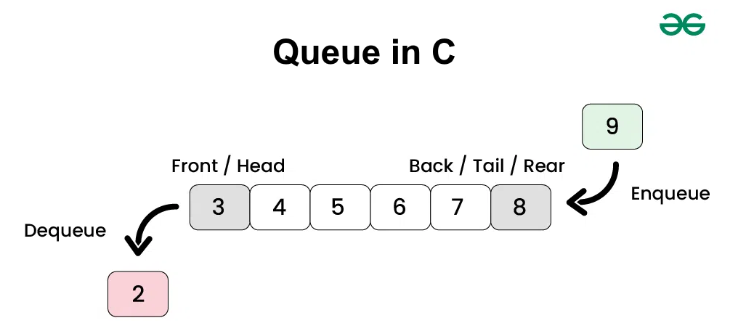

Representation of Queue in C

struct Queue {
type arr[MAX_SIZE];
int back;
int front;
}

---code---

#include <stdio.h>
#define SIZE 5

int queue[SIZE];
int front = -1, rear = -1;

void enqueue(int value) {
if (rear == SIZE - 1) {
printf("Queue is full!\n");
return;
}

if (front == -1) front = 0; // First element
rear++;
queue[rear] = value;
printf("Inserted: %d\n", value);
}

void dequeue() {
if (front == -1 || front > rear) {
printf("Queue is empty!\n");
return;
}

printf("Deleted: %d\n", queue[front]);
front++;
}

void display() {
if (front == -1 || front > rear) {
printf("Queue is empty!\n");
return;
}

printf("Queue: ");
for (int i = front; i <= rear; i++) {
printf("%d ", queue[i]);
}
printf("\n");
}

int main() {
enqueue(10);
enqueue(20);
enqueue(30);

display();

dequeue();
display();

enqueue(40);
display();

return 0;
}

