Week14-SH1

**Installing of Test Complete in laptop**

Step1: firstly, click on the following URL: <https://smartbear.com/product/testcomplete/overview/>

Step2: click on the free trail on the upper riogt side of the web page.

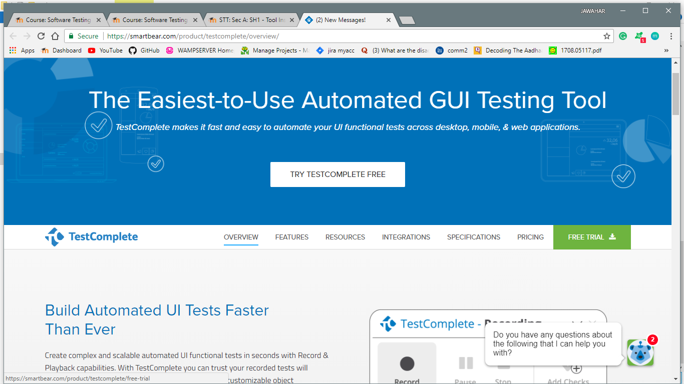

Step3: a screen will appear where u need to enter the following data. And click on the start trail.

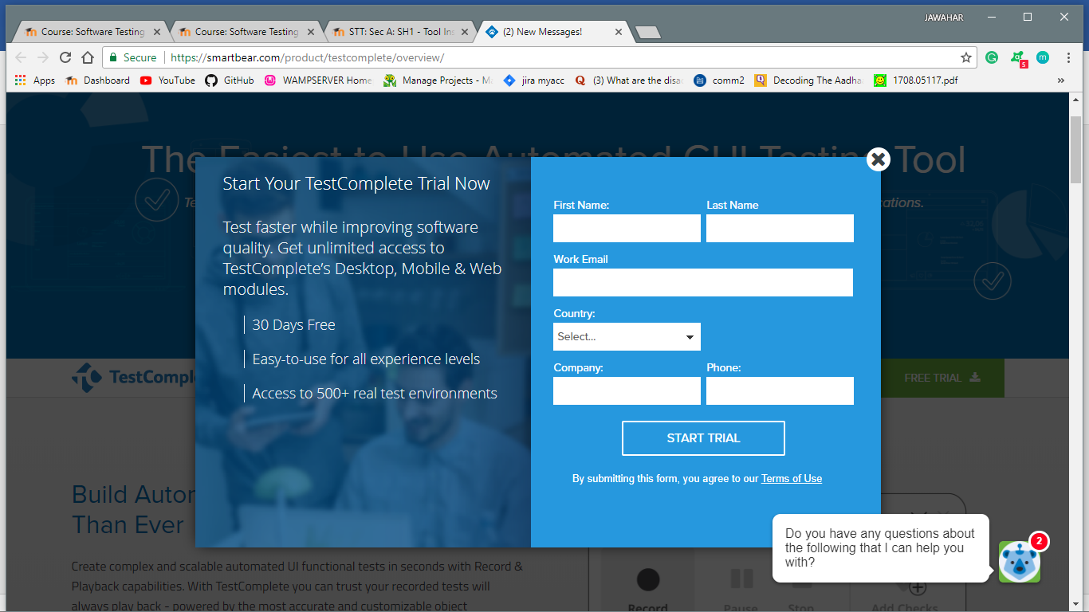

Step4: After this this the software stars downloading in your laptop.

Step5: After completion of download open the download folder and click on the downloaded software.

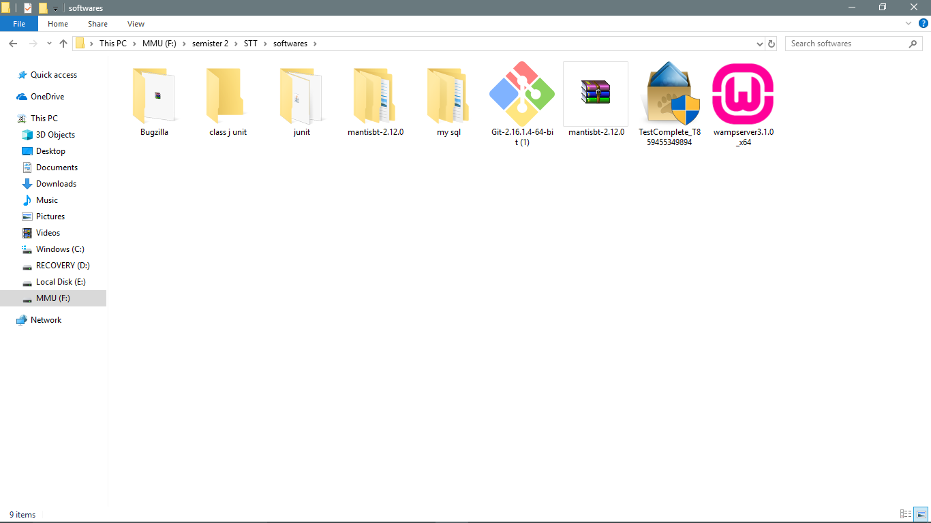

Step6: A screen will ask you to select yes or no, click on yes. After this you will see this screen.

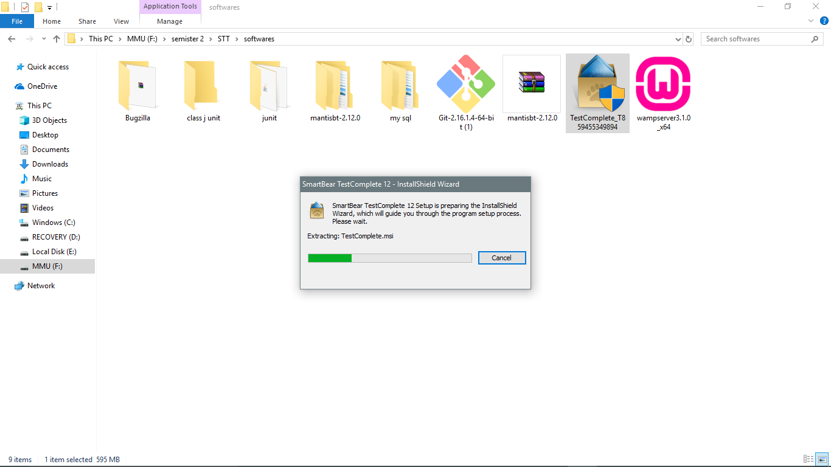

Step7: Now it will ask for the licence agreement, select I agree and click on next.

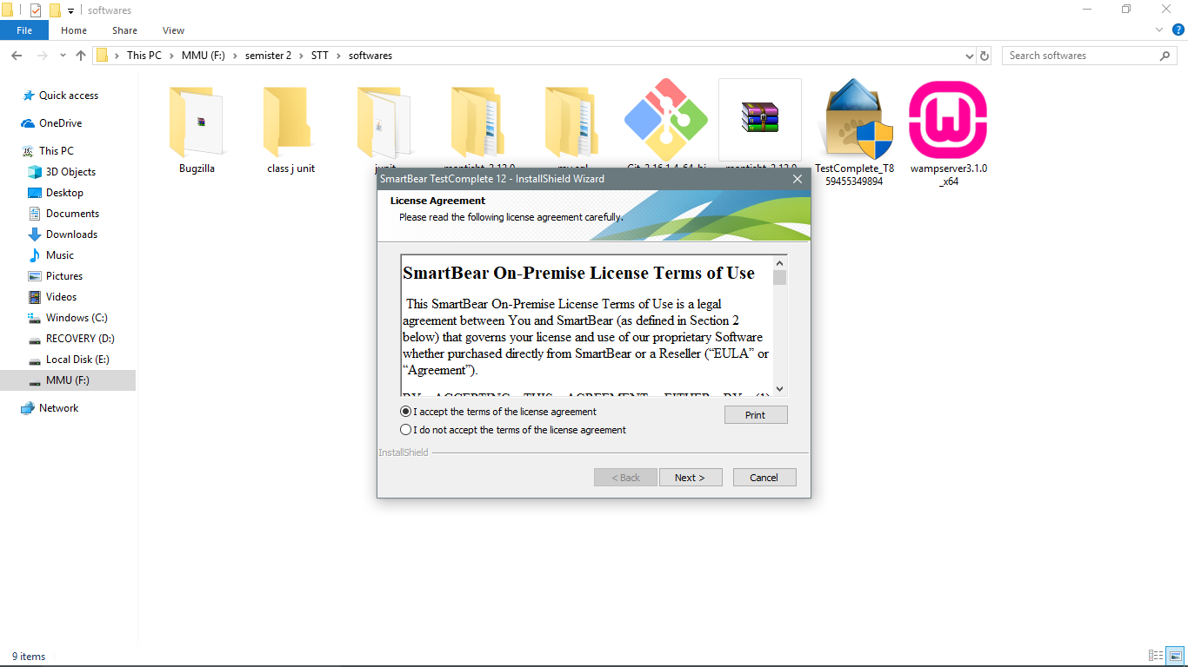

Step8: Now it will start installing the test complete in your laptop. It is a little time taking process, you may see the following screens while installing.

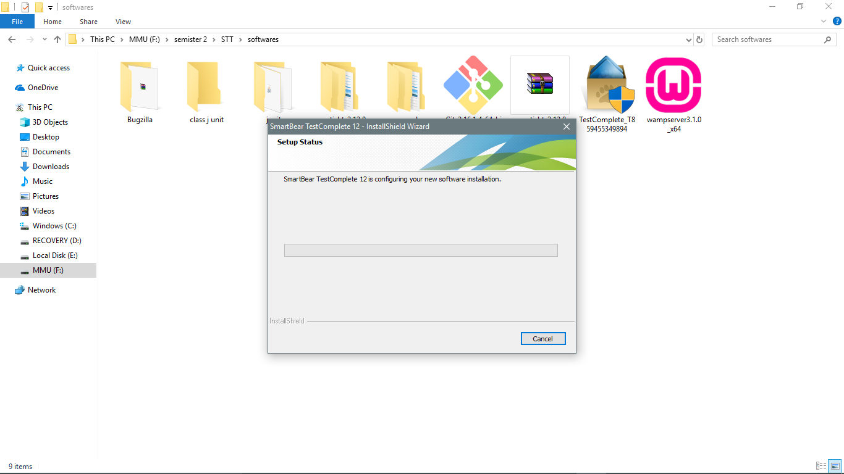

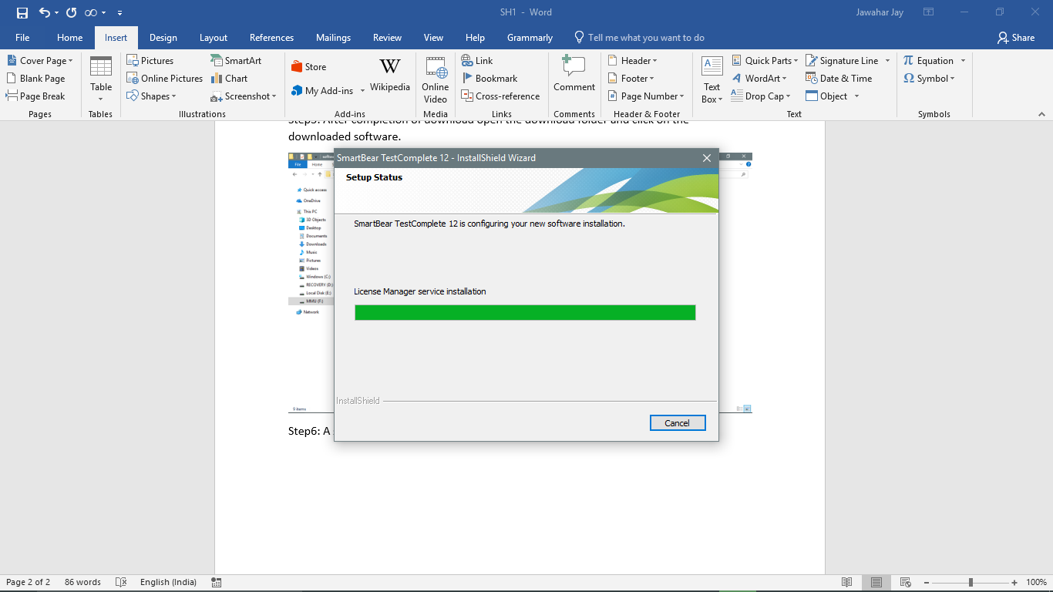

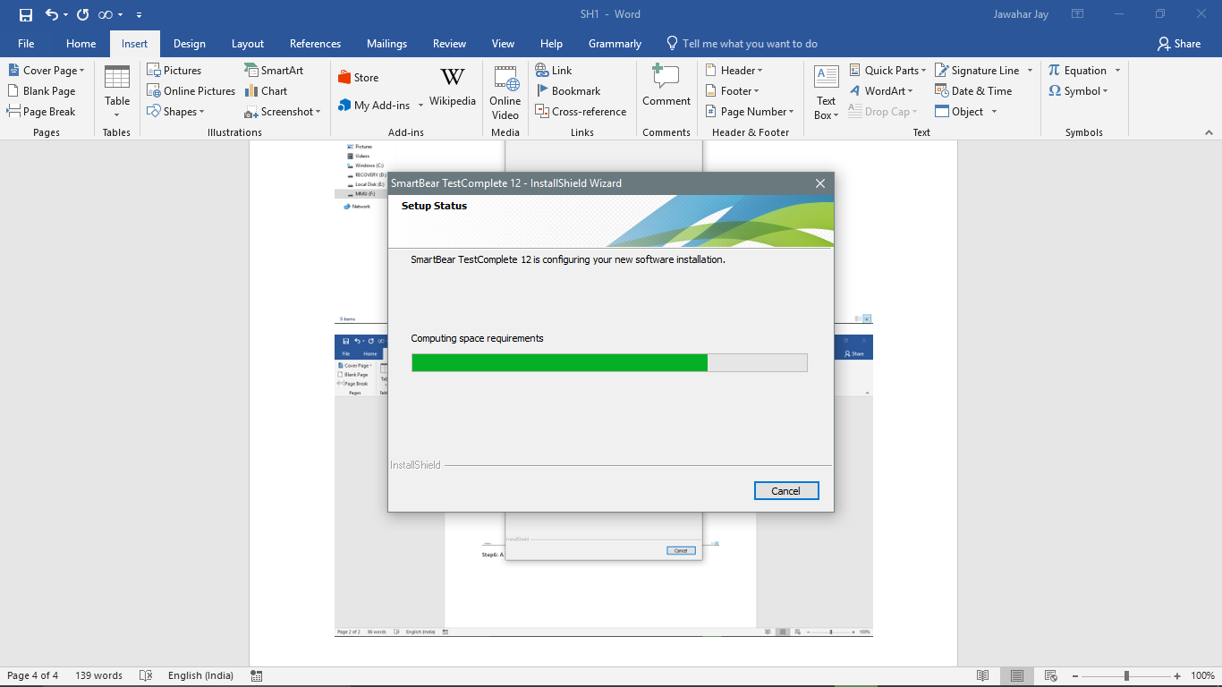

Step9: After this your software is installed and you will see this screens.

