EXP NO:1)A Analyze the trend of data science job postings over the last decade for the
given data on the number of data science job postings each year. Use
pandas for data manipulation and matplotlib /seaborn for visualization.

AIM:
To Analyze the trend of data science job postings over the last decade for the
given data on the number of data science job postings each year. Use
pandas for data manipulation and matplotlib /seaborn for visualization.

PROGRAM:
import pandas as pd
import matplotlib.pyplot as plt
data = {
"Year": [2015, 2016, 2017, 2018, 2019, 2020, 2021, 2022, 2023, 2024],
"Job_Postings": [1200, 1500, 1800, 2200, 2800, 3500, 4500, 5200, 6000, 6800]
}
df = pd.DataFrame(data)
print(df)
plt.plot(df["Year"], df["Job_Postings"], marker='o',color="red")
plt.title("Data Science Job Postings Over the Last Decade")
plt.xlabel("Year")
plt.ylabel("Number of Job Postings")
plt.grid(True)
plt.show()

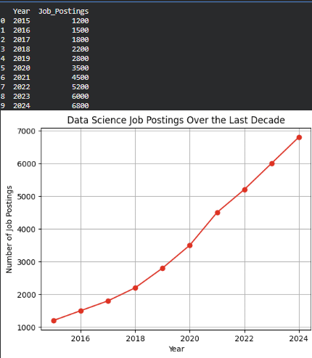
RESULT:
Analyze the trend of data science job postings over the last decade for the
given data on the number of data science job postings each year. Use
pandas for data manipulation and matplotlib /sea
born for visualization.

EXP NO:1)B Analyze and visualize the distribution of various data science roles (Data
Analyst, Data Engineer, Data Scientist, etc.) from a dataset.

AIM:
To analyze and visualize the distribution of various data science roles (Data
Analyst, Data Engineer, Data Scientist, etc.) from a dataset.

PROGRAM:
import pandas as pd
import matplotlib.pyplot as plt
data = {
"Role": ["Data Scientist", "Data Analyst", "Data Engineer",
"ML Engineer", "Data Analyst", "Data Scientist",
"Data Engineer", "Data Scientist", "ML Engineer",
"Data Analyst"]
}
df = pd.DataFrame(data)
role_count = df["Role"].value_counts()
print(role_count)
role_count.plot(kind="bar", color="brown")
plt.title("Distribution of Data Science Roles")
plt.xlabel("Role")
plt.ylabel("Count")
plt.show()

OUTPUT:

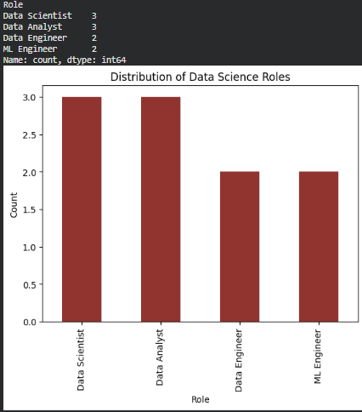

RESULT:
Thus the program Analyze and visualize the distribution of various data science roles
from a dataset.

EXP NO:1)C Conduct an experiment to differentiate Structured , Un-structured and
Semi structured data based on data sets given.

AIM:
To Conduct an experiment to differentiate Structured , Un-structured and
Semi structured data based on data sets given.

PROGRAM:
import pandas as pd
structured_data = pd.DataFrame({
"Name": ["John", "Mary", "Sam"],
"Age": [20, 25, 22]
})
semi_structured_data = {
"Name": "John",
"Age": 20,
"City": "Chennai"
}
unstructured_data = [
"Hello, this is a text file",
"Photo.jpg",
"Video.mp4"
]
print("Structured Data:")
print(structured_data)
print("\nSemi-Structured Data:")
print(semi_structured_data)
print("\nUnstructured Data:")
print(unstructured_data)

OUTPUT:
Structured Data:
Name Age
0 John 20
1 Mary 25
2 Sam 22

Semi-Structured Data:
{'Name': 'John', 'Age': 20, 'City': 'Chennai'}

Unstructured Data:
['Hello, this is a text file', 'Photo.jpg', 'Video.mp4']

RESULT:
Thus the program to Conduct an experiment to differentiate Structured , Un-structured and Semi structured data based on data sets given.

EXP NO:1)D Conduct an experiment to encrypt and decrypt given sensitive data Use cryptography library fernet.

AIM:
To Conduct an experiment to encrypt and decrypt given sensitive data Use the
cryptography library fernet.

PROGRAM:
from cryptography.fernet import Fernet
key = Fernet.generate_key()
cipher = Fernet(key)
data = "My password is 12345"
encrypted_data = cipher.encrypt(data.encode())
decrypted_data = cipher.decrypt(encrypted_data).decode()
print("Original Data:")
print(data)
print("\nEncrypted Data:")
print(encrypted_data)
print("\nDecrypted Data:")
print(decrypted_data)

OUTPUT:
Original Data:
My password is 12345

Encrypted Data:
b'gAAAAABqadsmPyzIuKKli9XeWhRJgqQIHXtcvkbCOgnQnpGRoqPh4k28pqIJyGWIFfREL4D0OV0dLFV9sYMQfGn2HZvEe3RFIwgzImlrmG2P7y-LM3TbRx0='

Decrypted Data:
My password is 12345

RESULT:

Thus the program to Conduct an experiment to encrypt and decrypt given sensitive data Use the cryptography library fernet.

