EXP NO: 12 | Experiment to detect outliers in a given data set.
AIM:
To detect outliers in a given dataset using statistical methods such as the Interquartile Range (IQR) method and visualize the outliers using Python libraries like Pandas and Matplotlib.
PROGRAM:
import numpy as np
import seaborn as sns
import matplotlib.pyplot as plt

# Generate random data
array = np.random.randint(1, 100, 16)

print(array)

# Mean
print("Mean:", array.mean())

# Percentiles
print("25%:", np.percentile(array, 25))
print("50%:", np.percentile(array, 50))
print("75%:", np.percentile(array, 75))
print("100%:", np.percentile(array, 100))

# Outlier detection
def outDetection(array):
Q1, Q3 = np.percentile(array, [25, 75])
IQR = Q3 - Q1
lr = Q1 - (1.5 * IQR)
ur = Q3 + (1.5 * IQR)
return lr, ur

lr, ur = outDetection(array)

print("Lower Range:", lr)
print("Upper Range:", ur)

# Plot original data
sns.displot(array)
plt.show()

# Remove outliers
new_array = array[(array > lr) & (array < ur)]

print("After removing outliers:")
print(new_array)

# Plot new data
sns.displot(new_array)
plt.show()

# Final outlier detection
lr1, ur1 = outDetection(new_array)

print("New Lower Range:", lr1)
print("New Upper Range:", ur1)

final_array = new_array[
(new_array > lr1) & (new_array < ur1)
]

print("Final Array:")
print(final_array)

sns.displot(final_array)
plt.show()

OUTPUT:
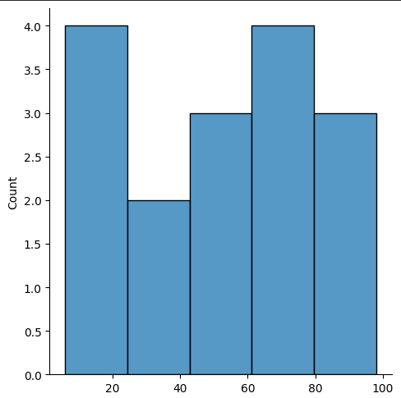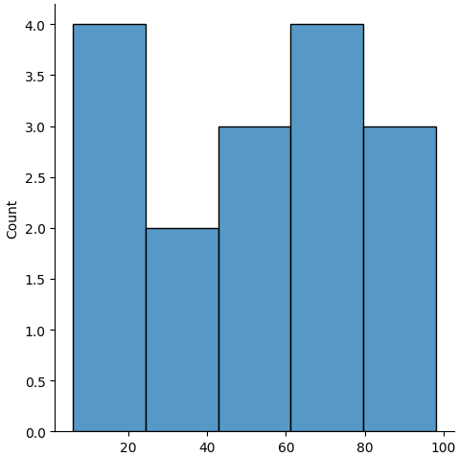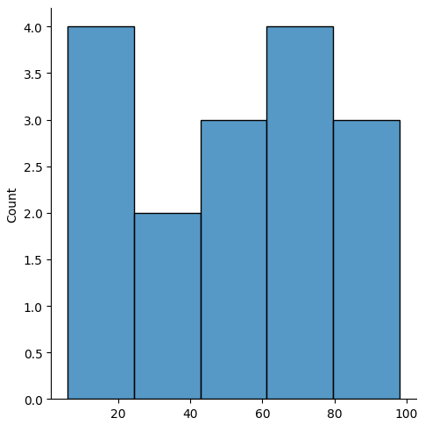

RESULT:
Thus, the outliers in the given dataset were successfully detected using the Interquartile Range (IQR) method and visualized using Python libraries such as Pandas and Matplotlib.

