EXP NO: 13 | Experiment to handle missing values and inappropriate data in a  given data set
AIM:
To identify and handle missing values and inappropriate data in a given dataset using Python libraries such as Pandas and NumPy by applying suitable data cleaning techniques, including removing, replacing, and correcting invalid values.
PROGRAM:
import numpy as np
import pandas as pd
from google.colab import files

uploaded = files.upload()
df = pd.read_csv("Hotel_Dataset.csv")
df

df.duplicated()

df.info()

df.drop_duplicates(inplace=True)
df

len(df)

df.reset_index(drop=True, inplace=True)
df

df.drop(["Age_Group.1"], axis=1, inplace=True)
df

df.loc[df["CustomerID"] < 0, "CustomerID"] = np.nan
df.loc[df["Bill"] < 0, "Bill"] = np.nan
df.loc[df["EstimatedSalary"] < 0, "EstimatedSalary"] = np.nan

df.loc[(df["NoOfPax"] < 1) | (df["NoOfPax"] > 20), "NoOfPax"] = np.nan
df

df["Age_Group"].unique()

df["Hotel"].unique()

df["Hotel"] = df["Hotel"].replace("Ibys", "Ibis")
df

df["FoodPreference"].unique()

df["FoodPreference"] = df["FoodPreference"].replace(
["Vegetarian", "veg"], "Veg"
)
df["FoodPreference"] = df["FoodPreference"].replace(
"non-Veg", "Non-Veg"
)
df

df["EstimatedSalary"] = df["EstimatedSalary"].fillna(
round(df["EstimatedSalary"].mean())
)

df["NoOfPax"] = df["NoOfPax"].fillna(
round(df["NoOfPax"].median())
)

df["Rating(1-5)"] = df["Rating(1-5)"].fillna(
round(df["Rating(1-5)"].median())
)

df["Bill"] = df["Bill"].fillna(
round(df["Bill"].mean())
)

df

df.info()
print("Total rows:", len(df))
print("Total columns:", len(df.columns))
print("Missing values:")
print(df.isnull().sum())

OUTPUT:
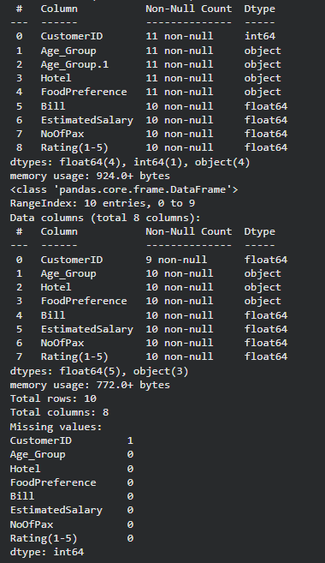

RESULT:
Thus, the missing values and inappropriate data in the given dataset were successfully identified and handled using Python Pandas, and the dataset was cleaned for further analysis.

