EXP NO: 14 | Experiment to understand feature scaling.
AIM:
To understand and implement feature scaling techniques such as Normalization and Standardization on a given dataset using Python.
PROGRAM:
import numpy as np
import pandas as pd
from google.colab import files

uploaded = files.upload()
df = pd.read_csv("pre-process_datasample.csv")
df

df.head()

df.info()

df["Country"] = df["Country"].fillna(df["Country"].mode()[0])

features = df.iloc[:, :-1].values
label = df.iloc[:, -1].values

from sklearn.impute import SimpleImputer

age = SimpleImputer(strategy="mean", missing_values=np.nan)
salary = SimpleImputer(strategy="mean", missing_values=np.nan)

age.fit(features[:, [1]])
salary.fit(features[:, [2]])

features[:, [1]] = age.transform(features[:, [1]])
features[:, [2]] = salary.transform(features[:, [2]])

features

from sklearn.preprocessing import OneHotEncoder

oh = OneHotEncoder(sparse_output=False)
Country = oh.fit_transform(features[:, [0]])

Country

final_set = np.concatenate((Country, features[:, [1, 2]]), axis=1)
final_set

from sklearn.preprocessing import StandardScaler

sc = StandardScaler()
sc.fit(final_set)

feat_standard_scaler = sc.transform(final_set)
feat_standard_scaler

from sklearn.preprocessing import MinMaxScaler

mms = MinMaxScaler(feature_range=(0, 1))
mms.fit(final_set)

feat_minmax_scaler = mms.transform(final_set)
feat_minmax_scaler

OUTPUT:
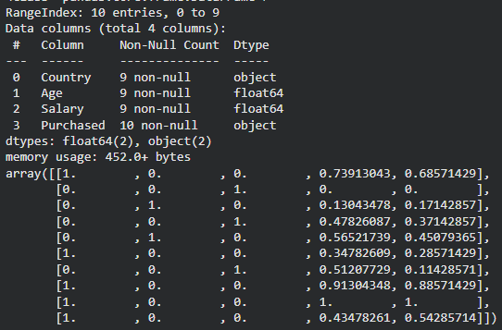

RESULT:
Thus, feature scaling techniques were successfully implemented on the given dataset to bring numerical features to a common scale.

