EXP NO:16 Experiment to understand EDA-Quantitative and Qualitative analysis.
AIM:
To make an experiment to understand EDA-Quantitative and Qualitative analysis.
PROGRAM:
import seaborn as sns
import pandas as pd
import numpy as np
import matplotlib.pyplot as plt
%matplotlib inline
tips = sns.load_dataset('tips')
print(tips.head())
sns.displot(data=tips, x='total_bill', kde=True)
plt.show()
sns.displot(data=tips, x='total_bill', kde=False)
plt.show()
sns.jointplot(data=tips, x='tip', y='total_bill')
plt.show()
sns.jointplot(data=tips, x='tip', y='total_bill', kind='reg')
plt.show()
sns.jointplot(data=tips, x='tip', y='total_bill', kind='hex')
plt.show()
sns.pairplot(tips)
plt.show()
print(tips.time.value_counts())
sns.pairplot(tips, hue='time')
plt.show()
sns.pairplot(tips, hue='day')
plt.show()
plt.figure(figsize=(8, 6))
sns.heatmap(tips.corr(numeric_only=True), annot=True)
plt.show()
plt.figure(figsize=(8, 5))
sns.boxplot(x=tips.total_bill)
plt.show()
plt.figure(figsize=(8, 5))
sns.boxplot(x=tips.tip)
plt.show()
plt.figure(figsize=(8, 5))
sns.countplot(data=tips, x='day')
plt.show()
plt.figure(figsize=(8, 5))
sns.countplot(data=tips, x='sex')
plt.show()

tips.sex.value_counts().plot(kind='pie', autopct='%1.1f%%')
plt.show()
tips.sex.value_counts().plot(kind='bar')
plt.show()
plt.figure(figsize=(8, 5))
sns.countplot(data=tips[tips.time == 'Dinner'], x='day')
plt.show()

OUTPUT:

total_bill tip sex smoker day time size
0 16.99 1.01 Female No Sun Dinner 2
1 10.34 1.66 Male No Sun Dinner 3
2 21.01 3.50 Male No Sun Dinner 3
3 23.68 3.31 Male No Sun Dinner 2
4 24.59 3.61 Female No Sun Dinner 4
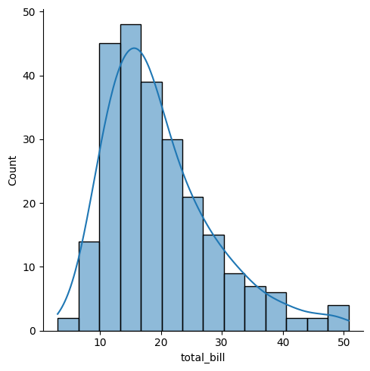
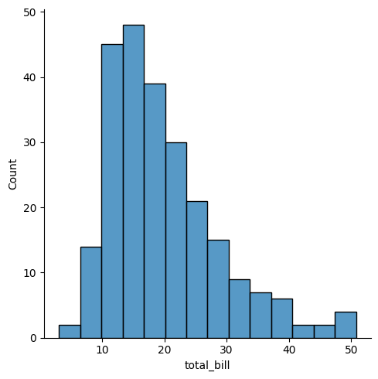
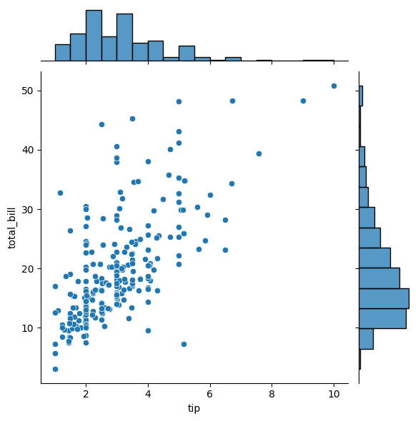
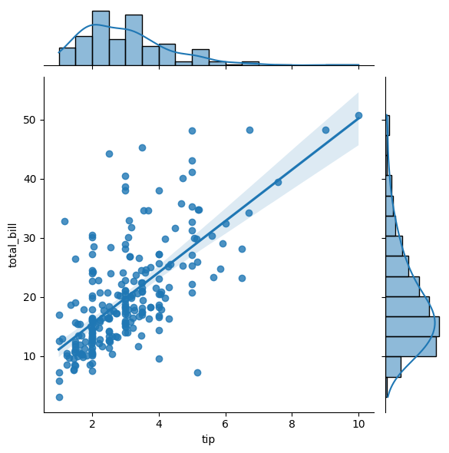
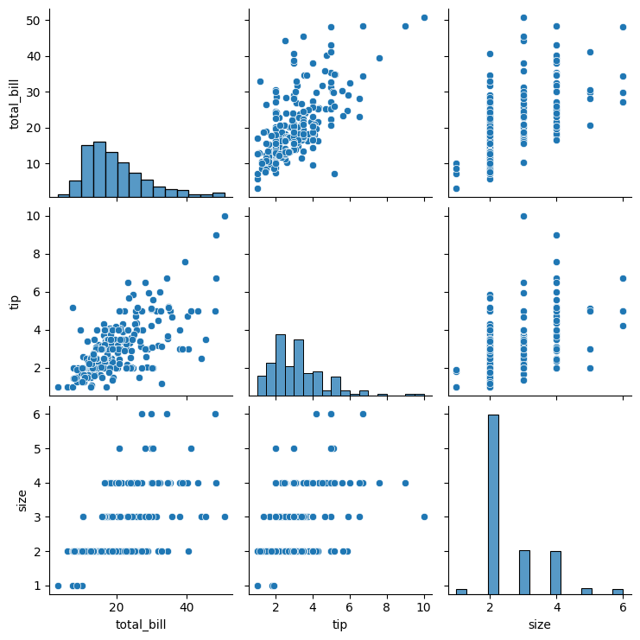
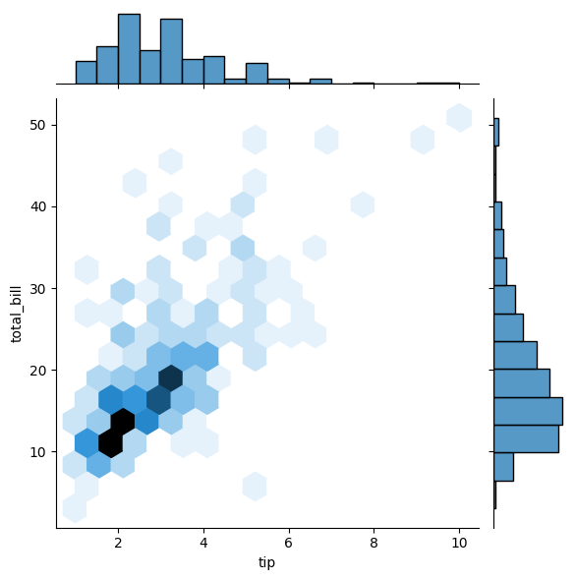

time
Dinner 176
Lunch 68
Name: count, dtype: int64
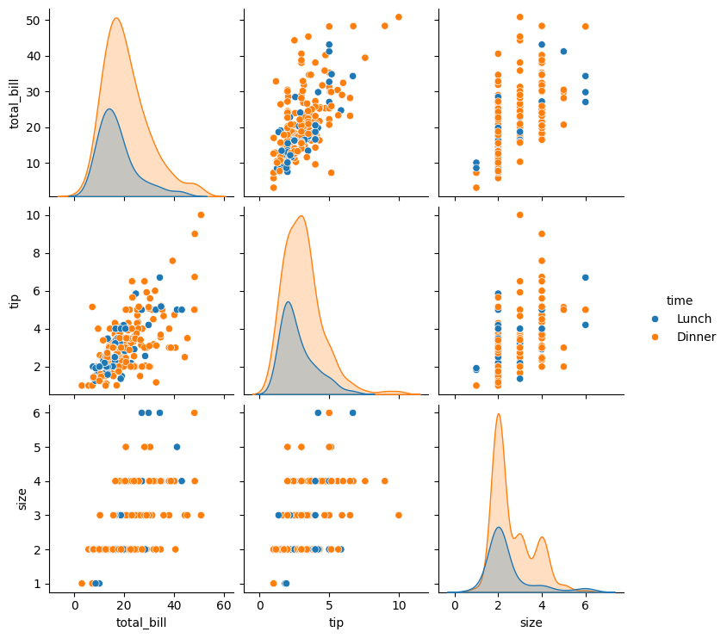
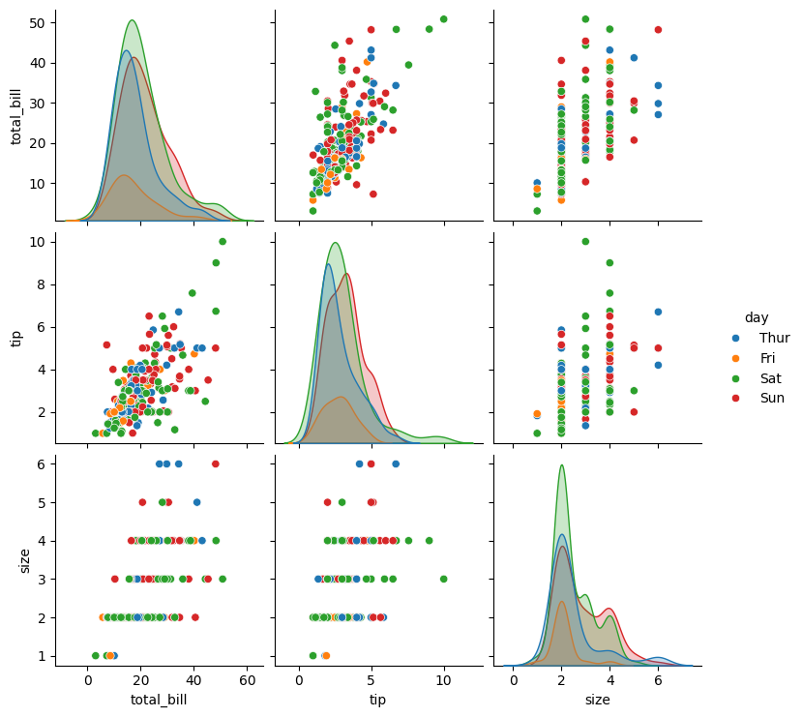
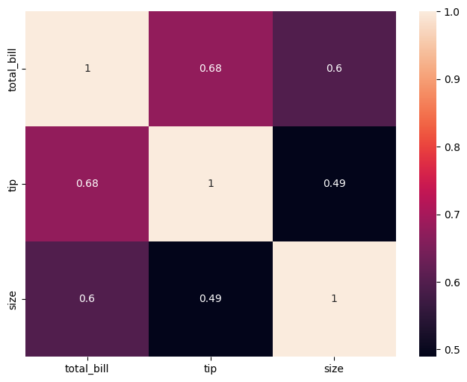

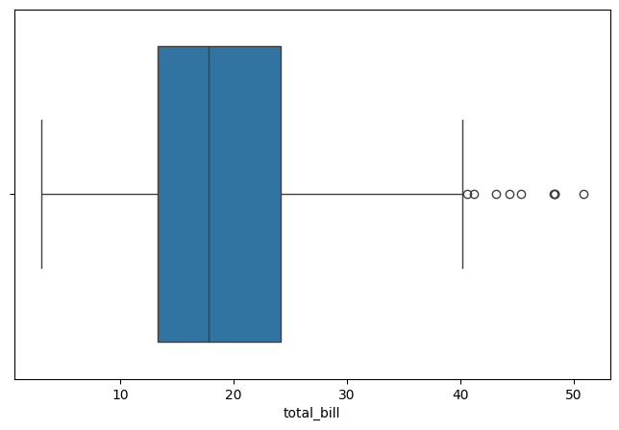
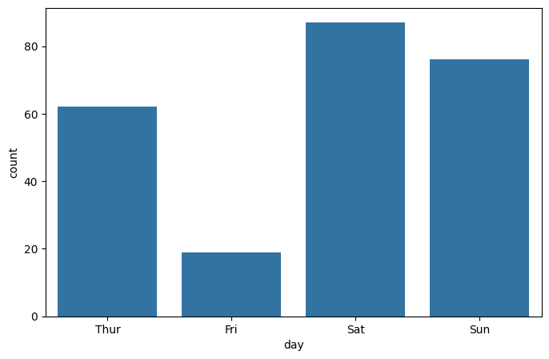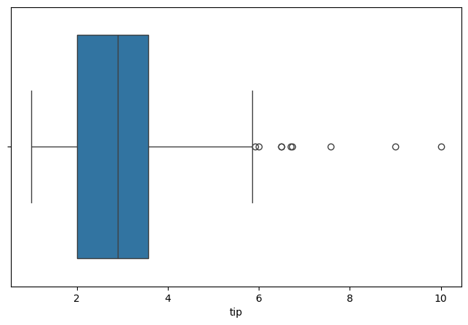
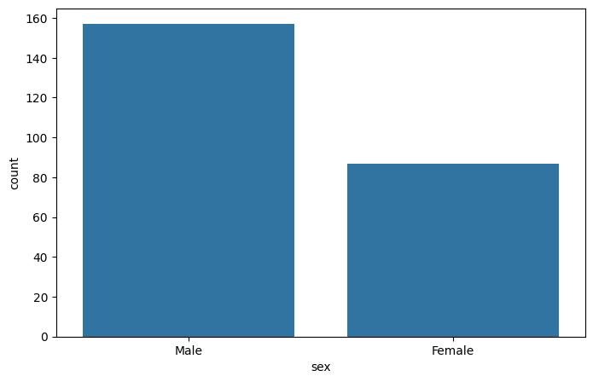
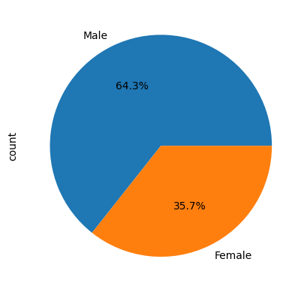
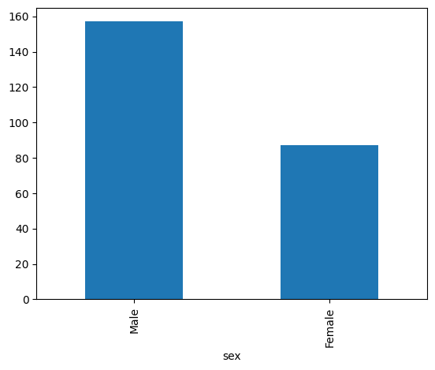
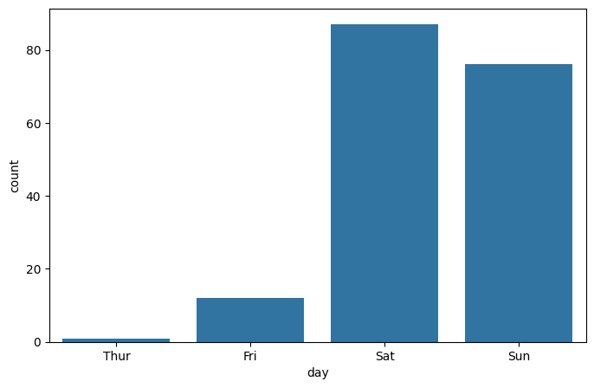

RESULT:
Thus the experiment to understand EDA-Quantitative and Qualitative analysis is done.

