EXP NO:2 Upload and Analyze the data set given in csv format and perform data
preprocessing and visualization.

AIM:

To upload and Analyze the data set given in csv format and perform data
preprocessing and visualization.

PROGRAM:
import pandas as pd
import numpy as np
import matplotlib.pyplot as plt
import seaborn as sns
from google.colab import files
uploaded = files.upload()
file_name = list(uploaded.keys())[0]
df = pd.read_csv(file_name)
print("File Loaded Successfully:", file_name)
print("\nFirst 5 rows of the dataset:")
print(df.head())
print("\nMissing values:")
print(df.isnull().sum())
df['Sales'] = df['Sales'].fillna(df['Sales'].mean())
df.dropna(
subset=['Product', 'Quantity', 'Region'],
inplace=True
)
df['Date'] = pd.to_datetime(df['Date'], errors='coerce')
df.dropna(subset=['Date'], inplace=True)
print("\nMissing values after preprocessing:")
print(df.isnull().sum())
print("\nSummary Statistics:")
print(df.describe())
product_summary = df.groupby('Product').agg({
'Sales': 'sum',
'Quantity': 'sum'
}).reset_index()
print("\nProduct-wise Sales and Quantity:")
print(product_summary)
plt.figure(figsize=(10, 6))
plt.bar(
product_summary['Product'],
product_summary['Sales'],
color='steelblue'
)
plt.xlabel('Product')
plt.ylabel('Total Sales')
plt.title('Total Sales by Product')
plt.xticks(rotation=45)
plt.tight_layout()
plt.show()
sales_over_time = df.groupby('Date').agg({
'Sales': 'sum'
}).reset_index()
plt.figure(figsize=(10, 6))
plt.plot(
sales_over_time['Date'],
sales_over_time['Sales'],
marker='o',
color='green'
)
plt.xlabel('Date')
plt.ylabel('Total Sales')
plt.title('Sales Over Time')
plt.xticks(rotation=45)
plt.tight_layout()
plt.show()

pivot_table = df.pivot_table(
values='Sales',
index='Region',
columns='Product',
aggfunc='sum',
fill_value=0
)
print("\nSales by Region and Product:")
print(pivot_table)
numeric_df = df.select_dtypes(include=np.number)
correlation_matrix = numeric_df.corr()
print("\nCorrelation Matrix:")
print(correlation_matrix)
plt.figure(figsize=(8, 6))
sns.heatmap(
correlation_matrix,
annot=True,
cmap='coolwarm',
fmt='.2f'
)
plt.title('Correlation Matrix')
plt.tight_layout()
plt.show()
print("\nFinal Preprocessed Dataset:")
print(df.head())
print("\nFinal Dataset Shape:", df.shape)
print("\nData preprocessing and visualization completed successfully!")

OUTPUT:

First 5 rows of the dataset:
Date Product Quantity Sales Region
0 2026-01-01 Laptop 2 120000.0 North
1 2026-01-02 Phone 5 75000.0 South
2 2026-01-03 Headphones 8 16000.0 East
3 2026-01-04 Tablet 3 45000.0 West
4 2026-01-05 Laptop 1 60000.0 East

Missing values:
Date 0
Product 1
Quantity 0
Sales 1
Region 1
dtype: int64

Missing values after preprocessing:
Date 0
Product 0
Quantity 0
Sales 0
Region 0
dtype: int64

Summary Statistics:
Date Quantity Sales
count 29 29.000000 29.000000
mean 2026-01-15 00:00:00 3.931034 65151.279199
min 2026-01-01 00:00:00 1.000000 8000.000000
25% 2026-01-08 00:00:00 2.000000 30000.000000
50% 2026-01-15 00:00:00 3.000000 60000.000000
75% 2026-01-22 00:00:00 5.000000 75000.000000
max 2026-01-29 00:00:00 10.000000 240000.000000
std NaN 2.374433 53471.083438

Product-wise Sales and Quantity:
Product Sales Quantity
0 Headphones 1.493871e+05 49
1 Laptop 1.020000e+06 17
2 Phone 4.200000e+05 28
3 Tablet 3.000000e+05 20
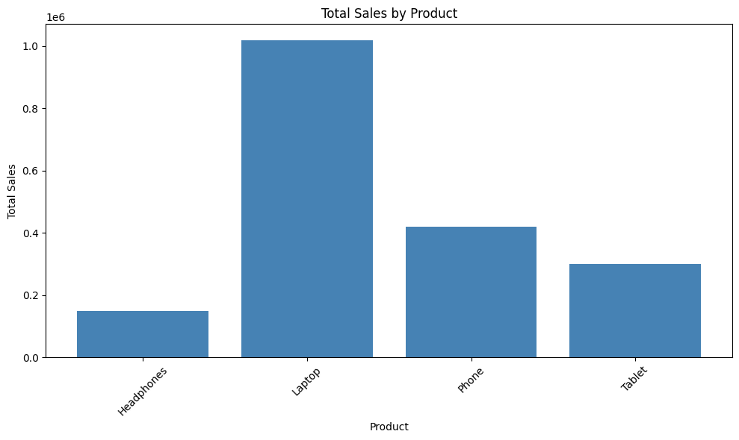
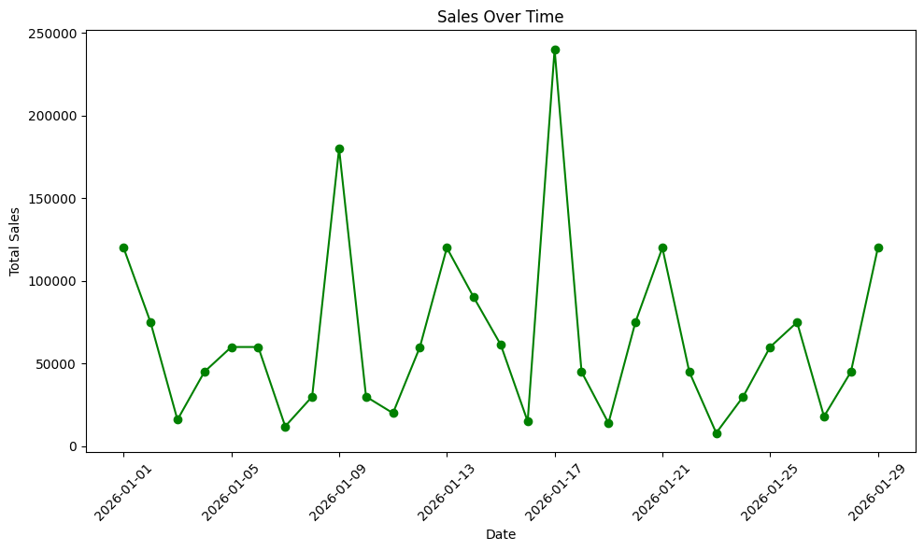

Sales by Region and Product:
Product Headphones Laptop Phone Tablet
Region
East 30000.000000 120000.0 75000.0 15000.0
North 61387.096774 480000.0 135000.0 30000.0
South 20000.000000 120000.0 120000.0 105000.0
West 38000.000000 300000.0 90000.0 150000.0

Correlation Matrix:
Quantity Sales
Quantity 1.000000 -0.272382
Sales -0.272382 1.000000
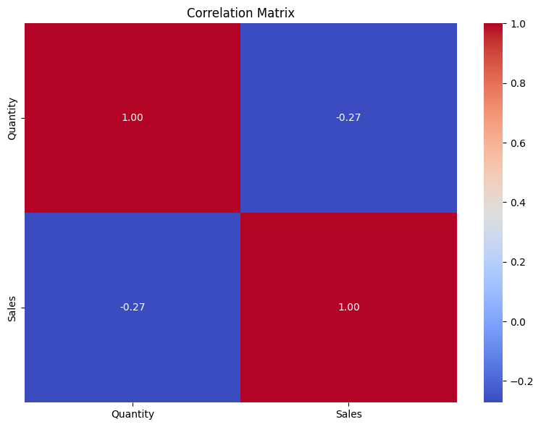

Final Preprocessed Dataset:
Date Product Quantity Sales Region
0 2026-01-01 Laptop 2 120000.0 North
1 2026-01-02 Phone 5 75000.0 South
2 2026-01-03 Headphones 8 16000.0 East
3 2026-01-04 Tablet 3 45000.0 West
4 2026-01-05 Laptop 1 60000.0 East

Final Dataset Shape: (29, 5)

Data preprocessing and visualization completed successfully!

RESULT:

Thus the program to Upload and Analyze the data set given in csv format and perform data preprocessing and visualization.

