EXP NO:3)A Conduct an experiment to show data visualization using line plot

AIM:
To conduct an experiment to show data visualization using line plot
PROGRAM:
import matplotlib.pyplot as cricket
Overs=list(range(5,51,5))
Indian_Score=[20,50,90,128,170,190,239,270,310,350]
Srilankan_Score=[28,75,95,120,145,172,195,220,255,279]
cricket.plot(Overs,Indian_Score)
cricket.plot(Overs,Srilankan_Score)
cricket.show()
cricket.title("INDIA Vs AUSTRALIA")
cricket.xlabel("Overs")
cricket.ylabel("Score")
cricket.legend()
cricket.plot(Overs,Indian_Score,color="darkblue",label="INDIA")
cricket.plot(Overs,Srilankan_Score,color="yellow",label=" AUSTRALIA")
cricket.legend(loc="center right")

OUTPUT:

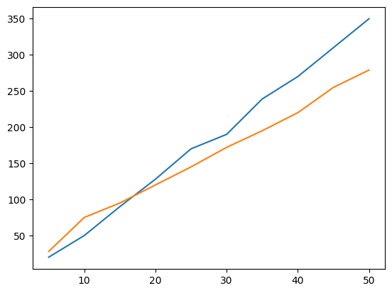
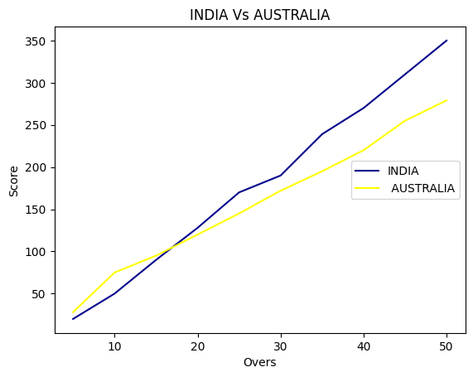

RESULT:

Thus the program to Conduct an experiment to show data visualization using line plot is done

EXP NO:3)B Conduct an experiment to show data visualization using bar chart

AIM:

To conduct an experiment to show data visualization using bar chart

PROGRAM:
import matplotlib.pyplot as hscmark
import numpy as np
Names = ['Logan', 'Tom', 'steve', 'Tony']
xaxis = np.arange(len(Names))
Percentage_hsc = [75,90,80,98]
hscmark.bar(Names, Percentage_hsc)
hscmark.xticks(xaxis, Names, rotation=45)
hscmark.xlabel("Names of Pupil")
hscmark.ylabel("Percentage")
hscmark.title("Comparison of HSC Percentage", fontsize=20, color="green")
hscmark.show()

OUTPUT:

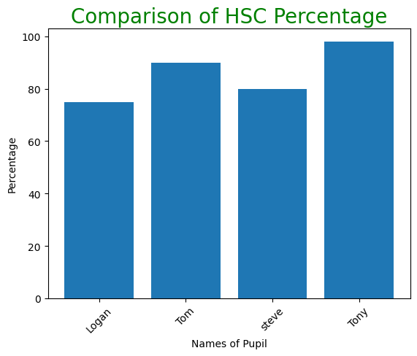

RESULT:
Thus the program to conduct an experiment to show data visualization using bar chart is done
EXP NO:3)C Conduct an experiment to show data visualization using pie chart

AIM:
To conduct an experiment to show data visualization using pie chart

PROGRAM:
import matplotlib.pyplot as plt
labels = ['Computer science and engineering', 'Electronics and communcation engineering', 'Information technology', 'Civil engineering']
section = [10,9,5,2]
colors = ['skyblue', 'green', 'purple', 'brown']
explode = (0.2, 0, 0, 0)
plt.pie(section, labels=labels, colors=colors, explode=explode, autopct='%0.2f%%')
plt.title('Department Sections')
plt.show()

OUTPUT:
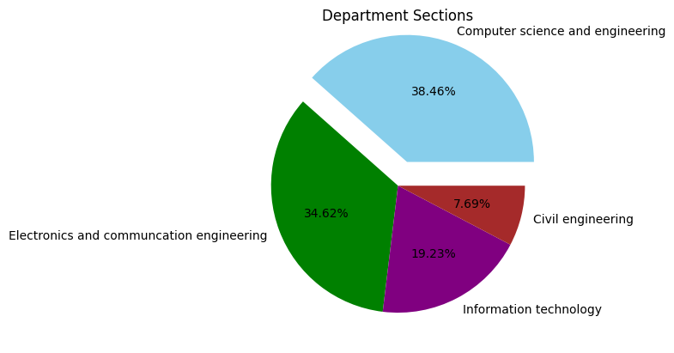

RESULT:
Thus the program to conduct an experiment to show data visualization using pie chart is done.

