Exp No:5 Data Collection and Initial Exploration
AIM:
To collect a sales dataset in CSV format and explore the data using Python. To identify missing values and visualize sales data using graphs.
PROGRAM:
from google.colab import files
uploaded = files.upload()
import pandas as pd
import matplotlib.pyplot as plt
import seaborn as sns
df = pd.read_csv("student_data.csv")
print(df.head())
print(df.info())
print(df.describe())
df.hist(bins=10, figsize=(12, 15))
plt.show()
sns.pairplot(df)
plt.show()

OUTPUT:

Student_ID Age Study_Hours Attendance Marks Assignments_Completed
0 1 18 2 75 55 6
1 2 19 4 82 68 8
2 3 18 3 78 60 7
3 4 20 6 90 85 10
4 5 19 5 85 76 9
<class 'pandas.core.frame.DataFrame'>
RangeIndex: 20 entries, 0 to 19
Data columns (total 6 columns):
# Column Non-Null Count Dtype
--- ------ -------------- -----
0 Student_ID 20 non-null int64
1 Age 20 non-null int64
2 Study_Hours 20 non-null int64
3 Attendance 20 non-null int64
4 Marks 20 non-null int64
5 Assignments_Completed 20 non-null int64
dtypes: int64(6)
memory usage: 1.1 KB
None
Student_ID Age Study_Hours Attendance Marks \
count 20.00000 20.000000 20.00000 20.000 20.000000
mean 10.50000 19.250000 4.70000 84.750 74.300000
std 5.91608 1.069924 1.92217 8.309 14.733063
min 1.00000 18.000000 2.00000 70.000 50.000000
25% 5.75000 18.000000 3.00000 78.750 61.500000
50% 10.50000 19.000000 4.50000 84.500 74.500000
75% 15.25000 20.000000 6.00000 91.250 87.250000
max 20.00000 21.000000 8.00000 98.000 96.000000

Assignments_Completed
count 20.000000
mean 8.250000
std 1.743409
min 5.000000
25% 7.000000
50% 8.500000
75% 10.000000
max 10.000000
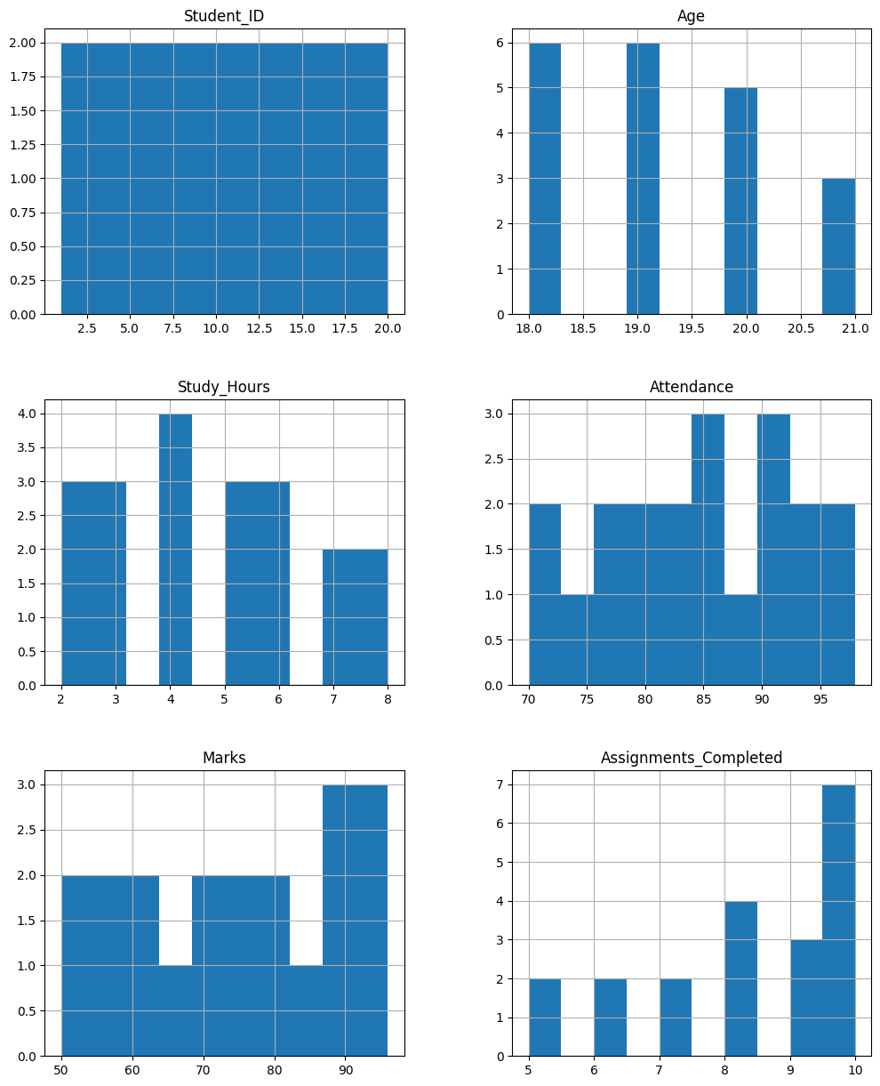
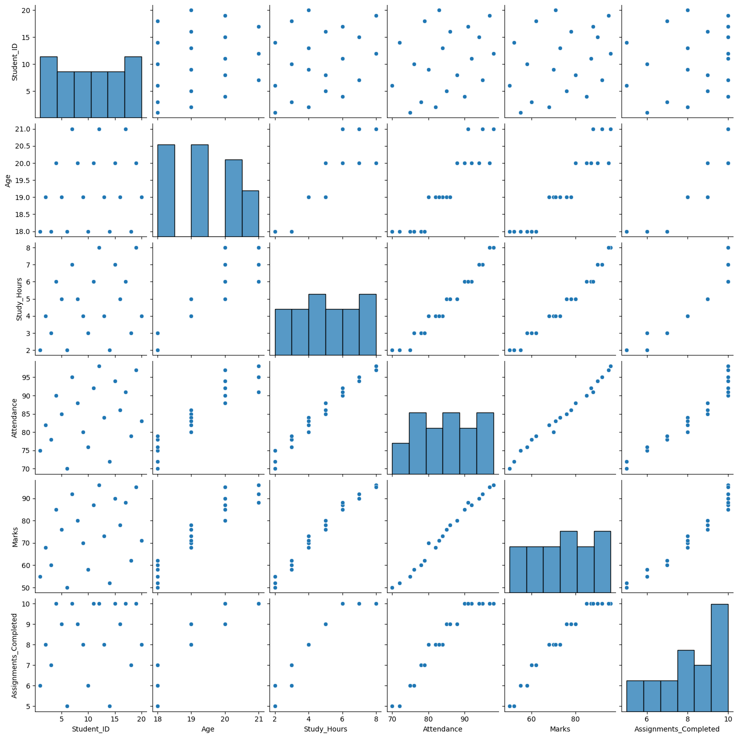

RESULT:
The student dataset was successfully loaded and explored using Pandas. Summary statistics and visualizations were generated to understand the distribution and relationships among the student data.

