Experiment 6: Time Series Analysis of Website Traffic
Aim :
To analyze the time series data of website traffic to identify trends, seasonality,
and anomalies.
Program Code :
import pandas as pd
import matplotlib.pyplot as plt
from statsmodels.tsa.seasonal import seasonal_decompose
from google.colab import files

uploaded = files.upload()
# Load dataset
data = pd.read_csv(
'website_traffic.csv',
parse_dates=['Date'],
index_col='Date'
)

# Time Series Decomposition
decomposition = seasonal_decompose(
data['Page_Views'],
model='additive',
period=7
)

decomposition.plot()
plt.show()

# Moving Average
data['Page_Views_MA'] = data['Page_Views'].rolling(window=30).mean()

data[['Page_Views', 'Page_Views_MA']].plot(
figsize=(10, 5)
)

plt.title('Page Views with Moving Average')
plt.xlabel('Date')
plt.ylabel('Page Views')
plt.show()

# Anomaly Detection using Z-score
data['Page_Views_Z'] = (
(data['Page_Views'] - data['Page_Views'].mean())
/ data['Page_Views'].std()
)

# Find anomalies
anomalies = data[data['Page_Views_Z'].abs() > 3]

# Plot anomalies
plt.figure(figsize=(10, 5))

plt.plot(
data.index,
data['Page_Views'],
label='Page Views'
)

plt.scatter(
anomalies.index,
anomalies['Page_Views'],
color='red',
label='Anomalies'
)

plt.title('Page Views with Anomalies')
plt.xlabel('Date')
plt.ylabel('Page Views')
plt.legend()
plt.show()

# Display anomalies
print("Anomalies:")
print(anomalies[['Page_Views', 'Page_Views_Z']])
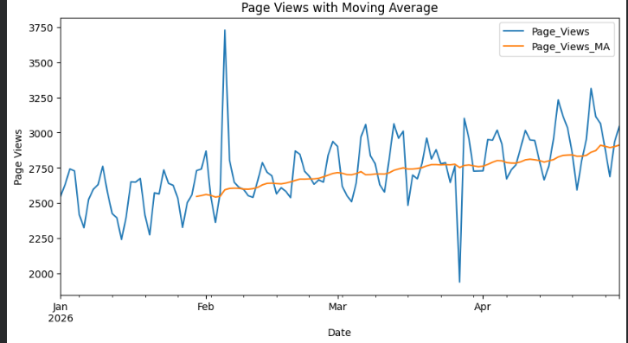
Output :

Result :
Thus, Time Series Analysis of Website Traffic were Programmed.

