Experiment 7:. Random Sampling and Sampling Distribution
Aim :
To explore random sampling from a population and understand the concept of sampling distribution using Python in Jupyter Notebook.
Program Code :
import numpy as np
import matplotlib.pyplot as plt

# Step 1: Generate a population
population_mean = 70
population_std = 15
population_size = 50000

population = np.random.normal(
population_mean,
population_std,
population_size
)

# Step 2: Random sampling
sample_sizes = [20, 40, 80]
num_samples = 500

sample_means = {}

for size in sample_sizes:
sample_means[size] = []

for _ in range(num_samples):
sample = np.random.choice(
population,
size=size,
replace=False
)

sample_means[size].append(np.mean(sample))

# Step 3: Plot sampling distributions
plt.figure(figsize=(12, 8))

for i, size in enumerate(sample_sizes):
plt.subplot(len(sample_sizes), 1, i + 1)

plt.hist(
sample_means[size],
bins=30,
alpha=0.7,
label=f"Sample Size {size}"
)

plt.axvline(
np.mean(population),
color="red",
linestyle="dashed",
linewidth=1.5,
label="Population Mean"
)

plt.title(f"Sampling Distribution (Sample Size {size})")
plt.xlabel("Sample Mean")
plt.ylabel("Frequency")
plt.legend()

plt.tight_layout()
plt.show()
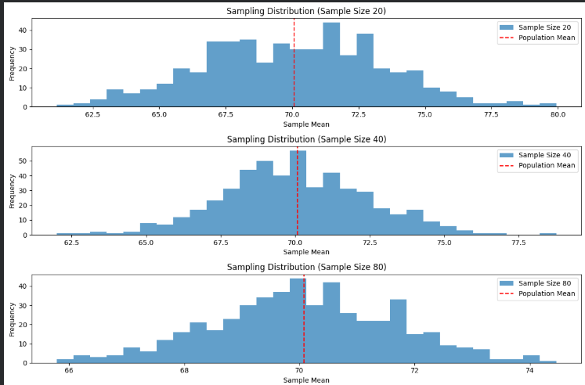
Output :

Result :
Thus, explore random sampling from a population and understand the concept of sampling distribution using Python in Jupyter Notebook.

