Experiment 9 : Experiment to understand Matplotlib library use cases in Data Science
through visualization
Aim :
Experiment to understand Matplotlib library use cases in Data Science
through visualization
Description: Use Iris data set to understand the Matplot lib library
Program Code :
from google.colab import files

uploaded = files.upload()
import pandas as pd
import matplotlib.pyplot as plt
import seaborn as sns

%matplotlib inline

# Read dataset
data = pd.read_csv('/content/Iris_Dataset.csv')

data

# Dataset information
data.info()

# Statistical description
data.describe()

# Count varieties
data.value_counts('variety')

# Count plot
sns.countplot(x='variety', data=data)
plt.show()

# Convert categorical variable into dummy variables
dummies = pd.get_dummies(data.variety)

FinalDataset = pd.concat(
[pd.get_dummies(data.variety),
data.iloc[:, [0, 1, 2, 3]]],
axis=1
)

FinalDataset.head()

# Scatter plot - Sepal Length vs Sepal Width
sns.scatterplot(
x='SepalLengthCm',
y='SepalWidthCm',
hue='variety',
data=data
)

plt.xlabel('SepalLengthCm')
plt.ylabel('SepalWidthCm')
plt.show()

# Scatter plot - Petal Length vs Petal Width
sns.scatterplot(
x='PetalLengthCm',
y='PetalWidthCm',
hue='variety',
data=data
)

plt.xlabel('PetalLengthCm')
plt.ylabel('PetalWidthCm')
plt.show()

# Pair plot
sns.pairplot(data, hue='variety', height=3)
plt.show()

# Histogram - Petal Length
sns.FacetGrid(
data,
hue='variety',
height=5
).map(
sns.histplot,
'PetalLengthCm'
).add_legend()

plt.show()

# Histogram - Petal Width
sns.FacetGrid(
data,
hue='variety',
height=5
).map(
sns.histplot,
'PetalWidthCm'
).add_legend()

plt.show()

# Histogram - Sepal Length
sns.FacetGrid(
data,
hue='variety',
height=5+++
).map(
sns.histplot,
'SepalLengthCm'
).add_legend()

plt.show()

# Histogram - Sepal Width
sns.FacetGrid(
data,
hue='variety',
height=5
).map(
sns.histplot,
'SepalWidthCm'
).add_legend()

plt.show()
Output :
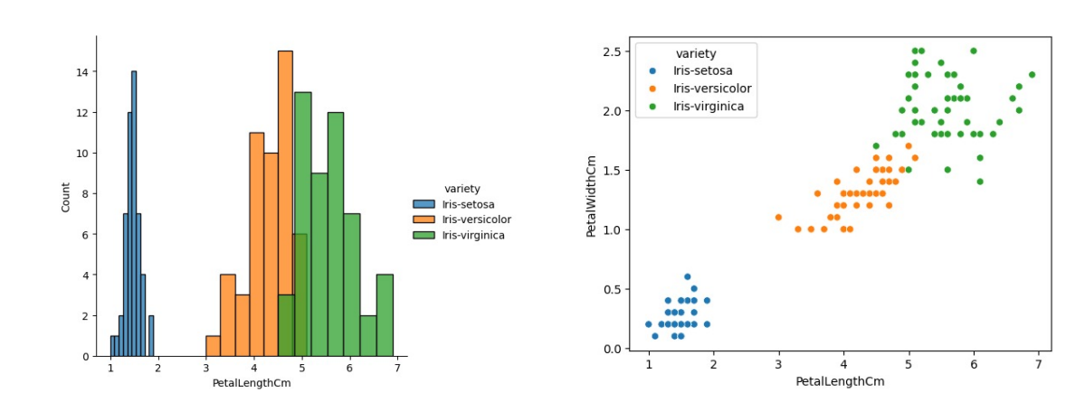

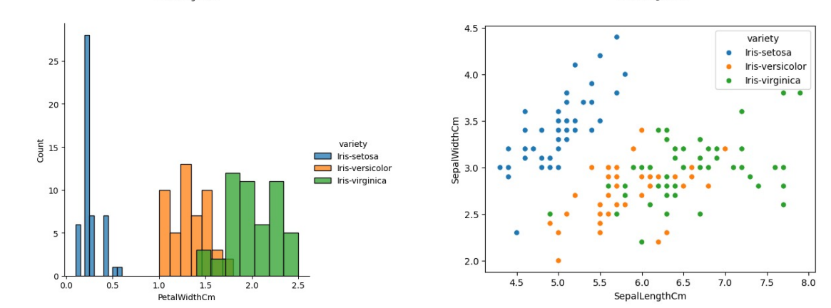
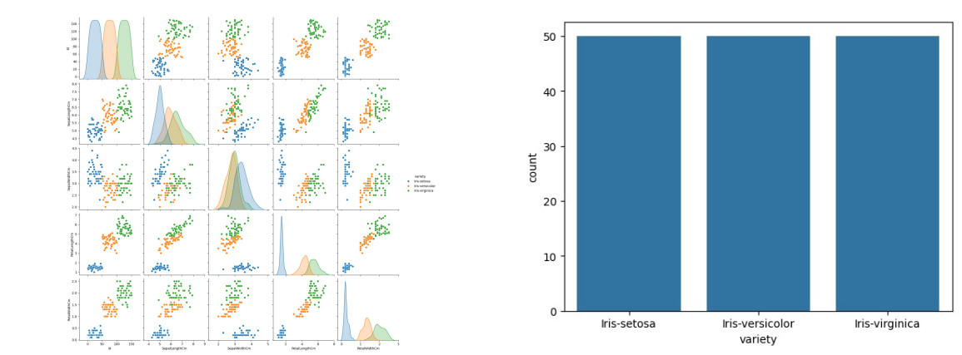

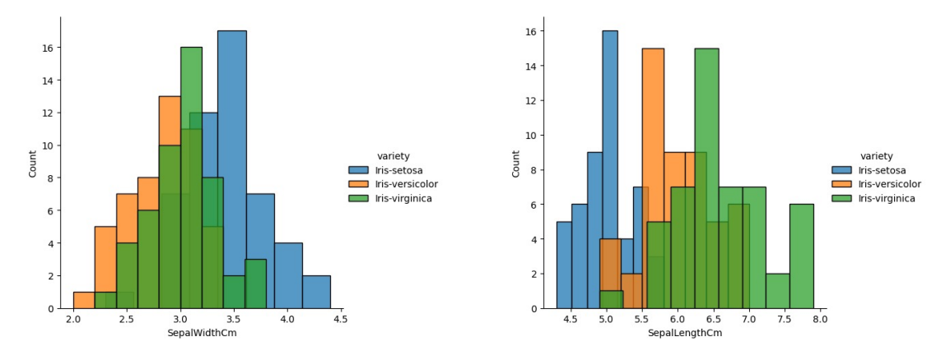

Result :
Thus,we Experiment to understand Matplotlib library use cases in Data Science
through visualization

