Predicted Performance of Structural Bracket Design

by Group 58: Nabeel Azafer & Jawal Trivedi

Scale drawing of bracket indicating pipe and cable locations, including the outlines of the two rectangular regions where they could have been placed:

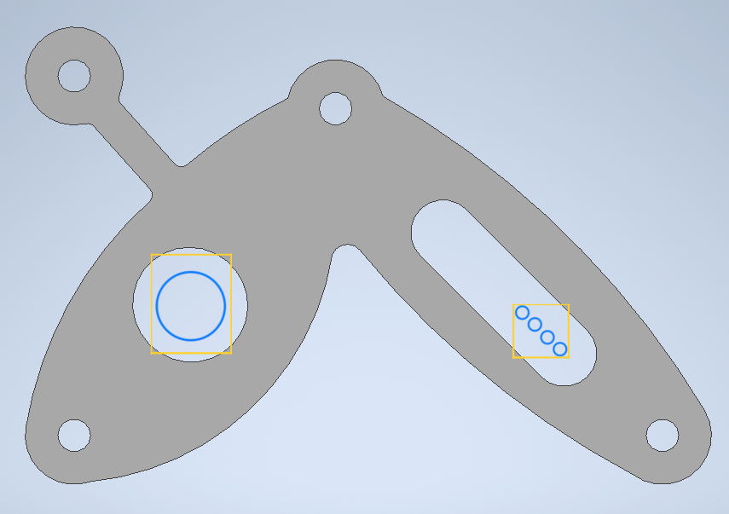
Figure 1: 2D Image of Bracket
Blue annotation is the Pipe and the Wires. Yellow annotation is the rectangular region where they could have been placed

Prediction of Mass: 136.28g

Predictions of Stiffness:
Predicted Resistance Force at 1.0mm upwards displacement ( in kN) | Predicted Resistance Force at 1.0mm downwards displacement ( in kN)
3.27 kN | 4.1 kN

Prediction of Strength:
Predicted Resistance Force just Prior to Failure ( in kN)
8.38 kN
Describe your predicted mode of failure at the force value provided above
Failure due to yielding will occur at the Force Value calculated above.

