**Homework T2 Instructions**

You can work individually or in groups of 2.

|  |  |  |  |
| --- | --- | --- | --- |
| Names: | Joanne Wardell |  | KD Adkins |

**Problem**

Consider the *Store* and *Employee* classes below. The *Employee* class was considered in a previous assignment and you can consider it to be fully tested. You will use the category-partition method to construct a test specification using the category partition method and and then write JUnit tests for the two *Store* methods: *addEmp* and *removeEmployee.*

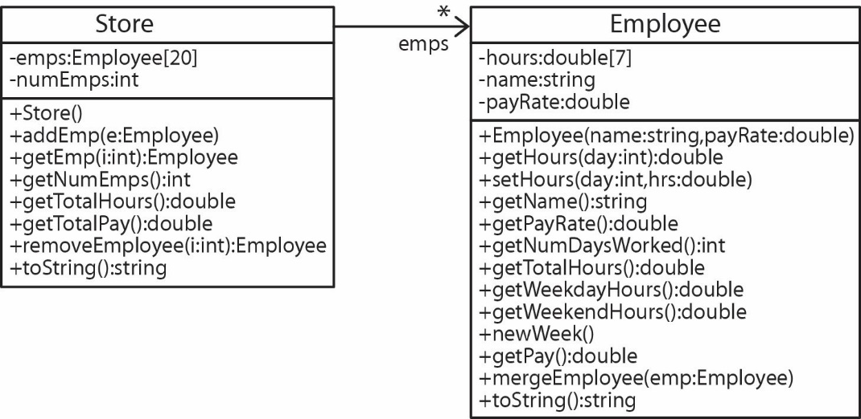

1. *emps* – An instance variable, which is an array that can hold up to 20 Employee objects. Employees are stored sequentially, with no gaps, starting with position 0.
2. *numEmps* – An instance variable that stores the total number of Employee objects in the *emps* array. Initially this value is 0.
3. *addEmp(e:Employee)* – Adds the Employee, *e* in the next available position. If there are already 20 employees and there is an attempt to add another then this method should do nothing, but should not crash.
4. *getEmp(i:int):Employee* – Returns theemployee at position *i* if there is one, otherwise returns *null.*
5. *getNumEmps():int* – Returns the number of employees.
6. *getTotalHours():double* **–** Returns the total number of hours worked over all the employees.
7. *getTotalPay():double* **–** Returns the total pay worked over all the employees.
8. *removeEmployee(i:int):Employee* – Removes theemployee at position *i* if there is one and returns it. All other employees to the right should be moved over one position to the left. If *i* is out of range then return null.
9. *toString():string*– Returns a message with this format: like the one shown below (for example, if there are 3 employees).

**Steps**

1. Use the category-partition method to develop a test specification for *addEmp* and *removeEmployee* using the template provided*.*

* **The more I can see your thought process the better.**

1. Download the code for the *Store* class*.* Drag the *Store* class into an Eclipse project. You can obtain the *Employee* class from via request when you have submitted HW T1.
2. Develop JUnit tests for each method from the specification.

**Deliverables**

1. Code – zip the *prob1* package which includes your JUnit test class, *Store* class, *Employee* class, and Test Derivation document. Name the zip file: LastName1_LastName2.zip and submit on Blazeview in the dropbox named, *HW T2*.