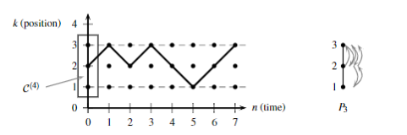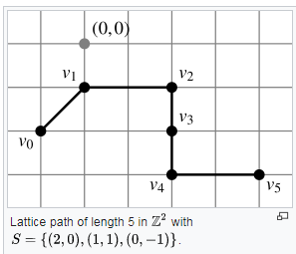

Parameters

Starting Value: this denotes the value placed at the beginning of the corridor

Starting position: this denotes the position of the starting value in the corridor

Upper boundary slope: this denotes the sloope of the upper boundary line

Gap size: this denotes the

Lattice Corridors

A corridor restricts lattice paths to reside within and touch certian upper and lower boundary lines.

Conjecture

Fix the following parameters:

upper boundary line slope = ½

starting value = 1

starting position = (0,1)

Allow the gap, ***g***, parameter to vary.

Arithmetic sequences of nth degree lie within the corridors and contribute to each other in various ways.

Lattice Paths

A lattice path is a sequence of vertices on a lattice.

Introduction

A lattice is the set of all points Z2. The lattice paths that we study are the set of movements on a lattice with restrictions of up-right and down-right moves. The paths that we are studying reside within an upper and lower boundary. We call this structure a corridor.

In a classic corridor, the top and bottom boundary lines have a slope of zero. In a different model, we allow the upper boundary line to vary with a non-zero slope. We call this model the skewed-top corridor.

How does the data set differ in skewed-top corridors based on the variation of parameters?

What observations have we made about the varying data sets within this skewed-top model?

What relationships exist within this model?