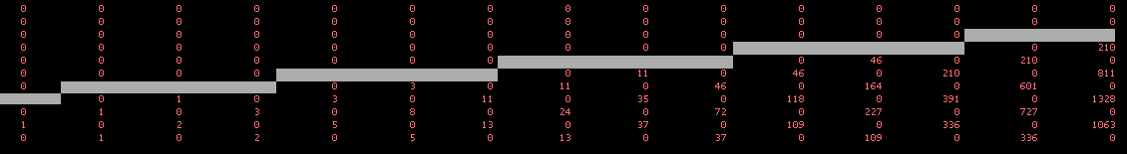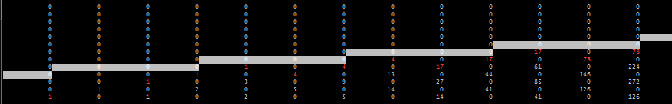

Other Cases of Skewed-Top Corridors