**Android Lec 4,5 MCSF19M006**

**Activity Life Cycle:**

Step1:

Insert Layout (linear) ,text view named (Counter) you can set colour of background and text colour , text view named(0) you can set size and colour accordingly,button named click in constraint Layout.

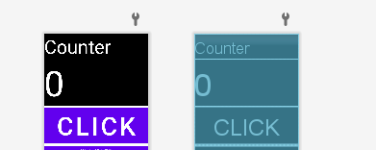

Step2:

In main activity make variables of text view and button,make instances of button and text view.



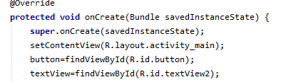

Step3:

Make on click event of click button named increase number

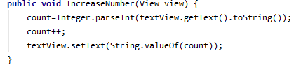

Step4:

Run app

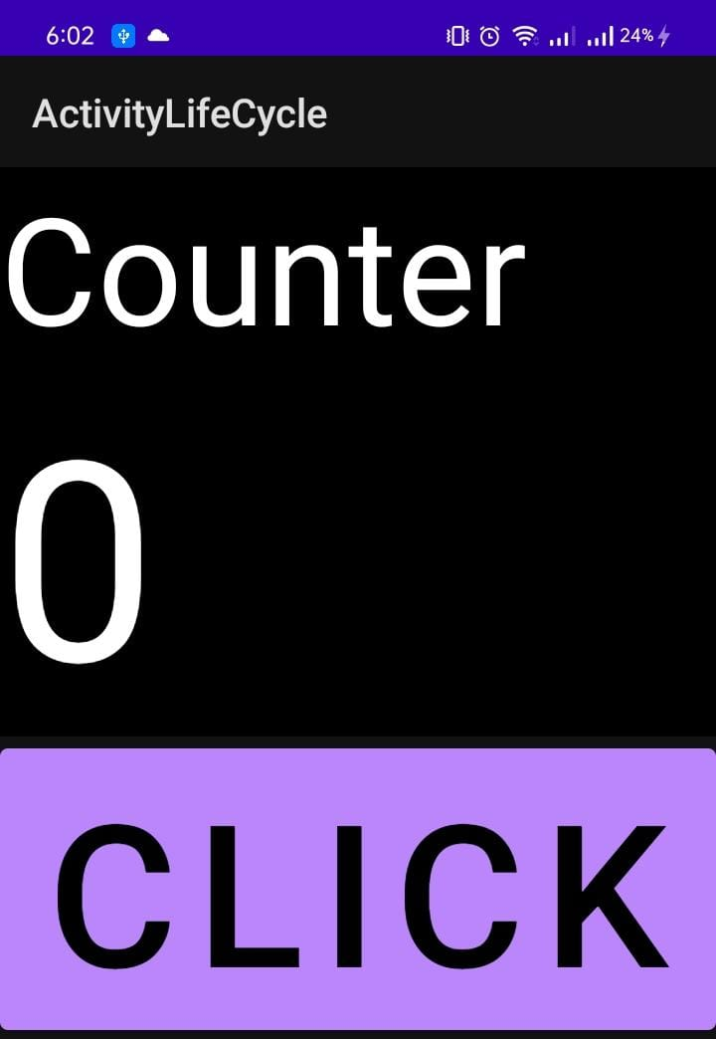

Step5:

Click on click button to increase values in text view

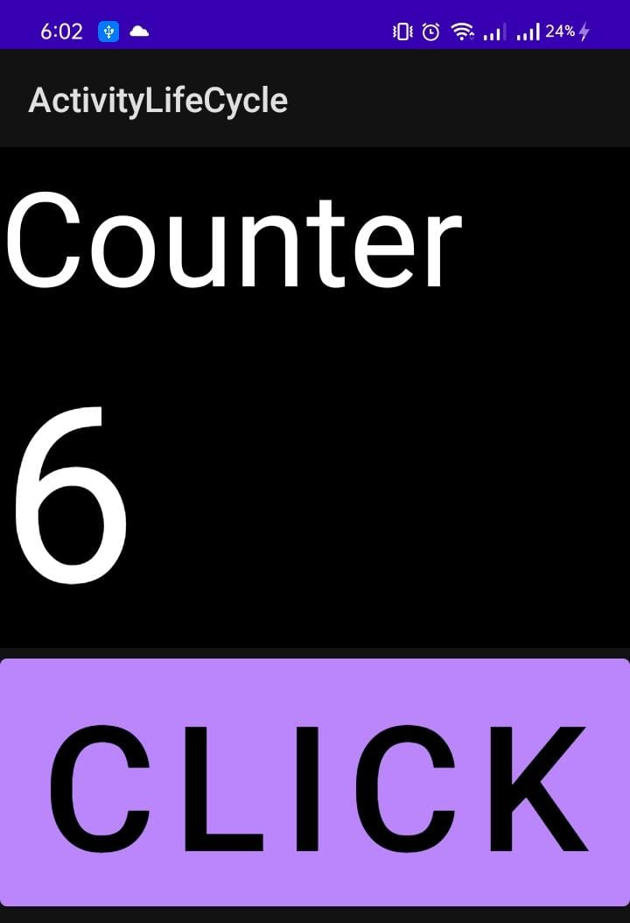

Step 6:

Rotate mobile

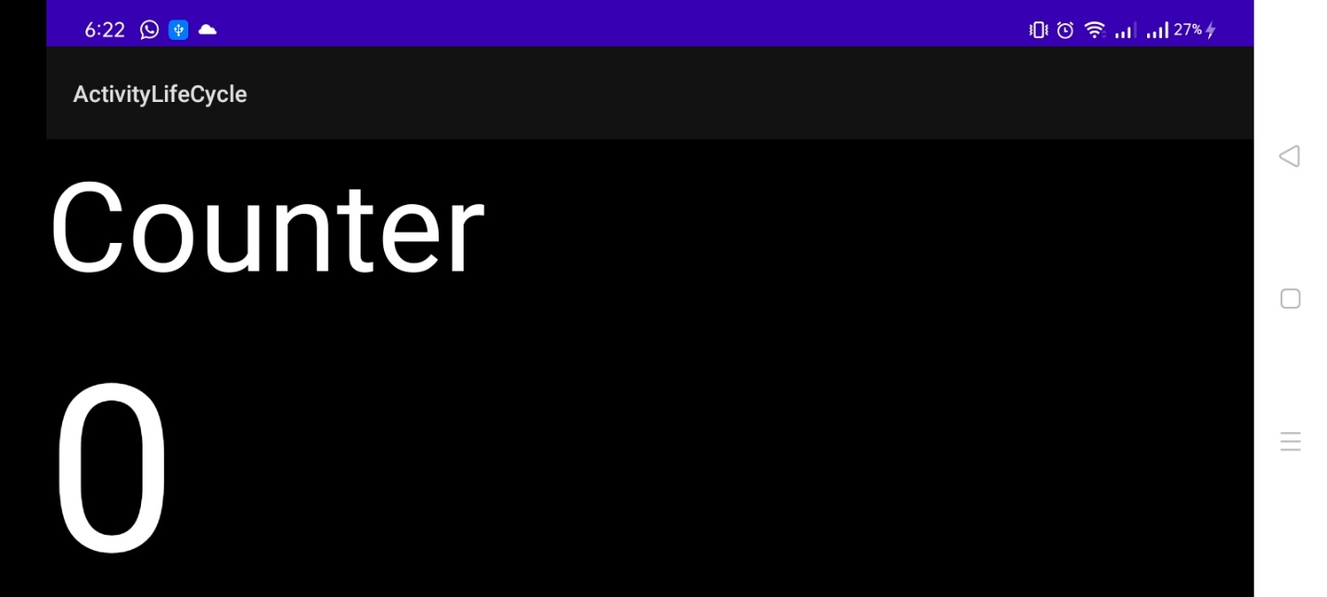

You will see text value is reset to 0 .

There are different call backs avalible which run as event created ,destroyed , paused etc

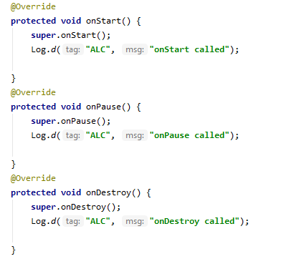

On save instance state is used to save the value of count so that it can be set when on creat is called.

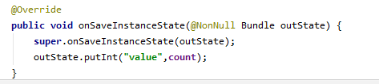

When we rotate mobile event is destroyed and created again to solve this write following code in on creat event

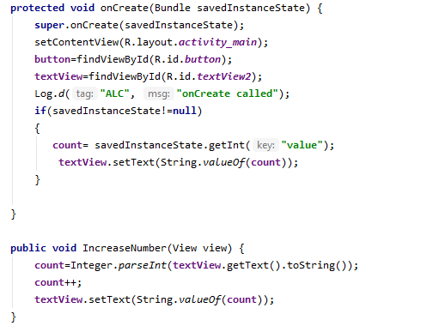



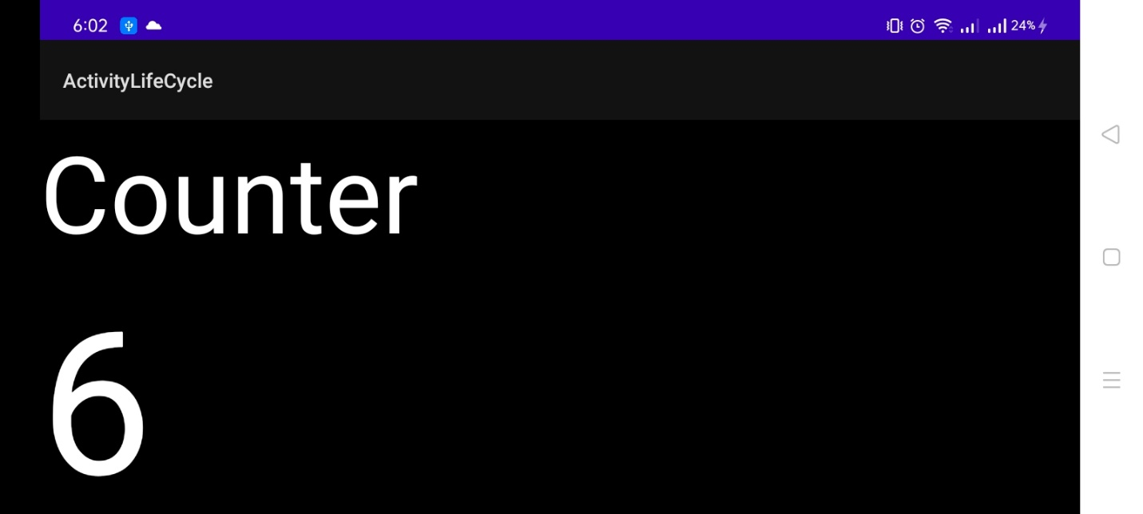

Step 7:

Creat new main activity to check if count value get change if we move from one activity to another

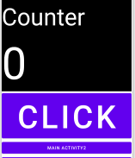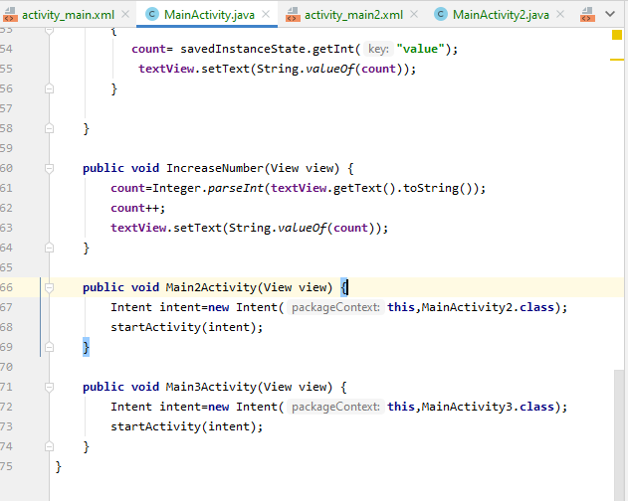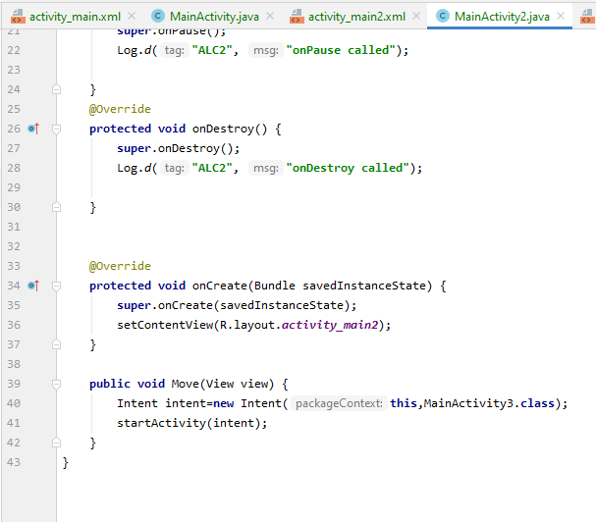

So when we move to another activity previous activity is stoped.when we move back activity is destroyed from which we move back.

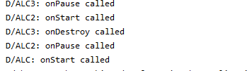

If we move from one to another activity previous activity is stopped if we rotate phone activity is destroyed.

Lec5:

List view binding:

Step1:

Search listview drag and drop on constraint layout.

Add button and editable text

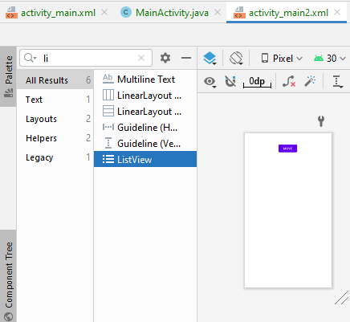

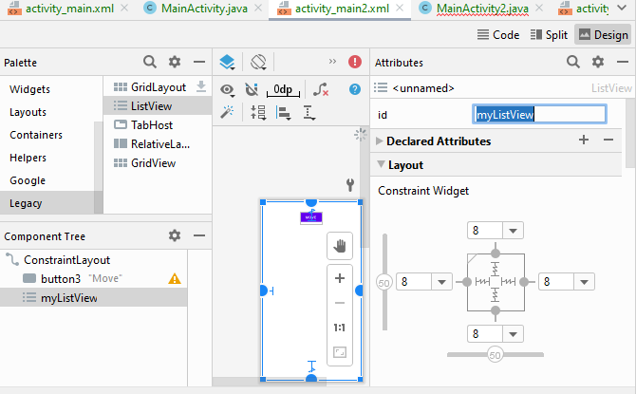

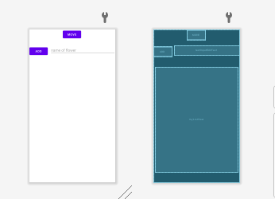

Step2:

Creat instance of list view,text view.

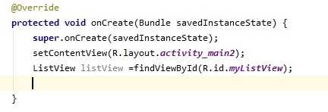



Step3:

Make array list and put some initial values.

Make array adapter and initilize it.

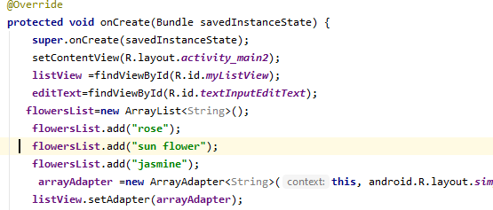

Step4:

Creat on creat event of button Add.

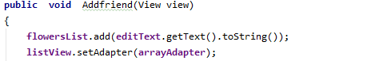

Step5:

List view click listner:

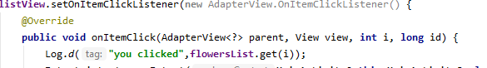

Step6:

Creat new main activity place text view in it.

Used to make list item to move to another activity.

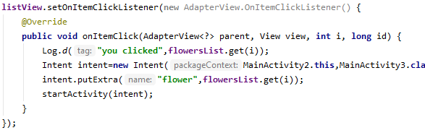

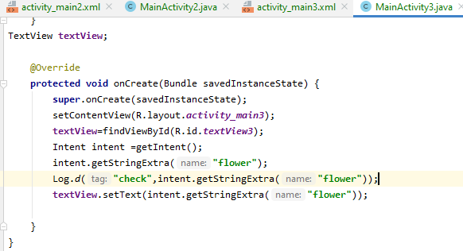

You can make llist sorted as folow:

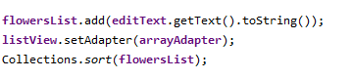

Step7:run code:

