**MCSF19M006_LEC7_ANDROID**

**DATABASE:**

STEP1:

To get all records from data base make following function which return list of all records. With thw help of

Select query

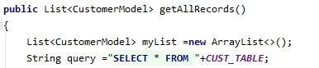

Step2:

Use cursor in order to show every raw detail.

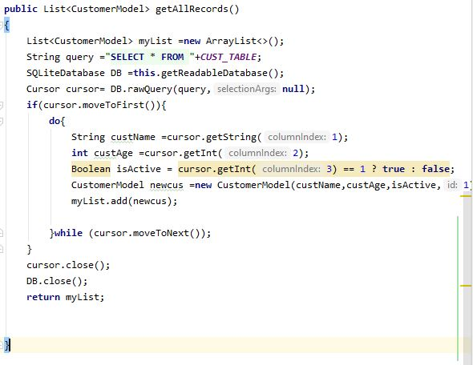

Step3:

Set 2 text view which is editable,swich button to check if customer is active or not,buttons for view detail and add records.

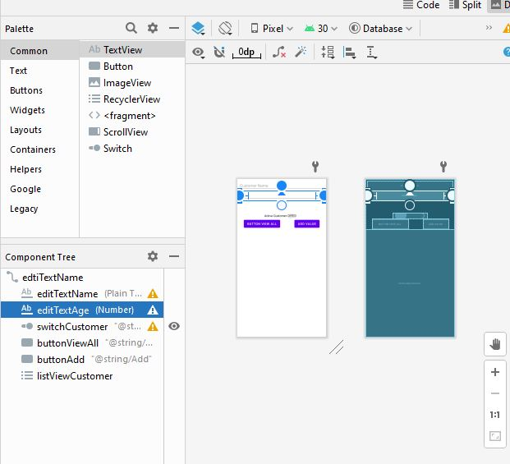

Step4:

We can use dbhelper in order to get records.

And toast to check weather record is being added or not.

E:\Desktop\github\a7.4.JPG

Step5:

Make variables for buttons and texts.

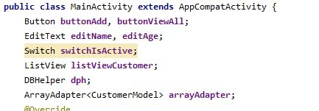

Step6:

Write code for button view all .

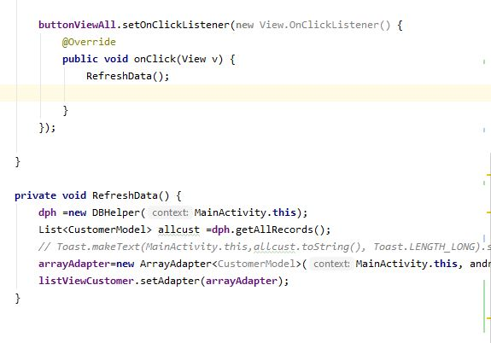

Step7:

Write on click event for button add.

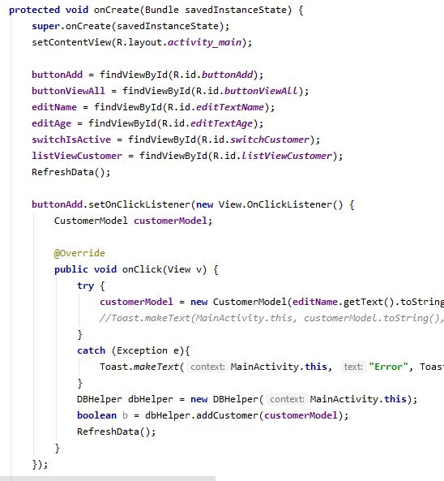

Step8:

In dp helper we have used curser for getting attributes detail.

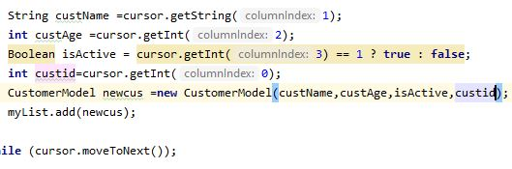

Step9:

Enter index or id in order to get id in database table.

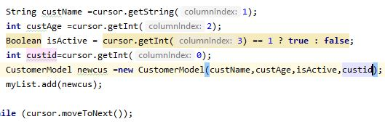

Step10:

Set on item click listner on list view

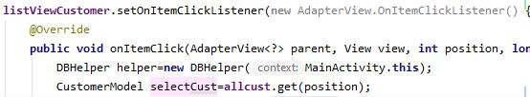

Step11:

Make delete funtion in dbhelper

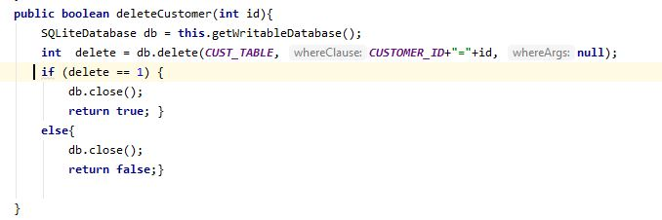

Step12:

Call delete function in listview item click listner when click on data it is being deleted.

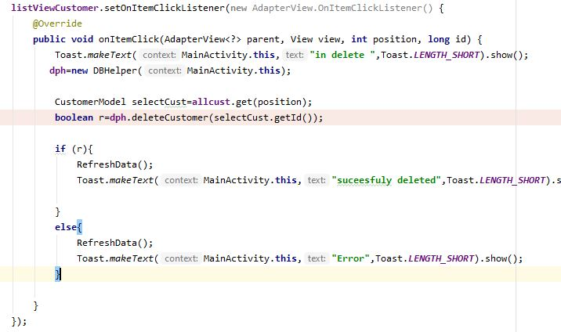

Step13:

Run code:

