**Android Studio Lec1:**

**Step1: Creat new project**

**1.1**

**Open Android Studio**

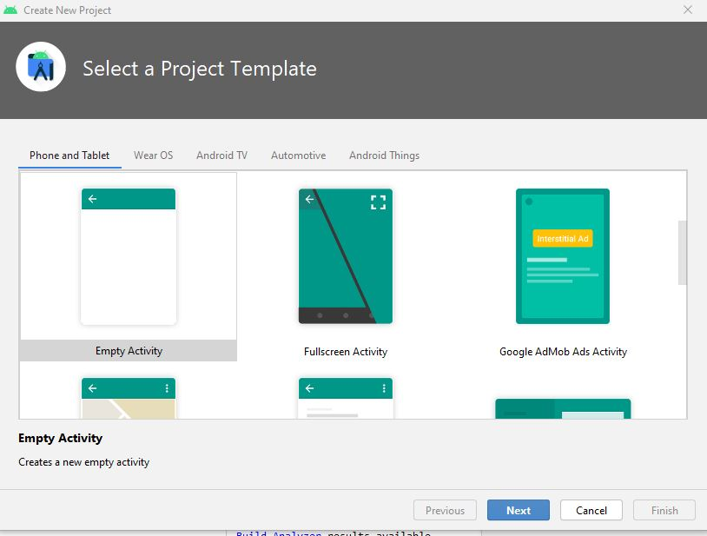

1.2

Select Empty Activity.

Click on Next

1.3

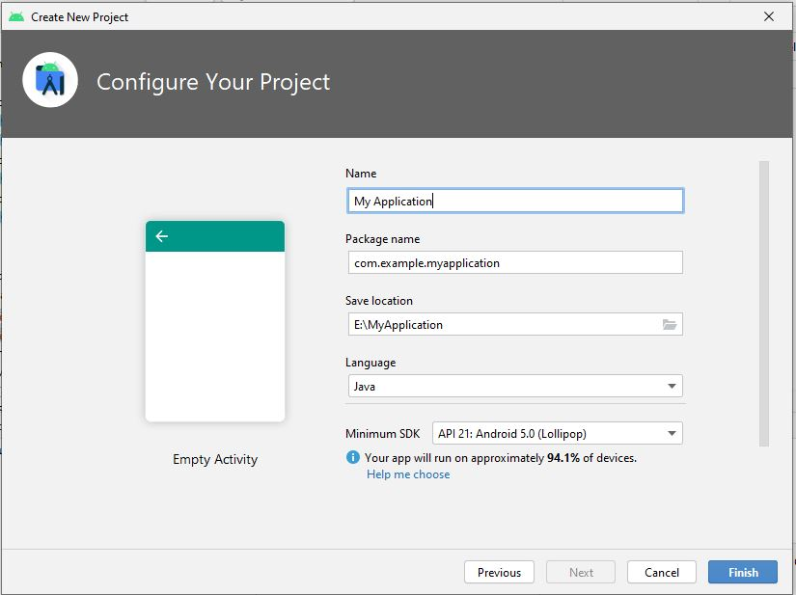

Fill appropiatelly(application Name,unique package name,Location to save in,Language in which you are woking,Select max sdk )

Click Finish.

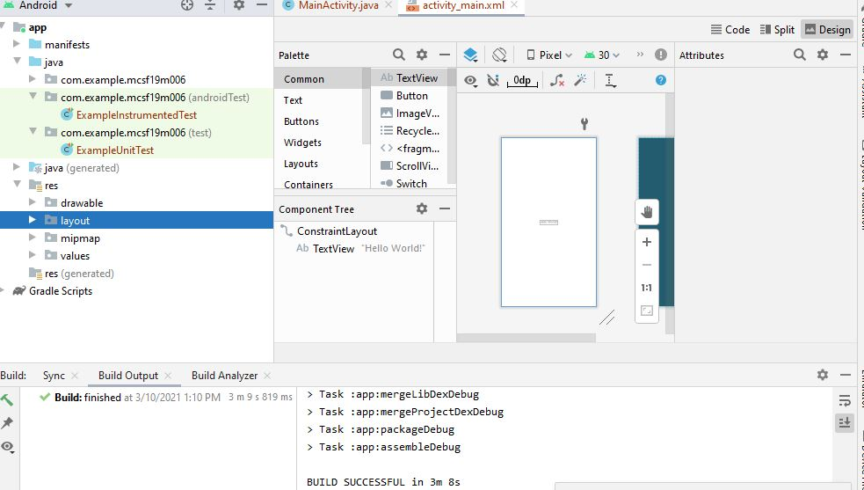

Project is created contain MainActivity in java>yourfile and acivity. Xml for view handling in res>layout

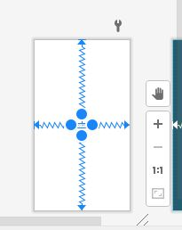

Uper picture show activity.xml file

You can view coding section of activiy also

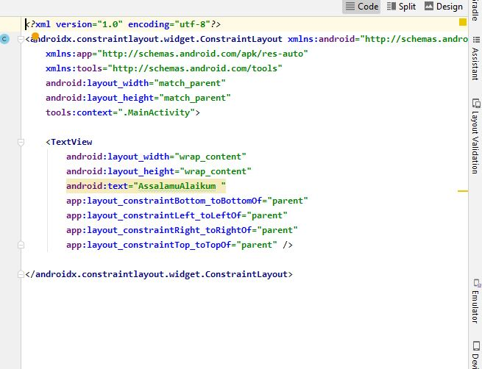

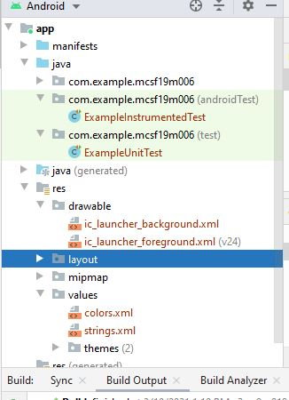

App contain different options

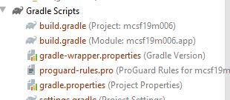

We have build gradle file is important file dependecies third party tools informations avalible in it.

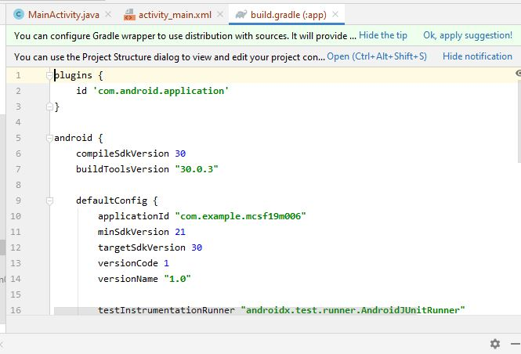

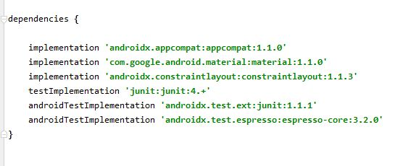

All the dependency is present in build gradle(module)

**STEP 2: TODO**

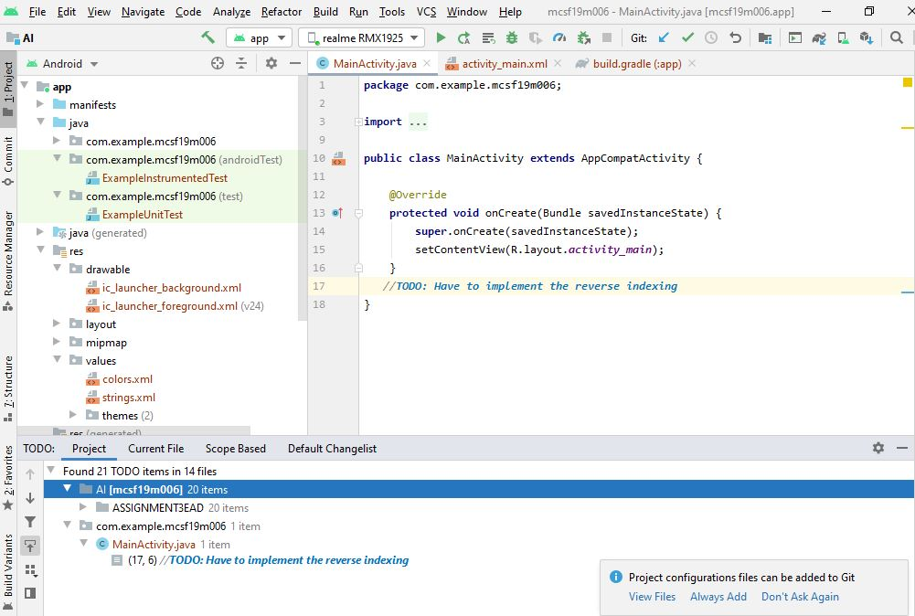

Todo detail is avalible show which things are pending and we have to perform all that information.

**2.2:Terminal**

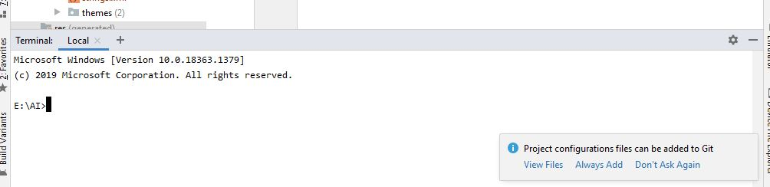

We can use terminal local to write commands in it

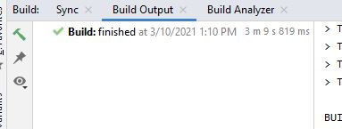

To build prject button is avalible on top.

And nbuild option show info about your project.

**Logcat:**

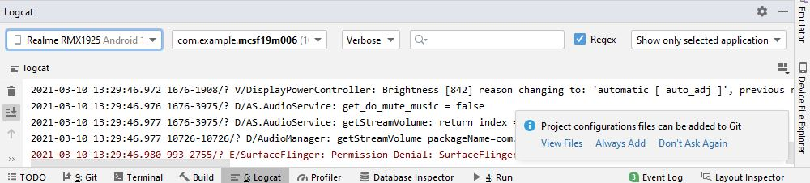

Contain all the details like which operation is running,warnings .

**AVD manager**

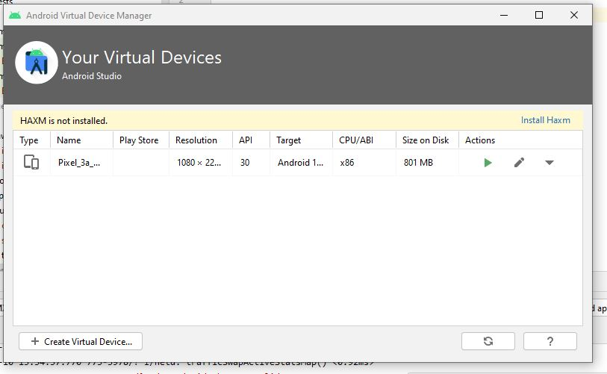

Tools>AVD manager

Show virtual devices already installed.

**CREAT virtual devices:**

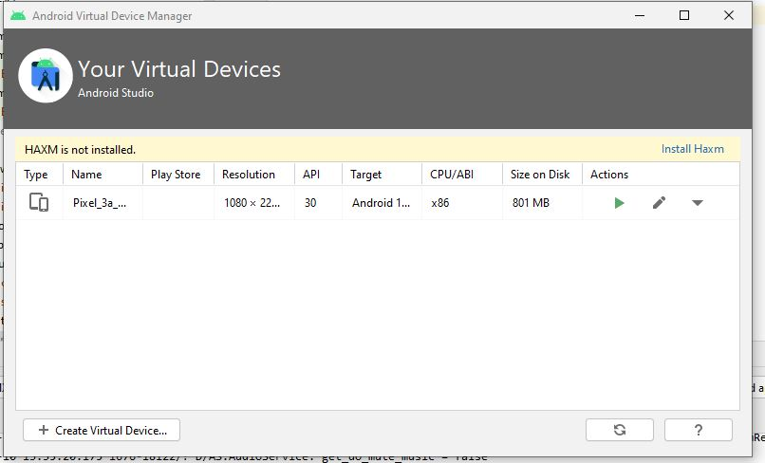

Click on creat virtual devices.

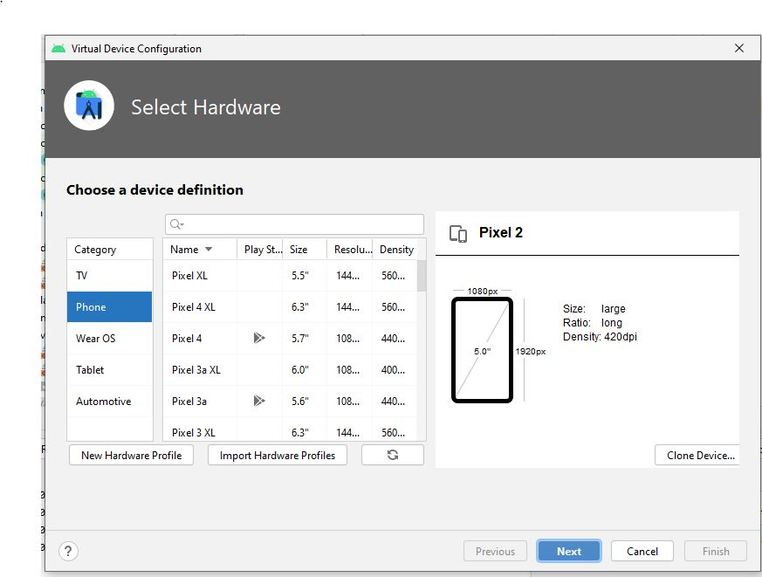

Choose device and select next you can also connect with your own physical devices.

* In your phone (setting>developer options >usb debbuging)
* Connect to usb.
* Device will show as:
* 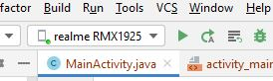

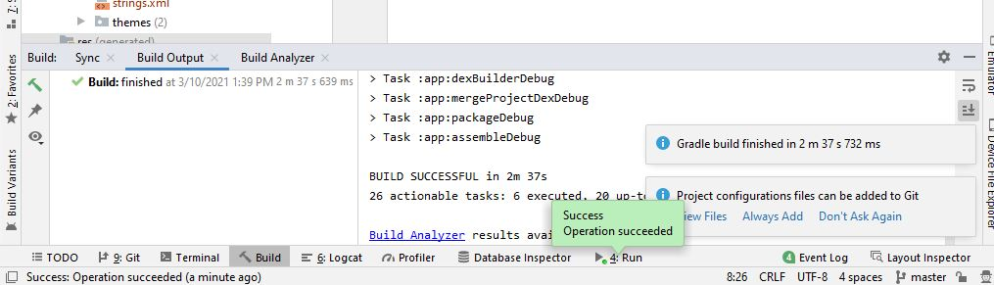

File is build sucessfully.

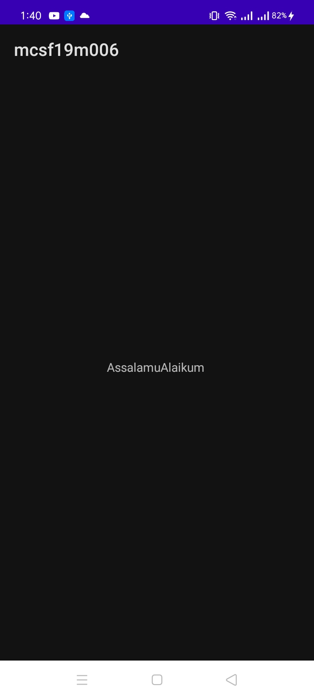

You can view on your mobile screens.