DialogueBox_MCSF19M006

Step1:Creat new Project

Add Vector Aseest in Drawable

Drawable>right click>new>vector assests

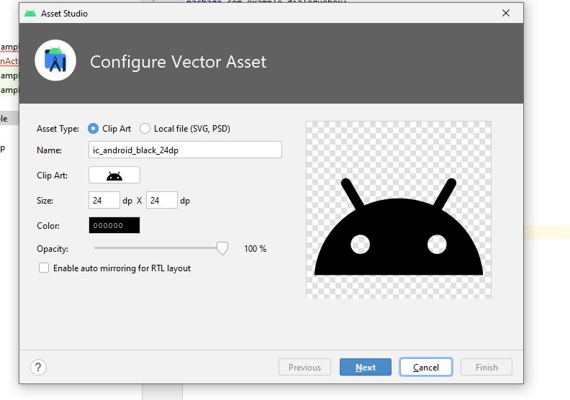

Step2:

Click clip art search for warning icon.

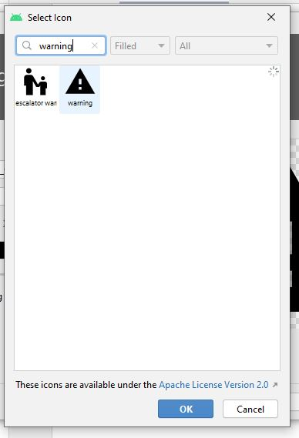

Click ok

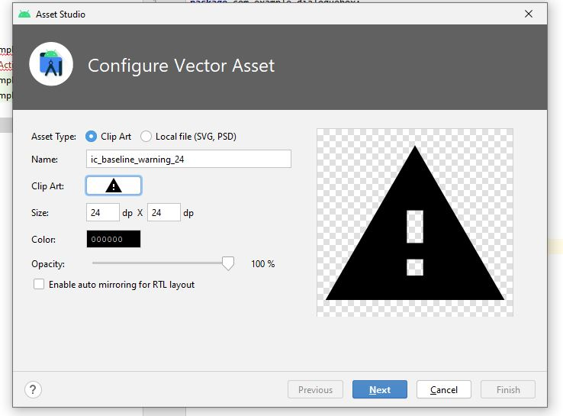

Click next

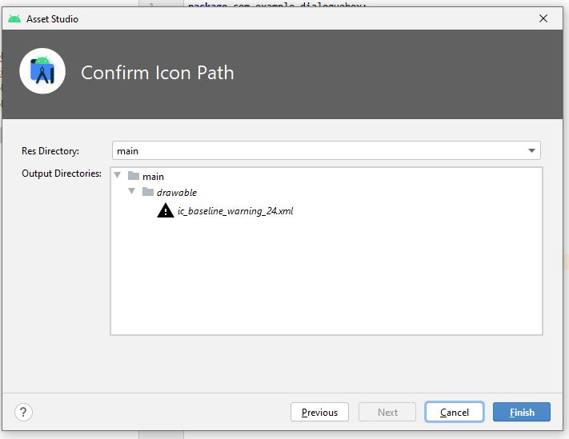

Click finish

Step3:  
Add Button in xml file name it esit and set it id as exit.

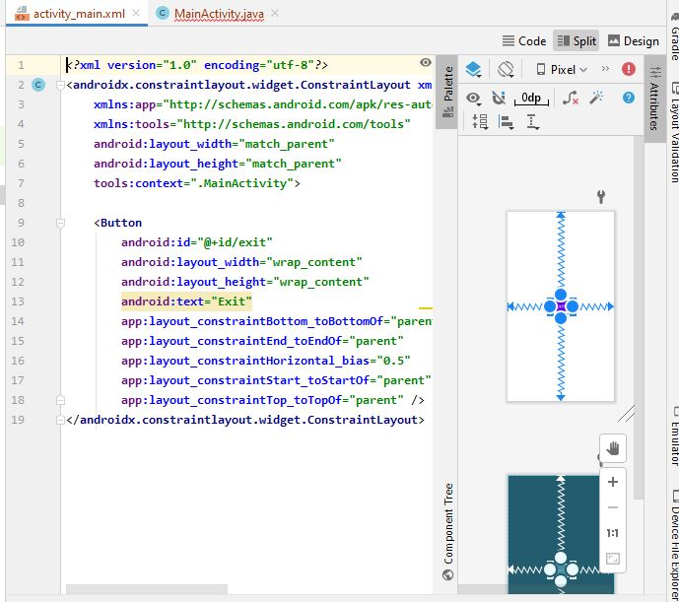

Step4:

Creat instance of exit button AND select button.click listner in order to write code for click event.

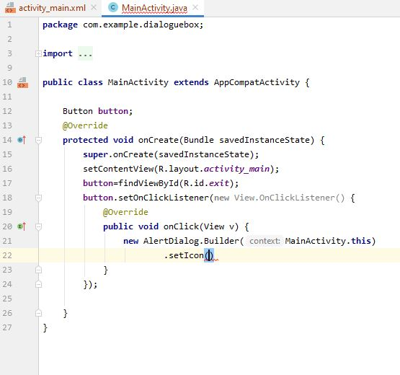

Step5:

Initialiaze AlertDialogue.Builder and set icon which is in drawable ,set title as exit and setMessage of Dialogue Box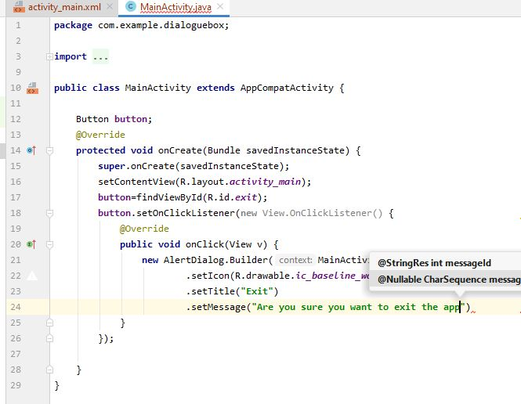

Step6:

Set possitive ,neative and neutral Button for exit app,dismiss dialogue box and Help message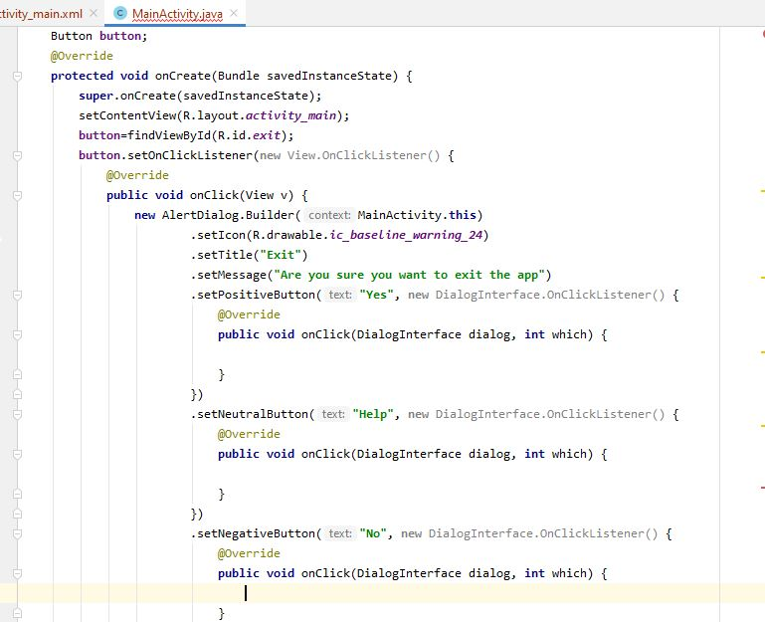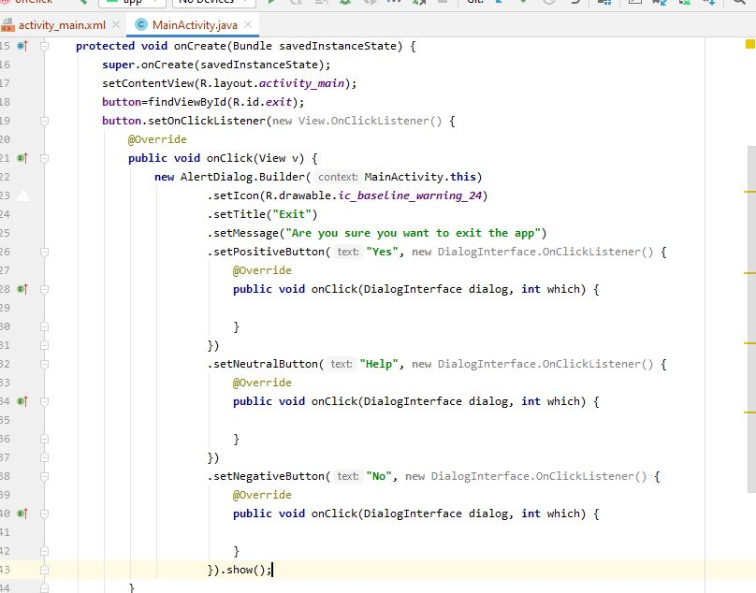

Step7:finish() will close app

Dialogue .dismiss will off dialogue box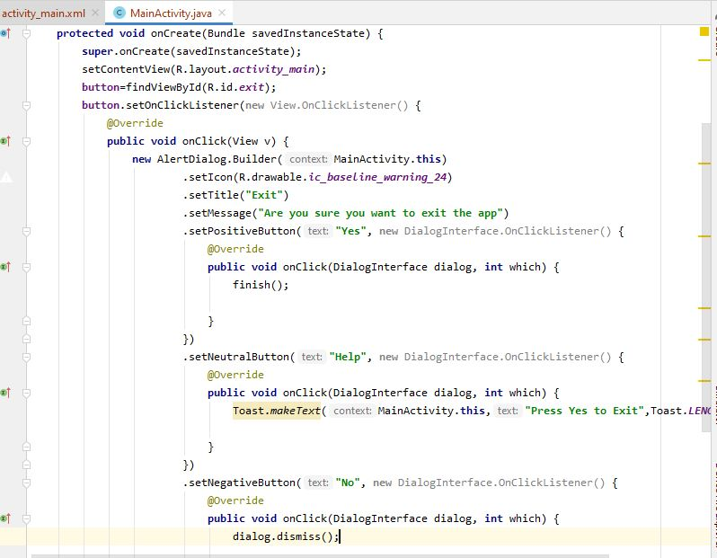

Dialogue box with list of items

Step1:

Creat button in xml with name Diaologue Button.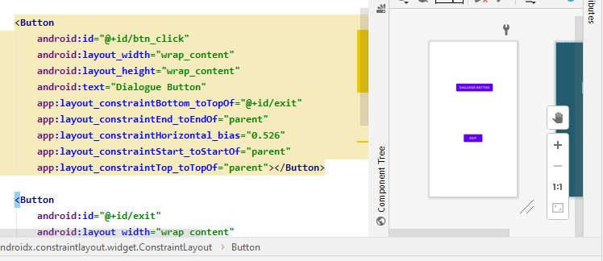

Step2:

Write code ggiven below

Flowers is array with name of different flowers on whatever you click its name will be shown

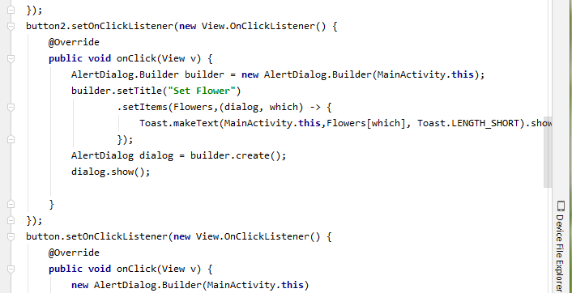

Dialoue box with check list:

Step1:

Creat button in xml file with name check.

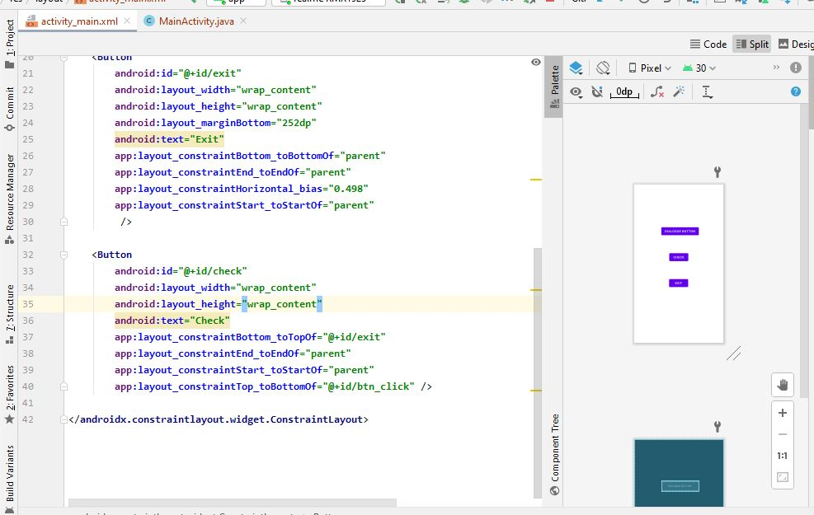

Step2:

Creat instance of button 3 and click listner and write following code.

Selected item list will maintain the list of all selected items and is checked will ensure which item is checked.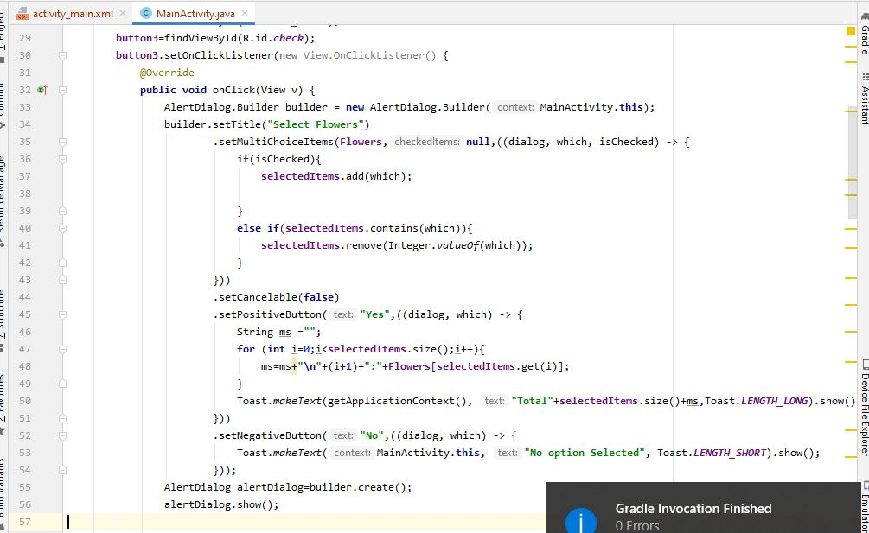

Customize Dialogue BOX

Step1:

Creat new button in xml to move to customize dialogue page name

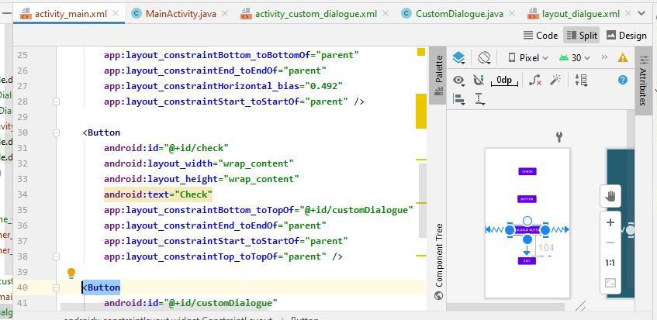

Step2:

Creat new resource file for designing dialogue box layout

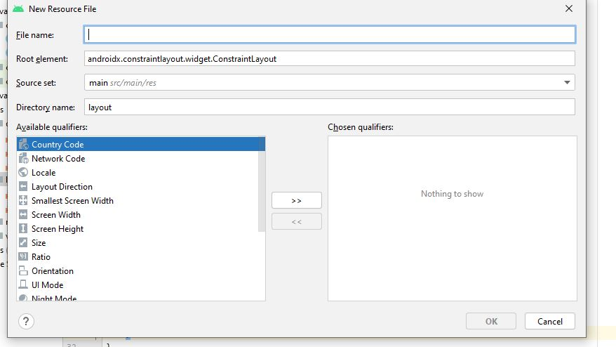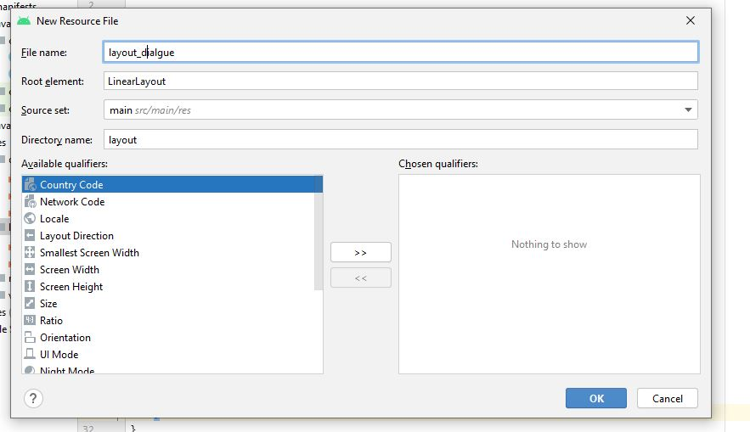

Step3:

Design layout with two edit text box and one button

j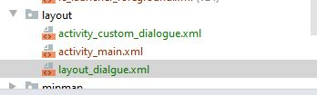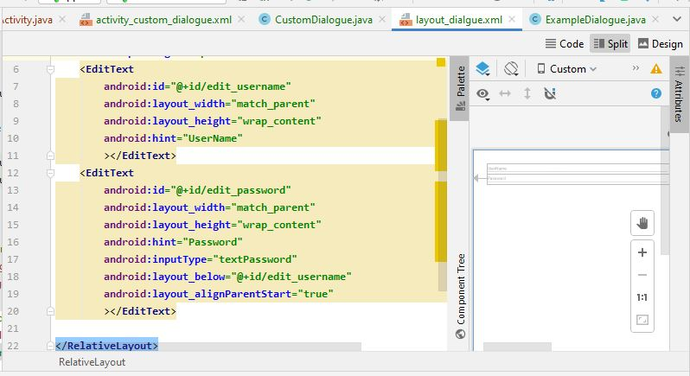

step4:

creat new main activity name customized dialogue

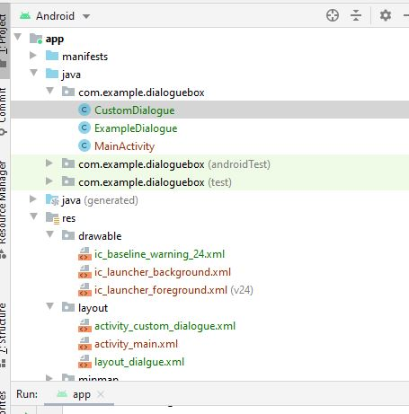

Step5:

creat new java class name example dialogue

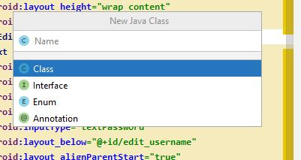



Step6:

Creat on click function in main activity to move to customized dialogue

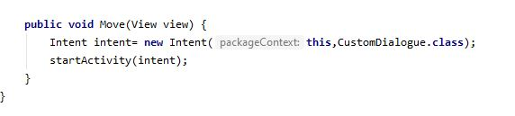

Step7:design customized dialogue interface

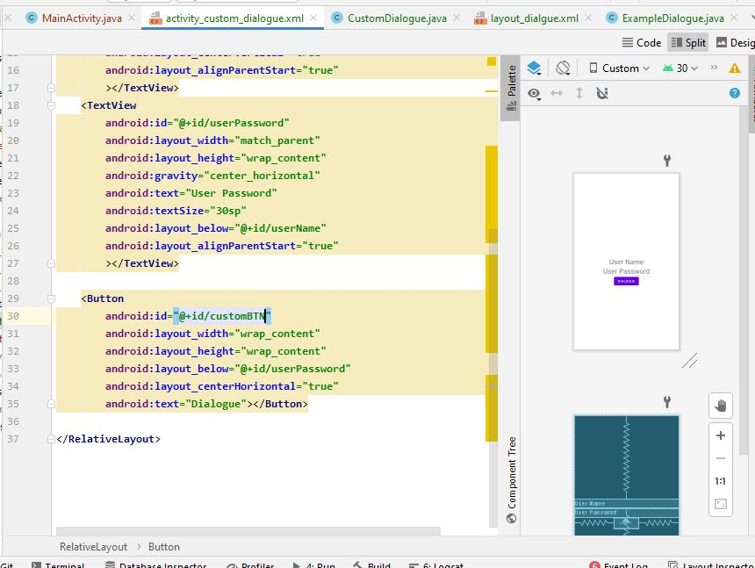

Step8:

Write code given below in customized class

Instance for button and text boxes

Open Dialogue function to link with dialogue layout through examle dialogue

Apply test function to set customized xml text boxes as information will be provided n dialogue box by user

Implement example dialogue.listner

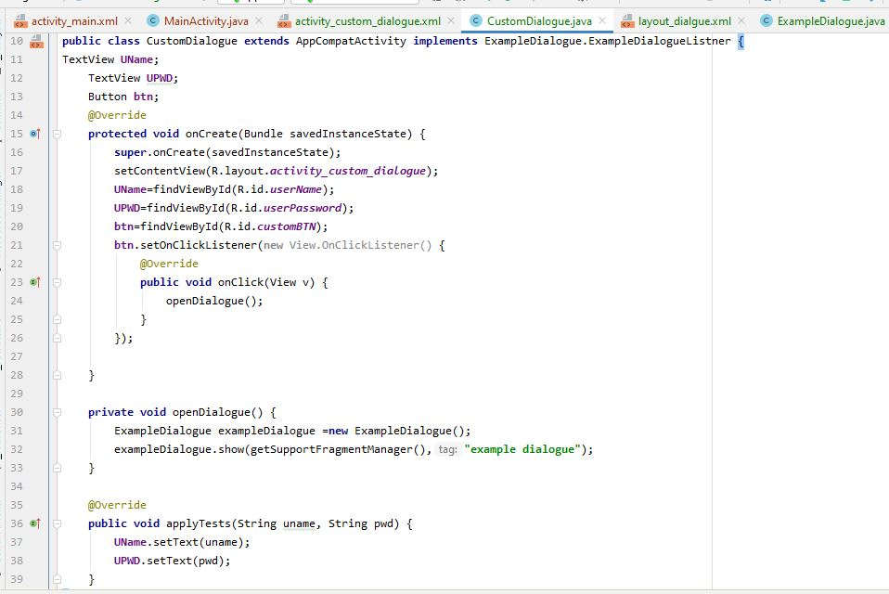

Step9:

Write code given below in example class

Extends app dialoguefragment

Creat instance of layout.xml text boxes

Interface type function of example dialogue listner and make variable of it to use

Ctrl+o

On attach function

Set listner

Dialogue.creat dialogue contain layout of dialogue ,title,negative,possitive button

With the help of listner and applytest pass texts to customizedialogue class to set in cutomize xml file texts

e