**Lecture 1,2 – Github**

* **Step 1:creat Account on Github.**
* **Step 02: creat new repository on you account.**

1. **Click on plus sign and then new repository.**

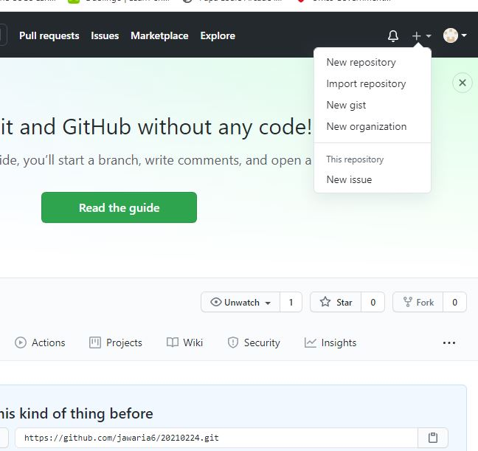

1. **New window apeared**

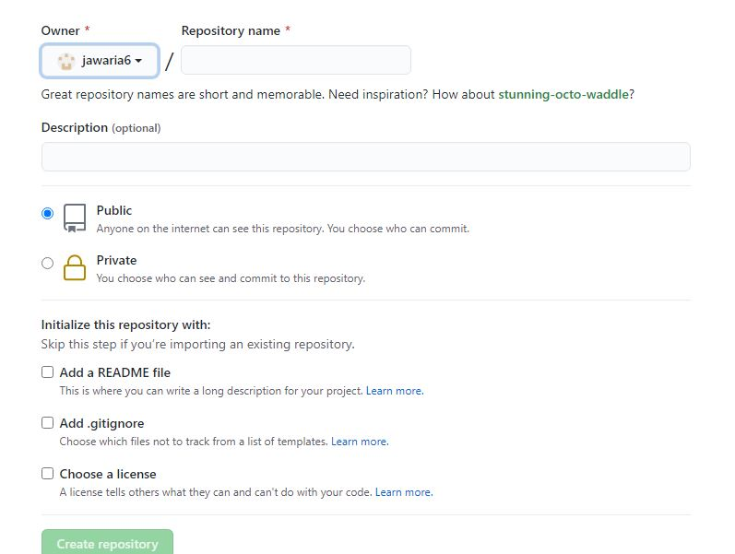

1. Fill appropiate columns and click on creat repository.
2. New window apear to show that repository is being created.
3. 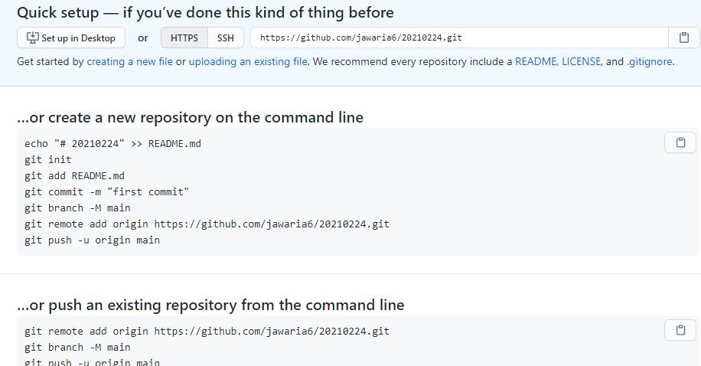Red box show link of the repository.

E:\Desktop\github\g4.JPG

* **Step 03:Add File in Repository**

1. Open GIT CMD for writing command.
2. Write git clone to make clone/cpy of central repository in in our repository.

E:\Desktop\github\g6.JPG

1. Git init creat newgit repository
2. Git status display state of working directory.

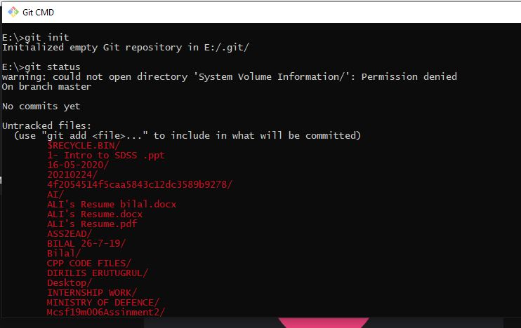

1. Git add to add file in repository.

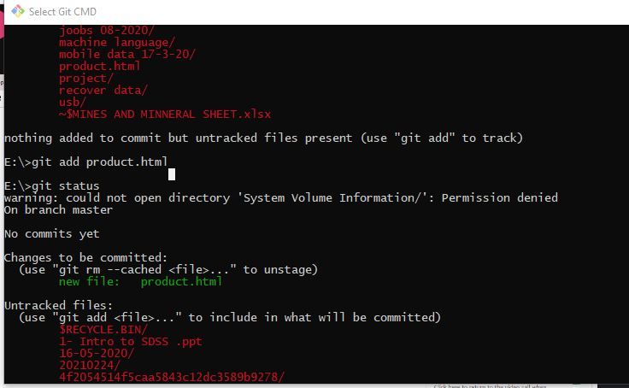

1. Git commit is use for save your changes to local repository

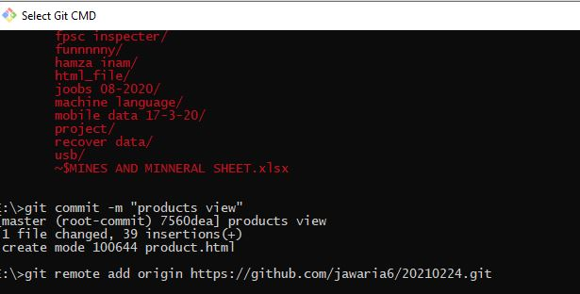

1. Git push command push/upload local repository content in remote repository

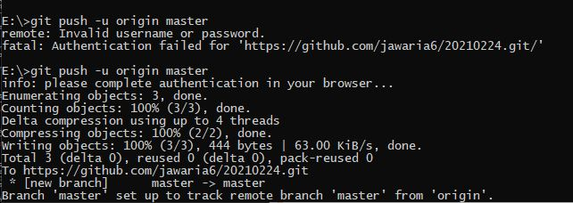

1. Now check remote repository.

* Step 3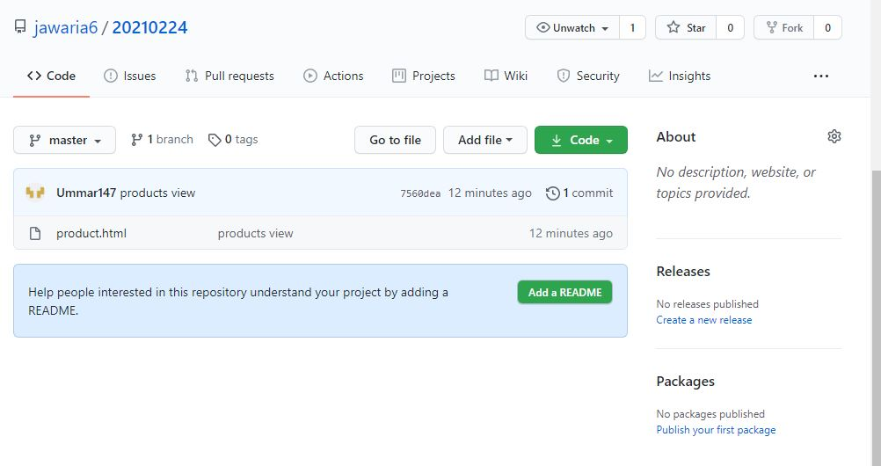
* Step 4:Edit

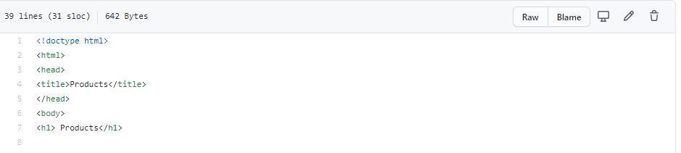

1.Red highlighted icon is used for editin in online repository.



2.commit changes can be performed

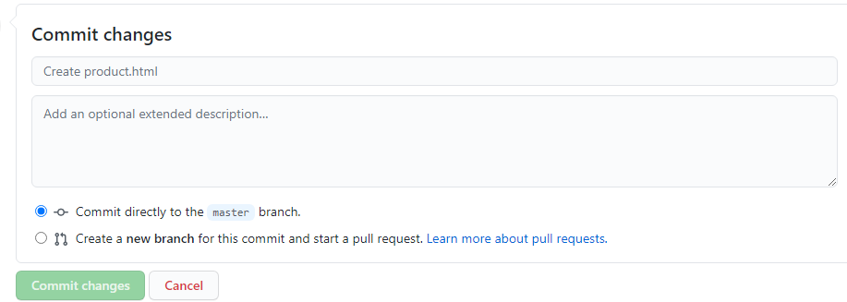

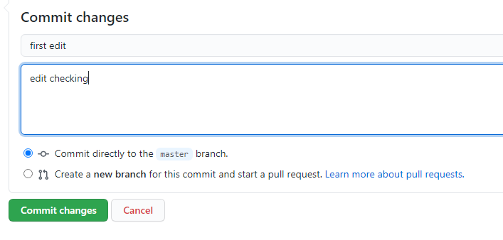

Press commit change button.

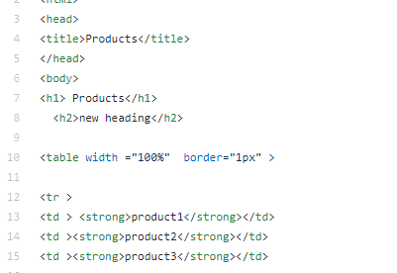

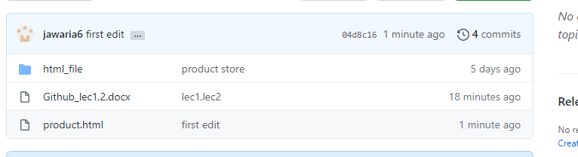

After click on first edit

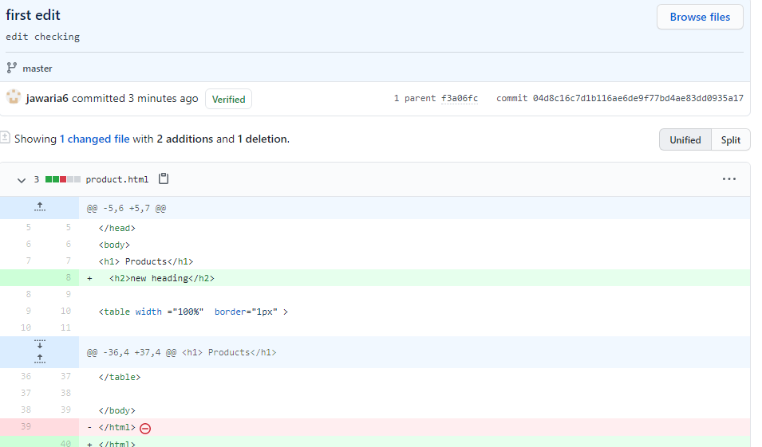

* Step 05:git pull use for retrieve data from centraal repository and synchronize with local repository.

