**Mcsf19m006 Android Lec 2,3**

**Layout:**

**Step1:**

**Creat new activity with layout patteren.**

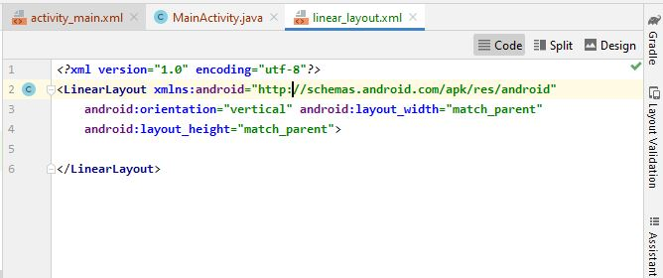

**\*change root element to linear layout and name the file.**

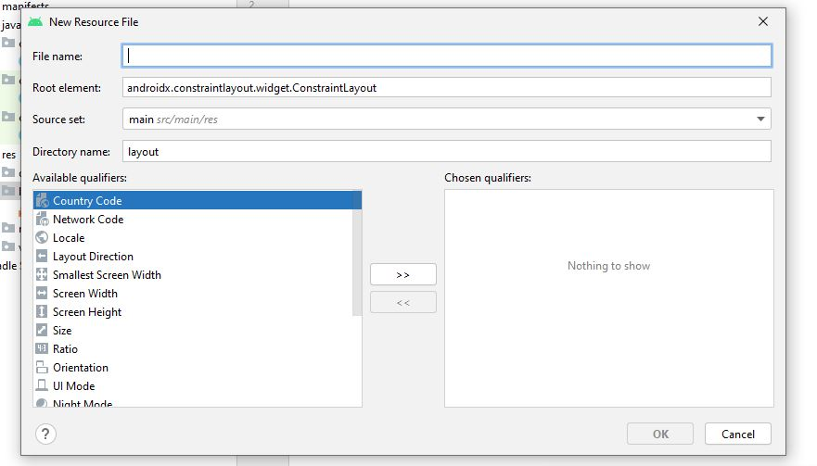

**Step2:**

**Set main activity (set contact view )as linear layout view.**

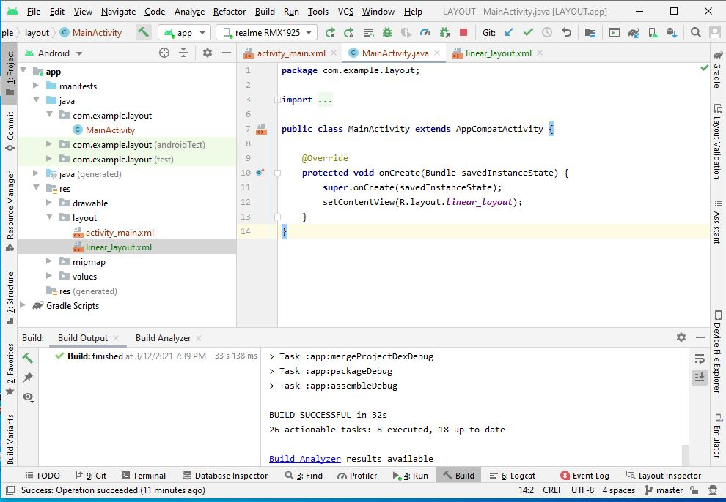

**Step3:**

**Layout iformation also set in dependencies**

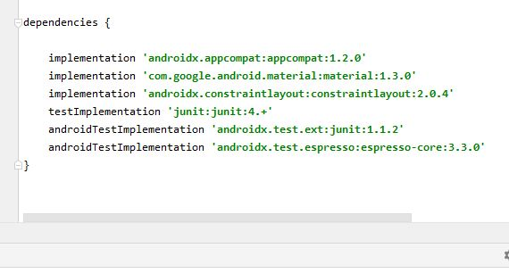

**Step4:**

**Add text to layout**

**It will bw show as follow**

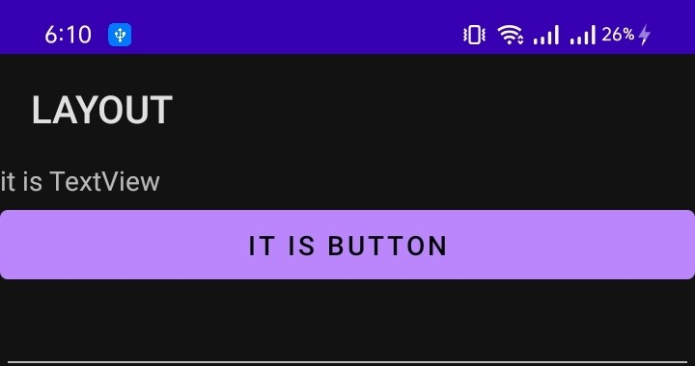

**Add Picture:**

**Step1:**

**Copy picture and paste in drawable.**

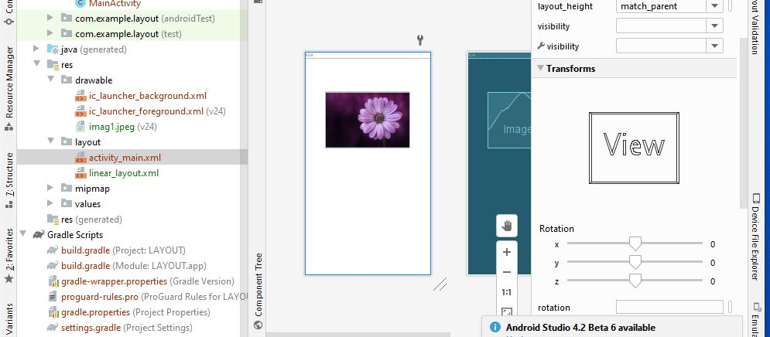

**Step2:**

**Select image viwer select image and place on layout.**

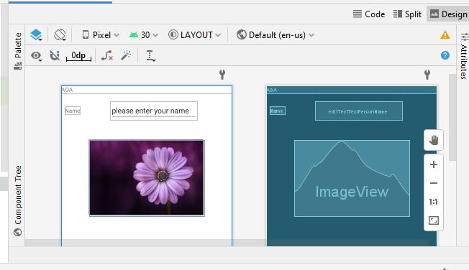

**Step3:it will shown as:**

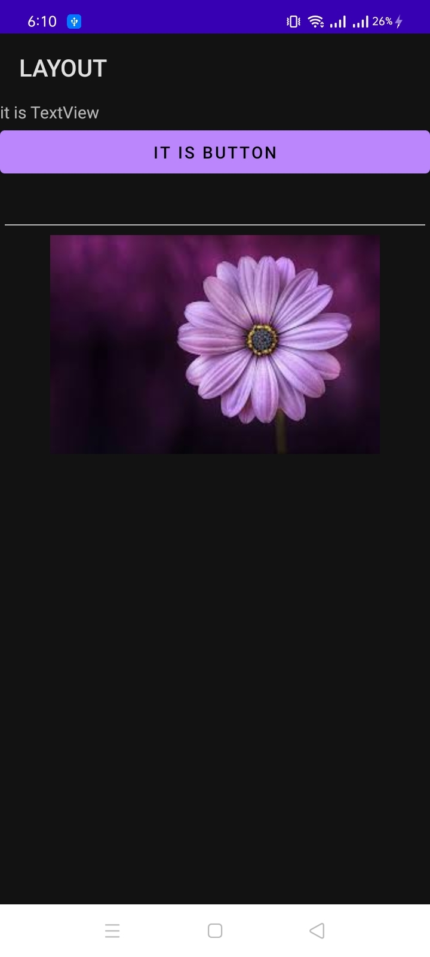

**Different forms of constraints on buttons:**

**selectall buttons and apply differe type of constraints.**

**1.**

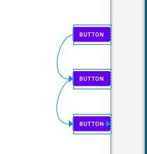

**2.**

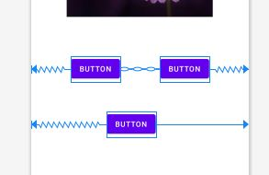

**3.**

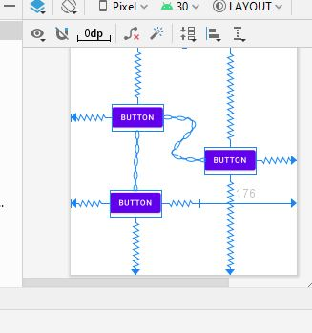

**4.**

**On Click Action of button**

**Step 1:**

**Add button and text view on layout.**

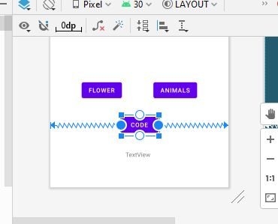

**Step2:**

**Go to design view**

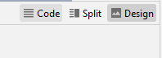

**Step3:**

**type on click and name of event**

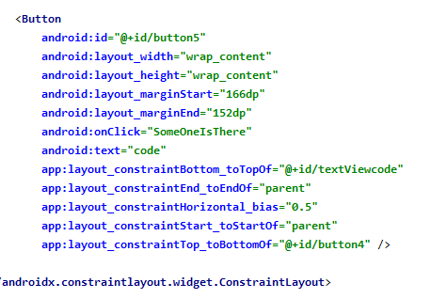

**Step 4:**

**Change text code id**

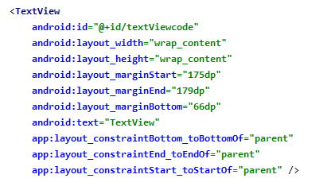

**Step5:**

**Write code in main activity.**

**Creat instances in on creat**

**And write fiunction of on click event**

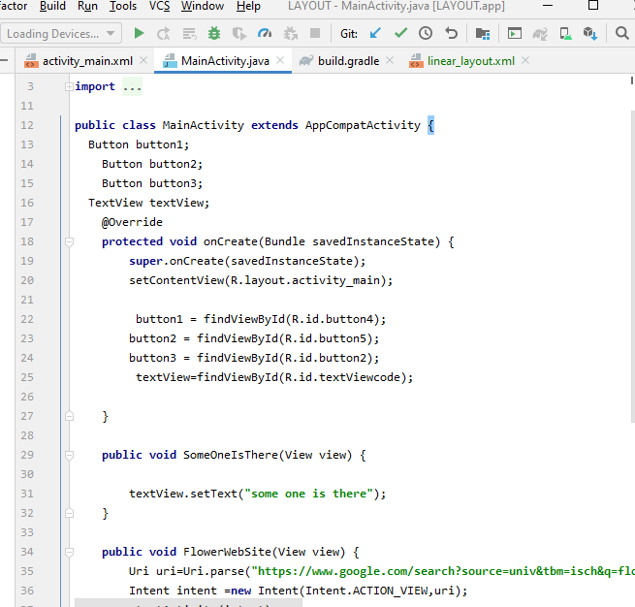

**Step 5:**

**Run the code.**

**By clicking on code some one there is typed.**

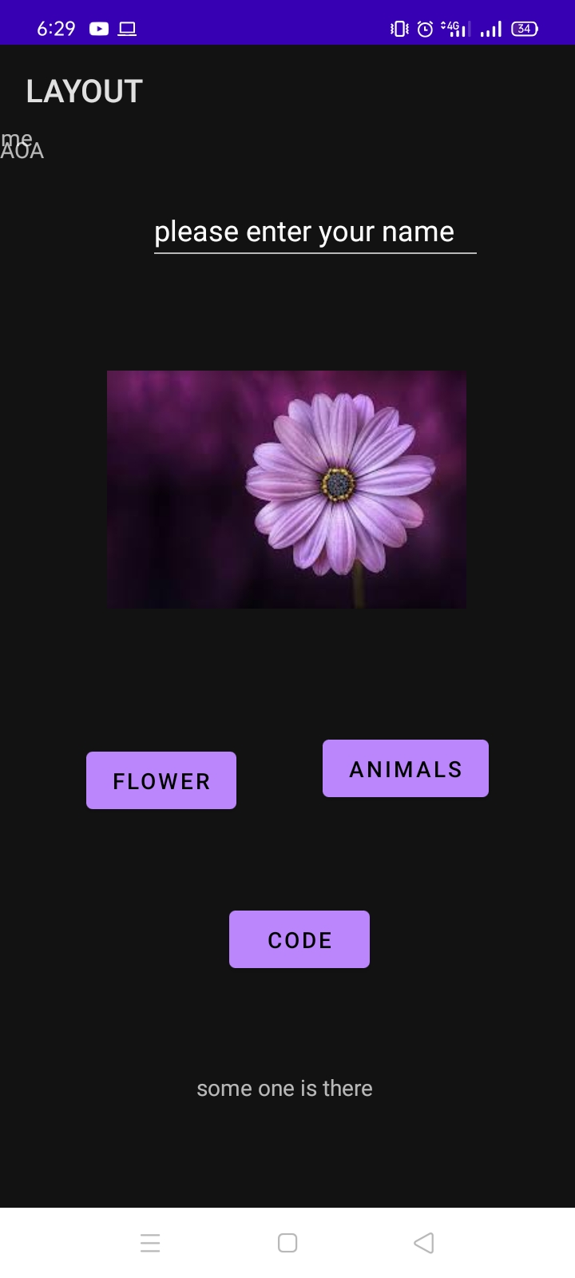

**Flower will move it t flowers site and animal website will move it to animal website using following code and same procedure as above**

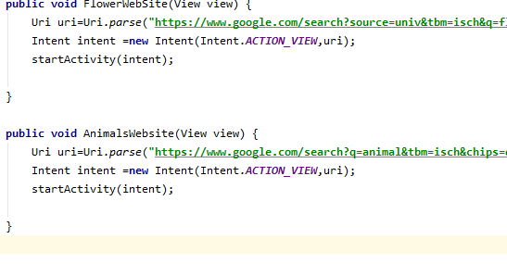

**Move screen from one to another:**

**Step1:**

**Creat new main activity file as main activity 2.**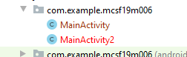

**Step2:**

**Go to mainfset and set main activity 2 as main runner**



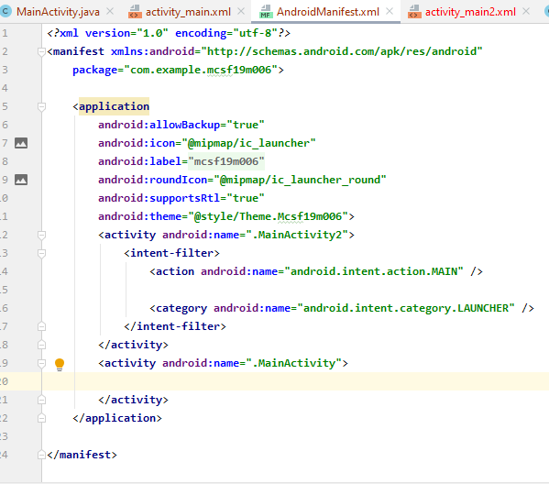

**Step3:**

**Creat two buttons in activity.main**

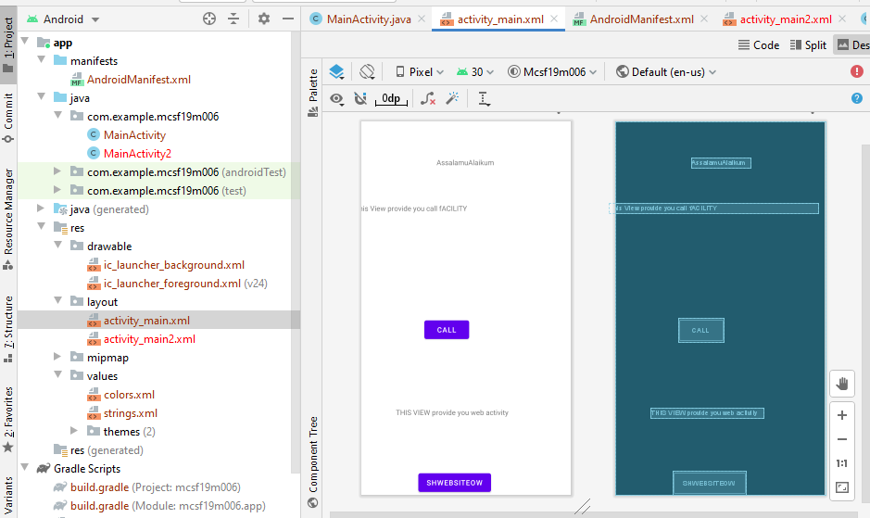

**Step4:**

**Set buttons and texts in activity.main2**

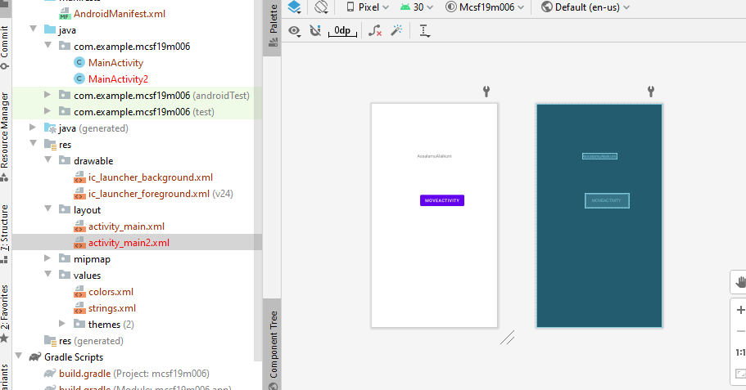

**Step6:**

**Write events of activity. Main in MainActivity**

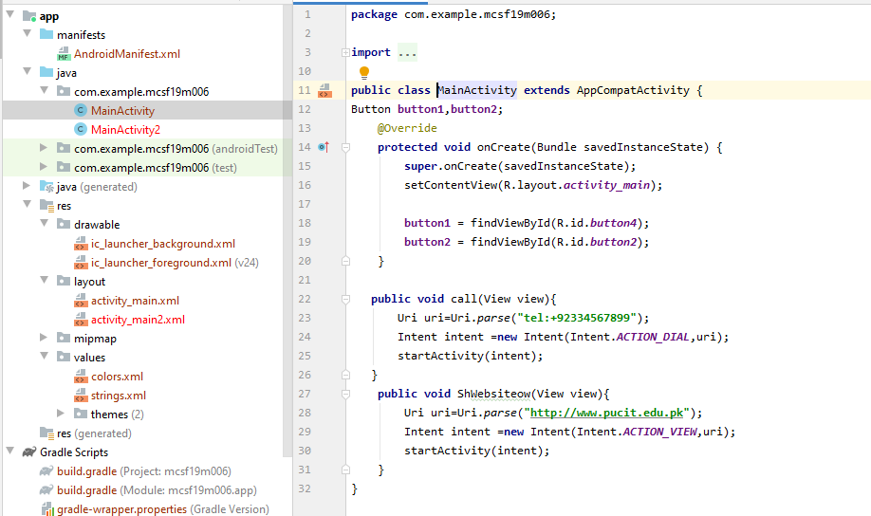

**Step7:**

**Write code to call main activity in main activity 2**

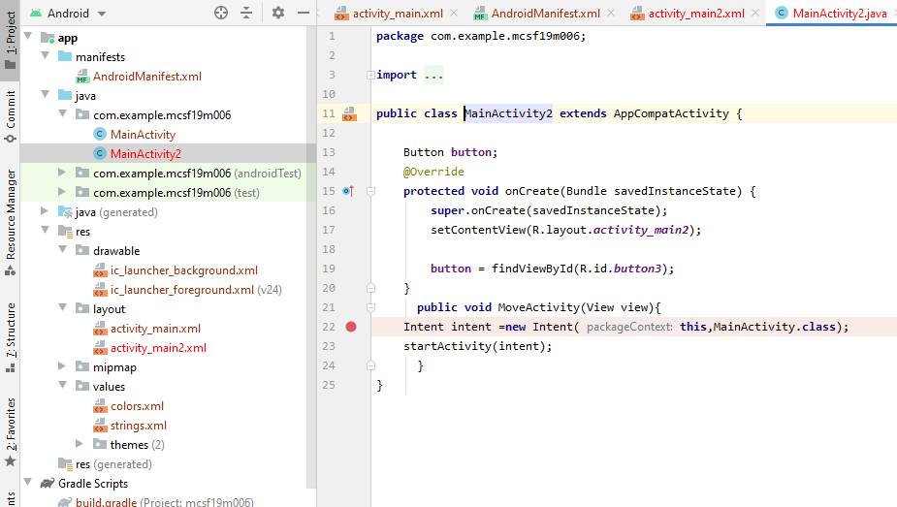

**Intent is used to move from one activity or page to another start activity is used to start that activity or page.**

**Step8:**

**run code**

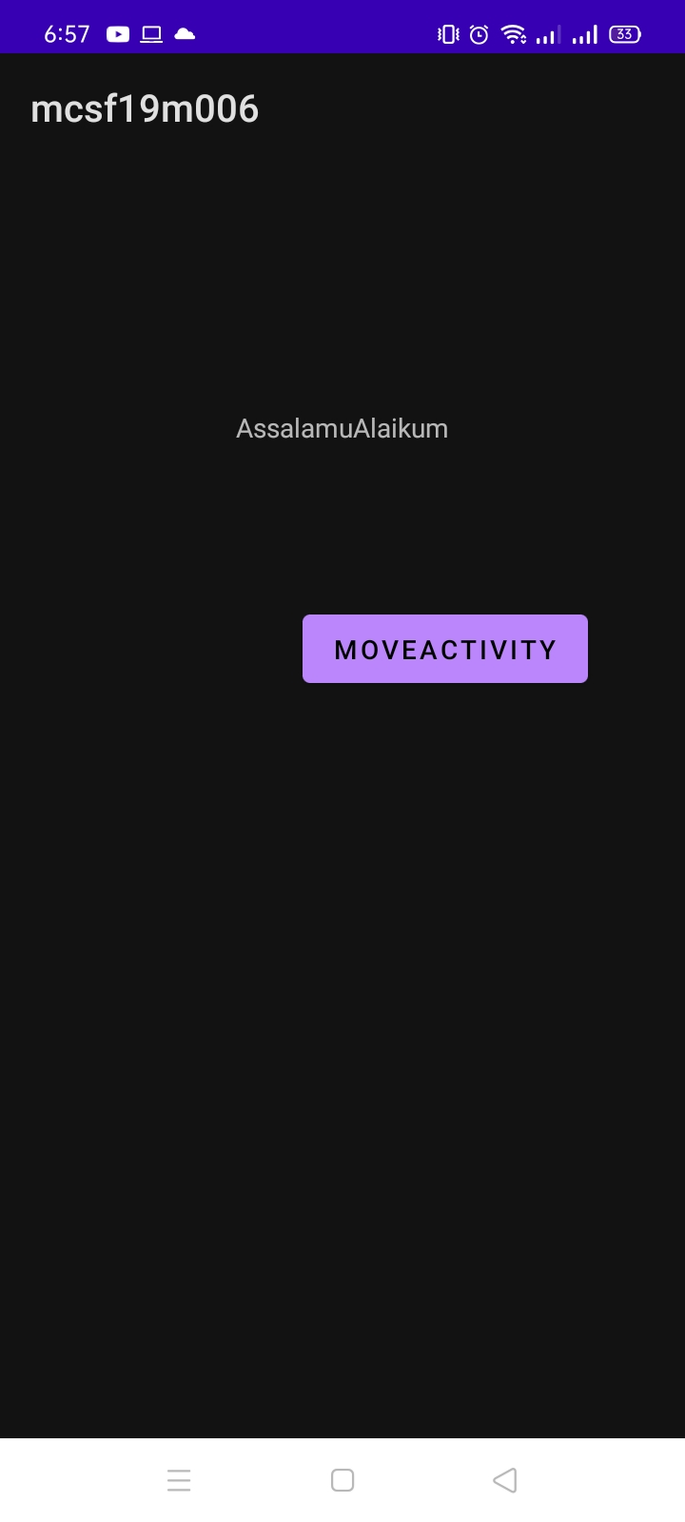

**Click on move activity button**

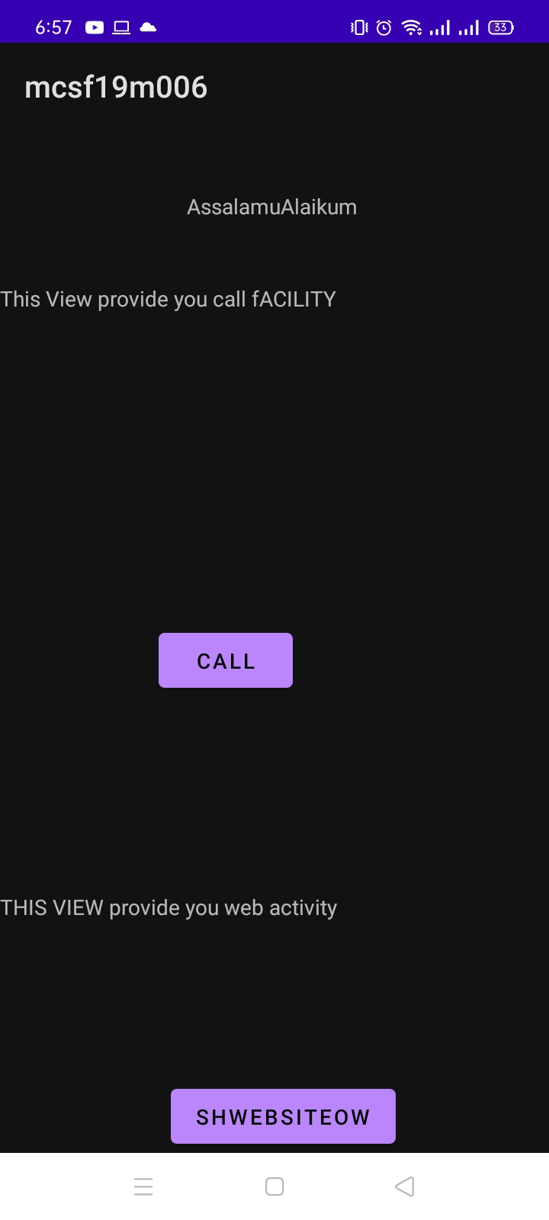

**Click on call**

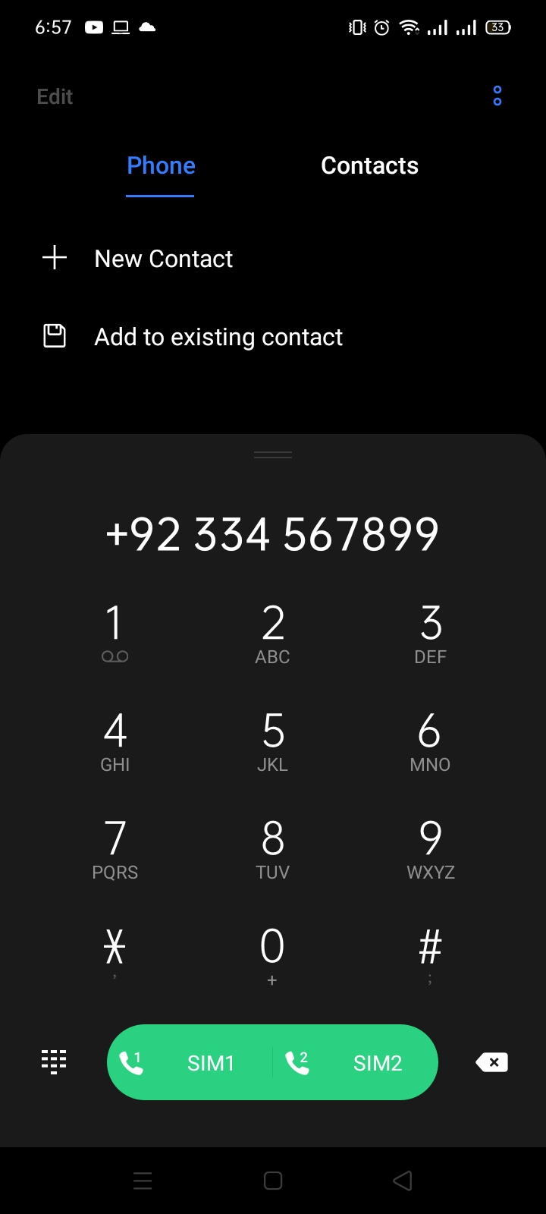

**Click on showWebsite**

