**Mcsf19m006_Android_Lec5,6**

ArrayList3:

Step1:

Put seek bar from widgets in activit.main

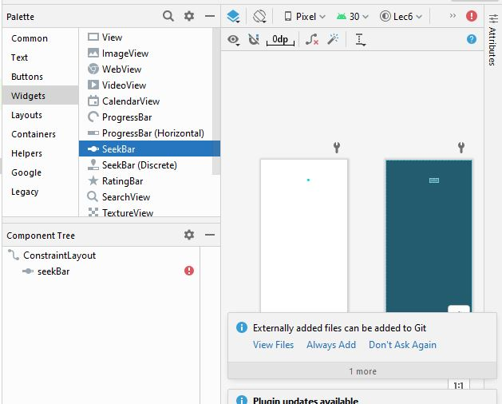

Step2:

Set constraints it will come on whole screen

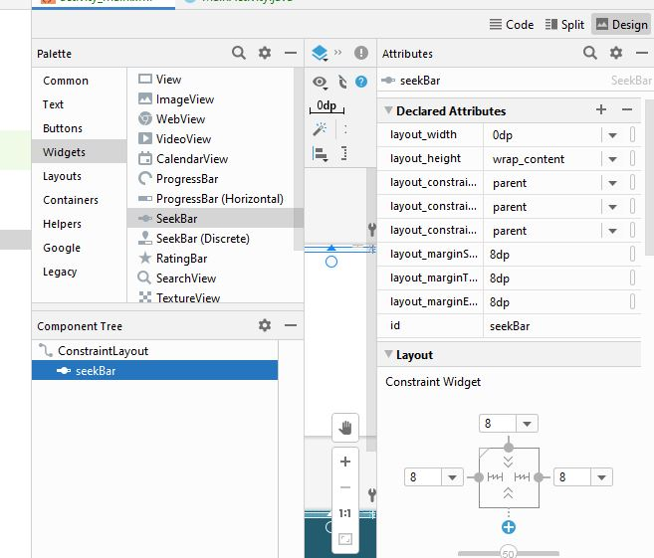

Step3:

Run and check

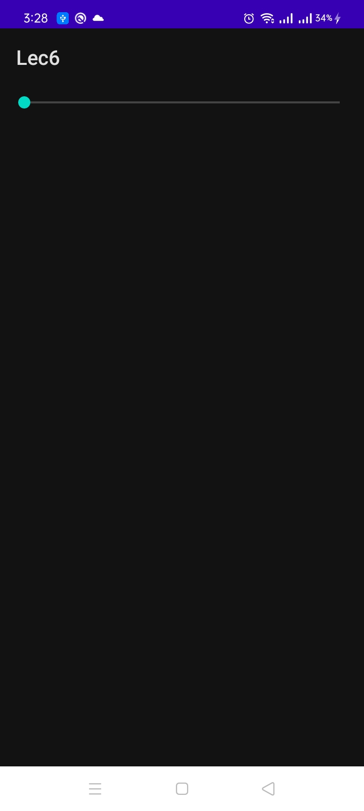

Step4:

Initialize seekbar in main activity and set max number to which it can move and set change listner.

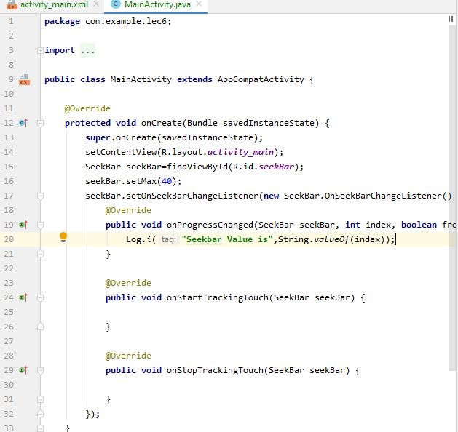

Step5:

Run and see

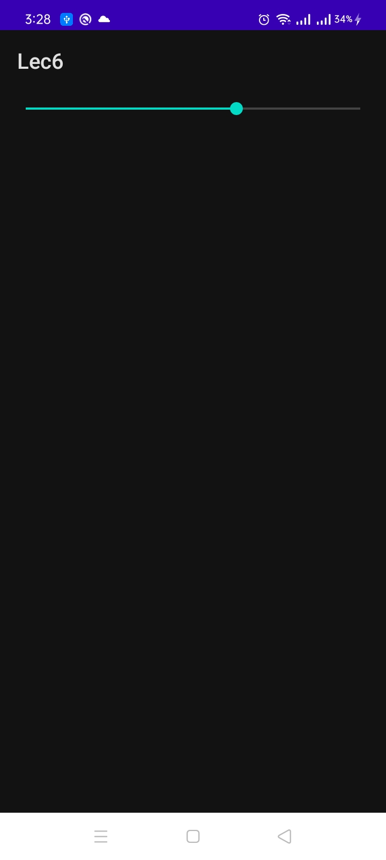

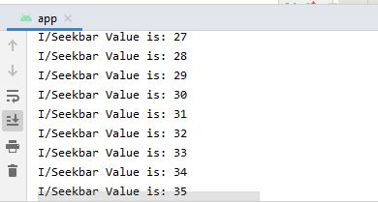

Maximum limit is set upto 40.

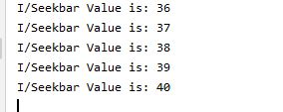

Step6:

If we set max to 100 then it will run upto 100.

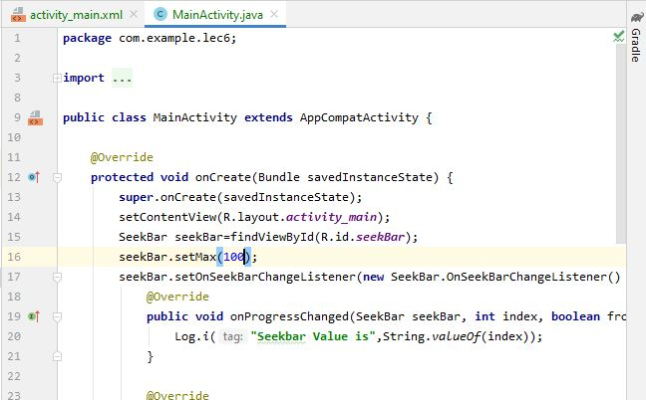

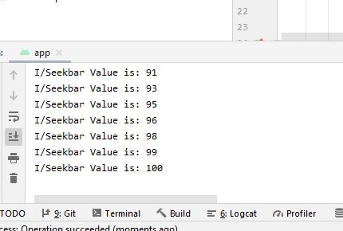

Step7:

Put list in activity.main.

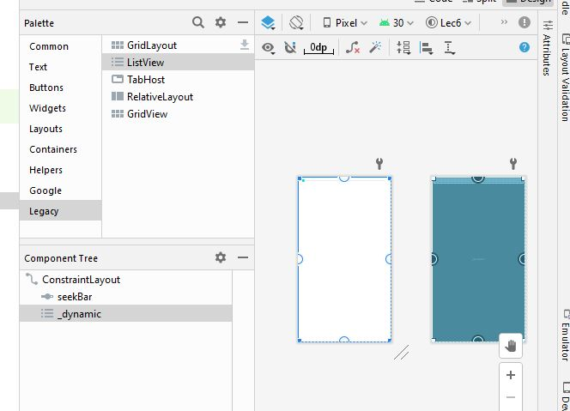

Step8:

Set id and constraints.

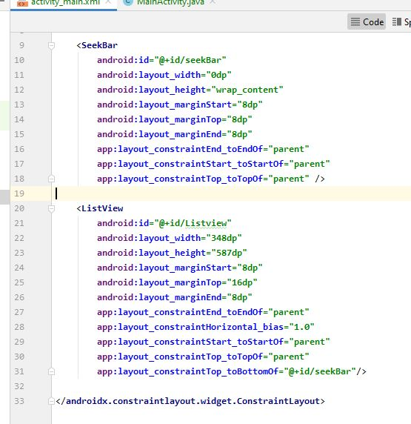

Step9:

In code we have use for loop in order to print table of specific index and index is value on which seek bar is moved list view and addapter is used to connect list of activity. Main and main activity.

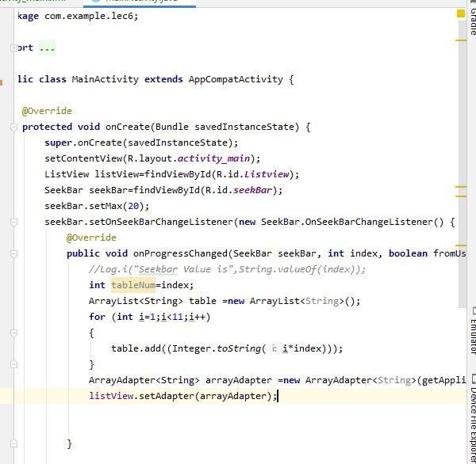

Step10:

Run

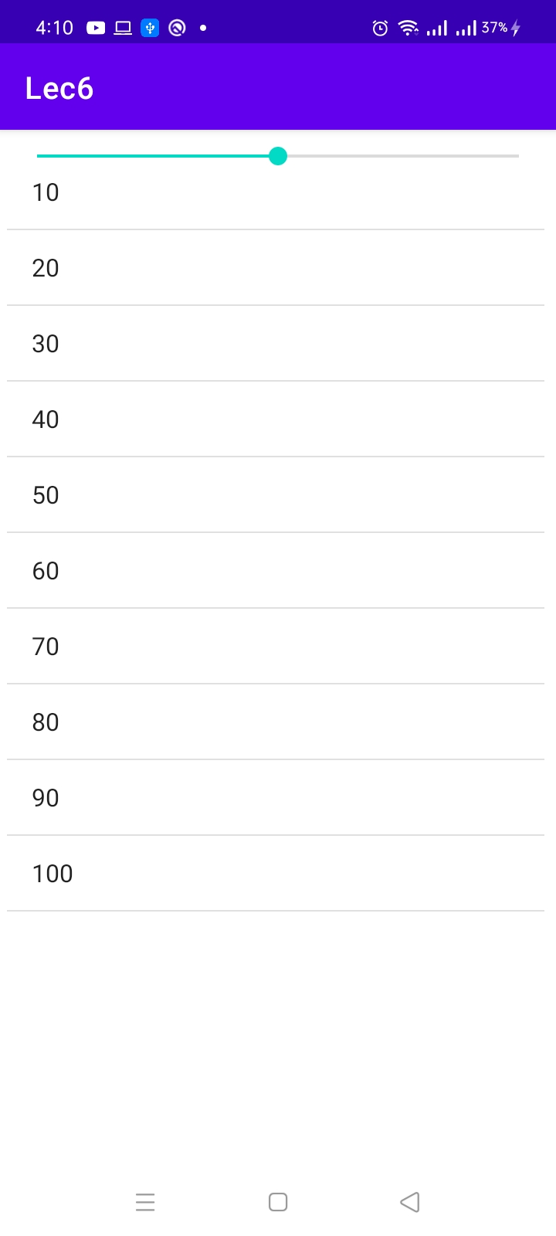

Animation:

Step1:

Copy paste imae in drawable and put image in activity.main and apply constraints.

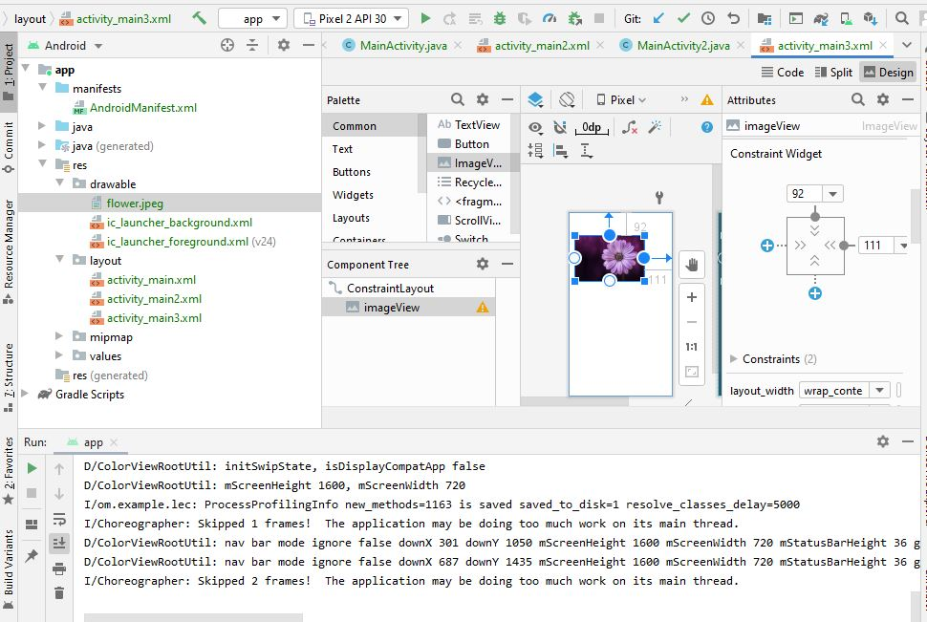

Step2:

Use followind animation features on imae view alpha to make it disappear,duration show how long it remain on screen.

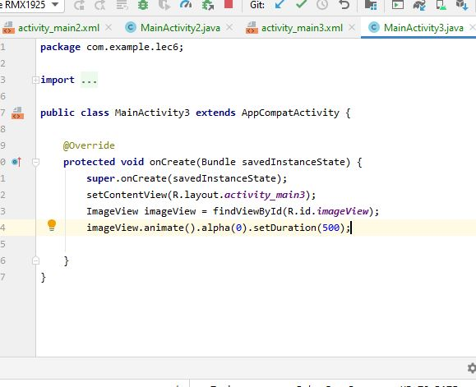

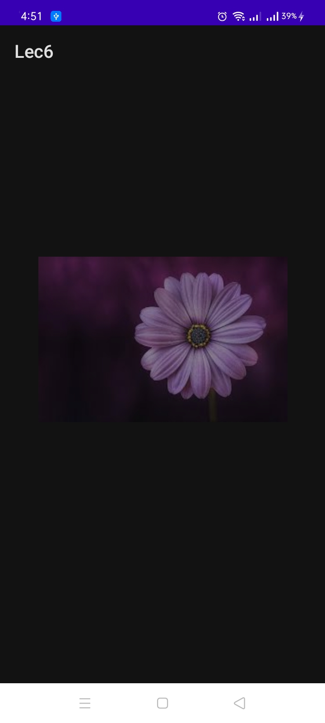

Step3:

Translate by y will mve pic toward left

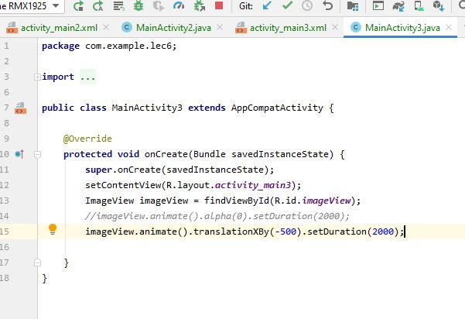

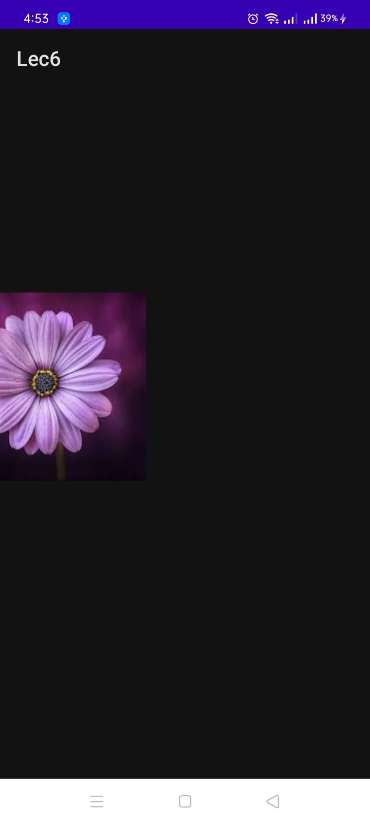

Step4: rotatotion rotate pic

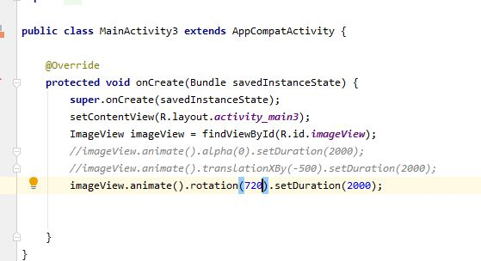

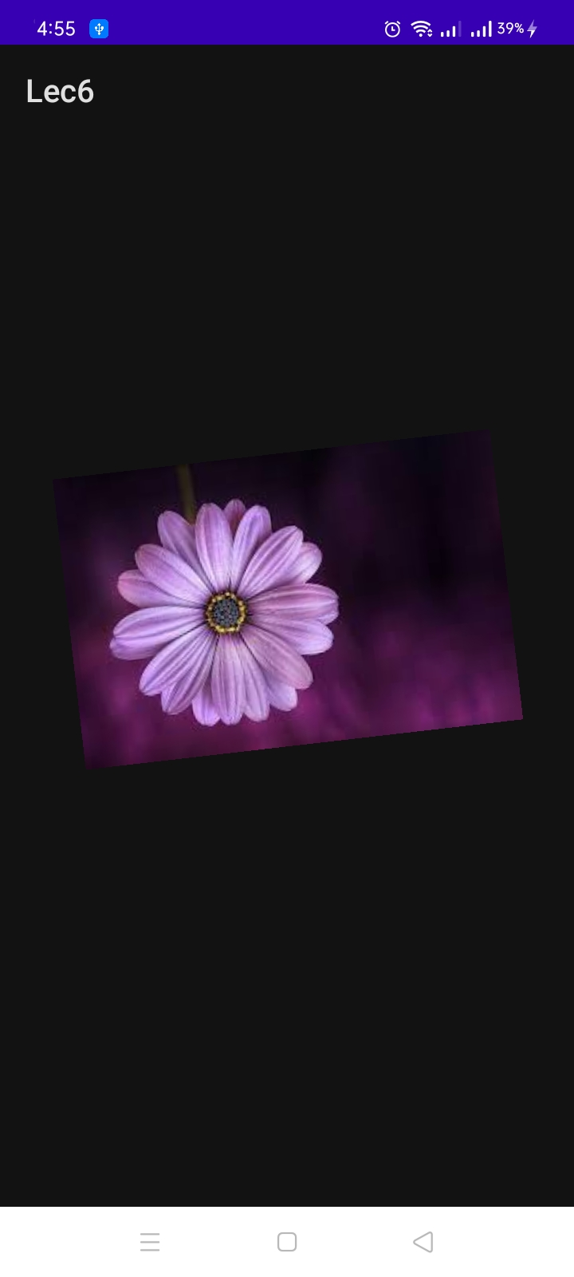

Step5:

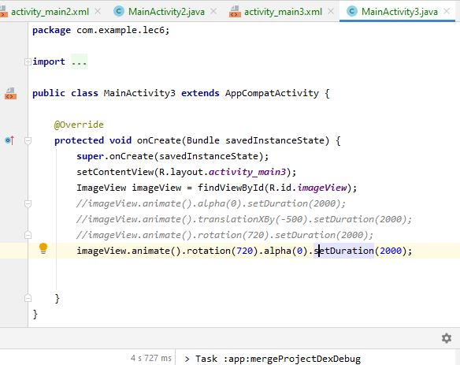

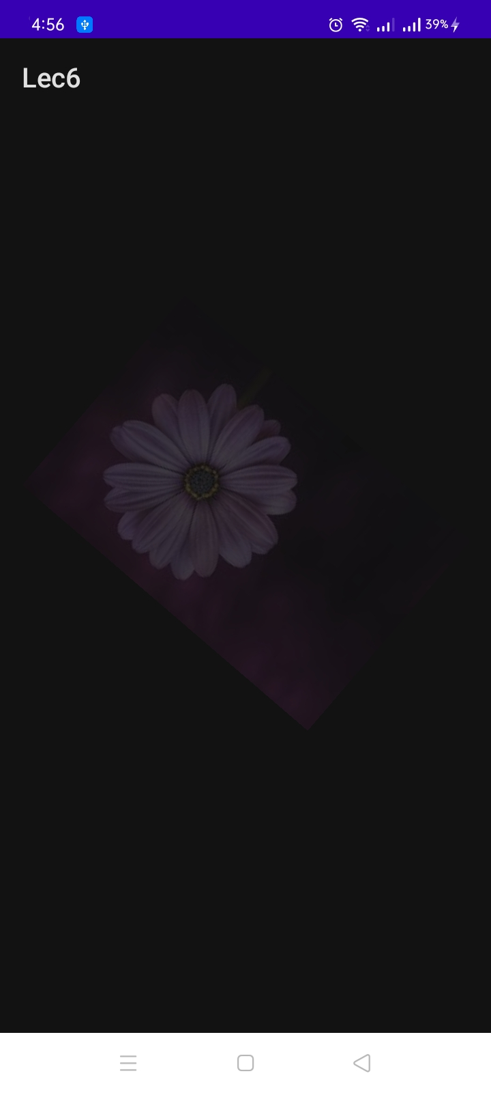

Step6:

Scale x and y make it ch\ange with and length of pic

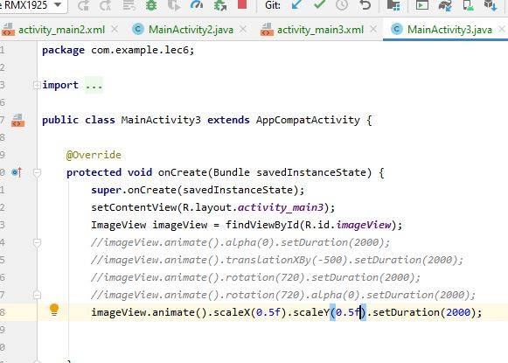

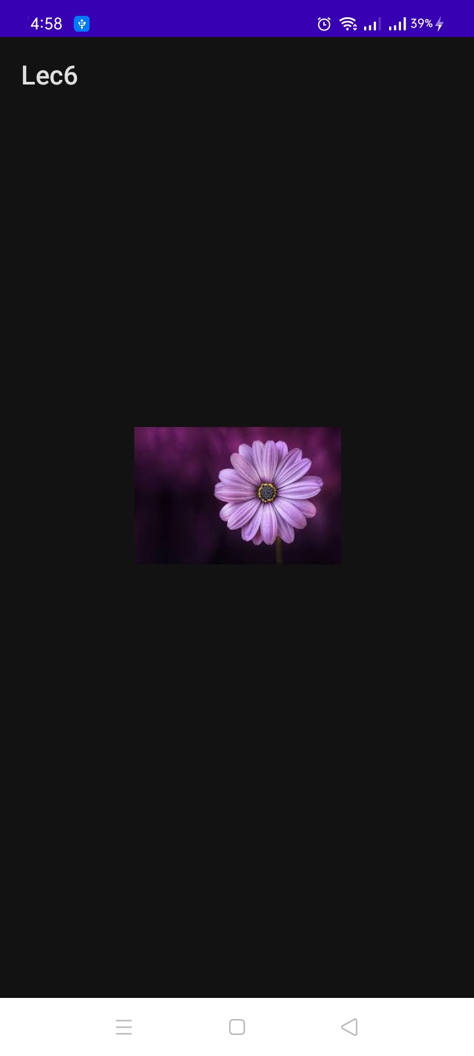

Step7:

All the features can be used together.

