**Android NavigationBar Mcsf19m006**

Step1:

Creat empty project.

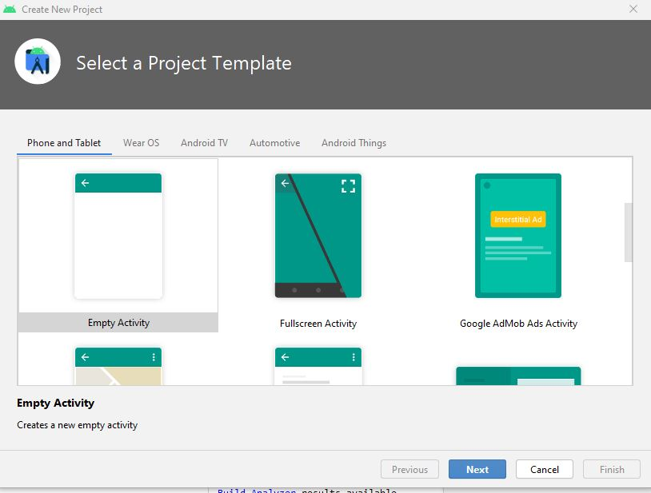

Step2:

Add vector assests in raw>drawable by drawable>rightclick>new>vectorAssests

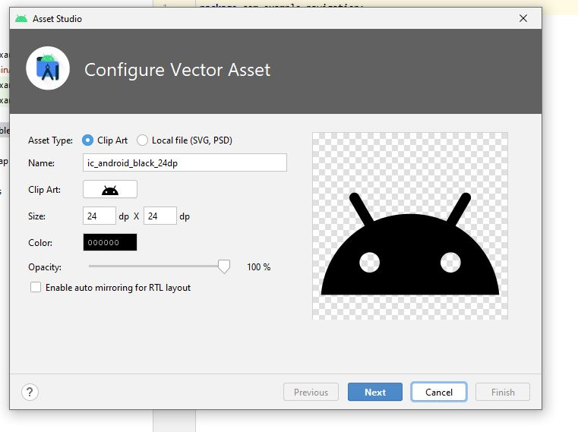

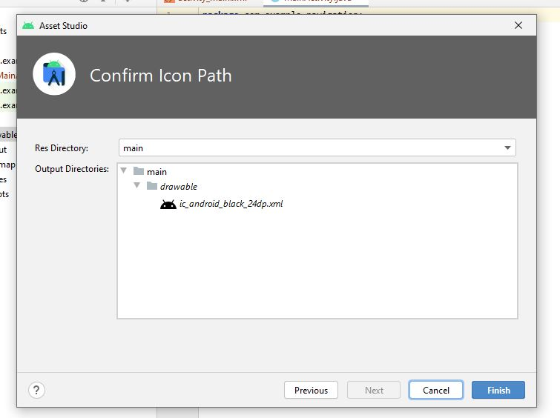

We can add different types off vectorassests icons

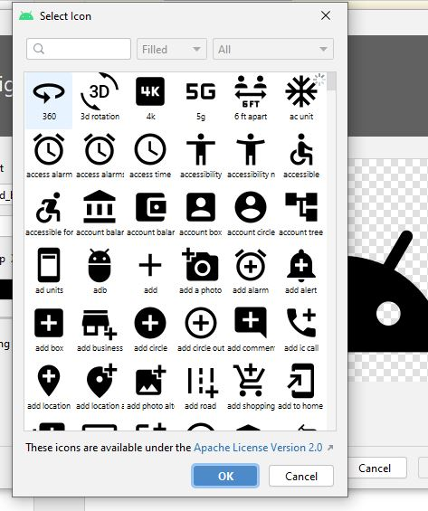

Step3:

Creat new resource file values if not present to store strings

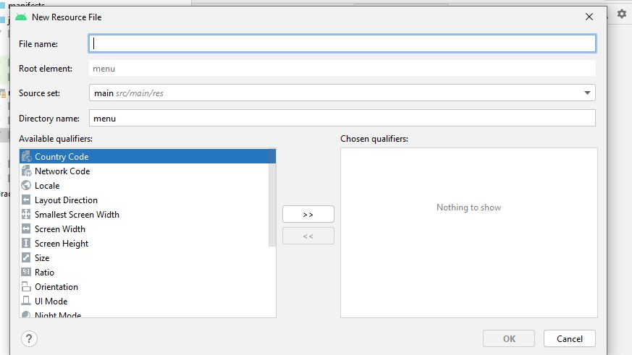

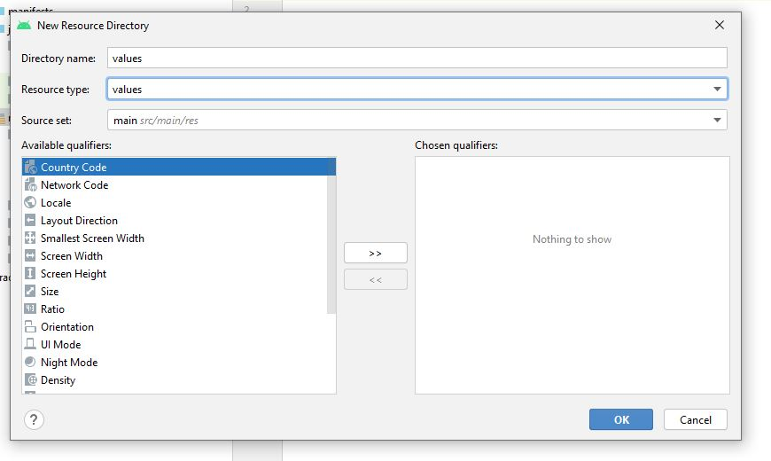

Step4:

Creat new resource file name header file in Layout to design header of nav bar

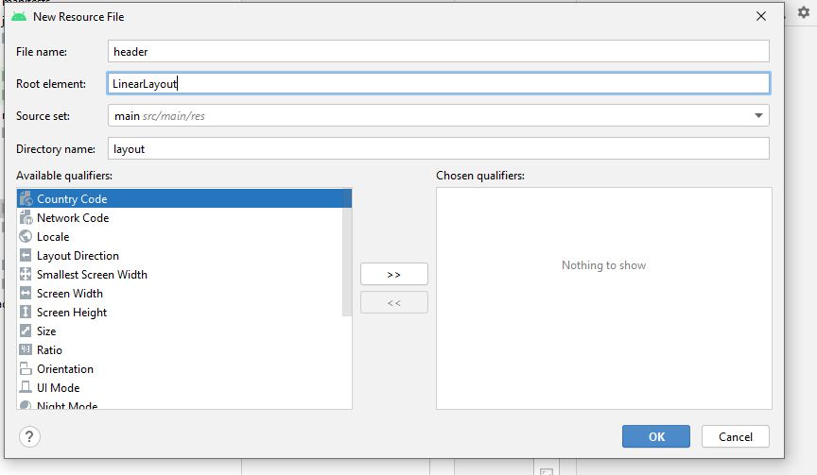

Step5:

Creat one more resourse file name menu In order to design menue items

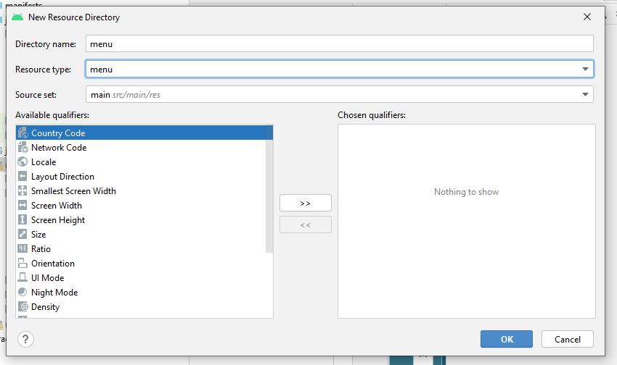

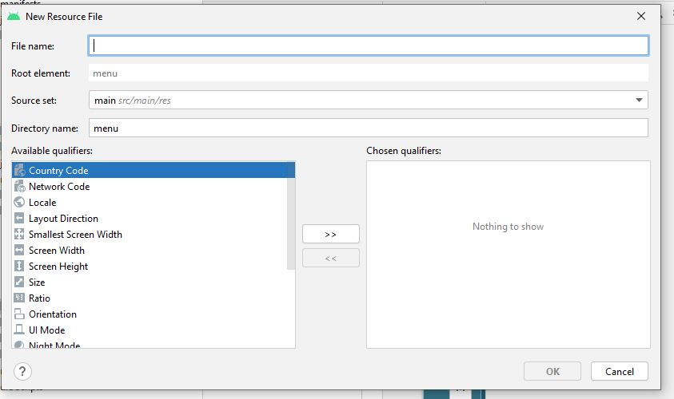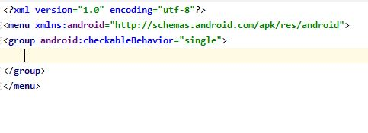

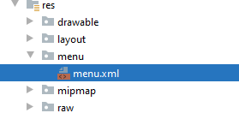

Step6:

Design view of menu.xml

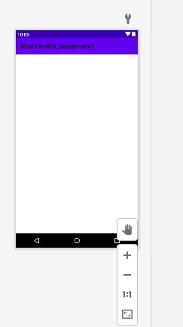

Step7:

Add items in menu.xml

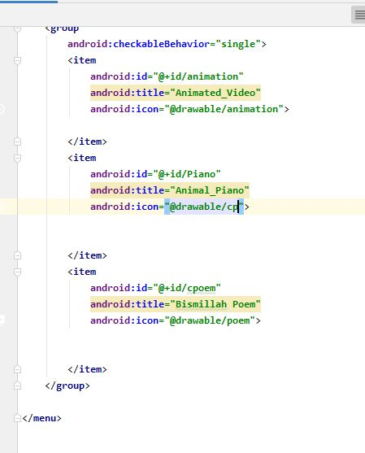

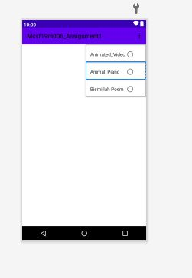

Step8:

Design header file as following

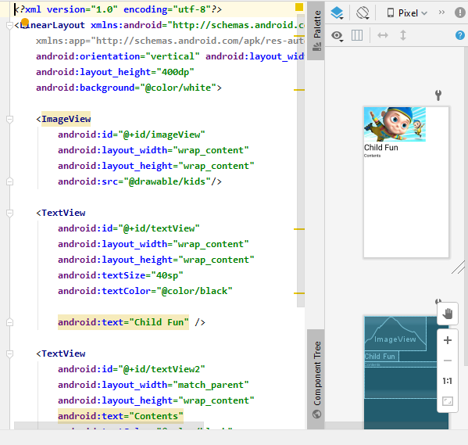

Add text image and sub text as you like

Step9:

Set activity.main layout as drawer layout and set navigation.view in main.xml and set header and menue file as shown below.

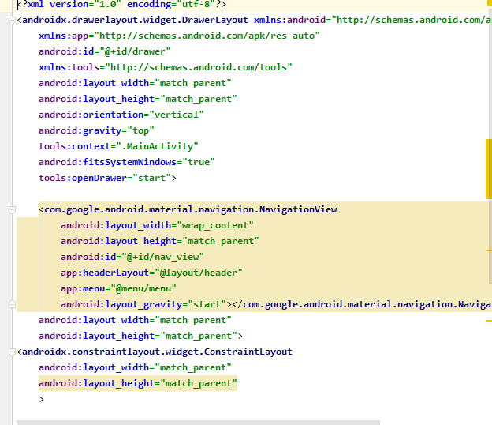

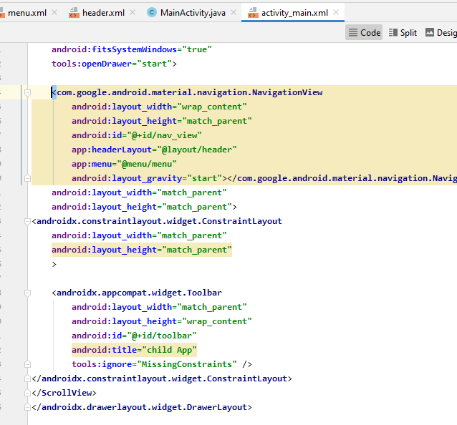

Design view:

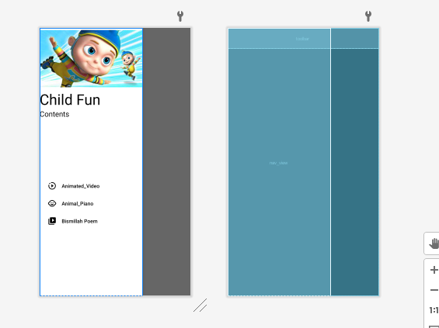

Step10:

Make local variables of navigation view,drawerLayout,toogle and toolbar

Use on back pressed function to close drawer on back pressed.

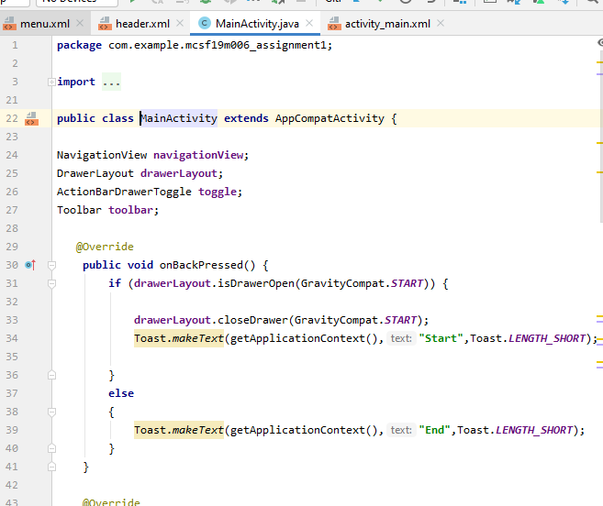

Step11:

Creat instances of all variables.

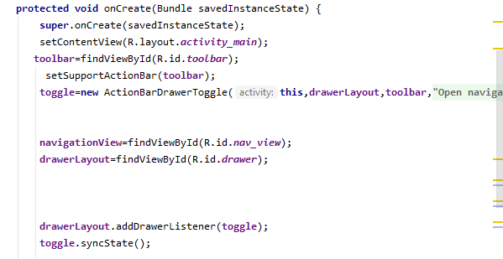

Step12:

Set support toolbar

Initialize toogle

addDrawerListner toogle

synch toggle

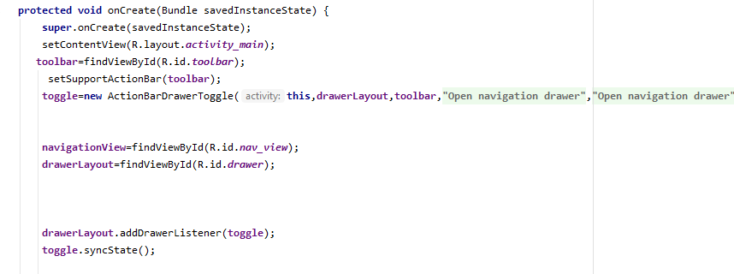

Step13:

Creat click event function for nav bar

