Notifications_Mcsf19m006:

Step1:

Creat new peoject

Add vector assests

Drawable>right clik>new>vector assests

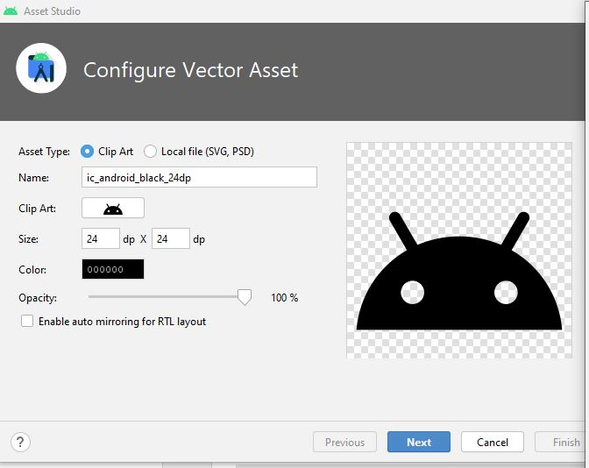

Step2:

Search one

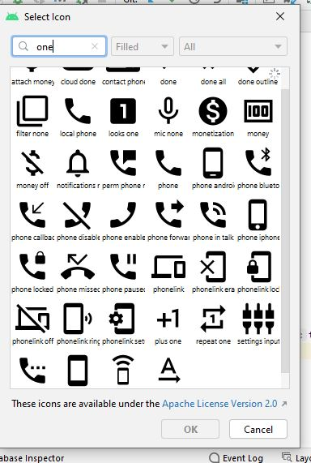

step3:

click ok ,next, finish

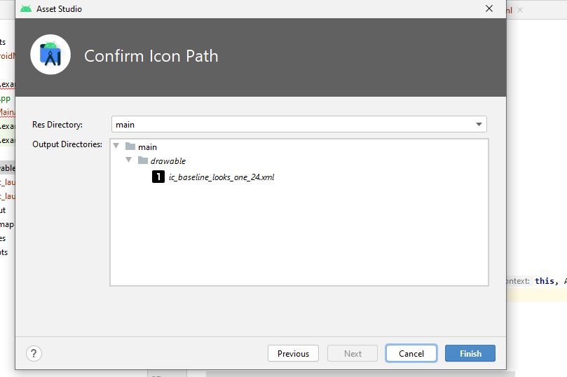

Step4:add one more assest by searching two

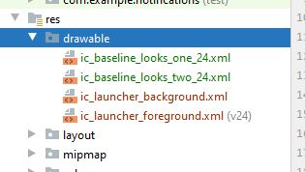

Step5:

Add java class name app

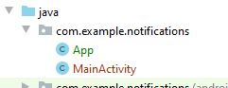

Step6:

Write code as given below in App

Two strings

creatNotificationChanne function

set attributes of notification channel

use notification manager to creat notifications

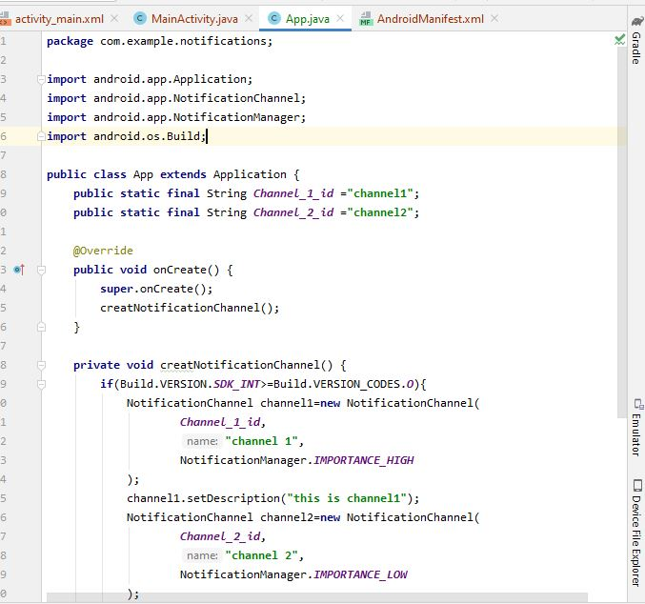

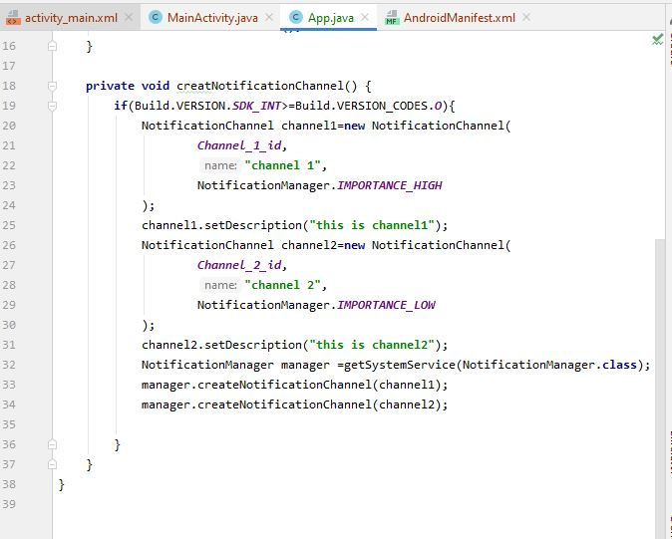

Step7:

Design xml file as given below.

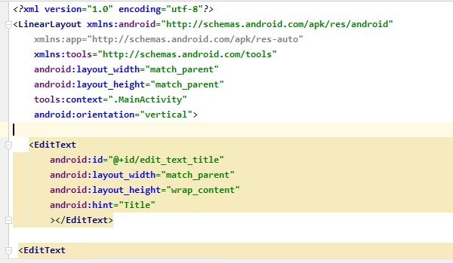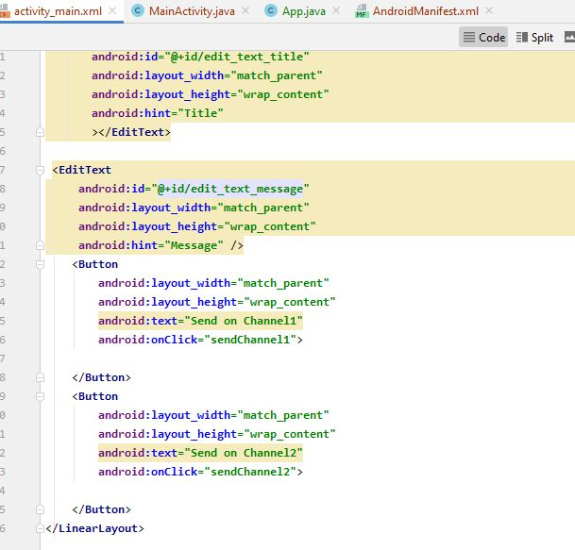

Step8:

In main class creat instances of texts a nd on click event of buttons

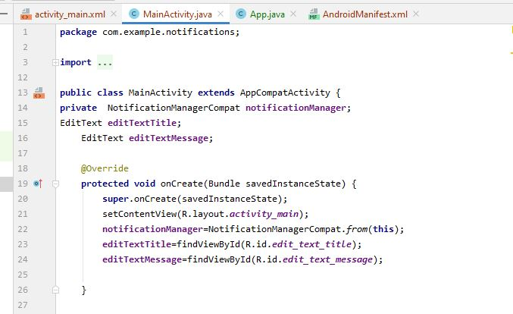

Step9

:

Add app in android manifset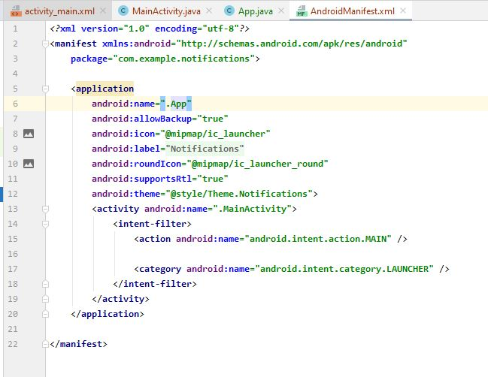

Step9:

Write following code given below in two on creatt funtions

Set icon,title and othe things

And use notification manager 