**Android_RecyclerView_Mcsf19m006**

Step1:

Add recycler view in main xml file

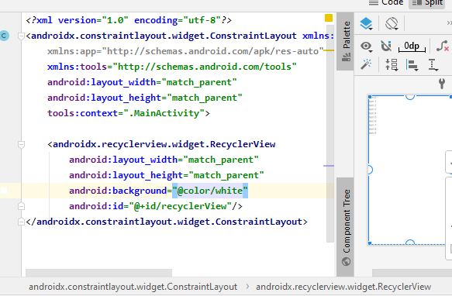

Step2:

Creat new xml file name item_design

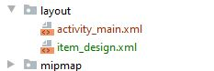

And write following code to design item.

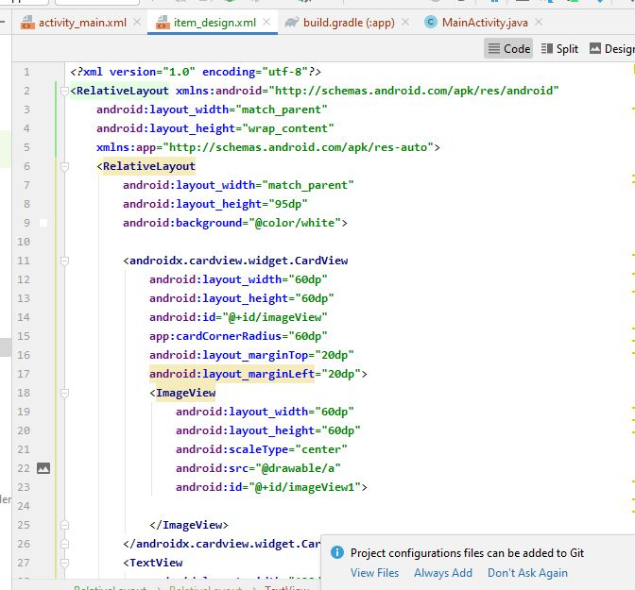

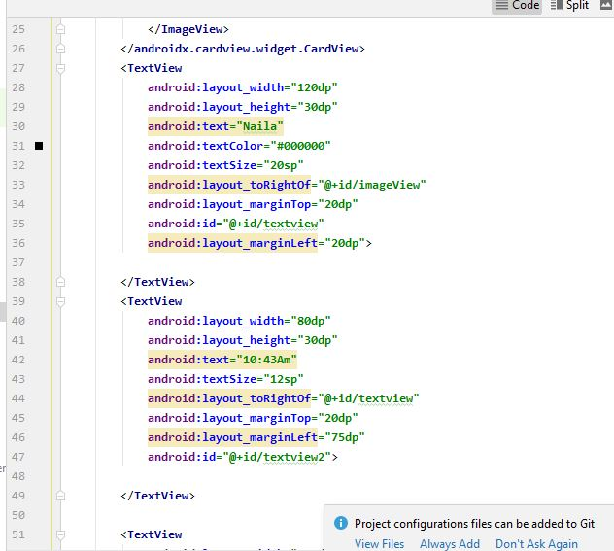

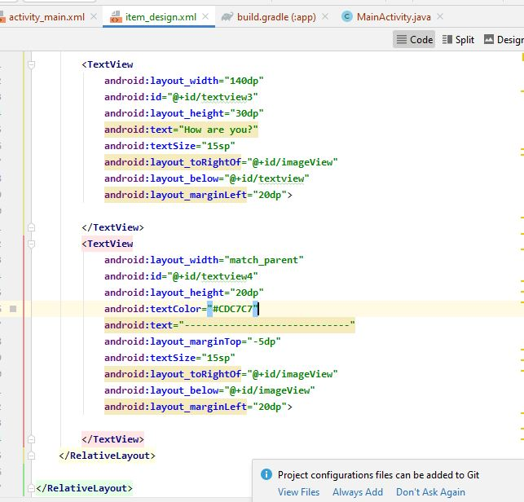

Design View

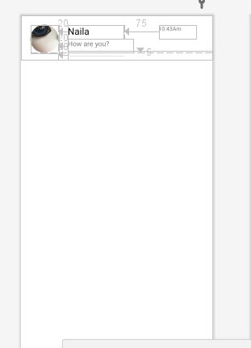

Step3:

Add different images in drawable

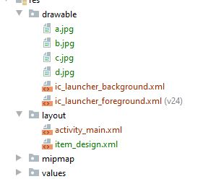

Step4:

Add java class named ModelClass

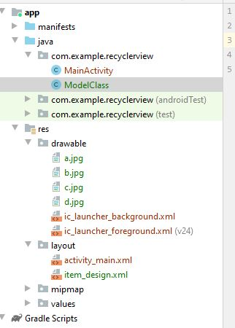

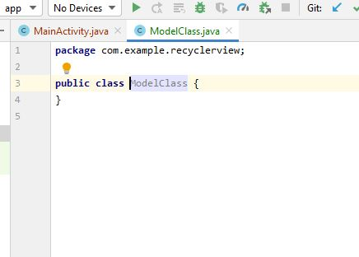

Step 5:

Add getters in model class

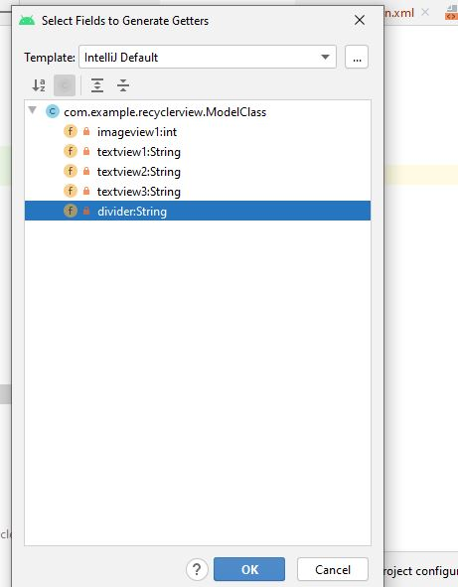

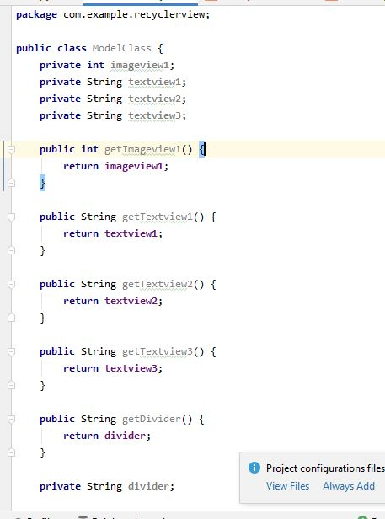

Step6:

Add constructer in model class

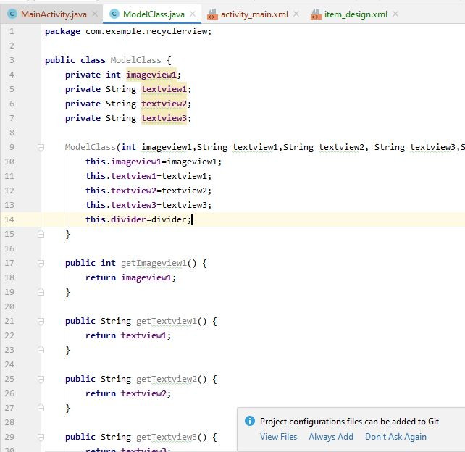

Step7:

Add java class name addapter

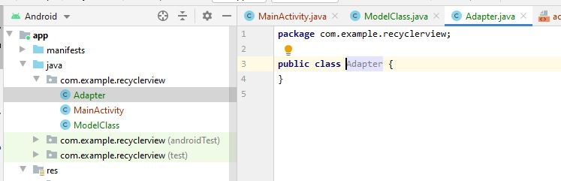

Step8:

Extend adapter class with Recycler view viewHolder

Make list variable

Set adapter for list

Use adapet.view holder

onBindview holder

and write code given in fig below

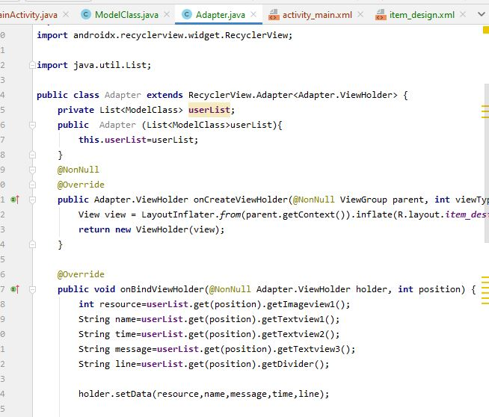

Step9:

Use vieHolder constructer as dscribed below

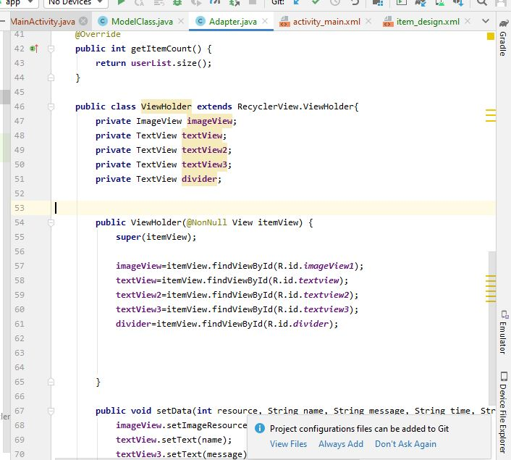

Step10:

Creat setData function as described below

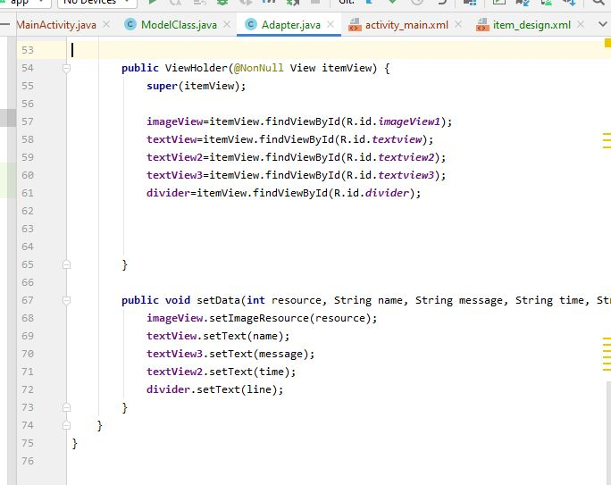

Step 11:

In main class make two functions initData and initRecyclerview

initData to get data

and other to set RecyclerView

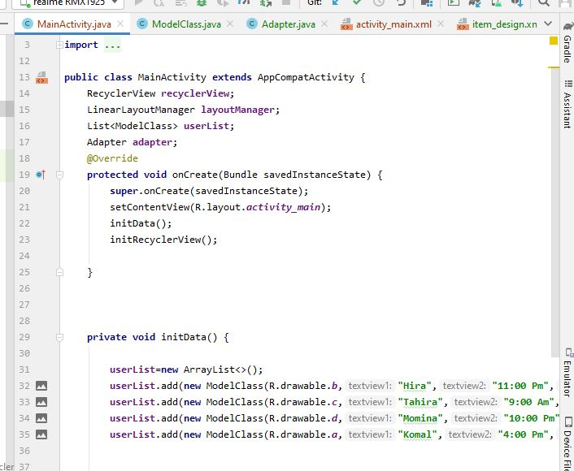

Write code as given below

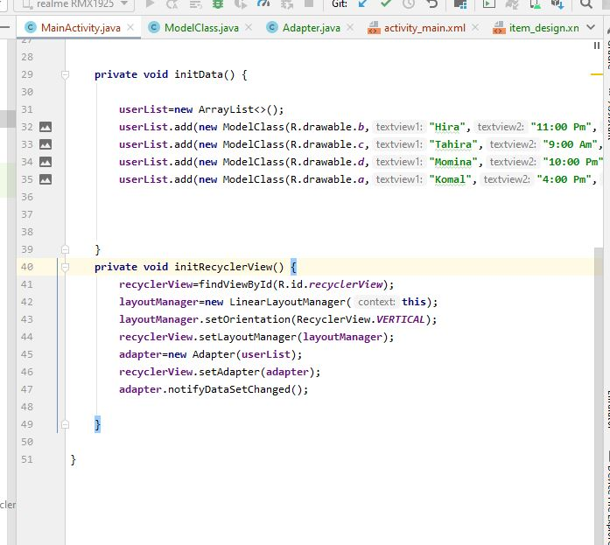

Nw you can Run and see