Jordan Morris Portfolio Design -- CAB011813

Contents

Website Definition 2

Problem definition 2

Site Audience 2

User Stories 2

Original Design 3

Layout Philosophy 3

Colour Scheme 3

Typography 4

Wireframes 4

Accessibility Design 4

Logo Design 4

Implementation Process 5

Code Creation 5

Accessibility Development 5

Sight Reader 5

Colour Deficiencies 5

Cognitive Abilities 6

Logo Not Included 6

Hosting 6

Appendix A (Old Portfolio) 7

Appendix B (Wireframe) 8

# Website Definition

Problem definition  
I aim to create a portfolio to show off my website development skills.

## Site Audience

The intentional users are potential employers and recruiters. Accidental, but important users include co-workers, entrepreneurs and those working in other industries. My users will be both technical and non-technical. Users will be using desktop, mobile and other devices. Users will mostly be linked from my social media and other projects, this means it could be found with lack of context.

## User Stories

|  |  |  |  |  |  |
| --- | --- | --- | --- | --- | --- |
| As an | Intentional User | I should be able to | See an example of Jordan’s work | So that I can | Evaluate Jordan’s skillset |
| As an | Intentional User | I should be able to | Find external links of Jordan’s work | So that I can | Evaluate Jordan’s history and workflow |
| As an | Intentional User | I should be able to | See Jordan’s interests and personal goals | So that I can | Establish if Jordan is a cultural fit |
| As an | Intentional User | I should be able to | See Jordan’s contact details | So that I can | Contact him |
| As an | Intentional User | I should be able to | See Jordan’s social networks | So that I can | Follow Jordan’s progress |
| As a | Unintentional User | I should be able to | Instantly see a title name and small description | So that I can | Make sure I’m on the right page and get a small idea of who Jordan is |
| As a | Non-technical user | I should be able to | View information in plain English | So that I can | Easily understand Jordan’s skills and culture. |
| As a | Mobile user | I should be able to | Click a phone number | So that I can | Easily call Jordan |

# Original Design

## Layout Philosophy

My layout is mostly based on a pre-existing template I was using on my previous WordPress portfolio (Appendix A). This layout was originally chosen for a variety of reasons, working from the top down.

The full screen photo, with a large amount of focus being brought to a title. This was chosen as it matches many modern ‘Splash Screen’ styles. It’s clean and all focus is brought to just two simple pieces of text to begin with. The header is clear, with white text as to not take away from the attention the main header picture is trying to get. Whilst the original template has a static subtitle I would like to showcase a javascript effect that will type out keywords.

As you scroll the top navigation menu takes on a more solid look to be easily accessible. Next I wish to discuss my personal mission as a way of me discussing my personality, I personally feel this is the most important aspect of myself as a developer. This should be split into multiple sections to easily arrange information.

After personality should be an example of my work. This should be individual cards that highlight an individual project. A good way of separating, but keeping flow would be left, right switching. I have seen examples of this to showcase products and found it vidually pleasing and within my technical means – this is not included on the pre-existing layout (Appendix B).

Finally, my social details and be able to contact me. This is left to the bottom as that is the most usual location to find such items and with a link from the very top it could still be found easily.

Colour Scheme  
A colour scheme should include gray, white and red. My own personal style includes lots of gray, navy and plain but neat colours. Red was also included as it’s important to have a large contrasting colour to draw attention. Inspiration (fig1) was found on pinterest to get more specific colours. A final colour palate (fig2) was then created.  
  
Fig 1. Suit Inspiration Colours

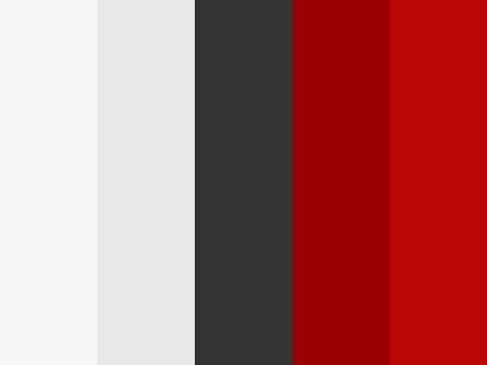  
Fig 2. Colour Palate

## Typography

Roboto was chosen due to how easy it is to read in all font sizes. At heavier weights it draws attention. Roboto will be used for paragraphs. A larger, but same weight version of Roboto will be used for all headers. A heavier weight version (700) will be used for the largest heading on the page on the main screen.

## Wireframes

See Appendix B

## Accessibility Design

Usability will be heavily considered. It should be one continuous screen to avoid complicated navigation. Responsiveness to multiple screen sizes and mobile. It needs to be accessible for those with traditional accessibility issues. This means it should work well on a screen reader, all colours should be well contrasted, the text must always be a readable size and the site should be zoomable. It should also be read easily by anyone.

## Logo Design

A local graphic designer has been contacted to design a personal brand logo. The logo should be my initials in the preferred colour scheme of red and gray. The J should be made in to a cane to subtly incorporate my personal identity.

# Implementation Process

## Code Creation

All code implementation can be found on <https://github.com/jawdinmorris> (fig3).

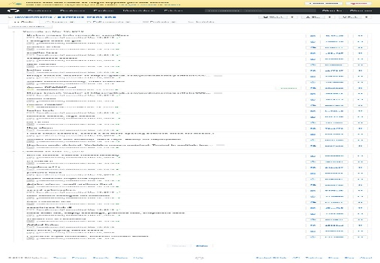  
Fig3. Screenshot of commit history.

All changes made from the original design will be justified in the following paragraphs except one. The decision to move the summary of my work out of the contact section to above my examples of work. This was done under the advice of David Cook from Readify. The justification of this is to provide links to all my work for those that already know what they’re looking for.

## Accessibility Development

### Sight Reader

Screen reading was the most difficult part of the site to implement well. A lot of research was done using WACG2, StackOverflow, Social Media and advisors. The initial order of reading from a HTML format was fine, a breaker class was created to help with the small issues.

Next it was tested using the most popular screen reading tool available to me – NVDA. The three column format was changed in the missions section to help with this process.

The contact form was removed and replaced with simple contact buttons to aid screen reading technology.

### Colour Deficiencies

This should have been more of a focus during the initial planning stage. The red used in headings had to be taken away. The gray used for text was darkened to allow better contrast. The red was darkened slightly to be kept on the contact button.

### Cognitive Abilities

Originally I had text on the page written by me, edited by a professional writer, for example:

“I aim to foster a culture that creates change on an individual level, through the use of free educational resources based on accessibility-themed technology. By impacting people personally to begin with, I hope to facilitate communities to teach those who are disadvantaged and less abled proper software development and technology.”

However, after using [www.hemingwayapp.com](http://www.hemingwayapp.com) it was edited to be an easier reading level to instead read:

“Accessibility is my driving point for being a developer and the purpose within my work. No human should have difficulty accessing our physical or digital world. Communities drive change and traditional disabilities should not exclude you from creating. In all my work I aim to create a discussion on accessibility and inclusiveness.”

This not only makes it easier for those with cognitive issues but also by those distracted or non-technical. The impact of sentences was not lost using a tool such as hemingwayapp.

## Logo Not Included

Unfortunately the logo was not completed on time. Due to this a placeholder was found and put into the design. As it’s not what I like it’s made much smaller than originally intended.

## Hosting

Github pages was used for hosting due to how easy it is to update during the working process. I can also easily host my code for others to see. The domain name jordanmorris.com.au was originally chosen as it quickly identifies me and my location.

Appendix A (Old Portfolio)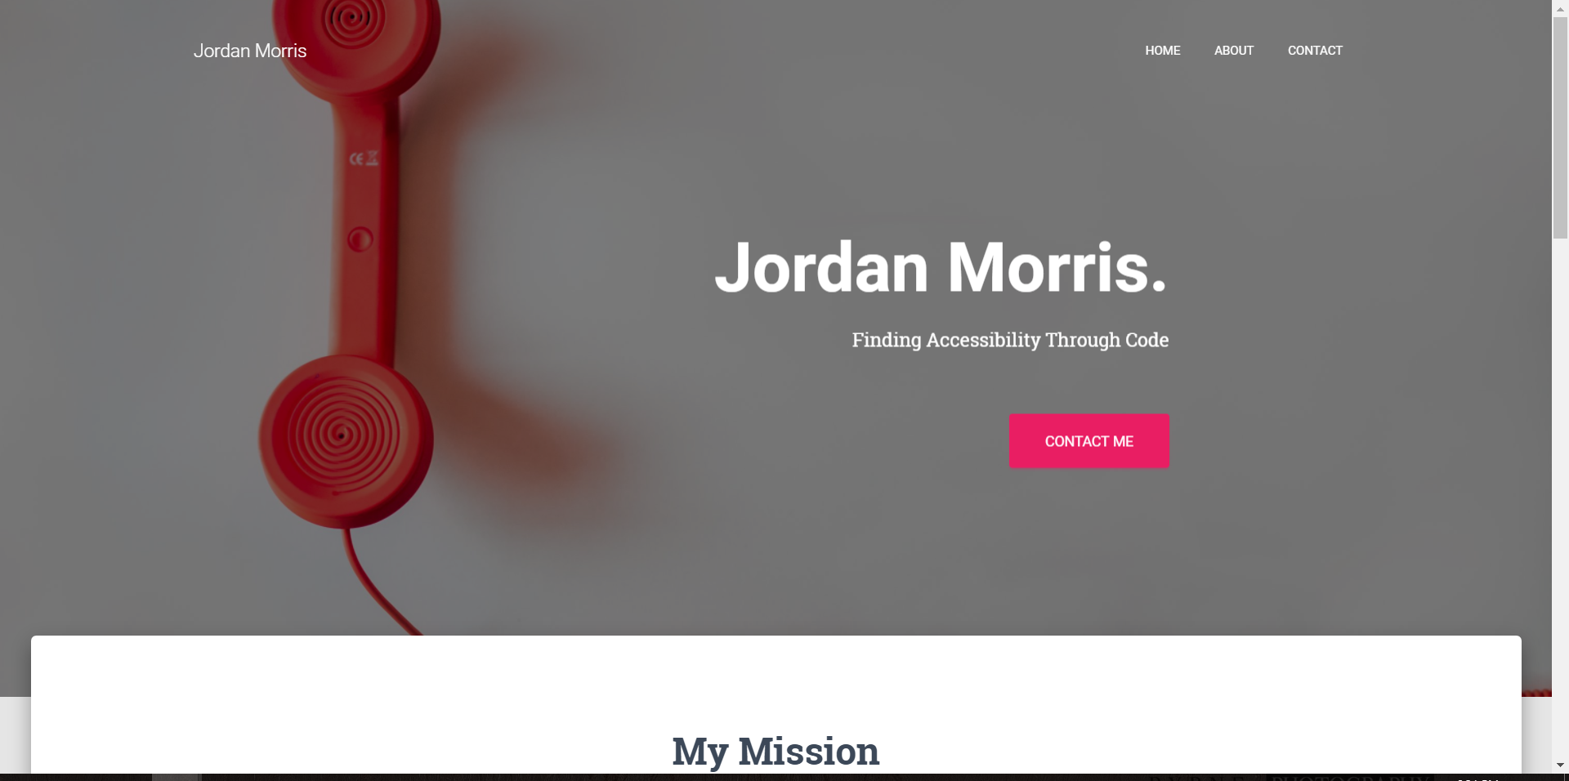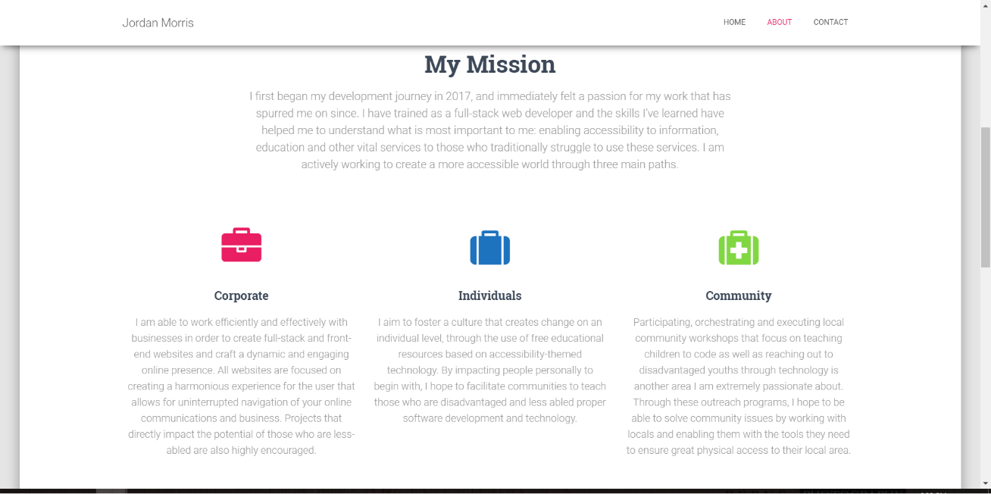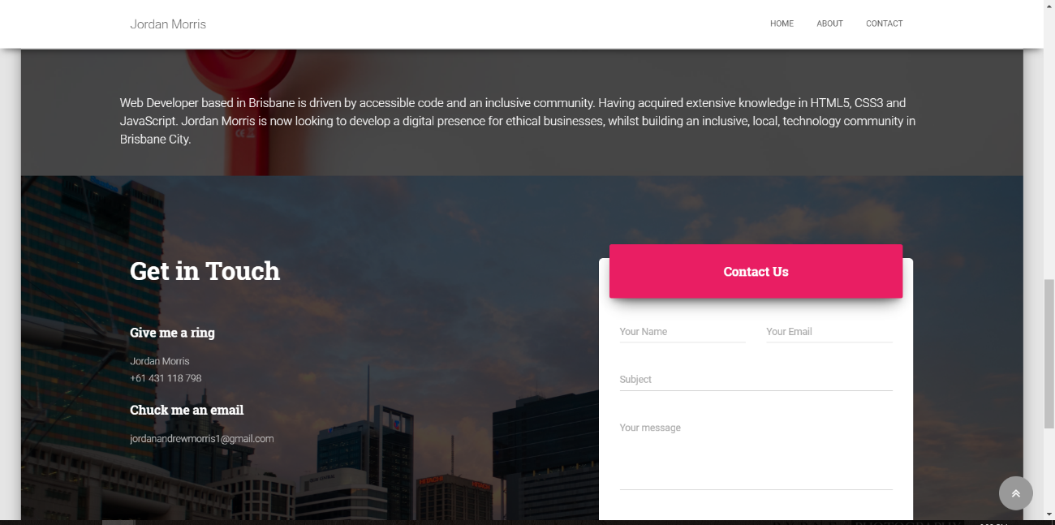

# Appendix B (Wireframe)

