Steps to install SonarLint in our eclipse

Help -> eclipse marketplace

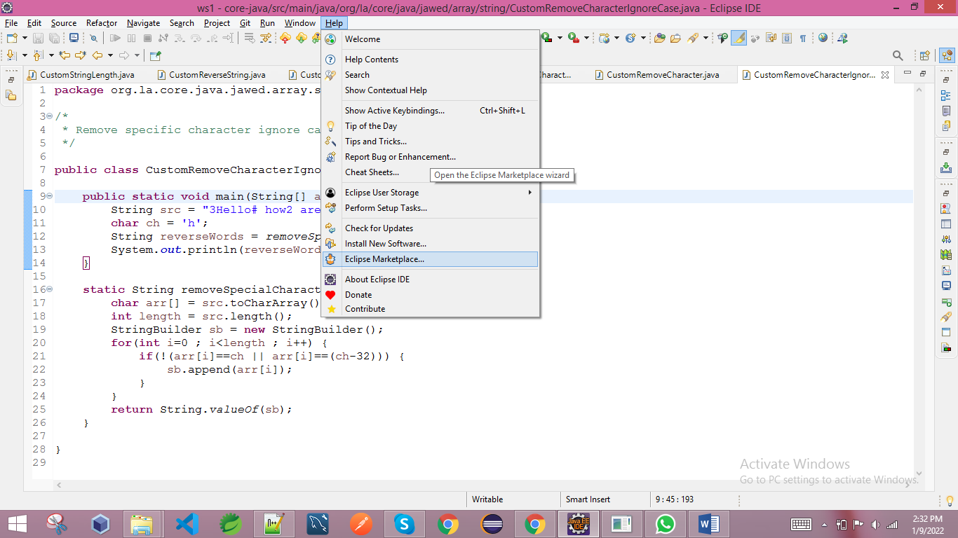

Search sonarlint

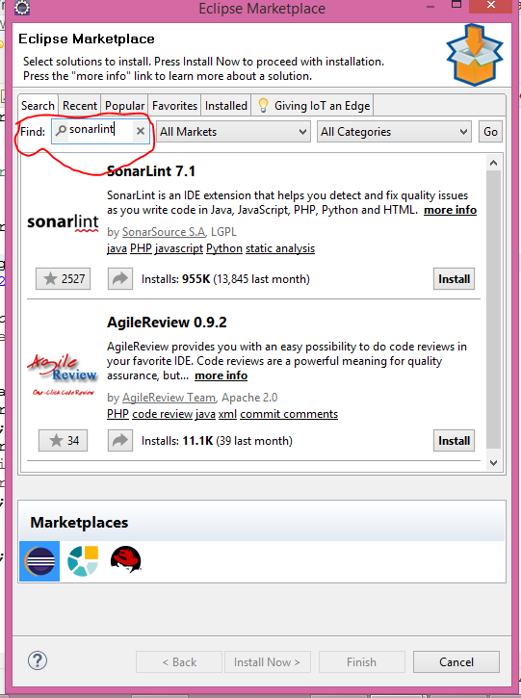

Then enter

We can see this result

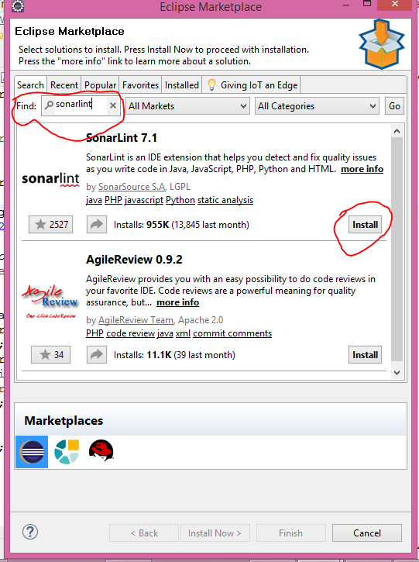

Click on install button

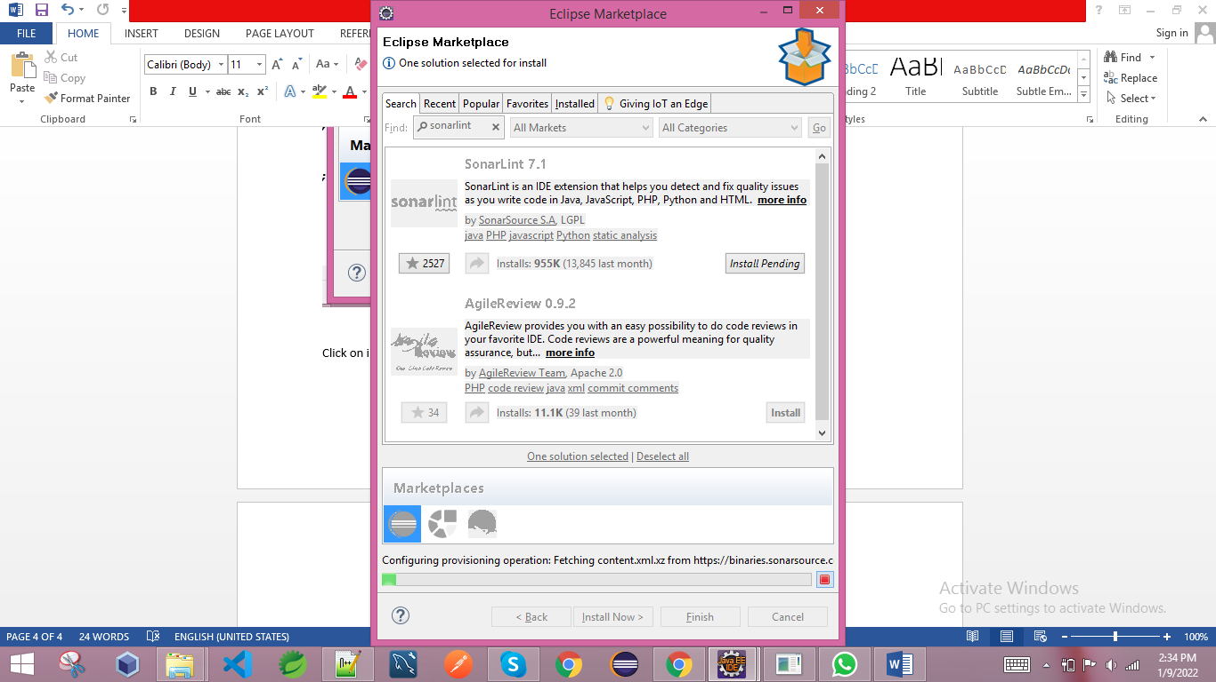

Wait for few minutes

Then accept the term

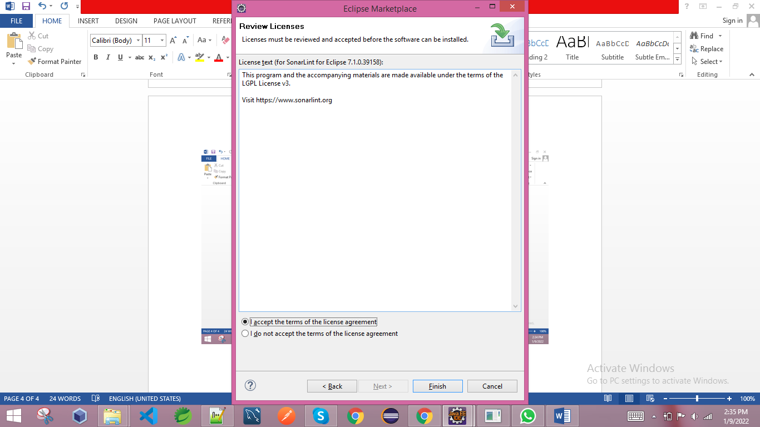

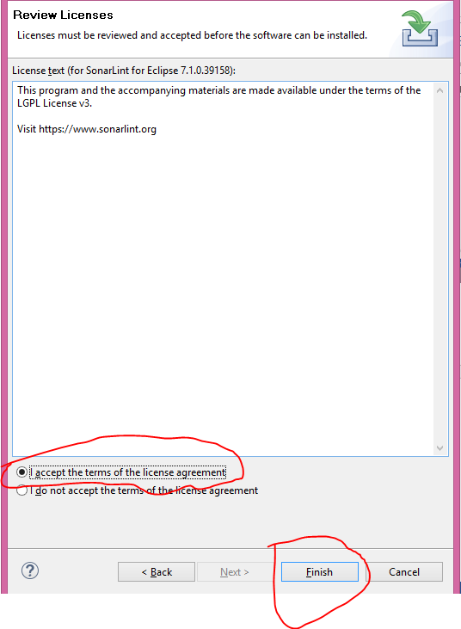

Then click finish button

It will take sometimes to install and download

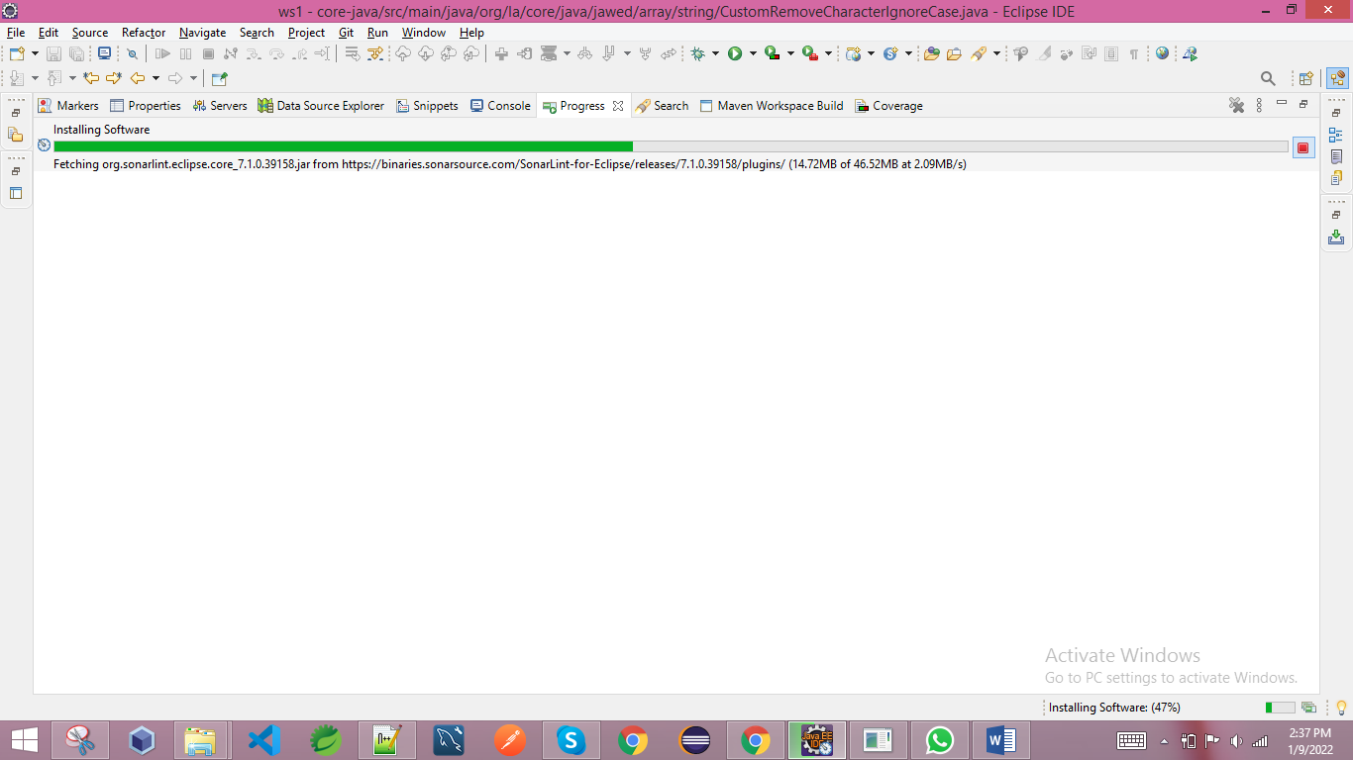

Then click Restart Now button

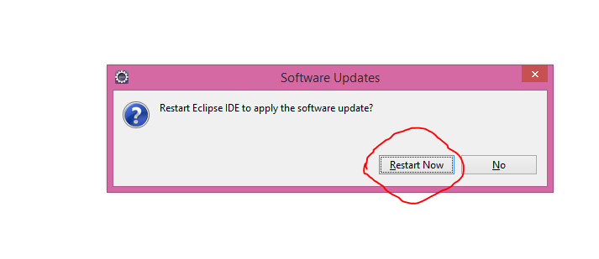

It will restart the eclipse

Once eclipse restarted then we have to right click our created class then we can see a new option SonarLint

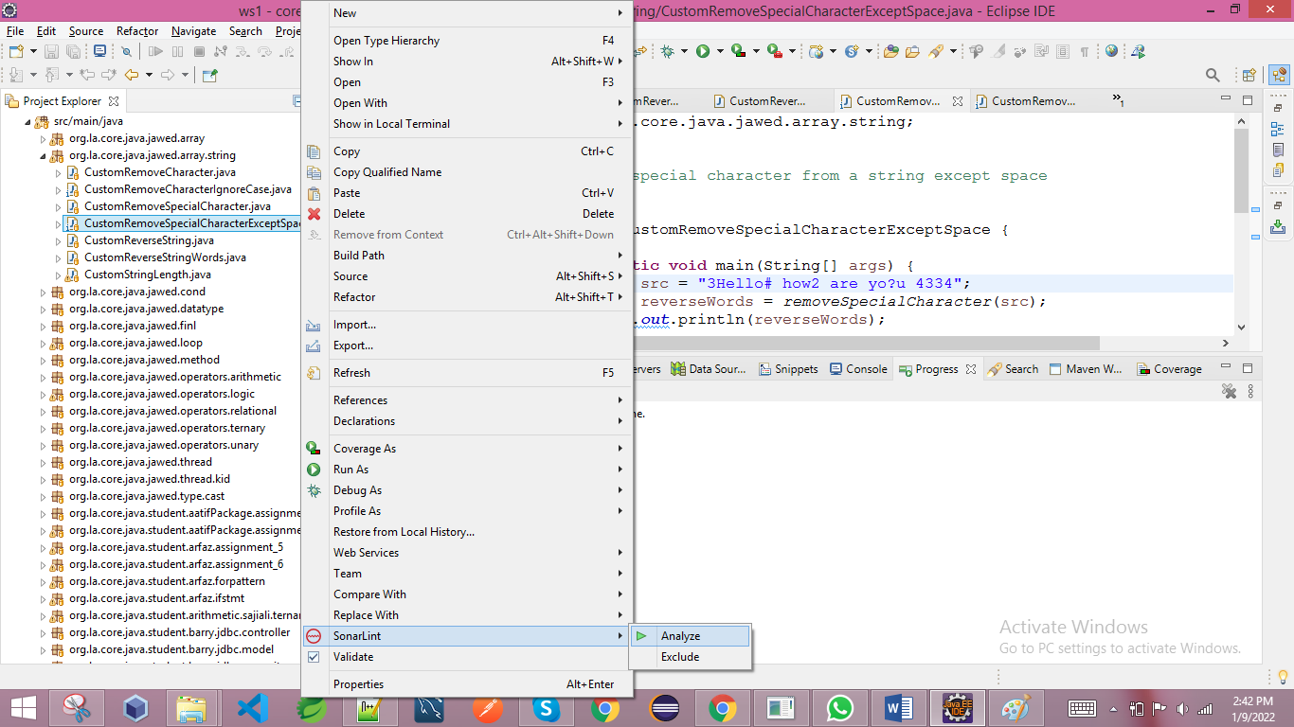

Then click on Analyze button

It will analyze our code and will give result that how many bugs code smell etc we have in our code.

Once I analyze my code using SonarLint option then it will show such kind of result

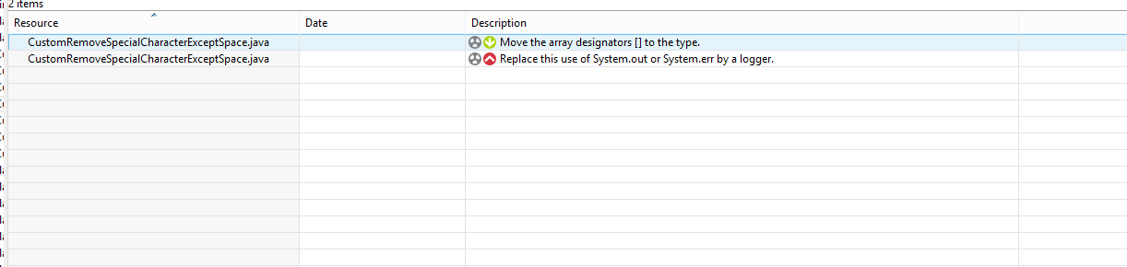

Bugs, code smell and other issue will depend on our way of writing code.