Support for password authentication was removed on August 13, 2021. Please use a personal access token instead.

Github changed login process

Instead of providing password at git commit push n pull we have to provide PAT (personal access token).

Process to generate PAT

1. Can follow this url

<https://docs.github.com/en/github/authenticating-to-github/connecting-to-github-with-ssh/generating-a-new-ssh-key-and-adding-it-to-the-ssh-agent>

first execute this command

ssh-keygen -t ed25519 -C "*your_email@example.com*"

[*your_email@example.com*](mailto:your_email@example.com)*: please provide here ur github registered email*

*for me*

ssh-keygen -t ed25519 -C "*jawednazeer87@mail.com*"

then it will ask question like provide passphrase etc

just enter don’t give any value

above command will generate private and public key

Location of key files : /c/Users/you/.ssh/id_ed25519

Users is a folder in C drive

In may case

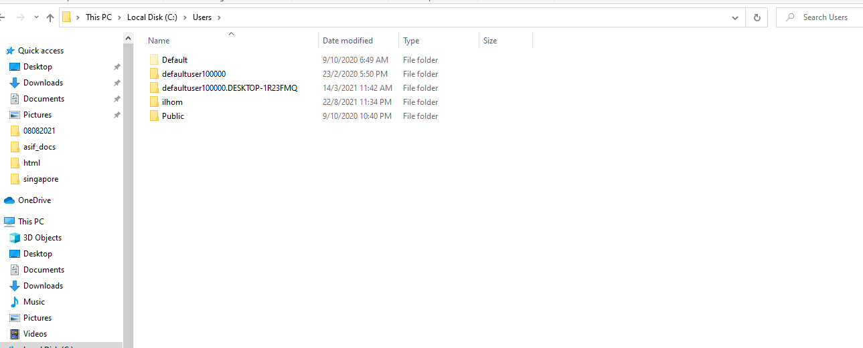

Ilhom is my username folder of my laptop

For you please check what is your username

Sometime our folder is in hidden format

If you cannot see .ssh inside your user_name folder then plz make hidden folder visible

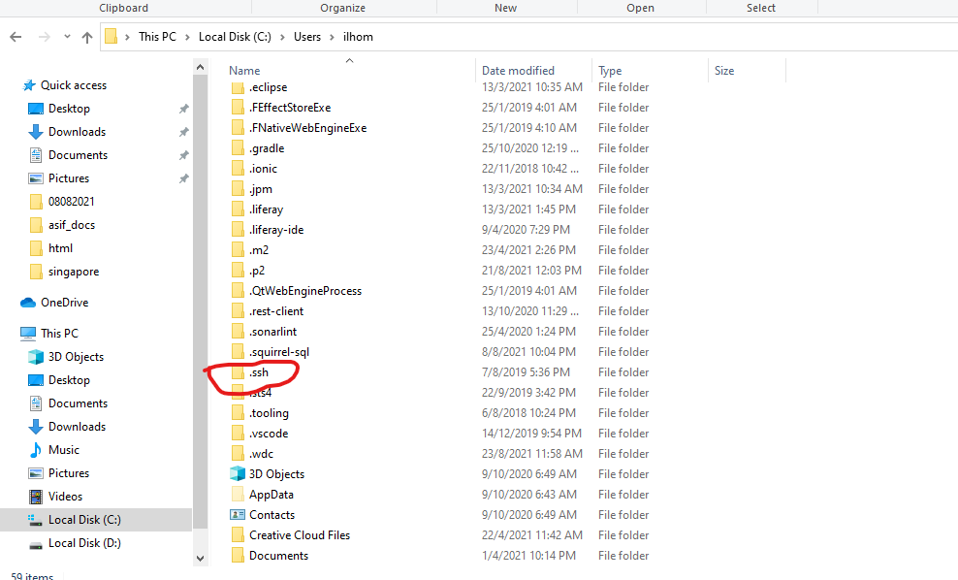

In image u can see that I am inside ilhom folder which is inside Users folder then I have one .ssh folder.

In below image we can see three files

id_ed25519 is our private key

id_ed25519.pub is public key

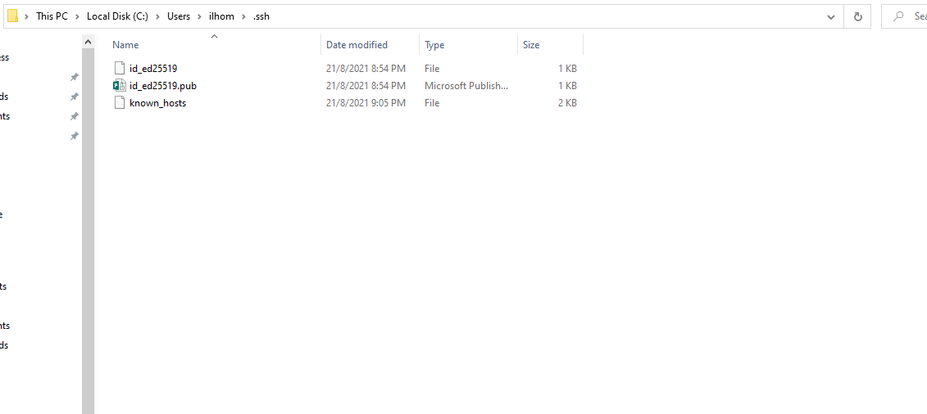

After generation of ssh keys we have to sure that our ssh agent is running

Plz execute this command

eval "$(ssh-agent -s)"

above command will produce this: Agent pid 59566

here pid value may be different

now we have to add our ssh key to our ssh agent

please use this command

ssh-add ~/.ssh/id_ed25519

now our computer ssh key generation and adding to ssh agent done

Next step is to add this ssh key to our github account

Please open github in browser and login

Please go through this url

<https://docs.github.com/en/github/authenticating-to-github/connecting-to-github-with-ssh/adding-a-new-ssh-key-to-your-github-account>

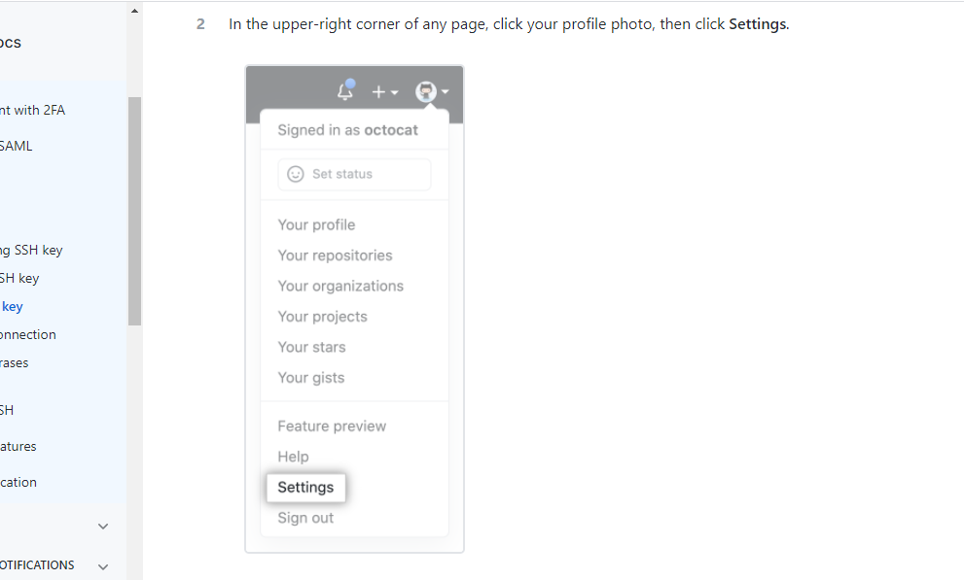

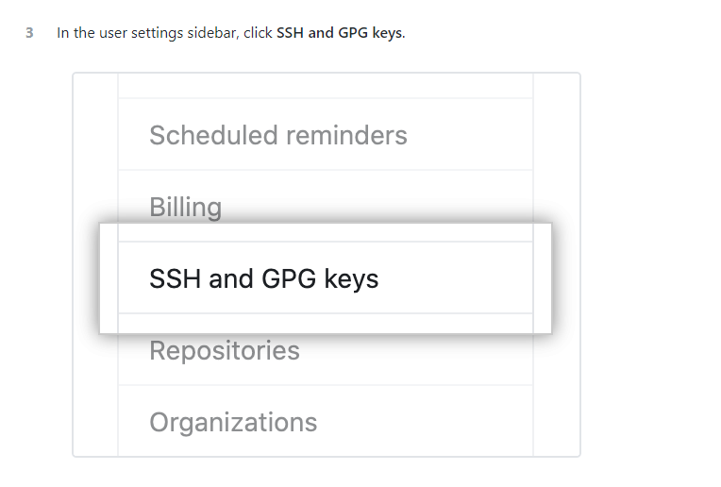

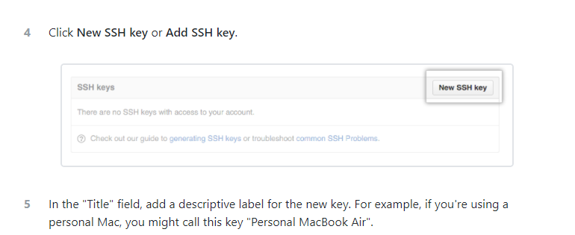

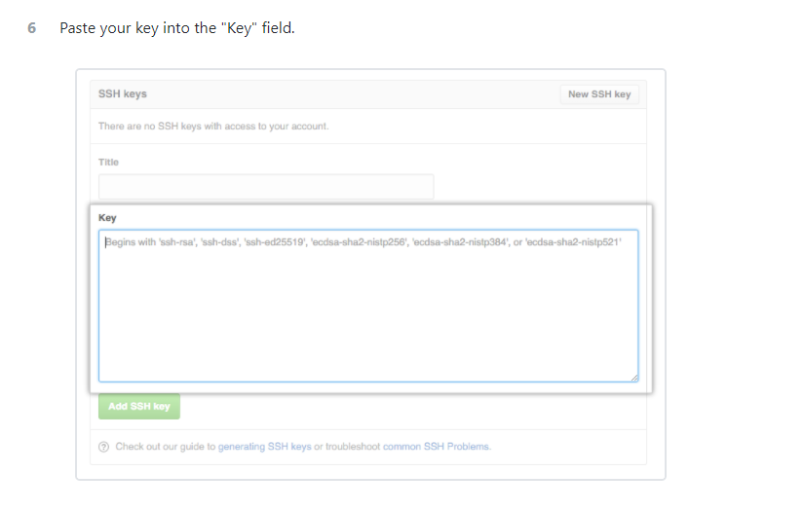

In above image we have to add our public key value

Go to ur C:\Users\ilhom\.ssh folder

For your case only ilhom will change

Right click on id_ed25519.pub file

Edit with notepad++

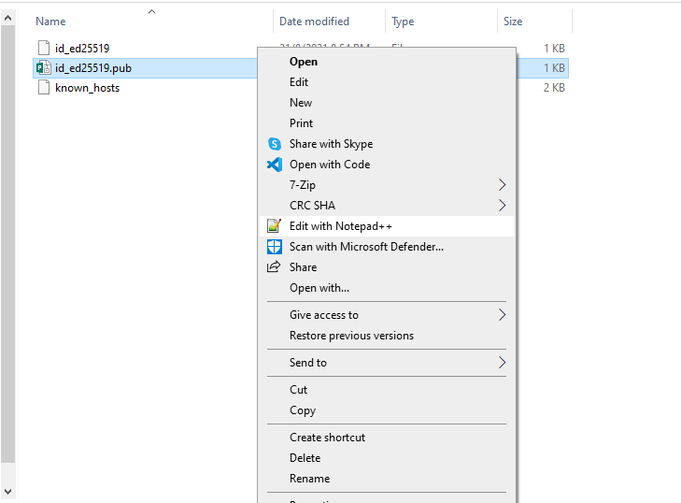

Then copy paste the content of this file to



Here

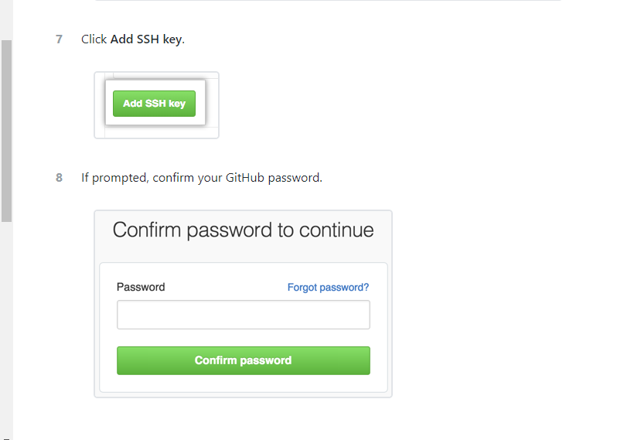

For testing that our ssh working fine

ssh -T git@github.com

Below message will appear (all commands have to be executed inside gitbash)

The authenticity of host 'github.com (20.205.243.166)' can't be established.

RSA key fingerprint is SHA256:nThbg6kXUpJWGl7E1IGOCspRomTxdCARLviKw6E5SY8.

Are you sure you want to continue connecting (yes/no)?

Please provide yes in the answer

Hi jawednazeer87! You've successfully authenticated, but GitHub does not provide shell access.

Then it will display this result

Note: it will display your registered email id.

execute this command

now we have to create a personal access token PAT

plz go through this url

<https://docs.github.com/en/github/authenticating-to-github/keeping-your-account-and-data-secure/creating-a-personal-access-token>

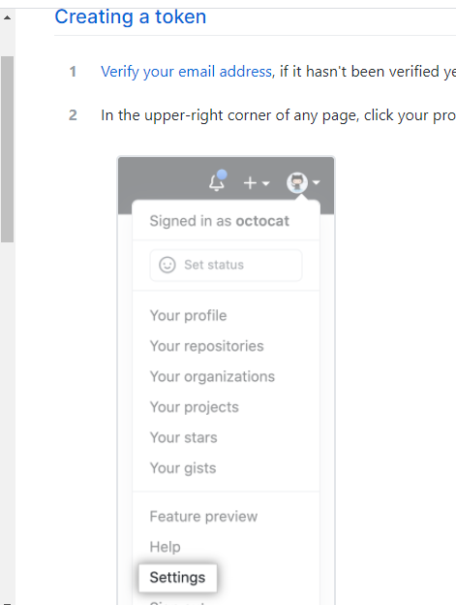

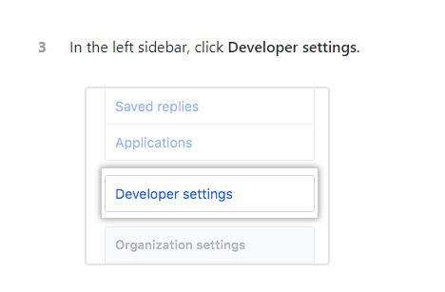

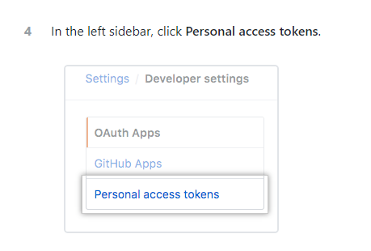

Note field have to be given some value, cannot leave empty

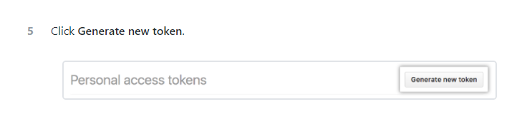

Select all check boxes

Then click Generate token button

Your personal access token you have to copy and keep in safe place. This is only time you can see pat so we have to keep it safe, after this we cannot see our token again.

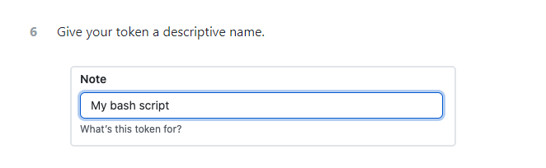

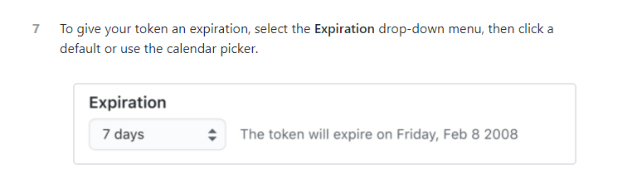

Please select option never expire token

Select all checkboxes

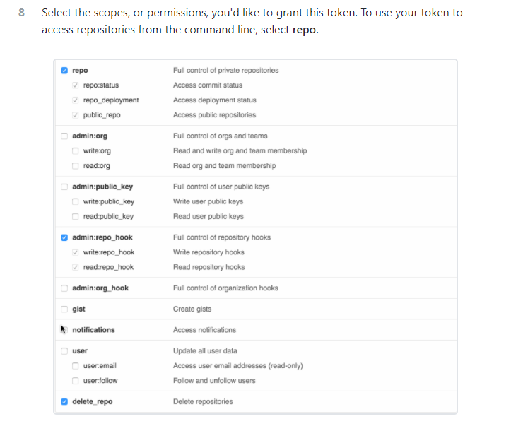

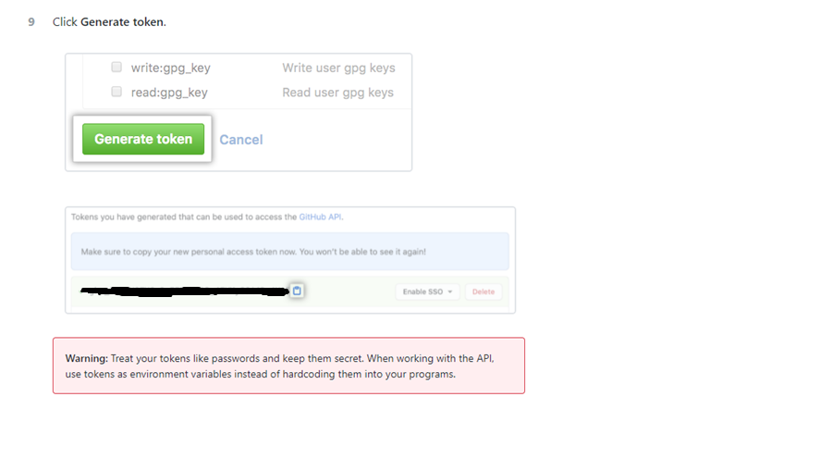

Your personal access token you have to copy and keep in safe place. This is only time you can see pat so we have to keep it safe, after this we cannot see our token again.

Now clone newly and provide this pat as your password

Means instead of password we have to use personal access token as password.