REGISTER SCREEN
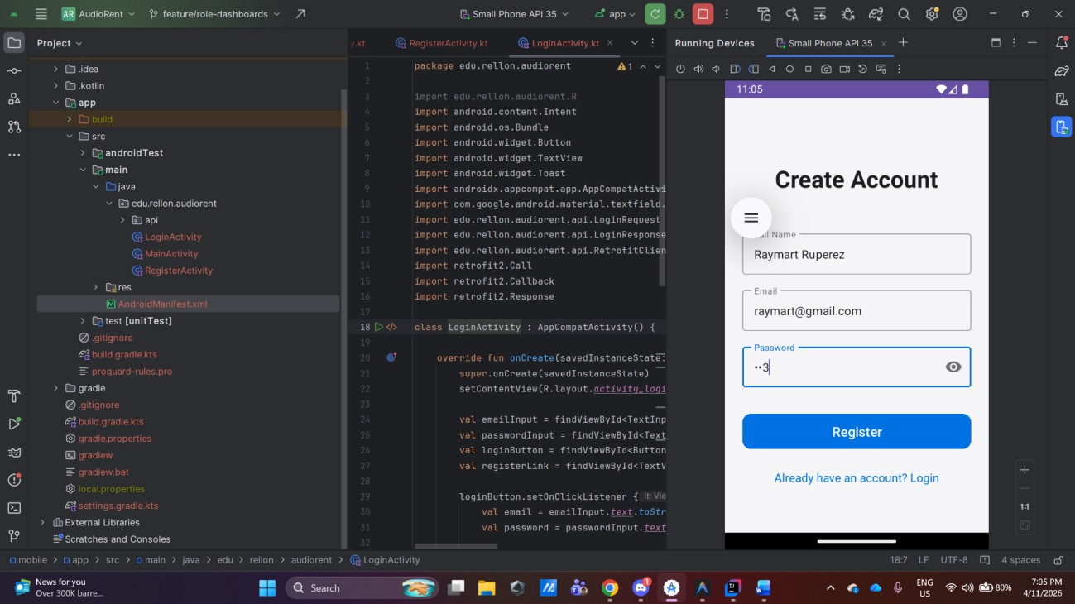
SUCCESSFUL REGISTER / LOGIN SCREEN
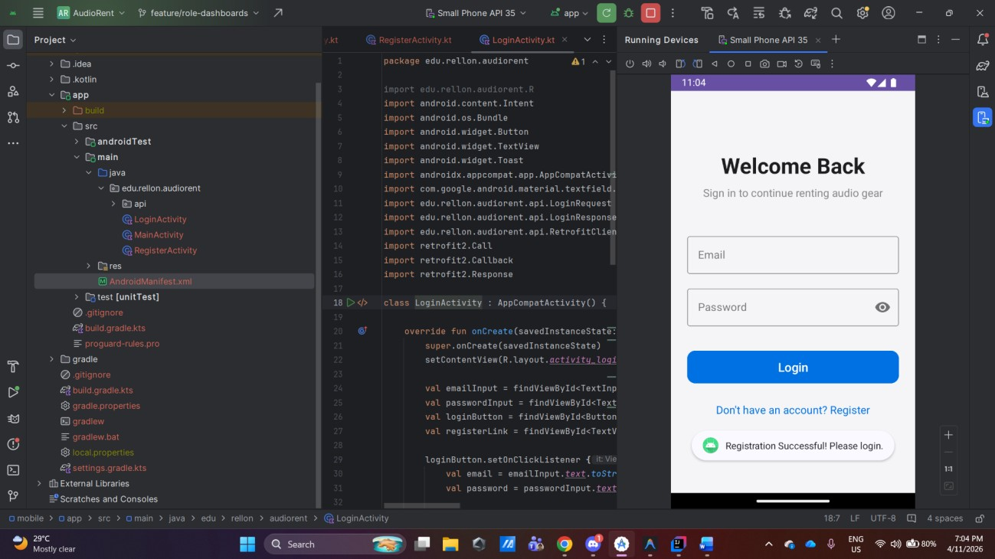

SUCCESSFULL LOGIN / AFTER LOGIN SCREEN
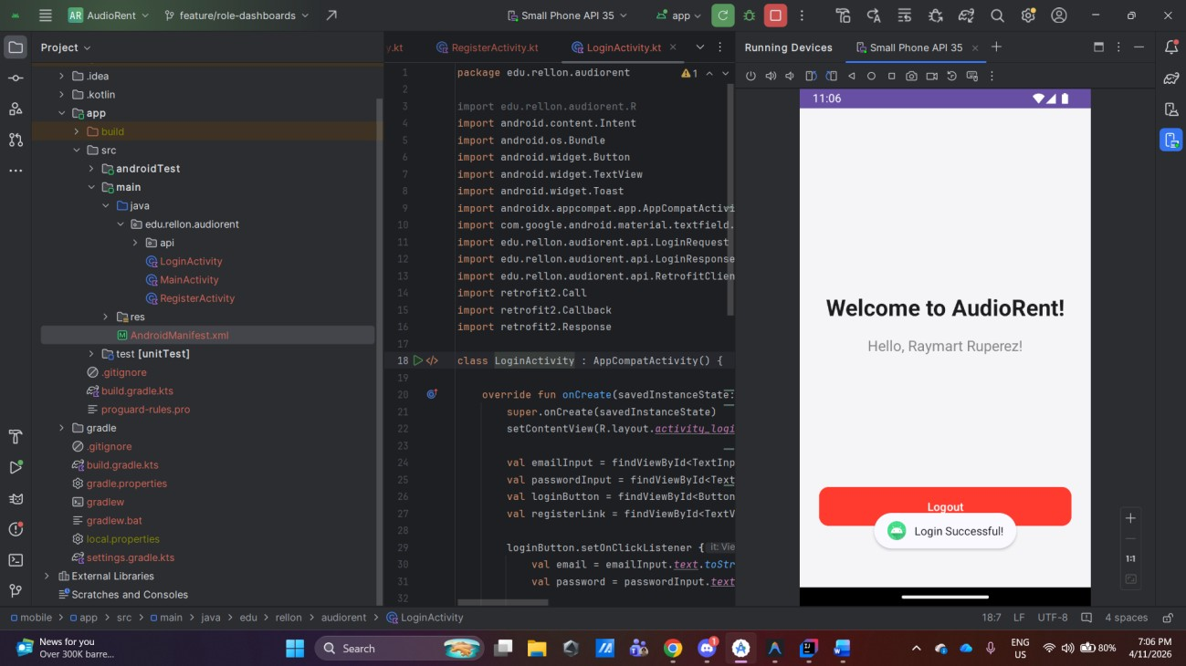
DATABASE RECORD
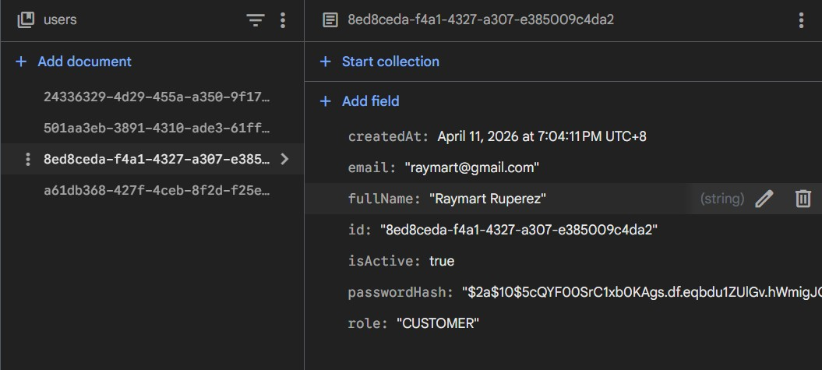

SUMMARY
- How Registration Works
The registration process begins in the RegisterActivity, where the user provides their Full Name, Email, and Password.
  - Validation: The application first ensures all fields are filled.
  - Data Transfer: Upon clicking "Register," the application creates a RegisterRequest data object. This is sent as a POST request to the backend’s /auth/register endpoint.
  - Backend Processing: The Spring Boot backend receives the request, hashes the password for security, and stores the new user account in the database.
  - Response Handling: If the registration is successful, the app displays a success message and finishes the activity, returning the user to the Login screen.
- How Login Works
The login flow is handled by LoginActivity and serves as the entry point for the application.
  - Authentication: The user enters their email and password. These are bundled into a LoginRequest and sent to the /auth/login API.
  - Security Logic: The backend verifies the credentials. If valid, it generates an internal JWT (JSON Web Token) and returns it along with the user's name and role.
  - User Progression: On success, the application extracts the user’s name from the response and transitions to the MainActivity (Home screen) using an Intent, passing the name to personalize the welcome message.
  - Error Handling: If the credentials are incorrect, the app catches the 401 Unauthorized status and displays an "Invalid credentials" toast to the user.
- API Integration Used
The mobile application uses a modern networking stack to communicate with the Spring Boot backend:
    - Retrofit 2: Used as the primary Type-Safe HTTP client. It simplifies defined endpoints into simple Kotlin interfaces (ApiService.kt).
    - Gson Converter: Automatically handles the conversion between Kotlin Data Classes and JSON strings, ensuring seamless data exchange between the Android app and the Java backend.
    - OkHttp: Acts as the underlying communication engine, handling network timeouts and connection management.
    - Networking Configuration:
    - Base URL: Configured to http://10.0.2.2:8080/ to allow the Android Emulator to access the host machine's local server.
    - Security: Enabled usesCleartextTraffic in the Android Manifest to allow local development communication without requiring HTTPS during this phase.

