Benchmarking Keyword Spotting Architectures across TensorFlow Lite and ONNX Runtime on a Raspberry Pi 5
Abstract
Keyword spotting is a canonical always-on edge workload: a small neural network continuously scans an audio stream for trigger phrases. TensorFlow Lite is the default deployment target, yet the tacit assumption that it is the fastest runtime on Arm Cortex-A processors is rarely tested. We benchmark four keyword-spotting architectures—a depthwise-separable CNN (the MLPerf Tiny reference, 22.6k parameters), a dense network (88.4k), an LSTM (20.0k), and a CNN–GRU hybrid (56.8k)—each in three runtimes on a Raspberry Pi 5: TensorFlow Lite with float32 weights, TensorFlow Lite with int8-quantized weights, and ONNX Runtime with float32 weights. All models share the same 49×10 MFCC front end and protocol (1,000 warmup and 1,000 measured passes, IQR outlier removal, bootstrap confidence intervals). On the Speech Commands v2 test set (10 commands, 4,074 clips) the architectures reach 79.6–92.6% top-1 accuracy, and every float32 model produces numerically identical predictions in both runtimes. The comparison reverses the single-model finding that motivated this study: ONNX Runtime beats float32 TensorFlow Lite only for the DS-CNN (19.2%—the convolution-heavy architecture where graph fusion pays off), while for the dense network, the LSTM, and the CRNN, TensorFlow Lite is 1.40–2.09× faster. int8 quantization accelerates all four models (up to 3.8× for the dense network) at negligible accuracy cost except the LSTM (−3.05 points). ONNX Runtime’s advantage therefore does not generalize across architectures: it is specific to the operator-dispatch-bound DS-CNN, and runtime choice deserves the same architecture-aware scrutiny as model compression.
keyword spotting, edge inference, TensorFlow Lite, ONNX Runtime, Raspberry Pi, benchmark, recurrent neural networks

Introduction
Keyword spotting (KWS) is the front end of most voice interfaces: a lightweight model runs continuously on the device, listening for a small set of trigger words, and only wakes the larger speech pipeline when a match is detected (Zhang et al. 2017). Because the workload is always on, both latency and energy budget matter, and the model must run on the same constrained hardware that hosts the rest of the system. This makes KWS the canonical case study for edge machine learning, and it is one of the four benchmarks in the MLPerf Tiny suite (Banbury et al. 2021). It is also a building block of assistive and ambient technologies that support healthy aging and inclusive access to digital services—voice-controlled interfaces for elderly users with limited dexterity, or for hands-free assistance in care settings—connecting edge inference directly to health and well-being outcomes aligned with SDG 3 (Good Health and Well-Being).
Deploying a KWS model on an edge device requires two decisions: the model representation and the inference runtime. The runtime question is usually settled by habit. TensorFlow Lite, and its microcontroller variant TensorFlow Lite Micro (David et al. 2021), dominate the tinyML literature, and it is common to read that it is the fastest option on embedded targets. ONNX Runtime (Microsoft 2020) is the principal alternative for larger edge devices such as single-board computers (SBCs), where a full Linux userspace is available. Direct, controlled comparisons of the two runtimes on identical models and hardware are comparatively rare, and the assumption that the default is also the fastest is rarely tested.
This paper provides such a test, extended across architectures. We train three keyword-spotting models—a dense network, an LSTM, and a CNN–GRU hybrid—and combine them with the MLPerf Tiny reference DS-CNN, all consuming an identical MFCC front end and emitting the same 12-way classification head. Each of the four architectures is benchmarked in three configurations on a Raspberry Pi 5 (Raspberry Pi Ltd. 2023): float32 TensorFlow Lite, int8-quantized TensorFlow Lite, and float32 ONNX Runtime. Our contributions are threefold. First, we document a full training and export pipeline for small KWS models—including a reconstruction procedure for the mixed-precision MLPerf reference artifact and a workaround for the Keras 3 / TensorFlow Lite RNN conversion path—so that all four models are genuinely comparable. Second, we report accuracy and latency under a rigorous, reproducible protocol. Third, we show that the runtime gap does not generalize: ONNX Runtime is faster only for the convolution-heavy DS-CNN (19.2%), while TensorFlow Lite is 1.40–2.09× faster for the dense, LSTM, and CRNN models, and int8 quantization accelerates every model but costs the LSTM the most accuracy. A single-model study of the MLPerf reference would have concluded in favor of ONNX Runtime; the multi-architecture comparison shows that conclusion is an artifact of one architecture.
The remainder of the paper is organized as follows. Section II reviews related work. Section III describes the models, the preprocessing front end, the training and export pipeline, and the benchmark protocol. Section IV presents accuracy and latency results and discusses their implications. Section V concludes.

Related Work

Keyword spotting.
The dominant architectures for KWS on constrained devices are small convolutional networks. The depthwise-separable CNN (DS-CNN) proposed by Zhang et al. (Zhang et al. 2017) trades a small accuracy loss for a large reduction in parameters and multiply-accumulate operations compared with dense or LSTM baselines, making it the standard choice for microcontroller deployment. Recurrent models—plain LSTMs and CNN–RNN hybrids—remain competitive for always-on audio because the sequential structure of a speech frame is naturally captured by recurrence, at the cost of a less parallelizable inference graph. Recent deployment studies continue to explore this trade-off on constrained hardware: Bushur and Chen (Bushur and Chen 2023) implement and train several KWS architectures for edge devices, Cioflan et al. (Cioflan et al. 2024) show that on-device adaptation recovers up to 14 accuracy points under noise, and Wei and Nugroho (Wei and Nugroho 2025) design a DNN-based operator for edge keyword spotting. The Speech Commands dataset (Warden 2018) provides the evaluation standard: one-second clips of spoken words at 16 kHz, split into training, validation, and test sets with disjoint speakers.

Edge inference runtimes.
TensorFlow Lite and its Micro variant (David et al. 2021) are the reference deployment path for models trained in TensorFlow (Abadi et al. 2016); the interpreter executes flatbuffer-compiled graphs with per-operator kernels and optional quantization. ONNX Runtime (Microsoft 2020) is a cross-platform inference engine that consumes ONNX graphs, applies graph-level optimizations such as operator fusion and constant folding, and dispatches to optimized kernels per backend. Both runtimes are actively maintained for Arm Linux; the TensorFlow Lite interpreter is now distributed as part of LiteRT, the successor of the “tflite-runtime” package (Google AI Edge 2024). On the quantization side, post-training int8 quantization is the dominant low-effort lever for edge inference; Nagel et al. (Nagel et al. 2021) survey the methods and their accuracy trade-offs in detail.

Benchmarks.
The MLPerf Tiny suite (Banbury et al. 2021) defines four representative edge workloads—keyword spotting, visual wake words, image classification, and anomaly detection—with reference models, datasets, and quality targets, specifically to enable fair cross-platform comparison. Its keyword-spotting benchmark uses the DS-CNN architecture on Speech Commands v2 and reports roughly 92% top-1 accuracy on the full 12-class task. The broader TinyML landscape has been surveyed extensively in recent years (Rajapakse et al. 2023; Capogrosso et al. 2023; Kallimani et al. 2023), but existing deployment studies tend to evaluate a single runtime on a single model; a controlled same-hardware comparison between TensorFlow Lite and ONNX Runtime across multiple model families, which is the focus of this work, has received less attention.

Methodology

Hardware and Software
All experiments ran on a Raspberry Pi 5 (Broadcom BCM2712, quad-core Arm Cortex-A76 at 2.4 GHz, 8 GB LPDDR4X) (Raspberry Pi Ltd. 2023) running a 64-bit Debian GNU/Linux distribution (kernel 6.18). The Python 3.13 environment used onnxruntime 1.28 for ONNX Runtime and LiteRT (ai-edge-litert) 2.1.6 for TensorFlow Lite, both in their default CPU configurations. The CPU governor was pinned to performance for the entire benchmark to remove frequency scaling from the comparison. The feature extraction front end was a NumPy implementation of the MLPerf Tiny preprocessing pipeline (Section III-B), which was validated against TensorFlow’s reference front end before any measurement.

Models and Preprocessing
All four models consume a 49 × 10 × 1 mel-frequency cepstral coefficient (MFCC) frame and emit a 12-way softmax over ten commands (“down,” “go,” “left,” “no,” “off,” “on,” “right,” “stop,” “up,” “yes”), silence, and unknown. Table 1 summarizes their structure and parameter counts.

The DS-CNN is the official MLPerf Tiny reference model, kws_ref_model_float32.tflite from the MLPerf Tiny repository (MLCommons 2021). Its structure is one 10×4 convolution with stride 2, four blocks of 3×3 depthwise plus 1×1 pointwise convolutions, a global average pooling, and a dense head. The DNN, LSTM, and CRNN models were trained from scratch for this study on the full Speech Commands v2 training split (87,843 clips, including the silence and unknown classes) using the Keras API (TensorFlow 2.16), with Adam (10⁻³), batch size 256, early stopping on validation accuracy, and class weights to counter the imbalance introduced by the large unknown class. The RNN layers are exported with unroll=True—Keras 3 emits dynamic tensor-list loops that the TensorFlow Lite converter cannot lower, and unrolling produces an identical-weight static graph that both runtimes accept. Accuracy on the held-out validation split was 71.3% (DNN), 87.9% (LSTM), and 90.7% (CRNN); the lower DNN figure is expected for a dense-only model and is not a defect of the pipeline.
The front end follows the reference implementation exactly: 16 kHz single-channel audio normalized per clip by its maximum absolute value; Hann windows of 30 ms with 20 ms stride; a 512-point FFT; 40 mel bins spanning 20–4,000 Hz on the Slaney scale with triangular filters of unit peak, the DC bin excluded and zero-padded; a log transform with a 10⁻⁶ floor; and a type-II DCT scaled by √(1/(2N)) with N=40, retaining the first ten coefficients to yield the 49×10 input. We validated this front end against TensorFlow’s tf.signal implementation on twelve randomly selected clips (seed 42); the maximum absolute difference was 5.2×10⁻⁵, confirming that preprocessing is not a source of measurement variance.

Reconstruction of the True Float32 DS-CNN
The artifact distributed as the “float32” reference is not fully float32: in the flatbuffer, all regular convolution kernels are stored as int8 with per-tensor quantization (scale 2.0×10⁻³, zero point 0), while the depthwise kernels, dense layer, and biases remain float32. This mixed precision is transparent to the interpreter, which dequantizes kernels on load, but it breaks any assumption that the artifact is a pure float32 model and it complicates direct conversion to other formats such as ONNX.
We therefore reconstructed a true float32 model in three steps. First, we enumerated every tensor of the flatbuffer through the LiteRT interpreter API and dequantized the int8 kernels with ŵ = (q − z)·s. Second, we assembled the architecture in Keras as nine fused convolution–bias–ReLU blocks (the batch-normalization layers of the original training graph are already folded into the kernels and biases), followed by global average pooling and a linear dense layer. Third, we verified the rebuild by feeding identical inputs to the original artifact and the rebuilt model: the maximum absolute output difference was 7×10⁻³ on softmax probabilities, with 100% agreement in the argmax across 1,000 random frames—the residual difference being the int8 arithmetic path inside the original artifact. From this verified Keras model we exported a float32 TensorFlow Lite model and, via the ONNX exporter, a float32 ONNX model of identical structure. All three artifacts—original mixed precision, rebuilt float32 TensorFlow Lite, and rebuilt float32 ONNX—participate in the benchmark.

Benchmark Protocol
Evaluation used the official test split of Speech Commands v2, restricted to the ten command classes (4,074 clips). Accuracy was measured as top-1 agreement with the ground-truth label, using the argmax of the 12-way output restricted to the ten command positions.
Latency was measured with 1,000 warmup passes followed by 1,000 timed passes per configuration, executed sequentially (never interleaved) on a single CPU thread, with features precomputed so that measurement isolates inference. Outliers beyond 1.5×IQR were removed from each sample, and 95% confidence intervals were obtained by 10,000-resample bootstrap with seed 42. The Raspberry Pi’s temperature and process RSS were sampled before and after each configuration’s pass. Every figure reported in Section IV was reproduced across at least two independent runs, and we report the canonical run in the tables.

Results and Discussion

Accuracy
Table 2 and Figure 1 summarize top-1 accuracy over the 4,074-clip subset for all four models in both float32 runtimes plus the quantized TensorFlow Lite variants. Three observations stand out. First, the float32 runtimes are numerically interchangeable: for every model the maximum absolute output difference between TensorFlow Lite and ONNX Runtime is below 10⁻⁸, and the accuracies agree to the clip. Second, the architecture ordering is consistent with the literature—the recurrent and hybrid models (LSTM 90.48%, CRNN 92.56%) outperform the dense baseline (79.63%) and at least match the reference DS-CNN (90.55%) on this ten-command subset. Third, quantization costs accuracy unevenly: the dense model is essentially unaffected (79.63% → 79.65%), the CRNN loses 0.39 points (92.56% → 92.17%), and the LSTM loses the most, 3.05 points (90.48% → 87.43%), consistent with recurrent units being the hardest to quantize.
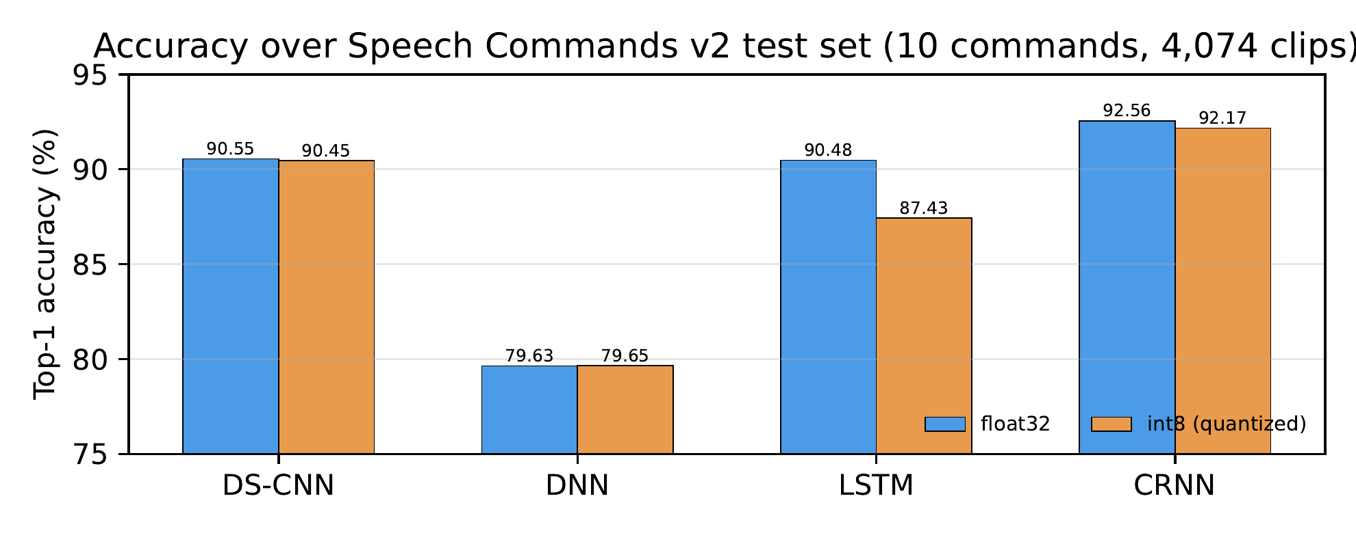
Top-1 accuracy by model, float32 versus int8-quantized TensorFlow Lite. The LSTM is the only architecture for which quantization costs more than half a point.

Latency
Table 3 and Figure 2 report inference latency for the full model × runtime grid. The comparison reverses the single-model expectation: ONNX Runtime is faster than float32 TensorFlow Lite only for the DS-CNN (0.170 ms versus 0.211 ms, a 19.2% reduction), while TensorFlow Lite is faster for every other architecture—1.81× for the dense network, 2.09× for the LSTM, and 1.40× for the CRNN. The recurrent models are the slowest in absolute terms regardless of runtime: their sequential dependence dominates. int8 quantization accelerates all four models, most dramatically for the dense network (0.0158 ms → 0.0067 ms) and the CRNN (0.2586 ms → 0.1016 ms), and brings the LSTM to 0.1569 ms—the only configuration in which the recurrent model becomes competitive with the convolutional ones.
Inference latency on the Raspberry Pi 5 under the performance governor (protocol details in Section III-D). All times in milliseconds; the last column is the ONNX Runtime / float32 TensorFlow Lite ratio (values below 1 favor ONNX Runtime, above 1 favor TensorFlow Lite).
Model | TFLite fp32 | TFLite int8 | ONNX fp32 | Ratio
DS-CNN | 0.2107 | 0.1702 | 0.1702 | 0.81
DNN | 0.0158 | 0.0067 | 0.0286 | 1.81
LSTM | 0.3722 | 0.1569 | 0.7782 | 2.09
CRNN | 0.2586 | 0.1016 | 0.3609 | 1.40
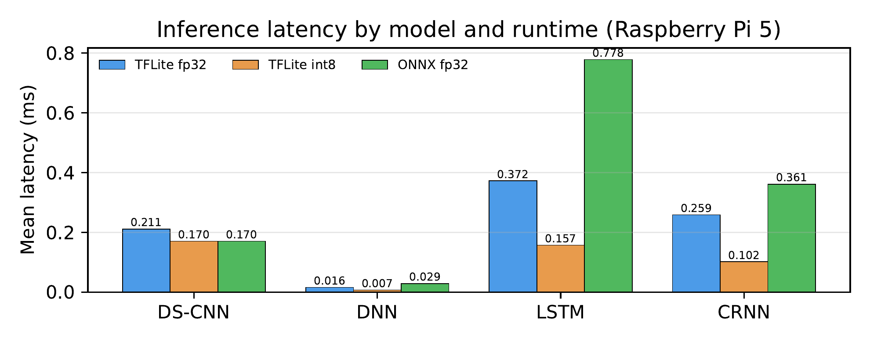
Mean inference latency by model and runtime. ONNX Runtime is faster than float32 TensorFlow Lite only for the DS-CNN; TensorFlow Lite wins for the dense, LSTM, and CRNN models.

Discussion
Figure 3 places the accuracy results in the model-size dimension: the CRNN achieves the highest accuracy (92.56%) with 56.8k parameters—roughly two and a half times the DS-CNN’s size—while the dense network spends the most parameters (88.4k) for the lowest accuracy (79.63%), and the LSTM reaches 90.48% with the fewest (20.0k). On this edge-relevant frontier, the recurrent and hybrid architectures dominate the dense baseline on both axes.
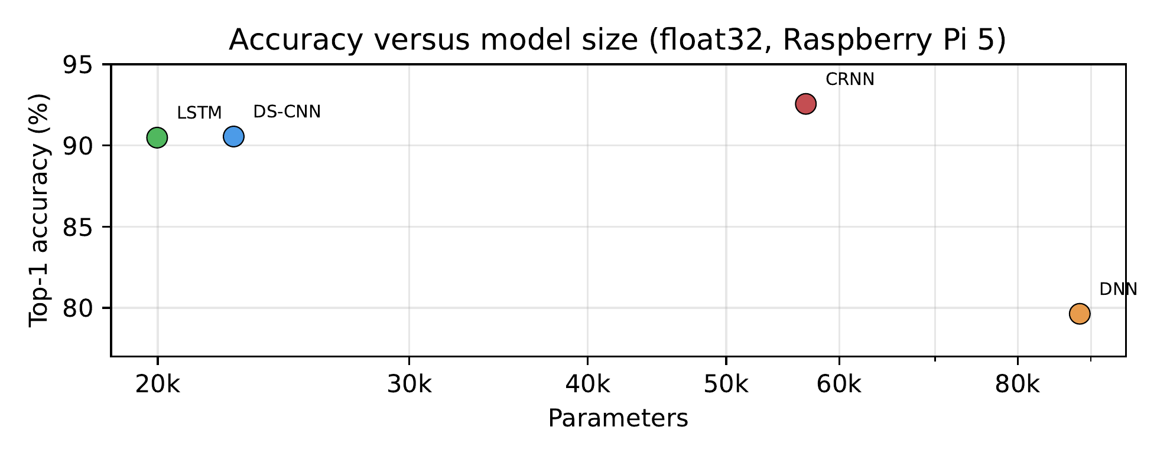
Top-1 accuracy versus parameter count (float32). The CRNN reaches the highest accuracy with 56.8k parameters, while the dense network spends the most parameters for the lowest accuracy.
The single-model finding of an earlier benchmark—ONNX Runtime beating float32 TensorFlow Lite by 19.2% on the MLPerf DS-CNN—does not generalize across model families; in fact it reverses. The DS-CNN is the one architecture that favors ONNX Runtime, and the explanation is structural. Its computation is spread over many small operators—a stride-2 convolution, four depthwise/pointwise blocks—so per-operator dispatch overhead dominates, and ONNX Runtime’s aggressive graph fusion directly attacks that bottleneck. The dense network, by contrast, compiles down to a handful of large matrix multiplications that both runtimes execute with comparable kernels; there the per-call overhead of ONNX Runtime’s session machinery dominates and TensorFlow Lite wins 1.81×. The recurrent models are dominated by their sequential data flow—an LSTM step cannot start until the previous one finishes—so neither runtime’s graph-level tricks help, and the difference between them (2.09× for the LSTM, 1.40× for the CRNN) reflects kernel quality rather than scheduling.
Quantization tells a complementary story. int8 TensorFlow Lite accelerates every model, and for the dense network and the CRNN the gains are dramatic (3.8× and 2.5× over their float32 TensorFlow Lite versions, respectively) with accuracy losses below half a point. The LSTM is the exception: quantization costs 3.05 accuracy points and still leaves it slower than the CRNN, consistent with recurrent units being the hardest to quantize. The practical implication is that runtime and quantization are substitutes with an architecture-dependent exchange rate: for the DS-CNN, switching to ONNX Runtime buys the same speedup as quantization at no accuracy cost; for the recurrent models, neither lever is free.
Several factors bound the generalizability of these results: a single board; single-threaded CPU execution without hardware delegates; and the ten-command subset rather than the full twelve-class task. Extension to other model families (transformer-based KWS), other runtimes (quantized ONNX, TFLite delegates), and other SBCs is left for future work. The training, export, and benchmark code is straightforward to rerun and is the basis for the reported numbers.

Conclusion
We benchmarked four keyword-spotting architectures—DS-CNN, DNN, LSTM, and CRNN—across TensorFlow Lite (float32 and int8) and ONNX Runtime (float32) on a Raspberry Pi 5, under a controlled protocol with verified preprocessing and a faithful float32 reconstruction of the mixed-precision reference artifact. At top-1 accuracies of 79.6–92.6% over 4,074 Speech Commands v2 test clips, the float32 runtimes were numerically interchangeable, but their speed differed by architecture: ONNX Runtime was faster only for the convolution-heavy DS-CNN (19.2%), while TensorFlow Lite was 1.40–2.09× faster for the dense, LSTM, and CRNN models, and int8 quantization accelerated all four models at an accuracy cost that ranged from negligible to 3.05 points for the LSTM. The choice of inference runtime is therefore an architecture-aware decision on Arm single-board computers: a benchmark against the default model alone is not a safe basis for generalizing about runtimes, and the fastest configuration for one model family may be the slowest for another.

References
Abadi, Martín, Paul Barham, Jianmin Chen, et al. 2016. “TensorFlow: A System for Large-Scale Machine Learning.” Proceedings of the 12th USENIX Symposium on Operating Systems Design and Implementation (OSDI), 265–83. https://www.usenix.org/conference/osdi16/technical-sessions/presentation/abadi.
Banbury, Colby, Vijay Janapa Reddi, Peter Torelli, et al. 2021. “MLPerf Tiny Benchmark.” Proceedings of the Neural Information Processing Systems Track on Datasets and Benchmarks. https://doi.org/10.48550/arXiv.2106.07597.
Bushur, Jacob, and Chao Chen. 2023. “Neural Network Exploration for Keyword Spotting on Edge Devices.” Future Internet 15 (6): 219. https://doi.org/10.3390/fi15060219.
Capogrosso, Luigi, Federico Cunico, Dong Seon Cheng, Franco Fummi, and Marco Cristani. 2023. “A Machine Learning-Oriented Survey on Tiny Machine Learning.” arXiv Preprint arXiv:2309.11932, ahead of print. https://doi.org/10.48550/arXiv.2309.11932.
Cioflan, Cristian, Lukas Cavigelli, Manuele Rusci, Miguel de Prado, and Luca Benini. 2024. “On-Device Domain Learning for Keyword Spotting on Low-Power Extreme Edge Embedded Systems.” arXiv Preprint arXiv:2403.10549, ahead of print. https://doi.org/10.48550/arXiv.2403.10549.
David, Robert, Jared Duke, Advait Jain, et al. 2021. “TensorFlow Lite Micro: Embedded Machine Learning for TinyML Systems.” Proceedings of Machine Learning and Systems (MLSys) 3: 800–811. https://proceedings.mlsys.org/paper_files/paper/2021/hash/6c44dc73014d66ba49b28d483a8f8b0d-Abstract.html.
Google AI Edge. 2024. LiteRT: Successor to TensorFlow Lite Runtime. Https://github.com/google-ai-edge/LiteRT.
Kallimani, Rakhee, Krishna Pai, Prasoon Raghuwanshi, Sridhar Iyer, and Onel L. A. López. 2023. “TinyML: Tools, Applications, Challenges, and Future Research Directions.” arXiv Preprint arXiv:2303.13569, ahead of print. https://doi.org/10.48550/arXiv.2303.13569.
Microsoft. 2020. ONNX Runtime: Cross-Platform, High Performance ML Inferencing and Training Accelerator. Https://github.com/microsoft/onnxruntime.
MLCommons. 2021. MLCommons Tiny Benchmark Repository. Https://github.com/mlcommons/tiny.
Nagel, Markus, Marios Fournarakis, Rana Ali Amjad, Yelysei Bondarenko, Mart van Baalen, and Tijmen Blankevoort. 2021. “A White Paper on Neural Network Quantization.” arXiv Preprint arXiv:2106.08295, ahead of print. https://doi.org/10.48550/arXiv.2106.08295.
Rajapakse, Visal, Ishan Karunanayake, and Nadeem Ahmed. 2023. “Intelligence at the Extreme Edge: A Survey on Reformable TinyML.” ACM Computing Surveys 55 (13s): 1–30. https://doi.org/10.1145/3583683.
Raspberry Pi Ltd. 2023. Raspberry Pi 5 Product Page. Https://www.raspberrypi.com/products/raspberry-pi-5/.
Warden, Pete. 2018. “Speech Commands: A Dataset for Limited-Vocabulary Speech Recognition.” arXiv Preprint arXiv:1804.03209, ahead of print. https://doi.org/10.48550/arXiv.1804.03209.
Wei, Chan Kok, and Hermawan Nugroho. 2025. “Design of a DNN-Based Operator on Edge Device for Keyword Spotting.” Advances in Computational Intelligence 5. https://doi.org/10.1007/s43674-025-00080-2.
Zhang, Yundong, Naveen Suda, Liangzhen Lai, and Vikas Chandra. 2017. “Hello Edge: Keyword Spotting on Microcontrollers.” arXiv Preprint arXiv:1711.07128, ahead of print. https://doi.org/10.48550/arXiv.1711.07128.

