Dataset Report – One Section per Paper
Jaweher Hichri · Master’s thesis · Supervisors: Dr. Samah Mansour, Dr. Mohamed Almukhtar · 25 October 2026

Purpose
Choose the dataset for the thesis (fixes of AI-generated code after submission). For each paper’s dataset we answer Mohamed’s questions: size, latest PR date, number of items per AI agent, and how the agent is involved. Each dataset has its own notebook (Paper_Datasets/<paper>/analysis.ipynb) that produces every number and chart in this report.

All datasets at a glance
Paper | 1 row = | Size | Dates | Agents | Fixes of AI code
Who Finishes 2026 | AI PR → later PR | 2,510 pairs | → Jun 2025 | 5 agents | 334
Xia & Miller 2026 | commit | 247,348 (29,100 AI) | May 2025 → May 2026 | not named | 7,822
Sawada 2026 | commit on a file | 4,338 | 2021 → Feb 2026 | 4 agents | 216
Watanabe 2025 | Claude Code PR | 797 | Feb → Apr 2025 | Claude Code | 214 PRs revised
Yu 2024 | file | 1,413 | 2023 → 2024 | 4 LLM tools | 113
Dovhoshliubnyi 2026 | PR / hunk | 428 / 1,254 | Jan → Jul 2025 | 5 agents | none
Wang 2025 | LLM error | 687 errors | HumanEval | 6 LLMs | error taxonomy
DECODE (Liang 2026) | before/after edit | 53,614 pairs | ≈ 2024–25 | 20 LLMs | edits before submit
Khemissi 2026 | commit → agent PR | 2,010 refs | Dec 2024 → Aug 2025 | 5 agents | 1,032 (keyword)
Alam 2026 | AI fix PR | 8,106 | Dec 2024 → Jul 2025 | 5 agents | AI fix attempts
AIDev v4 (base) | AI PR | 2.74M PRs | → Nov 2025 | 6 agents | needs linker.py

Steps in every notebook: 1) first look (files, first lines, all columns, size) · 2) data-science view (size, dates, per agent, involvement) · 3) charts (type of change, fixes per agent, who fixed, how fast) · 4) final figure · 5) fixes saved in one common format.

0. AIDev – the base dataset
Paper: Li et al. 2025 – AIDev (used by Who Finishes, Sawada, Dovhoshliubnyi, Rahman, Khemissi…)
Data: https://huggingface.co/datasets/hao-li/AIDev
What it is: Pull requests written by AI agents on GitHub, with repositories, users, commits, reviews, comments and the code changes (pr_commit_details.patch).
Item | Value
One row = | one AI pull request
Size (v4) | 2,743,854 PRs (all_pull_request); curated subset = repos with >100 stars
Dates | v4 up to Nov 2025 · v5 (in progress) up to March 2026, ≈ 7.6M PRs
Agents | Codex, Copilot, Devin, Cursor, Claude Code, Jules
Tables downloaded (v4) | all_pull_request, all_repository, all_user, pull_request, repository, user, pr_commits, pr_commit_details, pr_comments, pr_reviews
Missing in v4 | pr_task_type, human_pull_request, human_pr_task_type, pr_timeline, issue, related_issue (needed by linker.py)
Fixes of AI code | not in AIDev itself – linker.py builds the AI PR → fix PR pairs

Status: the notebook 00_AIDev runs on my PC with the files downloaded in evolution-assurance. Next: check v3 and v5 (fix labels, commit patches, Python PRs per agent).

1. Who Finishes the Job?
Paper: Takerngsaksiri et al. 2026 – Follow-Up Fixes and Commit Authorship on AI Coding Agent PRs
Data: https://github.com/wannita901/pr-fix-authorship
What it is: Pairs of an AI pull request (P) and a later pull request (Q) in the same repository, merged within 30 days and touching the same files. An LLM judge (Claude Opus) labelled each pair as Direct fix, Related touch or Unrelated. The code patches of both PRs are kept.

Size and dates
Item | Value
One row = | one pair (AI PR → later PR)
Rows | 2,510 candidate pairs
Repositories | 195
Dates | From AIDev-pop, PRs up to June 2025 (no dates in the released files)
Agents | Codex, Devin, Copilot, Cursor, Claude Code
Fixes of AI code | 334 direct fixes (13% of the pairs)
Size on disk | ≈ 68 MB

Main tables (all the columns are listed in the notebook)
- rq1_llm_judge_pop_…csv – 2,510 rows × 13 columns: pair_id, agent, q_is_human, label, confidence, rationale, p_url, q_url…
- rq1_judge_cases_population_12k.json – 2,510 rows × 30 columns: titles, commits, day_gap, ids, and “shared” = for each file, the AI patch (p_patch) and the fix patch (q_patch).

Numbers per AI agent
Agent | Pairs | Direct fixes | Direct fix % | Fixed by human | Fixed by agent | Median days
Codex | 1,085 | 167 | 15.4 | 48 | 119 | 1
Devin | 893 | 88 | 9.9 | 17 | 71 | 1
Copilot | 423 | 56 | 13.2 | 2 | 54 | 0
Cursor | 102 | 22 | 21.6 | 0 | 22 | 0.5
Claude Code | 7 | 1 | 14.3 | 0 | 1 | 2

How the agent is involved
The agent opens the PR (P). The fix PR (Q) is written by a human or by an agent (q_is_human). The LLM judge decides if Q really fixes P.

Charts
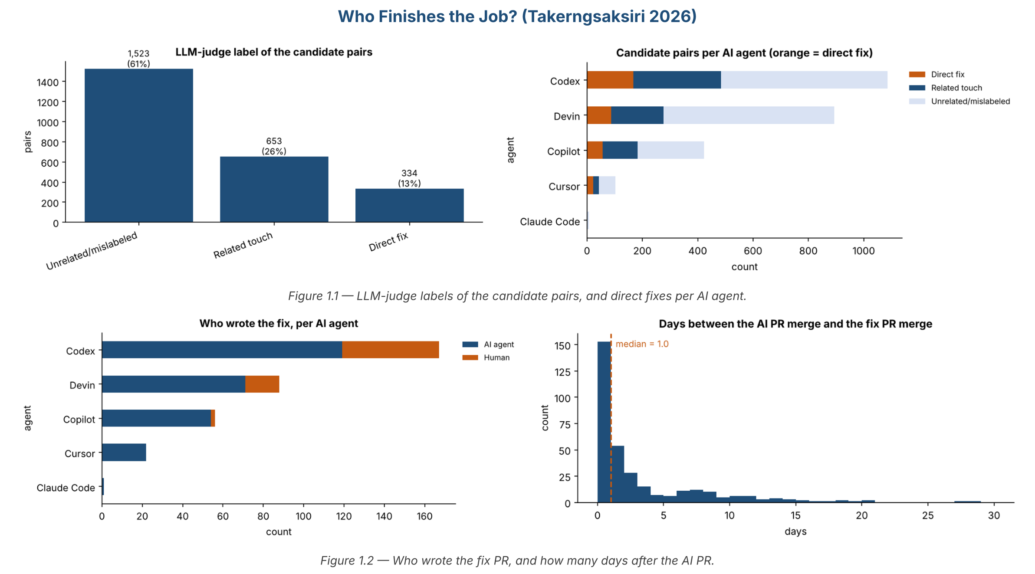
Figure 1 — Judge labels, direct fixes per agent, who wrote the fix, and days to the fix.

Key findings
- Only 334 of 2,510 candidate pairs are real fixes: the judge step is needed.
- Most fixes are written by an AI agent (267), only 67 by a human.
- Fixes come fast: median 1 day after the AI PR.

Use for our thesis
- The closest dataset to our thesis: AI PR → fix PR, with the real code patch (our Q3: how was it fixed).
- Its pipeline (linker.py) is the one Mohamed wants us to run on the newest AIDev.

2. Post-Merge Reality (Agents in the Wild)
Paper: Xia & Miller 2026 – Do These Violent Delights Have Violent Ends? Measuring the Post-Merge Fate of Agentic Code
Data: https://github.com/post-merge-reality/post-merge-reality
What it is: Every line added by an AI-co-authored commit or a human commit is followed until a later commit changes it. Each later commit gets a maintenance class: corrective (= fix), adaptive, perfective, preventive or management.

Size and dates
Item | Value
One row = | one origin commit (AI or human)
Rows | 247,348 commits (29,100 AI)
Repositories | 182 (682,970 PRs, 10,519 by agents)
Dates | 2025-05-01 → 2026-05-31 (the newest data)
Agents | 15 agents, but names are not in the released tables
Fixes of AI code | 7,822 AI commits later fixed (26.9%)
Size on disk | ≈ 139 MB

Main tables (all the columns are listed in the notebook)
- filtered_full_sample_repos.csv – 182 rows × 21 columns (repo, language, PRs, agent PRs…).
- rq1b_origin_commit_terminal_maintenance_summary.csv – 247,348 rows × 30 columns (origin commit, role, tracked lines, first later change, its class, days…).
- rq1_origin_to_terminal_actor_flow.csv – who changed the lines (AI, human, bot).

Numbers per AI agent
Origin | Commits | Fixed later | Fixed later % | Median days to first change
AI | 29,100 | 7,822 | 26.9 | 2.0
Human | 218,248 | 56,385 | 25.8 | 4.1

How the agent is involved
The agent co-authors commits (found from the commit author or the “Co-authored-by” line). Later, the lines are changed by an AI commit, a human commit or a bot.

Charts
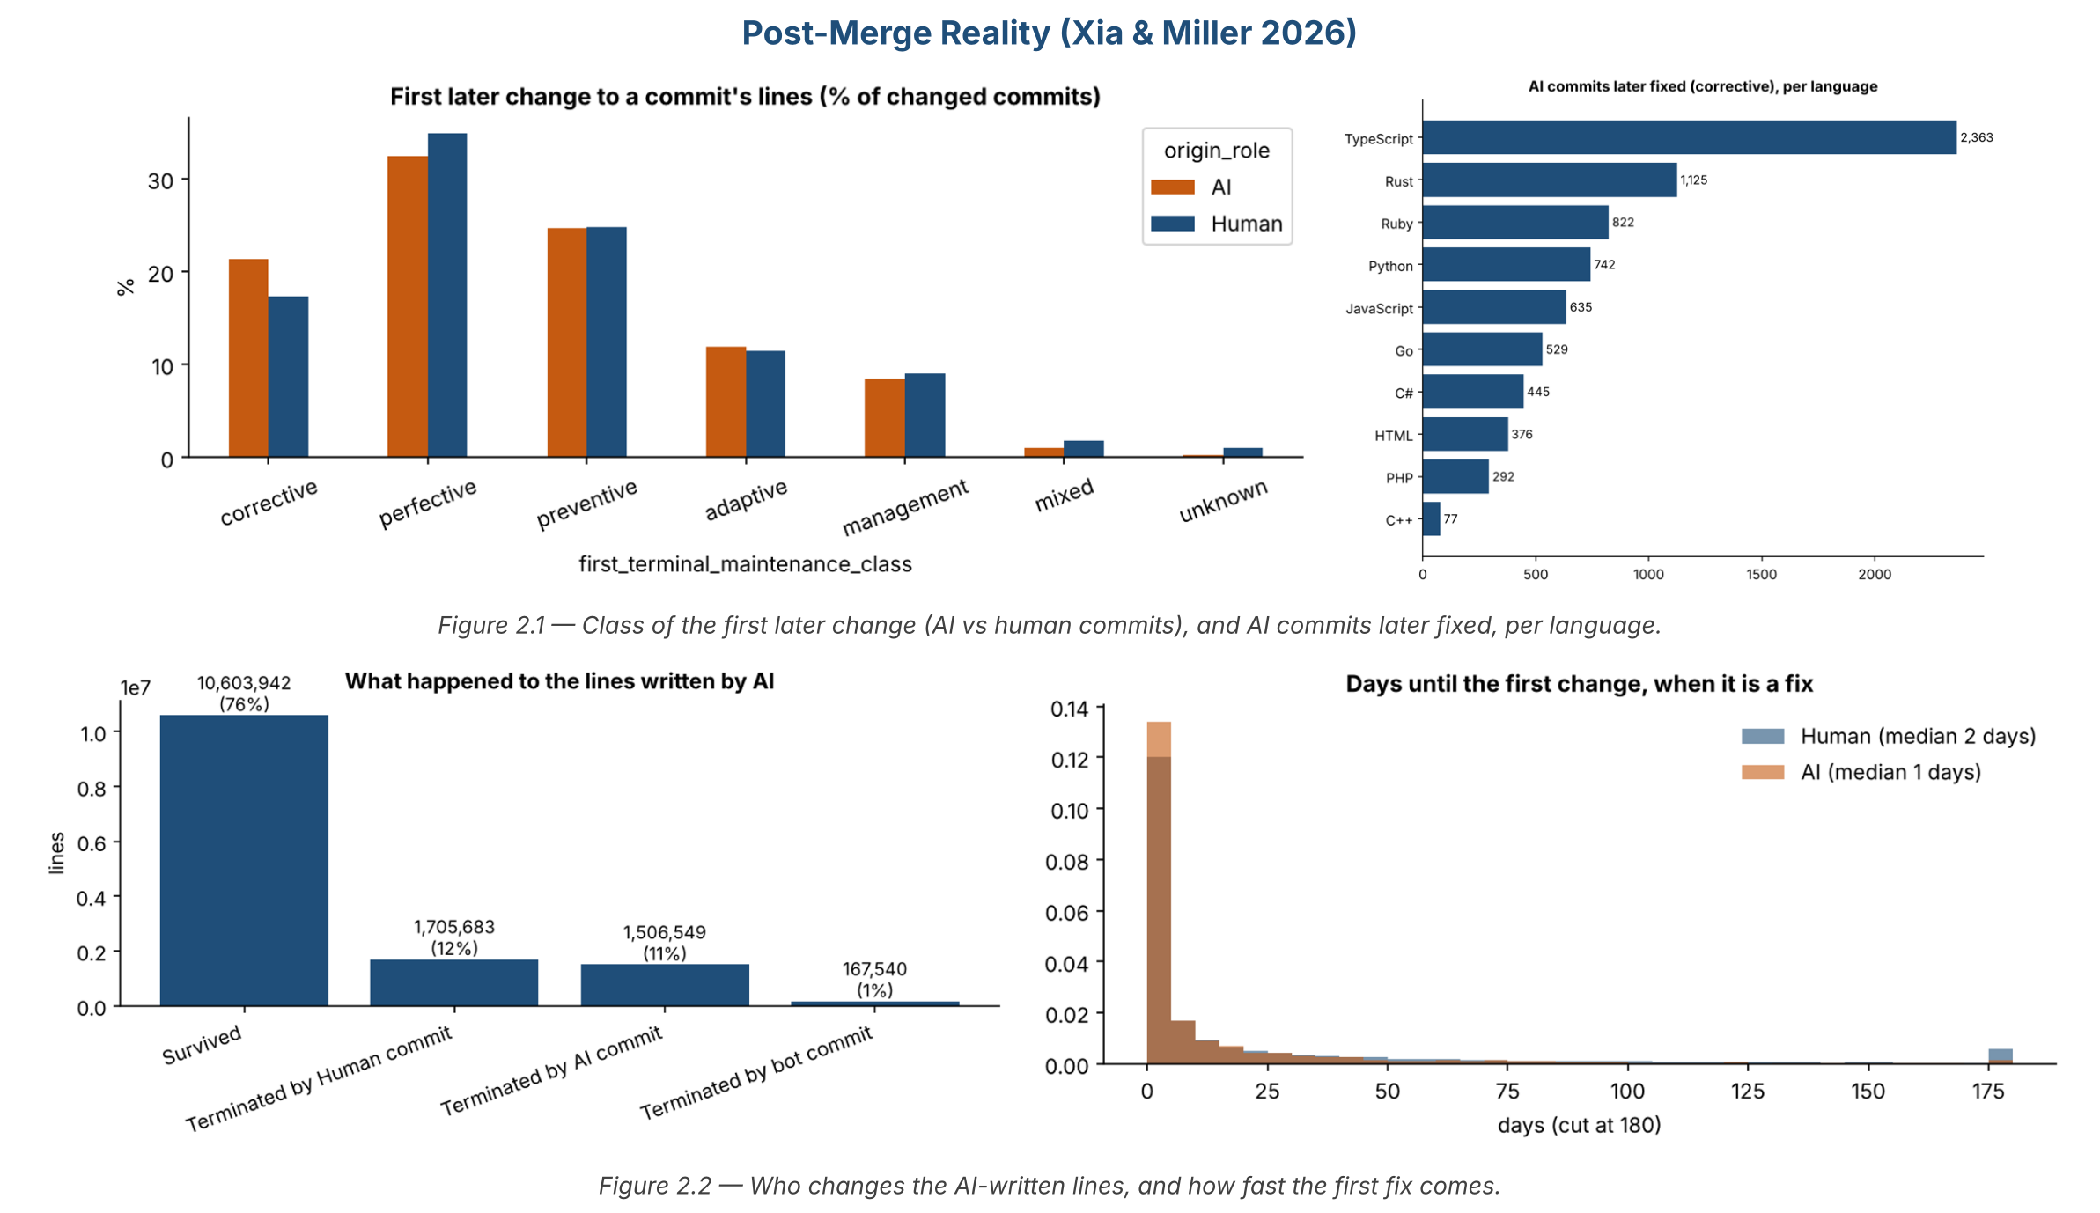
Figure 2 — First later change (AI vs human), AI fixes per language, who changes AI lines, and days to the first fix.

Key findings
- The first later change is a fix more often for AI code (21.3%) than for human code (17.3%).
- Of the lines written by AI: 76% survive, 12% are changed by humans, 11% by AI, 1% by bots.
- AI code is fixed quickly: median about 1 day when the first change is a fix.

Use for our thesis
- The newest data (up to May 2026) and the biggest number of fixes.
- Limit: commits, not PRs, and no agent names → good for comparison, not as our main dataset.

3. AI code maintainability
Paper: Sawada et al. 2026 – To What Extent Does Agent-generated Code Require Maintenance?
Data: https://github.com/ShouSawa/AI-Code-Maintainability
What it is: Files created by AI agents and by humans in 100 repositories (from AIDev), and every later commit on them, labelled with Conventional Commits types (fix, feat, refactor, docs…).

Size and dates
Item | Value
One row = | one later commit on one file
Rows | 4,338 (main table) · 49,547 (all commits table)
Repositories | 100
Dates | 2021-10-14 → 2026-02-16
Agents | Copilot, Devin, Cursor, Claude Code
Fixes of AI code | 216 fix commits on AI-created files
Size on disk | ≈ 15 MB

Main tables (all the columns are listed in the notebook)
- results_v7_released_commits_restriction.csv – 4,338 rows × 14 columns: repository_name, file_name, file_creators, file_created_by, file_creation_date, commit_hash, commit_created_by, commit_date, commit_classification…
- dataset_AI_commits.csv – 49,547 rows × 7 columns (is_ai, ai_tool), no messages and no labels.

Numbers per AI agent
File creator | Files | Later commits | Fix commits | By human | By AI | Median days
Copilot | 260 | 467 | 80 | 26 | 54 | 0
Devin | 174 | 492 | 83 | 70 | 13 | 78
Cursor | 39 | 262 | 37 | 32 | 5 | 7
Claude Code | 17 | 60 | 6 | 2 | 4 | 0
Human file (comparison) | 508 | 1,922 | 298 | 286 | 12 | 32

How the agent is involved
The agent creates the file (file_creators, e.g. devin-ai-integration[bot]). Later commits are made by humans or by AI (commit_created_by).

Charts
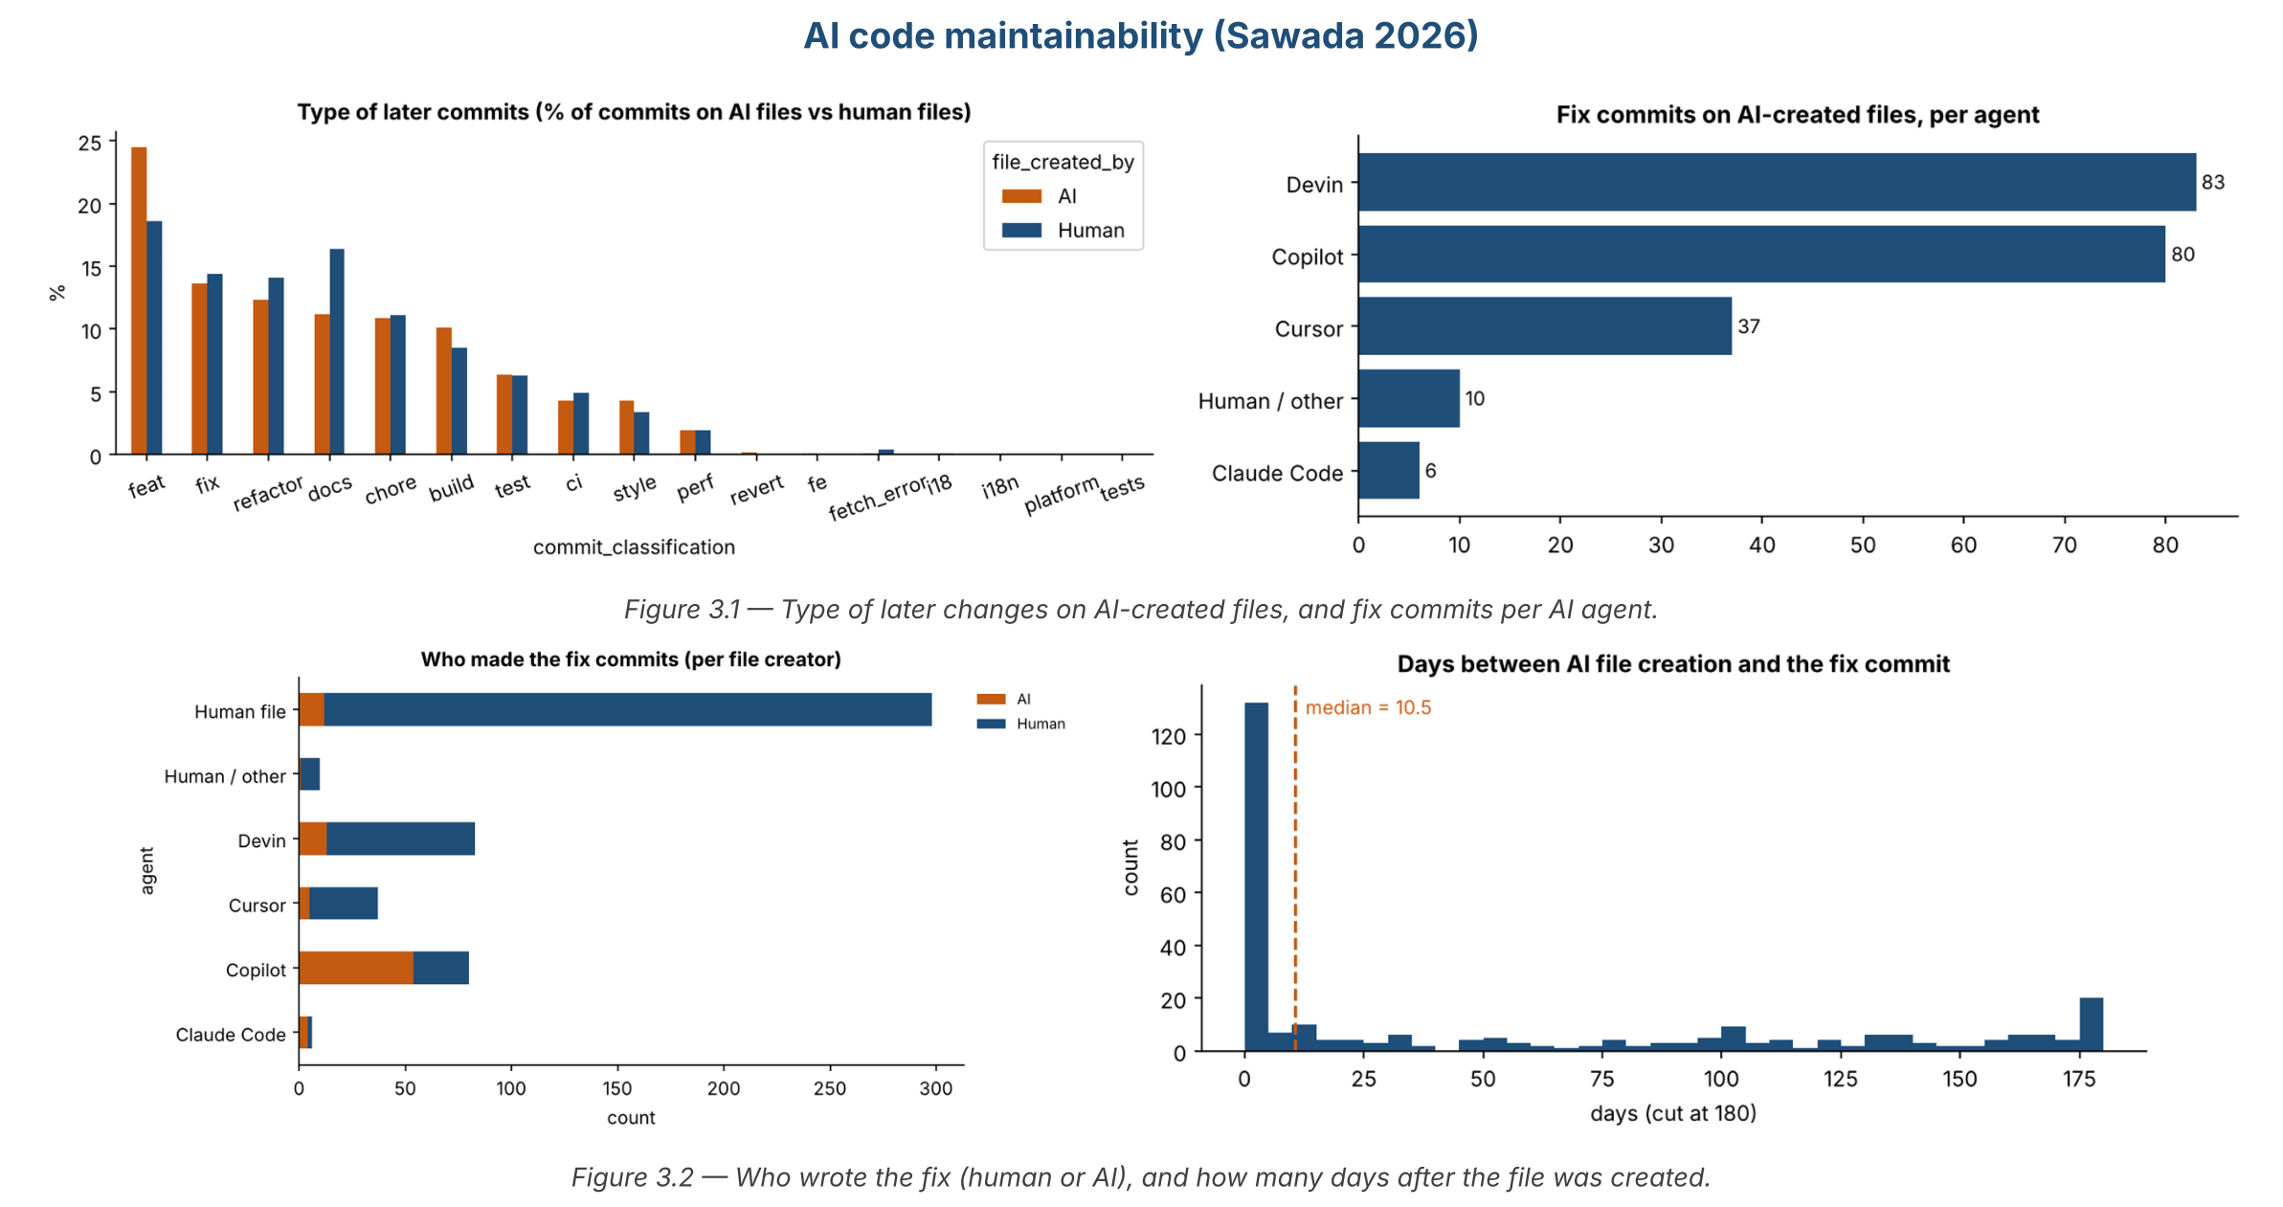
Figure 3 — Type of later commits, fix commits per agent, who made the fix, and days to the fix.

Key findings
- About 14% of later commits on AI files are fixes – close to human files (14.5%).
- Copilot files are mostly fixed by AI; Devin and Cursor files mostly by humans.
- Fix timing varies a lot: median 10.5 days, some after 6 months.

Use for our thesis
- Gives fix commits with dates and who fixed them, per agent.
- Limit: commit level and no code patch in the released data.

4. Claude Code pull requests
Paper: Watanabe et al. 2025 – On the Use of Agentic Coding: An Empirical Study of Pull Requests on GitHub
Data: https://github.com/mmikuu/OnTheUseOfAgenticCoding
What it is: Pull requests made with Claude Code: merged, closed or open. For merged PRs, whether they needed a revision, and the type of each revision commit (fix, docs, refactor…).

Size and dates
Item | Value
One row = | one Claude Code PR
Rows | 797 PRs (594 merged)
Repositories | 240
Dates | 2025-02-21 → 2025-04-30
Agents | Claude Code only
Fixes of AI code | 214 merged PRs needed a revision · 102 revision commits labelled fix
Size on disk | ≈ 7 MB

Main tables (all the columns are listed in the notebook)
- APR-MERGED / CLOSED / OPEN.csv – 17 columns: url, stars, commits, changed files, added/deleted lines, created_at, merged_at, time_to_merge…
- APR-require-revision.csv – 15 columns: revision commits, lines, Co-authored commits number…
- Revision-APR(RQ4).csv – one row per revision commit with up to 7 labels (fix, docs…).

Numbers per AI agent
Agent | PRs | Merged | Merge % | Needed revision | Fix revisions | Median hours to merge
Claude Code | 797 | 594 | 74.5 | 214 | 102 | 0.9

How the agent is involved
The developer writes the PR with Claude Code. Revision commits are made by the developer, sometimes with Claude as co-author (126 PRs human only, 88 with Claude).

Charts
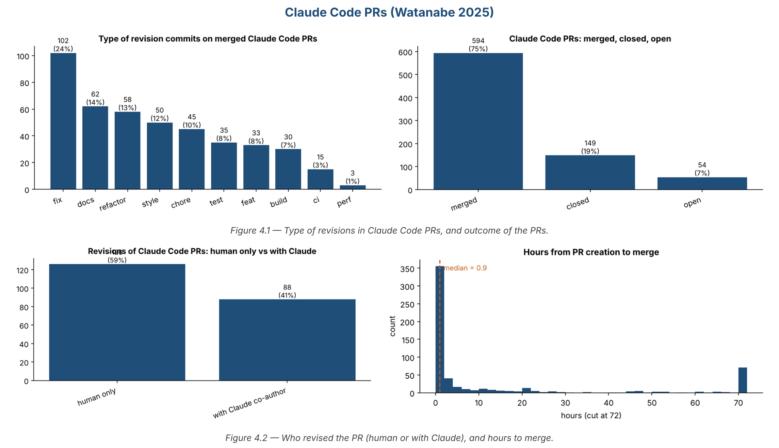
Figure 4 — Type of revisions, PR outcome, who revised, and hours to merge.

Key findings
- 75% of Claude Code PRs are merged; 36% of merged ones needed a revision.
- “fix” is the most common revision type (24%).
- PRs are merged very fast: median 0.9 hours.

Use for our thesis
- Shows what humans change inside AI PRs before merge.
- Limit: one agent only, fixes are inside the same PR (not later fix PRs).

5. Self-admitted ChatGPT / Copilot code
Paper: Yu et al. 2024 – Where Are Large Language Models for Code Generation in GitHub?
Data: https://github.com/lkpttxg/WhereCodeGenerationByLLM
What it is: Files whose comments say the code was generated by ChatGPT, GPT-4 or Copilot (5 languages), and what happened to them later: later commits, fix commits and the type of change.

Size and dates
Item | Value
One row = | one file with self-admitted LLM code
Rows | 1,413 files
Projects | 977
Dates | 2023-02 → 2024-05
Tools | ChatGPT, GPT-4, Copilot, GPT-3
Fixes of AI code | 113 files with fix commits (660 Python files, 53 with a fix)
Size on disk | ≈ 20 MB

Main tables (all the columns are listed in the notebook)
- *-code-change-type.xlsx (one per language) – about 96 columns: project, language, matched_keyword, code_change_type, number_of_all_change_fix_commit, real_fixed_commit_hash, real_fixed_commit_reason, code quality metrics…

Numbers per AI agent
Tool | Files | Projects | Changed later | Files with fix | Fix %
ChatGPT | 935 | 699 | 263 | 85 | 9.1
GPT-4 | 247 | 105 | 30 | 6 | 2.4
Copilot | 165 | 137 | 50 | 19 | 11.5
GPT-3 | 66 | 42 | 6 | 3 | 4.5

How the agent is involved
The developer pastes code generated by the tool and says so in a comment. Later commits are made by the developers.

Charts
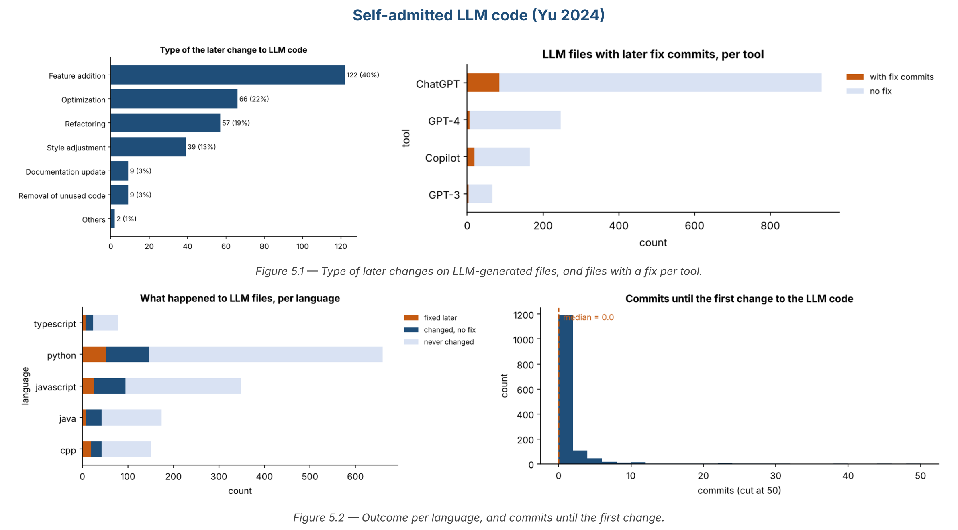
Figure 5 — Type of later changes, fixes per tool, outcome per language, and commits to the first change.

Key findings
- Most LLM code is never changed; only 8% of files get a fix.
- Later changes are mostly feature additions (40%), then optimisation and refactoring.
- Python has the most files (660).

Use for our thesis
- Older chat-style AI code (not agents) – useful as a baseline.
- Gives the reason of the real fix for some files.

6. What do AI agents actually change?
Paper: Dovhoshliubnyi et al. 2026 – What Do AI Agents Actually Change? (SSBSE challenge)
Data: https://github.com/5uper6rain/ssbse-challenge-2026
What it is: Performance pull requests from AIDev (AI and human). The AI PRs are cut into hunks (small pieces of changed code), and each hunk gets a change type (rename, new object, type change…). These are changes made BY the AI, not fixes.

Size and dates
Item | Value
One row = | one performance PR · one hunk
Rows | 428 PRs (340 AI, 88 human) · 1,254 hunks
Repositories | 135
Dates | 2025-01-03 → 2025-07-30
Agents | Codex, Devin, Copilot, Cursor, Claude Code
Fixes of AI code | none (not a fix dataset)
Size on disk | ≈ 15 MB

Main tables (all the columns are listed in the notebook)
- performance_prs_ai_vs_human.csv – 428 rows × 22 columns (agent, author_type, is_merged, time_to_merge_days, optimization_pattern…).
- perf_improvement_parts.csv – 1,254 rows × 11 columns (pr_id, hunk_content, categories…).

Numbers per AI agent
Agent | PRs | Merged | Merge % | Hunks
Codex | 207 | 141 | 68.1 | 305
Devin | 62 | 22 | 35.5 | 534
Copilot | 44 | 12 | 27.3 | 339
Cursor | 24 | 11 | 45.8 | 72
Claude Code | 3 | 2 | 66.7 | 4
Human (comparison) | 88 | 57 | 64.8 | –

How the agent is involved
The agent opens the whole PR (author_type = AI Agent); human PRs are the comparison group.

Charts
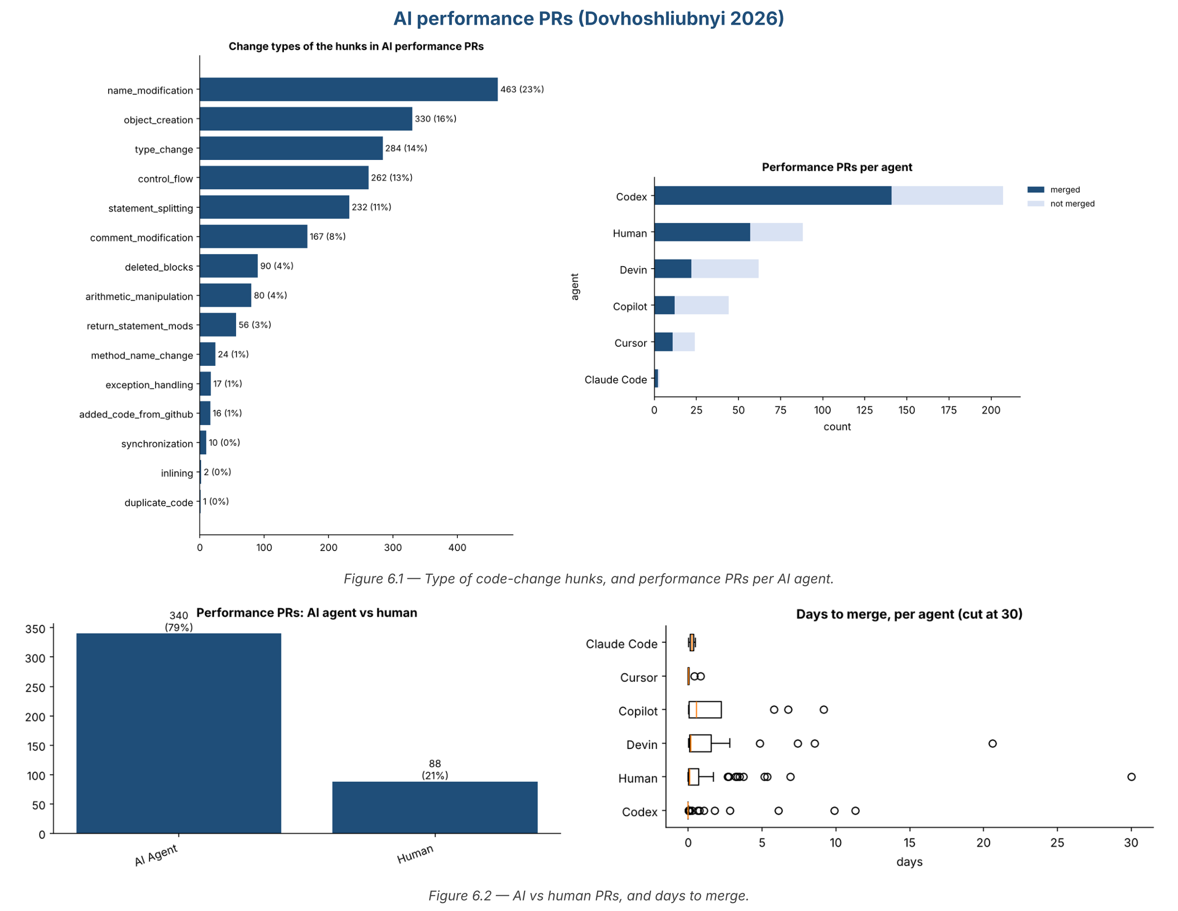
Figure 6 — Hunk change types, PRs per agent, AI vs human, and days to merge.

Key findings
- Most AI changes are renames (23%), new objects (16%) and type changes (14%).
- Codex has the most PRs and the highest merge rate (68%).

Use for our thesis
- Not for fixes – but its 18-type hunk taxonomy is a good model for describing “how the code was changed” (our Q3).

7. Where do LLMs fail when generating code?
Paper: Wang et al. 2025 (ICSE) – Towards Understanding the Characteristics of Code Generation Errors Made by Large Language Models
Data: https://github.com/ma-labo/defects4codellm
What it is: Wrong solutions written by 6 LLMs for the HumanEval benchmark (164 Python tasks). Each error is labelled by hand with a semantic type (what is wrong) and a syntactic type (where in the code), with the wrong code and the correct code.

Size and dates
Item | Value
One row = | one error in one LLM solution
Rows | 687 labelled errors (557 wrong solutions in the paper)
Tasks | HumanEval, 164 Python tasks
Dates | models from 2022–2023 · paper ICSE 2025
LLMs | CodeGen-16B, InCoder-1.3B, GPT-3.5, GPT-4, SantaCoder, StarCoder
Fixes of AI code | no real fixes – the correct code is given for each error
Size on disk | ≈ 30 MB

Main tables (all the columns are listed in the notebook)
- data/<llm>-humaneval_error.csv (6 files) – 8 columns: Error ID, Model, Task ID, Semantic Characteristics, Syntactic Characteristics, Incorrect Code (Complete), Ground Truth Code (Complete).

Numbers per AI agent
LLM | Errors | Tasks failed | Median lines of wrong code
InCoder-1.3B | 182 | 144 | 17
SantaCoder | 181 | 139 | 15
CodeGen-16B | 129 | 110 | 16
StarCoder | 123 | 104 | 14
GPT-3.5 | 52 | 42 | 20.5
GPT-4 | 20 | 18 | 25

How the agent is involved
The LLM writes the whole solution of a task. Researchers compare it with the correct solution and label the errors. No developer and no later fix.

Charts
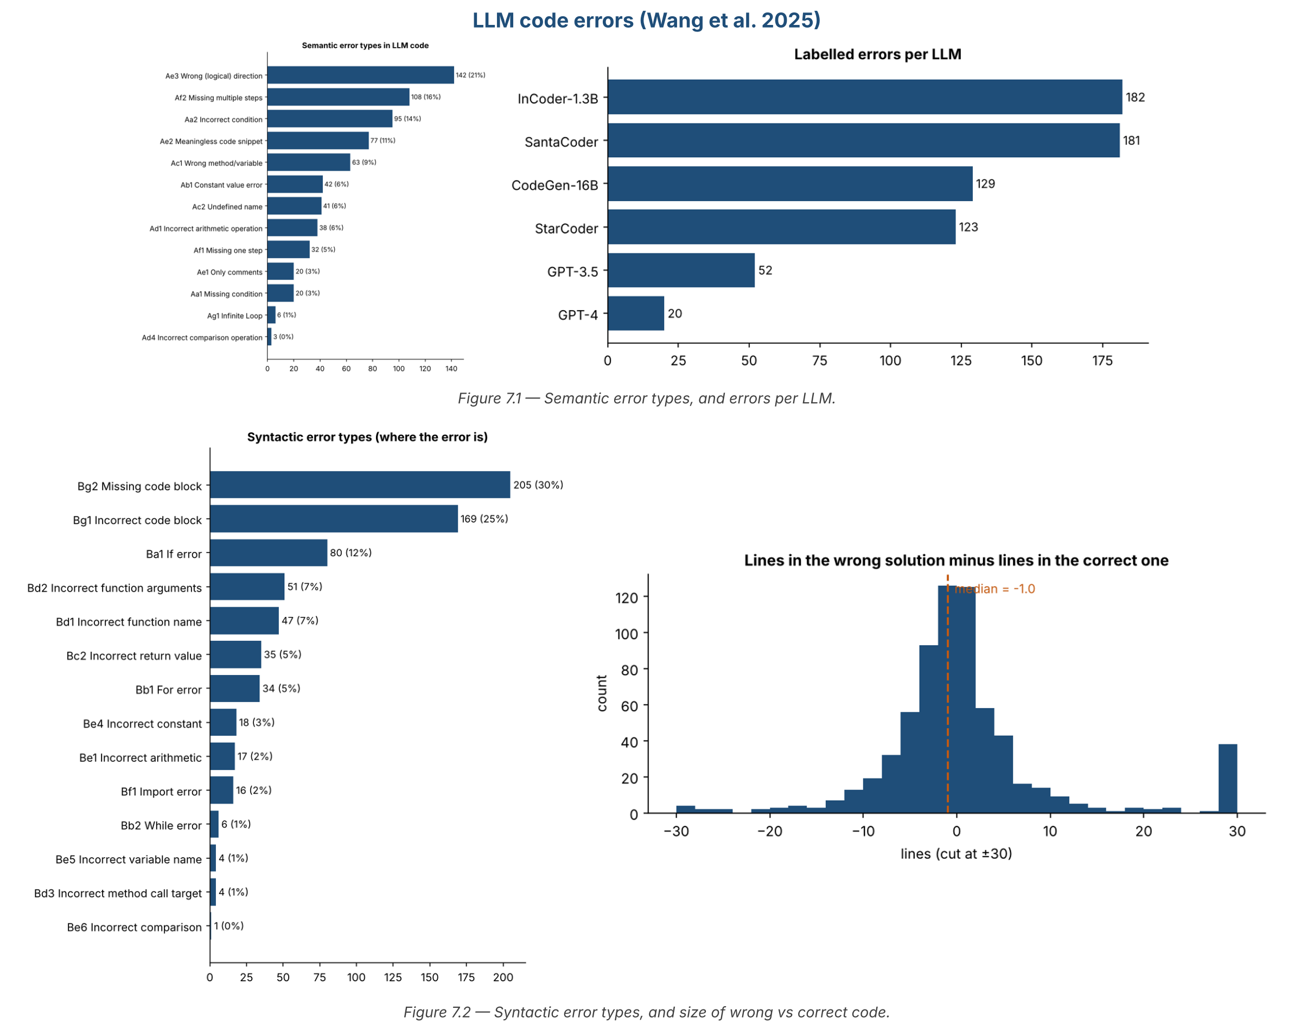
Figure 7 — Semantic error types, errors per LLM, syntactic error types, and size of wrong vs correct code.

Key findings
- Most common errors: wrong logical direction (21%), missing multiple steps (16%), incorrect condition (14%).
- Where: missing code block (30%) and incorrect code block (25%), then if errors (12%).
- Stronger models make fewer errors (GPT-4: 20) but their wrong code is longer.

Use for our thesis
- ★ A ready, validated error taxonomy for our Q2 (what was wrong): 13 semantic + 14 syntactic types.
- Limit: benchmark code, not real projects and not agents.

8. DECODE – developer edits of AI code
Paper: Liang et al. 2026 – Learning from 53.6K Real-World Developer Edits of AI-Generated Code (CMU)
Data: https://github.com/jennytliang/decode
What it is: A VS Code extension gave AI code completions from 20 LLMs; when a developer accepted one, the extension recorded how the developer edited it afterwards (before/after code pairs).

Size and dates
Item | Value
One row = | one before/after code pair (grouped into edit trajectories)
Rows | 53,614 pairs · 5,831 trajectories · 1,141 developers
Languages | Python 40,390 · JavaScript 7,993 · TypeScript 5,231
Dates | not stated (models suggest about 2024 – early 2025)
AI tools | 20 LLMs (GPT-4o, Claude 3.5/3.7 Sonnet, Gemini, Llama 3.1, Qwen 2.5 Coder, DeepSeek Coder…)
Fixes of AI code | edits right after acceptance – changing functionality 56%, improving quality 14%, customising 10%, removing 9%
Where | data on Hugging Face (jtliang/decode) – download on my PC

Main tables (all the columns are listed in the notebook)
- Hugging Face dataset jtliang/decode (before code, after code, trajectory, model, language).
- Code: src/pipeline (build the dataset), src/analysis (label edit types), src/modeling (predict edits).

Numbers per AI agent
Item | Value
Agents | not agents – inline completions from 20 LLMs
Median edit time | 49.7 minutes per trajectory; most edits in the first 15 minutes

How the agent is involved
The LLM suggests code inside the editor; the developer accepts it, then edits it. Edits happen BEFORE the code is submitted.

Charts
Not run here (Hugging Face is blocked in my cloud workspace). The notebook 08_DECODE in AI_Code_Datasets runs on my PC.

Key findings
- Most edits change what the code does (56%), not only its style.
- Python is 75% of the data – matches our focus.

Use for our thesis
- Real before/after code for AI code in Python, and an edit-type labelling script (label_edit_types.py).
- Limit: edits before submission, not maintenance fixes after the PR.

9. Khemissi – references to agent PRs
Paper: Khemissi et al. 2026 – Humans Integrate, Agents Fix (arXiv 2604.04059)
Data: https://figshare.com/s/e750940213ea9df98867
What it is: From AIDev-pop timelines: later commits that reference an earlier agent PR – 1,922 from human commits (often co-authored by an agent) and 88 from other agent PRs – with the commit message and the code patch. A sample was labelled by hand (add, fix, update, revert…).

Size and dates
Item | Value
One row = | one reference: later commit / PR → agent PR
Rows | 2,010 references (1,922 human commits + 88 agent PRs)
Repositories | 309
Dates | 2024-12-29 → 2025-08-04
Agents | Codex, Devin, Cursor, Copilot, Claude Code
Fixes of AI code | 1,032 references that look like a fix (keyword), 937 with the code patch; 63 confirmed “fix” by hand
Where | Figshare (downloaded) – folder replication_package_v2

Main tables (all the columns are listed in the notebook)
- results/05_human_references_with_co_authors.csv – 1,922 × 57: agent PR (url, dates, state) + referencing commit (sha, message, files, patch, agent co-author).
- results/01_data_agent_to_agent.csv – 88 agent PRs referencing agent PRs.
- manual_verification/*.csv – 124 + 88 references labelled by hand.

Numbers per AI agent
Agent of the PR | Human refs | Agent PRs referenced | Fix refs (keyword) | With agent co-author | Median days
Codex | 803 | 563 | 454 | 59 | 3.9
Devin | 620 | 468 | 316 | 453 | 19.3
Cursor | 257 | 185 | 99 | 157 | 4.0
Copilot | 162 | 120 | 91 | 125 | 2.9
Claude Code | 80 | 52 | 44 | 41 | 3.6

How the agent is involved
The agent opens the PR. Later, a human commit (42% co-authored by an agent) or another agent PR references it – to fix it, revert it, update it or build on it.

Charts
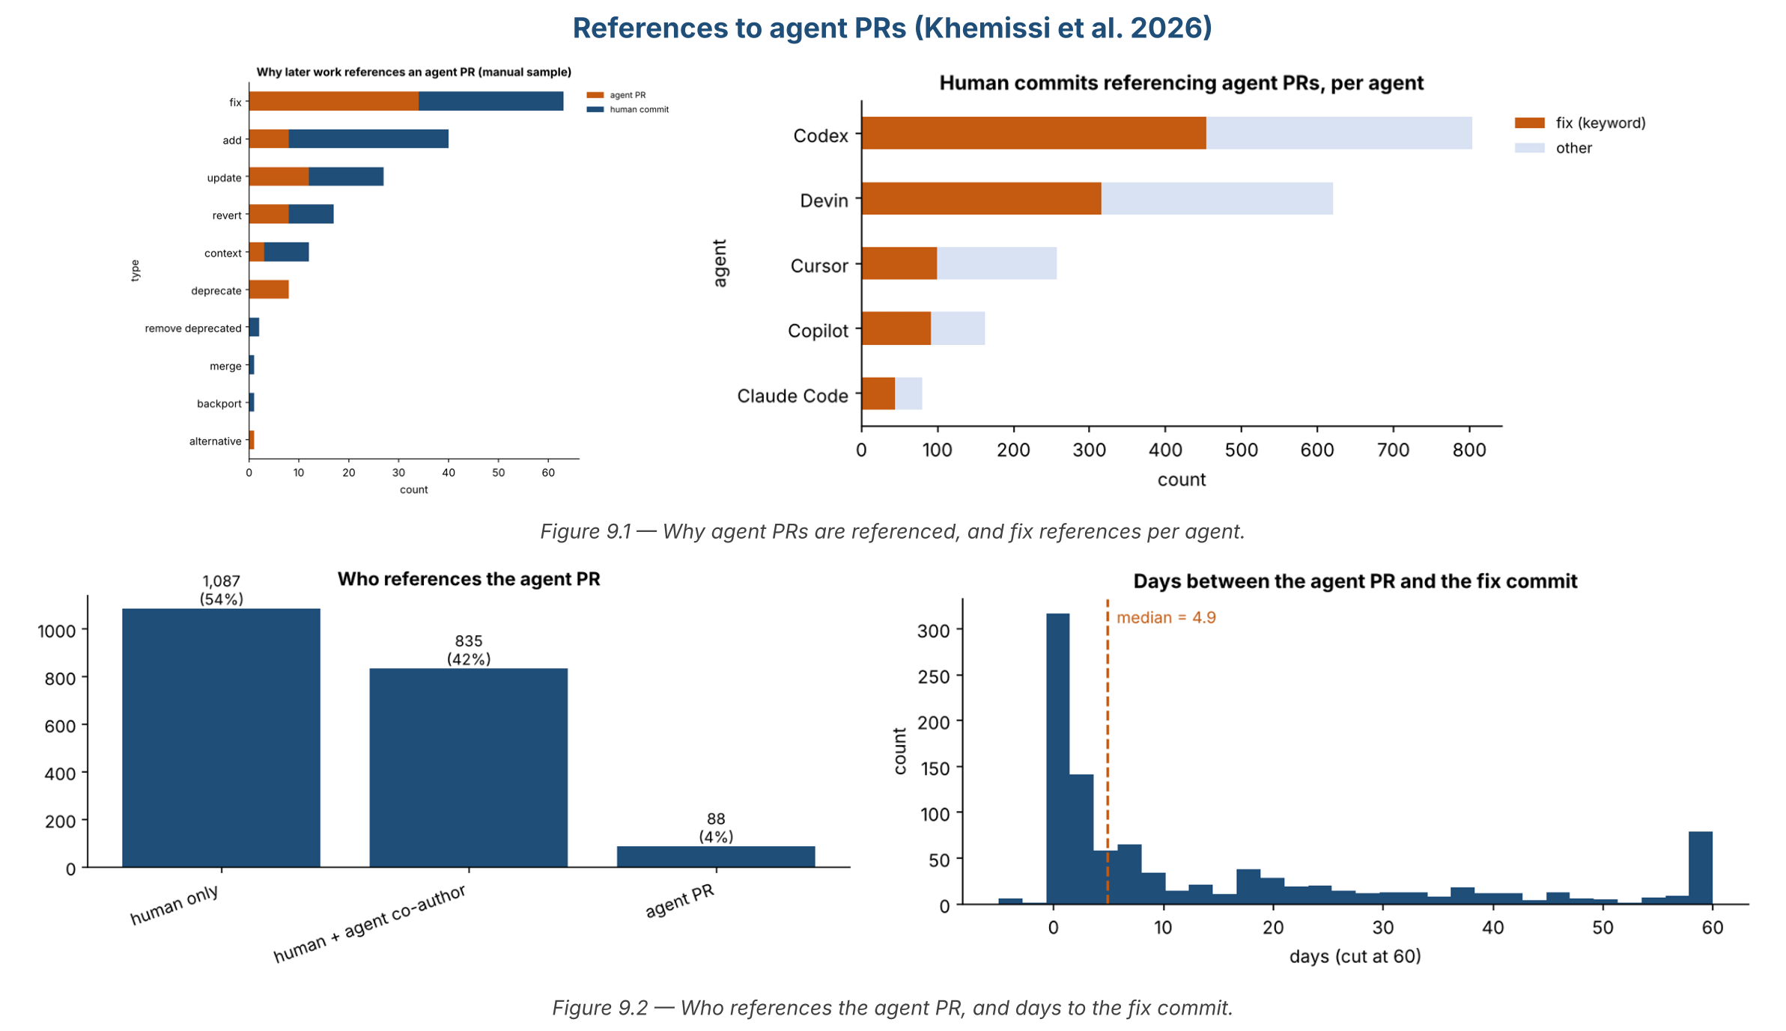
Figure 9 — Why agent PRs are referenced, fix references per agent, who references, and days to the fix commit.

Key findings
- “fix” is the most common reason in the hand-labelled sample (63 of 212), then add and update.
- Half of the references look like fixes; the median fix comes about 5 days after the agent PR.
- Many fixes are human commits co-authored by an agent (Devin: 453 of 620).

Use for our thesis
- ★ A second source of “fix of AI code” with the code patch: 1,032 fixes, 937 with code – added to the final dataset.
- Limit: the fix label is a keyword in the commit message (manual labels only for a sample).

10. Alam – why AI fix PRs are not merged
Paper: Alam, Mondal & Roy 2026 – Why Are AI Agent–Involved Pull Requests (Fix-Related) Remain Unmerged? (arXiv 2602.00164)
Data: https://doi.org/10.5281/zenodo.18105922
What it is: AIDev-pop with the pr_task_type table. The paper keeps the 8,106 PRs where an AI agent tries to fix a bug, checks the outcome, and labels 326 closed ones by hand (12 failure reasons). These are AI fix attempts, not later fixes of AI code.

Size and dates
Item | Value
One row = | one AI pull request (fix-related)
Rows | 8,106 fix PRs (of 33,596 AIDev-pop PRs)
Repositories | 1,619
Dates | 2024-12-24 → 2025-07-30
Agents | Codex, Copilot, Devin, Cursor, Claude Code
Fixes of AI code | none – AI fix attempts
Where | Zenodo (downloaded) – folder “Agents for Fixing”

Main tables (all the columns are listed in the notebook)
- dataset/pull_request.parquet – 33,596 × 14 (AIDev-pop PRs).
- ★ dataset/pr_task_type.parquet – 33,596 × 6: type (feat, fix, docs…), reason, confidence – the table removed in AIDev v4.
- dataset/pr_timeline.parquet, related_issue.parquet, pr_reviews.parquet – more AIDev-pop tables.
- Results/RQ2/Failure Analysis….xlsx – 326 closed fix PRs with the failure reason.

Numbers per AI agent
Agent | Fix PRs | Merged | Closed | Open | Merge %
Codex | 4,338 | 3,539 | 616 | 183 | 81.6
Copilot | 1,993 | 845 | 713 | 435 | 42.4
Devin | 1,249 | 536 | 675 | 38 | 42.9
Cursor | 411 | 281 | 84 | 46 | 68.4
Claude Code | 115 | 66 | 25 | 24 | 57.4

How the agent is involved
The agent opens a PR whose task is to fix a bug; maintainers merge it, close it or leave it open.

Charts
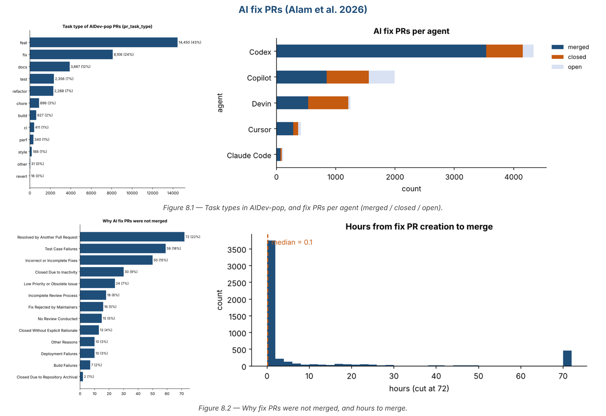
Figure 10 — Task types in AIDev-pop, fix PRs per agent, why fix PRs were not merged, and hours to merge.

Key findings
- 65% of AI fix PRs are merged; Codex 82%, Copilot and Devin about 42%.
- Top reasons for not merging: resolved by another PR (22%), test failures (18%), incorrect or incomplete fix (15%).

Use for our thesis
- ★ Gives the AIDev-pop tables missing in v4 (pr_task_type, pr_timeline, related_issue) → linker.py can run on AIDev-pop.
- Related work: AI fix attempts vs our fixes of AI code; failure reasons can be compared with Q2.

11. Tools for Q3 – how was the code changed?
These tools read two versions of the code and list the refactorings (rename, extract method, move…). We use them on the AI patch and the fix patch.
Tool | Language | Version / where | Use for us
RefactoringMiner (Tsantalis) | Java, Python (3.14), Kotlin, JS/TS, C/C++ | 3.x on Maven (com.github.tsantalis:refactoring-miner); github.com/tsantalis/RefactoringMiner | ★ Best choice: Python is now supported in the official tool, and option -gp analyses a whole GitHub pull request; AST diff; MCP server
Py-RefactoringMiner (Dilhara) | Python | 1.0.6 on Maven (io.github.maldil:python-refactoring-miner) or Docker; github.com/maldil/RefactoringMiner | Older Python port – used in Dilhara 2022; hard to build
PyRef (Atwi 2021) | Python | github.com/PyRef/PyRef (needs pandas < 2) | Simple Python tool, 9 method-level refactoring types; its benchmark is now inside RefactoringMiner

Example command: ./RefactoringMiner -gp https://github.com/<owner>/<repo>.git <PR number> 60 -json out.json
So, for each clean pair, we can run RefactoringMiner on the fix PR and get the exact refactorings (Q3), next to the LLM labels for Q1 and Q2.

12. All papers together – final dataset
Every notebook saves its fixes with the same 13 columns (tables/fixes.csv). The notebook 99_ALL_PAPERS_summary merges them into FINAL_AI_FIXES_DATASET.xlsx, grouped by AI agent → paper. Missing columns were filled from public GitHub (git history of 375 repositories): commit messages, dates, authors and code patches of the fixes, and for Xia & Miller the agent name from the Co-authored-by line of each AI commit (7,810 of 7,822 found).
Item | Value
Rows | 9,619 fixes of AI code (362 PR · 9,144 commits · 113 files)
Columns | 14: paper, fix_id, agent, repo, language, level, ai_change, fix_change, fixed_by, days_to_fix, fix_label, fix_reason, has_code_patch, is_python
Papers | Xia & Miller 7,822 · Khemissi 1,032 · Who Finishes 334 · Sawada 216 · Yu 113 · Watanabe 102
Columns | 20 (adds dates, fix author, fix size)
Python fixes | 1,015
With the real code patch | 5,679 (patches in ENRICH/patches_*.parquet)
Agents found | 12 (Claude Code, Copilot, Devin, Cursor, Codex, ChatGPT, Jules, Gemini…)

Agent | Fixes | Fixed by human | Fixed by AI | Median days
Claude Code | 5,136 | 727 | 2,062 | 0.4
Copilot | 2,504 | 680 | 737 | 2.0
Devin | 684 | 161 | 445 | 7.0
Codex | 666 | 452 | 184 | 2.9
Cursor | 387 | 124 | 149 | 3.1
ChatGPT | 85 | 85 | 0 | –
Jules | 77 | 23 | 14 | 0.7
Gemini | 49 | 22 | 5 | 7
Other | 31 | 22 | 3 | –

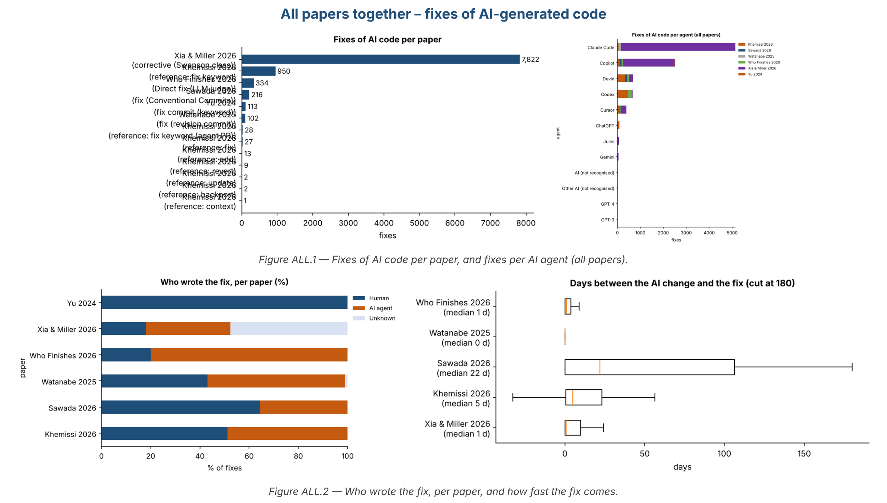
Figure 11 — All papers: fixes per paper, fixes per agent, who wrote the fix, and how fast.

AI PR → fix PR pairs
PR_FIX_PAIRS/AI_PR_FIX_PAIRS.xlsx keeps only PR-to-PR fixes: 334 pairs (AI PR id, url, title → fix PR id, url, title, who fixed, days between). The dates are filled from AIDev with add_dates.py.

13. Conclusion and next step
- Best match for our thesis: Who Finishes – AI PR → fix PR with the real code patch – but its PRs stop in June 2025.
- Second fix source: Khemissi – 1,032 fixes of agent PRs with 937 code patches (downloaded).
- Tables for linker.py: Alam’s package contains AIDev-pop with pr_task_type, pr_timeline and related_issue (removed in v4).
- Q2 and Q3 tools: Wang error taxonomy for “what was wrong”; RefactoringMiner (now with Python and PR support) for “how was it fixed”.
- Newest data: Xia & Miller (to May 2026): commits, now with agent names and fix code mined from GitHub.
- Proposal: run linker.py (Who Finishes method) on AIDev v5 (to March 2026), keep Python PRs, and build our own AI PR → fix PR dataset with dates and patches.
- Questions for Mohamed: v3 or v5? How do we mark fix PRs if pr_task_type is missing? Do we start testing our Q3 method on the 334 Who Finishes fixes?

