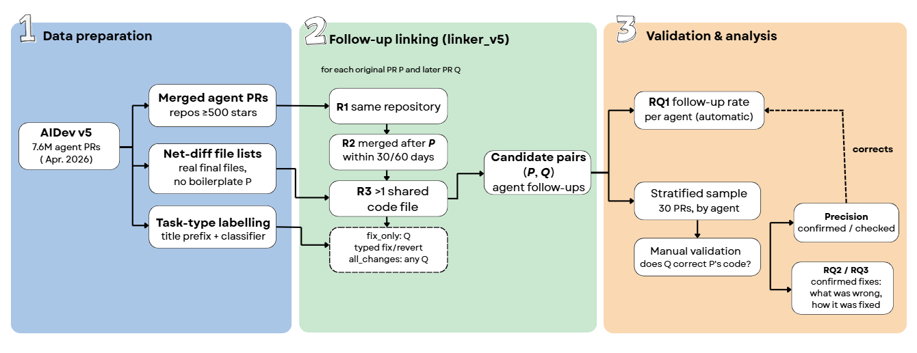

Stage 1: Data preparation (get the data ready)
AIDev v5
- about 7.6 million pull requests (PRs) written by AI agents (Claude Code, Copilot, Codex, Devin, Cursor, Jules), collected up to April 2026.
- It is too big and too messy to use directly, so we prepare three things from it.
Merged agent PRs (repos ≥500 stars)
- We keep only PRs that were merged, meaning accepted into the project. A PR that was never merged can’t be “fixed later”.
- We keep only popular projects with 500 stars or more. These are real, active projects, not toy repos.
- These PRs are our P list: the AI PRs we follow over time. That gives 22,496 merged Python agent PRs.
Net-diff file lists (real final files, no boilerplate)
- For every PR, we need the files it really changed in the end. This is called the net diff: the difference between the code before the PR and the code after the merge.
- AIDev only gives the files of each commit. A commit like “merge main” brings in files written by other people, so the commit list can contain files the PR never really changed. That creates false links.

- AIDev does not include the net diff, in v3 or v5. The paper took it from GitHub, and we do the same: we download the final file list of each PR from the GitHub API (14,705 PRs, about 4 hours, saved in a cache).
- We keep code files only (.py, .js, .java…). We remove files like README, changelogs and config files, because almost every PR touches them, so they would link PRs that have nothing to do with each other.
Task-type labelling (title prefix + classifier)
- We give every PR a type: fix, feat, docs, refactor…
- If the title starts with a prefix like fix:, we use that.
- If not, a small machine-learning model guesses the type from the title. We trained it on AIDev v3, where types already exist, and it is right about 84% of the time.
- We need this because v5 does not ship the type table.
Stage 2: Follow-up linking (the linker)
“For each original PR P and later PR Q”
- For every AI PR P, the linker looks at the PRs merged after it (Q). Each Q must pass the rules below.
R1: same repository
- Q must be in the same project as P. A PR in another project can’t fix P’s code.
R2: merged after P, within 30 / 60 days
- Q must be merged after P, and not too long after: within 30 days (or 60 days in the second test).
- Something that happens a year later is probably unrelated.
R3: at least one shared file (net diff)
- Q must change at least one file that P also changed, using the net diff (the real final files) of both PRs, like the paper.
- This is the main clue that Q touched P’s code.

fix_only: Q typed fix/revert
- This is an optional extra rule, with two modes:
  - all_changes mode: any Q that passes R1–R3 counts.
  - fix_only mode: Q must also be labelled fix or be a revert.
Candidate pairs (P, Q): follow-ups
- Every (P, Q) that passes all the rules becomes a candidate pair, and P gets +1 follow-up. With the net diff we get 104,450 candidate pairs.
- These are suspects only. The linker never reads the code; it only matches the repo, the dates, the file names and the title.

Stage 3: Validation & analysis (check and use the results)
RQ1: follow-up rate per agent (automatic)
- For each agent, we compute the % of its PRs that have at least one follow-up. For example, Claude Code has 51.8% (all_changes) and 34.9% (fix_only) within 30 days.
- This is the fast, automatic number, but it is too high because many of the pairs are false suspects.
Stratified sample: 30 PRs, by agent
- We randomly pick 30 AI PRs from the candidate pairs.
- “Stratified” means each agent gets a fair share. More PRs come from the bigger agents, but every agent gets at least 2.
Manual validation: does Q correct P’s code?
- You open P and Q on GitHub (the “Files changed” tab) and decide:
  - YES (+1): Q really fixes something in P’s code, such as a bug, a missing check or an error.
  - NO (0): Q is a new feature, docs, style, or touches other lines.
- Now a human has read the code, not only the file names.

Precision: confirmed / checked
- Precision = YES ÷ number of pairs checked.
- Example from our pilot: 3 YES out of 68 pairs = 4.4%. With the net diff, 42 of those 68 pairs remain, still with 3 YES → about 7%. The paper reports 4.5% verified.
- It tells us how much we can trust the linker.
“corrects” (Precision → RQ1)
- We use precision to correct the automatic rate: real fix rate ≈ linker % × precision.
- Example: 51.8% × 0.07 ≈ 3.6% real fixes for Claude Code. This is close to the paper’s 4.5%.
RQ2 / RQ3: what was wrong, how it was fixed
- We only study the YES pairs (the confirmed fixes) and ask two questions:
  - RQ2: what was wrong in the AI code? For example, a missing null check, a wrong condition or a crash.
  - RQ3: how did Q fix it? For example, it added a check, changed a condition or replaced a function call.

we prepare the AI PRs and their real final files (net diff). The linker then automatically finds the later PRs that look like follow-ups. Finally, we check a sample by hand to measure how accurate the linker is and to learn what was wrong and how it was fixed.

