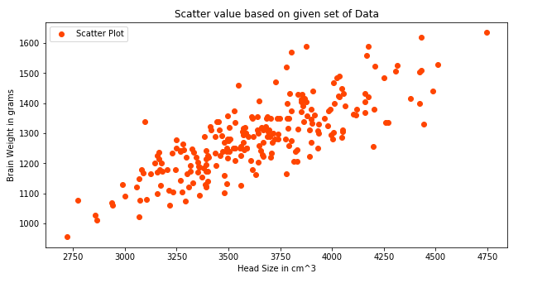

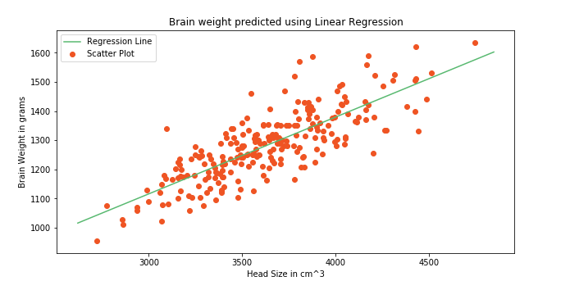

**VALUE OF R^2:**

R^2 = 0.6393117199570003

Its means that the prediction is 63.93% accurate.