EcoShift Technical Design
  - Distributed Web Applications Validation 1
4DAS_I 1 | Group EcoShift | Six students | 11 November 2026
EcoShift coordinates reusable cups and trays for campus events. It lets club organizers request stock, coordinators approve only feasible bookings, and stockroom staff track returns through cleaning or damage review. We propose a single ESPRIT stockroom as a pilot that other Tunisian universities could adapt.

Users and minimum scope
- Club organizer Submits requests, follows their status, and cancels before pickup.
- Campus coordinator Reviews bookings and uses stock previews and forecasts to respond to shortages.
- Stockroom staff Issues stock, reconciles quantities at return, and records recovery decisions.
The minimum scope covers one stockroom, cups and trays, one shared frontend, and the request-to-clearance flow. Multiple stockrooms and QR scanning are later extensions.

Priority demonstration
Use clearly labeled simulated data. A club reserves 40 cups and 10 trays. A second request overlaps the first and receives a stock conflict. Staff issue the approved booking and record 38 intact and two damaged cups, with all ten trays intact. After cleaning, the 38 intact cups become ready. The two damaged cups stay unavailable until cleared or retired. A separate simulated overdue return shows how the planner flags an upcoming shortage.

Business rules and measures
- Reserve all requested quantities in one decision. The booked window includes a proposed two-hour cleaning buffer. Check physical readiness again at pickup.
- An approved booking can be released before pickup. Issue and release compete in the same Stock transaction boundary.
- For each item type, intact, damaged, and missing counts must add up to the issued count. Cleaned or repaired stock becomes lendable only after staff record clearance.
- Measure fulfilled bookings, units issued on completed loans, return-to-clearance time, and early shortage warnings. Quantifying waste avoided requires real use data and a baseline.

Technical Architecture
The frontend sends business API requests through Spring Cloud Gateway. Keycloak handles sign-in and issues access tokens. Gateway and services validate tokens, and services enforce role and record-level permissions.
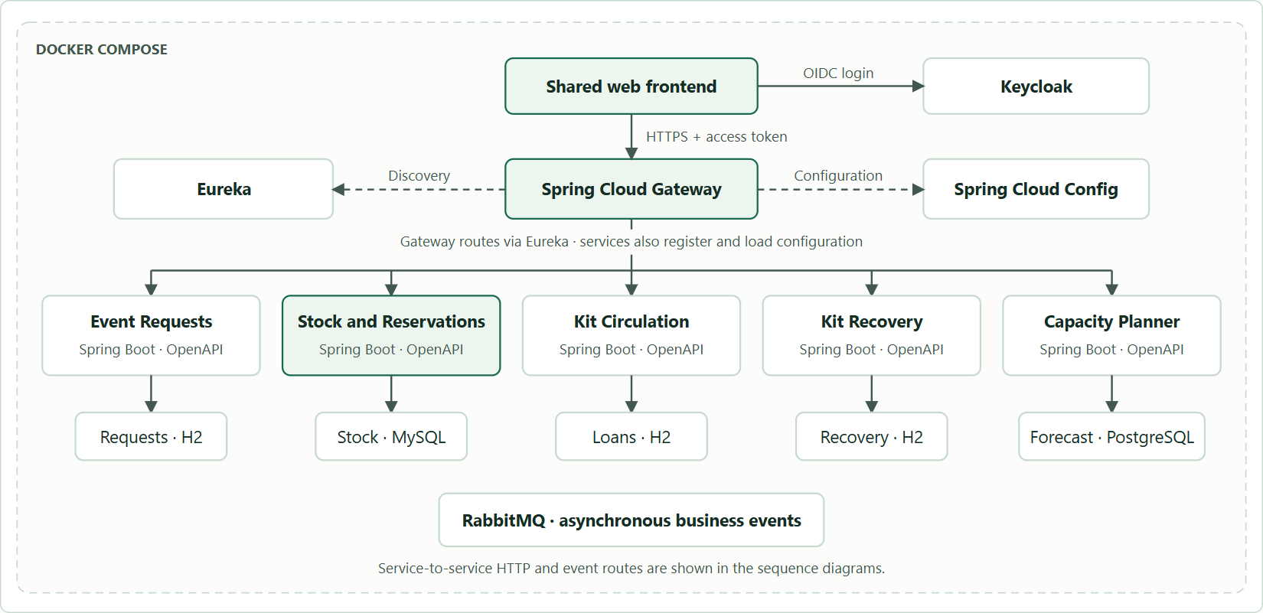
Figure 1. Proposed EcoShift architecture. Docker Compose hosts the frontend, shared platform, business services, databases, and broker.

Shared platform
Eureka resolves service names. Spring Cloud Config supplies versioned configuration, with secrets provided separately. OpenFeign handles immediate service-to-service decisions. The proposed RabbitMQ broker carries return, recovery, and forecast events. Each Spring Boot service documents its API with Swagger and OpenAPI.

Authentication and access
Use Keycloak OpenID Connect authorization code with PKCE. Organizers can read and cancel their own requests. Coordinators can review and decide requests and read stock and forecasts. Stockroom staff can read approved requests for pickup, issue loans, reconcile returns, and resolve recovery tasks. Scoped service accounts call internal routes, which are excluded from Gateway public routing. Database and broker ports stay inside the Compose network.

Use Cases and Service Data
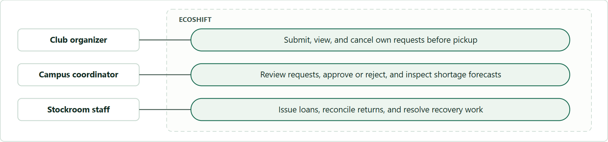
Figure 2. Use cases by role. The coordinator decides requests and the stockroom manages physical stock movements.
The class relationships below sit inside their owning service. A reference to another service is an ID sent through an API or event. Each service owns a separate database.

Event Requests · H2
EventRequest 1 ── 1..* RequestLine
EventRequest holds requestId, organizerSub, eventName, pickupAt, dueAt, status. RequestLine holds itemTypeId and quantity.

Stock and Reservations · MySQL
Reservation 1 ── 1..* Allocation | ItemType 1 ── 0..* Allocation | ItemType 1 ── 0..* StockHold
Reservation holds requestId, blockedUntil, status. Allocation holds item type and quantity. StockHold tracks a loan or return lot, state, and quantity.

Kit Circulation · H2
Loan 1 ── 1..* LoanLine | Loan 1 ── 0..1 ReturnReceipt | ReturnReceipt 1 ── 1..* ReturnLine
Loan references requestId and records pickup. Its lines hold issued counts. ReturnLine records intact, damaged, and missing counts for one item type.

Kit Recovery · H2
ReturnedLot 1 ── 1 RecoveryTask
A ReturnedLot is one item type and condition from one receipt. RecoveryTask tracks lotId, quantity, action, and resolution. Intact and damaged quantities form separate lots.

Capacity Planner · PostgreSQL
ItemProjection 1 ── 0..* ProjectedPickup
ItemProjection holds itemTypeId, stockVersion, ready quantity, forecastable releases, and asOf. ProjectedPickup holds the reservation window and quantity used to calculate shortages.

Request and Stock API Contracts
Use ISO 8601 timestamps with offsets and positive whole-number quantities for requests. Public writes require an Idempotency-Key. Replaying the same key and payload returns the same completed outcome. A different payload with the same key returns 409.

Event Requests
POST /api/requests · {eventName, pickupAt, dueAt, items:[{itemTypeId, quantity}]} → 201 {requestId, status: SUBMITTED}. Organizer comes from the token.
GET /api/requests?status=… and GET /api/requests/{id} → 200 with request data and status. Organizers see their own records, coordinators see the review queue, and stockroom staff see approved requests for pickup.
POST /api/requests/{id}/approval · no body → 200 {requestId, reservationId, status: APPROVED}. 409 on a shortfall or invalid state. 503 with APPROVAL_PENDING when the result is unknown.
POST /api/requests/{id}/rejection · {reason} → 200 {requestId, status: REJECTED}. 409 outside the submitted state.
POST /api/requests/{id}/cancellation · no body → 200 {requestId, status: CANCELLED}. 409 after issue or in an incompatible state. 503 with CANCELLATION_PENDING when release is unconfirmed.

Stock and Reservations
GET /api/stock/items → 200 [{itemTypeId, name}] for authenticated users. GET /api/stock/availability?pickupAt=…&dueAt=… → 200 [{itemTypeId, availableQuantity}] for a coordinator preview.
PUT /internal/reservations/{requestId} · {pickupAt, dueAt, items} → 201 or replay 200 {reservationId, blockedUntil, status}. 409 if capacity fails or the same ID has an incompatible booking.
POST /internal/reservations/{requestId}/issue · {loanId} → 200 {reservationId, loanId, items}. 409 if released, already issued to a different loan, outside the pickup window, or physically short.
DELETE /internal/reservations/{requestId} → 204 on confirmed release or repeat release. 409 if already issued.
Common errors use {code, message, details, correlationId}. Return 401 when authentication fails, 403 for unauthorized actions, and 404 for missing or owner-hidden resources. A capacity conflict identifies the affected item and shortfall.

Circulation Recovery and Forecast APIs
Responses represent the local outcome. A recorded return confirms the receipt. Stock becomes available only when the downstream clearance reaches Stock and Reservations.

Kit Circulation
POST /api/loans · {requestId} → 201 {loanId, items, status: ISSUED}. 409 if the request cannot be issued. 503 with PICKUP_PENDING if Stock’s result is unknown.
GET /api/loans?status=ISSUED → 200 with matching loans for the stockroom queue.
POST /api/loans/{id}/returns · {lines:[{itemTypeId, intact, damaged, missing}]} → 201 {returnId, loanId, status: RECORDED}. 400 for inconsistent counts, 409 for a second reconciliation.

Kit Recovery
GET /api/recovery/tasks?status=OPEN → 200 [{taskId, lotId, itemTypeId, quantity, condition, status}].
POST /api/recovery/tasks/{id}/resolution · {outcome: READY|RETIRED, note} → 200 {taskId, status: RESOLVED, outcome}. 409 on conflicting second resolution or retirement of an intact lot in this version.

Capacity Planner
GET /api/capacity/shortages?from=…&to=… → 200 {asOf, shortages:[{itemTypeId, pickupAt, shortfall, reason}]}. 400 for an invalid time range. 503 FORECAST_UNAVAILABLE before the first projection is loaded.

Internal lookup
GET /internal/requests/{requestId} returns 200 with requestId and status for the Circulation pickup check. An unapproved request cannot start a new pickup. The repeat of an already pending issue uses the original loan ID to reconcile the Stock outcome.

Persistence choices
Use file-backed H2 with separate volumes for the three smaller business workflows. MySQL holds Stock’s concurrent inventory and reservation writes. PostgreSQL holds the planner’s versioned projections and queries booked time windows. A service never reads or writes another service’s tables.

Interaction Sequences
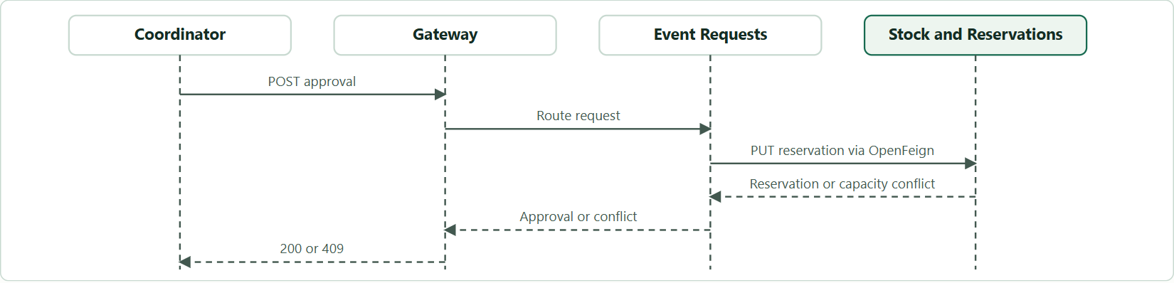
Figure 3. Synchronous approval through Gateway. Event Requests calls Stock over OpenFeign and returns the outcome.
A coordinator needs an immediate reserve-or-conflict decision. Event Requests records a pending decision, then calls Stock with the stable request ID. Stock either reserves all lines or returns a conflict. If the network call times out, the caller can retry the same action without creating a second reservation.
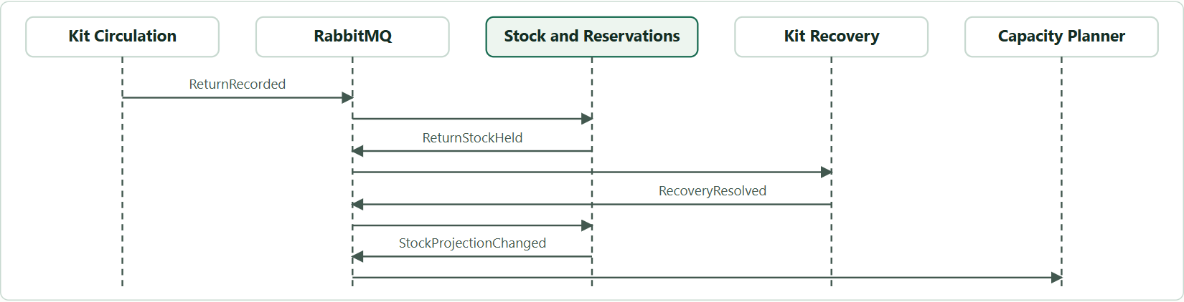
Figure 4. Asynchronous return, recovery, and forecast events. Stock applies the hold before Recovery can clear the lot.
Circulation records the receipt immediately. Stock classifies the returned units and emits one group of recovery lots. Recovery processes those lots independently and sends the staff decision back to Stock. The planner consumes Stock’s versioned snapshot.

Event payloads
Every event has eventId, type, schemaVersion, occurredAt, correlationId, and payload. The event ID supports duplicate detection. A snapshot version prevents an old projection replacing a newer one.
- ReturnRecorded from Circulation carries {returnId, loanId, lines}, using the return API’s count fields.
- ReturnStockHeld from Stock carries {returnId, lots:[{lotId, itemTypeId, quantity, condition}]}. Missing items remain in Stock and generate no recovery lot.
- RecoveryResolved from Recovery carries {taskId, lotId, outcome}. Stock uses its own lot quantity and allows a transition only from an active recovery hold.
- StockProjectionChanged from Stock carries {itemTypeId, stockVersion, readyQuantity, heldReservations, expectedReleases}. Reservations include request ID, pickup time, blocked-until time, and quantity. Releases include estimated ready time, quantity, source, and the original due time for a loan. Publish an initial snapshot and a new full item-type snapshot on relevant changes. The planner applies only newer versions.

Consistency Failure Handling and Forecasting

Reservation and pickup
Stock is the single authority for availability. A booking occupies a half-open interval from pickup until the cleaning buffer ends. Stock locks item-type rows in a fixed order and calculates the peak overlapping held demand for each type. It reserves all items in one transaction if the ready quantity covers demand and the new request. This conservative rule avoids promising uncleared stock but can reject some feasible future bookings.
Issue moves the booked quantities into loan holds in the same transaction so each unit counts once. Stock confirms that the reservation can be issued and that the quantity is physically ready. Cancellation releases an unissued reservation. A conflicting issue or cancellation returns 409.

Failures and retries
Requests and Circulation save pending actions before calling another service. If the result is unknown, return 503 and preserve the pending state. Replay with the same request or loan ID to reconcile the outcome. Hold conflicting actions until reconciliation.
Producers store outgoing events in a local outbox in the same transaction as the business update. They publish with broker confirms. Consumers store event IDs with their changes and acknowledge after commit. Duplicate deliveries do not repeat stock moves. Retry transient errors and route persistent errors to a dead-letter queue for inspection.
If the broker is unavailable, a return receipt can still be recorded and the outgoing event remains in the outbox. The issued units stay unavailable until Stock applies the return and clearance. This keeps the booking decision safe while projections catch up.

PostgreSQL capacity forecast
For each upcoming pickup, compare active demand with ready stock plus eligible expected releases. An overdue loan, missing unit, or damaged lot contributes no forecast release until its state changes. Show the item, pickup time, shortfall, reason, and projection timestamp. Estimated releases never authorize approval. A forecast unavailable response leaves booking functional.

Design tests
- Two approvals compete for the last cups. Only a feasible combination succeeds.
- The stock reservation commits before a timeout. Replaying the approval reconciles to the same reservation.
- A return or resolution event is delivered twice. Stock moves the quantity once.
- The planner misses a snapshot and receives a newer full snapshot. The result converges without replacing the newest version with an older one.

Team Delivery and Validation
The course rubric describes four individually owned business services plus a shared advanced service. Our team has six members. The workstreams below are provisional pending the instructor’s decision on individual assessment.
- Student A Event Requests and organizer flow
- Student B Stock and Reservations and concurrency checks
- Student C Kit Circulation and handover flow
- Student D Kit Recovery and clearance flow
- Student E Gateway, frontend integration, and shared platform
- Student F Acceptance checks, technical report, and shared planner presentation
All six contribute to Capacity Planner through event inputs, projections, frontend display, and acceptance scenarios. Each member should have a visible personal contribution and defend the design. Present the shared service through one speaker.

Git and project management
Use a public GitHub repository and add the instructor as a collaborator. Track tasks, dependencies, and evidence in GitHub Issues and Projects. Create one short branch per issue, request peer review, then merge into main. Store slides under Documentation/Presentation and diagrams under Documentation/Diagrams.

Schedule
S4 covers design approval and compiling, starting, and personally committing the confirmed service starter projects. S5 adds Gateway. S6 targets the request-to-approval path with OpenFeign. S7 adds the asynchronous return and clearance loop. S8 adds Keycloak. S9 verifies Docker Compose startup. S10 is the working demo and defense.

Risks and validation
Confirm the service allocation before initializing all projects. Prevent overbooking with Stock’s transaction boundary and preserve availability during delayed messages with stock holds and event deduplication. Rehearse a ten-minute talk, a quick repository walkthrough, and ten minutes of individual questions.
Course references: AWD Required Deliverables, pp. 1–2. Validation 1 Evaluation Grid, pp. 1–4. Presentation MiniProject AWD 2026–2027 EN, slides 5–9. Project and theme instructions and Blackboard submission screenshots.

