Display Themes
Administrator User Guide
Classroom Scheduler
Creating, editing, and applying display themes for room screens
Version 1 · June 2026

Contents

1. What a display theme is
A display theme controls how a room’s schedule looks on the screens running the Classroom Scheduler app. A theme is made of two parts: a layout archetype — the structural template the apps know how to draw (version 1 ships one, the agenda list) — and a set of design tokens: the colors, text sizes, labels, and on/off toggles layered on top of that structure.
The important thing for administrators: changing tokens never requires an app update. Colors, fonts, wording, and visibility switches are pure data. You edit them in the admin web app and the screens pick up the change the next time they refresh. Only a brand-new structural layout would require a developer and an app release — and that is rare.
Every theme is stored centrally and validated before it is saved, so a malformed theme can’t reach a screen. Two themes ship by default: System Default (the standard dark board) and a light “What’s Happening Today” example. The System Default is the only theme that cannot be changed — every other theme, including the example, can be edited, archived, or used as a starting point for a new one.

2. Who can create and edit themes
Access depends on your role in the admin app:
Role | What you can do with themes
System Admin | Create, edit, and archive any theme (global or any organization’s) except the System Default; assign themes and set defaults.
Org Admin | Create, edit, and archive global themes and your own organization’s themes (not another organization’s) except the System Default; assign themes to rooms and set the organization default.
Scheduler / Viewer | View themes and previews only — cannot create, edit, or assign.
If the New and Edit buttons are greyed out, your role is read-only — ask a System or Org Admin to make the change or to adjust your role.
A note on global themes: a global theme (one not tied to a single organization, such as “What’s Happening Today”) is shared. Editing or archiving it affects every organization that uses it, so change it deliberately — or make a copy with New Theme if you only want your own version.

3. How a theme reaches a screen
You don’t set a theme on a screen directly. Instead, the server decides which theme each room should use, in this order of priority, and sends the result to the app:
- Room override — if a specific theme is assigned to the room, that wins.
- Organization default — otherwise, your organization’s default theme is used.
- System Default — if neither is set, the built-in standard theme is used.
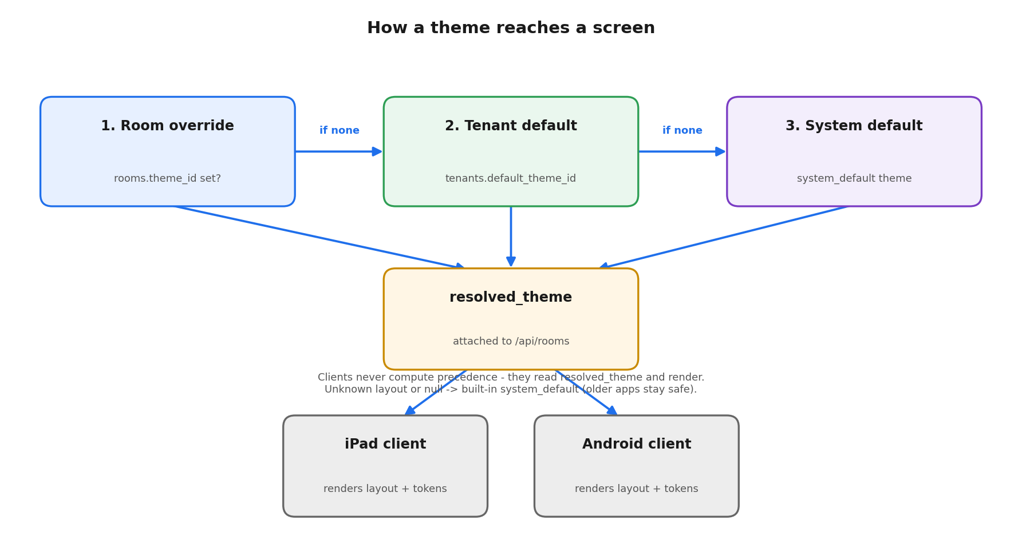
Theme resolution: room override → organization default → System Default.
Because the server resolves this, the screens never have to figure out priority themselves, and a screen running an older app version simply ignores anything it doesn’t understand and falls back to the System Default. That makes themes safe to change at any time.

4. Anatomy of the display
The diagram below maps the parts of a room screen to the theme settings that control them. Use it as a reference while you edit — each callout names the token group you’ll find in the editor.
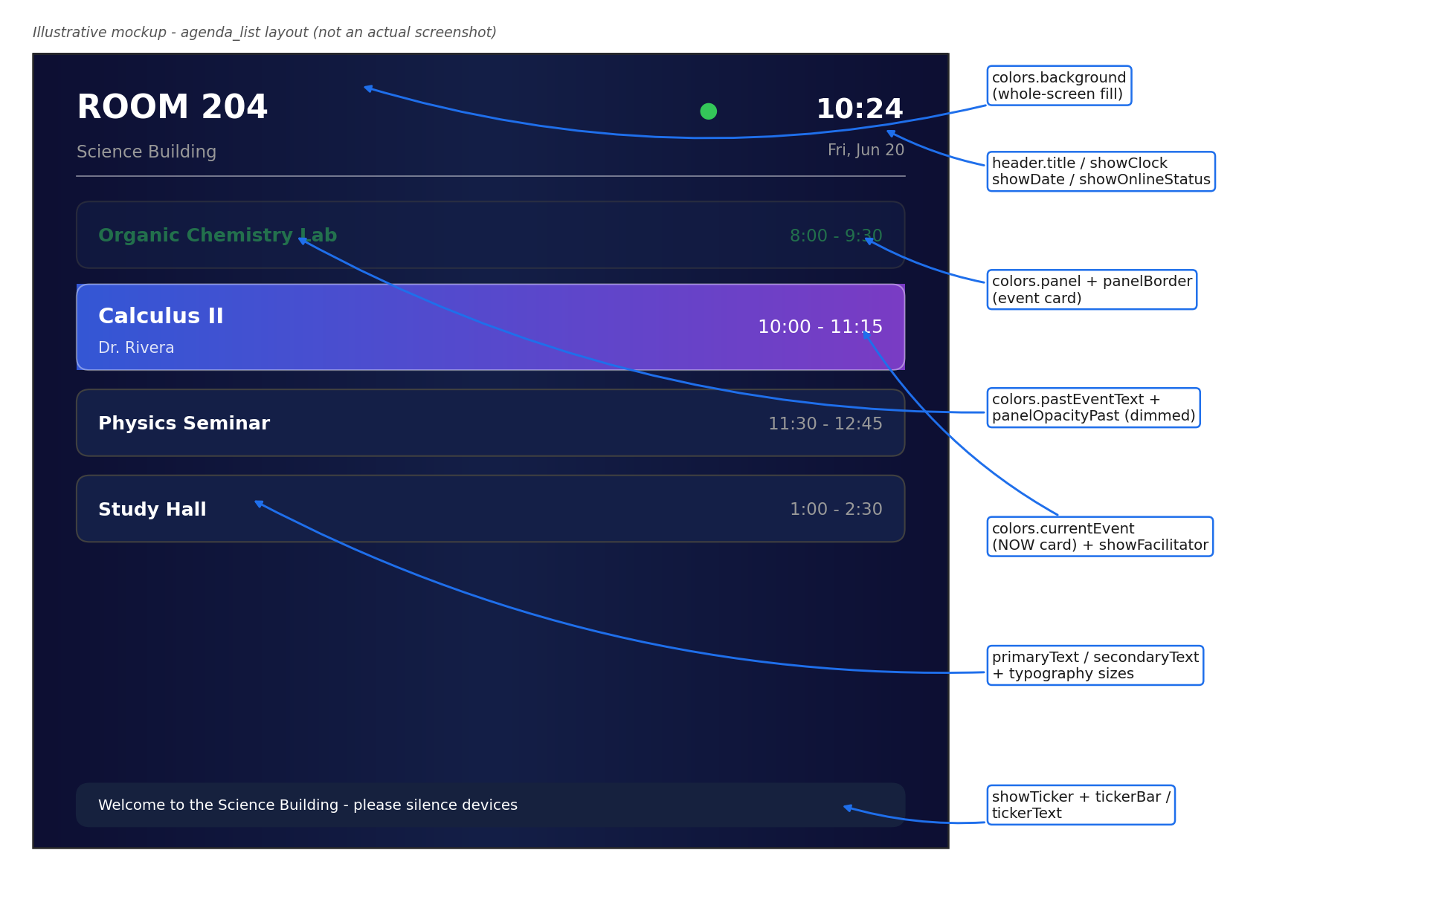
An illustrative agenda-list board with callouts linking on-screen elements to theme tokens.
Key elements: the background fills the whole screen; each event card uses the panel color and border; the current (“NOW”) card gets its own highlight fill; past events are dimmed and tinted; and an optional ticker and footer run along the bottom. The header carries the room name, clock, date, and online status.

5. Creating a theme
There are two ways to start, and both let you build on an existing look. The quickest is to Duplicate any theme — including the System Default — which opens a pre-filled copy you can rename and tweak. Or start from scratch with New Theme and choose a base from the Start from menu.

Duplicate an existing theme (quickest)
- On any theme card, click Duplicate. The editor opens in create mode, pre-filled with that theme’s design and a name like “… (Copy)”. Copying never changes the original.
- Adjust the name, scope, and any tokens, then click Create theme.

Start a new theme from scratch
- In the admin web app, open Settings ▸ Display Themes.
- System Admins: choose the organization you’re authoring for at the top of the page. (Org Admins are scoped to their own organization automatically.)
- Click New. Pick a starting point — an existing theme such as System Default — so you only change what should differ.
- Give it a clear name (for example, “Chemistry Wing — Dark”). A short key is generated from the name automatically.
- Adjust the design tokens — colors, typography, header, components, and footer (see the reference in section 8). The live preview updates as you make changes.
- Click Save. The theme is validated and stored; if anything is invalid, you’ll see a message describing what to fix.
Tip: you only need to set what differs from the starting theme — every token that you leave alone falls back to a sensible default.

6. Editing an existing theme
- Open Settings ▸ Display Themes and locate the theme in the list.
- Click Edit to open it in the Theme Editor.
- Change the tokens you want; watch the live preview to confirm the look.
- Click Save. Screens using this theme update on their next refresh.
Note: editing a theme affects every room currently using it. If you only want to change one room, create a copy and assign that copy to the room instead (section 7). The only theme you cannot edit or archive is the System Default; to base a new look on it, start a new theme from it (section 5) rather than changing it in place.

7. Applying a theme to rooms
A saved theme does nothing until it is assigned. You have two options:

Assign to a specific room
- Open the rooms list (under Settings ▸ Display Themes or your room management page).
- Choose the theme for the room you want to override.
- Save. That room now uses this theme regardless of the organization default.

Set the organization default
- Select the theme you want as the default for all rooms that don’t have their own override.
- Set it as the organization default. Every room without a specific override will use it.
Remember the priority order from section 3: a room’s own theme always beats the organization default, which beats the System Default.

8. Token reference
These are the settings available in the editor. Every token is optional and falls back to the default shown.

Colors
Plain colors are hex values (#RRGGBB or with alpha #RRGGBBAA). Background and the current-event highlight can also be a solid color, a gradient, or a blurred image.
Token | Controls | Default
background | Whole-screen fill (solid, gradient, or blurred image) | Dark navy gradient
panel | Event card background | #141F47
panelOpacityPast | Dimming applied to a past event’s card (0–1) | 0.5
panelBorder | Event card border | #404040
headerAccentBar | Accent bar in the header (none if unset) | None
tickerBar / tickerText | Ticker background / text (if ticker is on) | #16213E / #FFFFFF
primaryText | Main text | #FFFFFF
secondaryText | Secondary text (building, dates, end times) | #999999
accent | Badges and highlights | #FFFFFF
currentEvent | Fill behind the “NOW” card | Royal blue → purple gradient
currentEventText / Border | “NOW” card text / border | #FFFFFF / translucent white
pastEventText | Past event text | #34C759 (green)
dividerColor | Header / footer hairlines | #FFFFFF
onlineColor / offlineColor | Connection status dot | #34C759 / #FF3B30

Typography
Sizes are set at scale 1.0; the scale knob multiplies them all at once for denser or larger displays. Font family is the system font in version 1.
Token | Element (default size)
headingSize | Room / board title (32)
subheadingSize | Building name (14)
clockSize / dateSize | Clock (24) / date (13)
eventTitleSize / eventTimeSize | Event title (14) / time (13)
currentTitleSize / currentTimeSize | “NOW” card title (18) / time (16)
facilitatorSize | Facilitator name (11)

Header
Token | Effect
title | Fixed board title, or use the room name if unset
showRoomName / showBuildingName | Show or hide the room and building
showDate / showClock / showOnlineStatus | Show or hide the date, clock, and status dot
logoPosition | left, right, center, or none
dividers | Show header hairlines

Components
Token | Effect
eventRow | Row order: title-left/time-right, or the reverse
showCurrentEventHighlight | Highlight the in-progress event (“NOW” card)
showFacilitator | Show the facilitator name on events
showPastEvents | Show earlier events (dimmed) vs. hide them
showTicker + tickerText | Show a scrolling message and its text
clockPosition | header-right, header-center, bottom-left, bottom-right
cornerRadius | Roundness of cards
showRefreshButton | Show an on-screen refresh control

Footer
Token | Effect
show | Show or hide the footer
showVersion | Show the app version
showTenantInfo | Show the centered organization / address line

9. Tips and troubleshooting
- Start from a copy. Duplicate a close theme and adjust, rather than building from scratch.
- Use the live preview. Confirm contrast and readability there before saving — screens are viewed from a distance.
- A change isn’t showing on a screen? Screens update on their next refresh; confirm the room is actually assigned the theme you edited (section 3 priority order).
- Want to change one room only? Copy the theme and assign the copy to that room — don’t edit a shared theme.
- Background images are uploaded organization assets referenced by link; the apps always keep a fallback color in case the image is slow or missing.
- New layout structure? Adding a genuinely new layout (a grid or poster, say) is a developer task that needs an app release. Color, text, and visibility changes never do.
If a screen ever shows the plain dark board unexpectedly, it has fallen back to the System Default — usually because the assigned theme was removed or the app version doesn’t yet support a newer layout. Re-assign a supported theme to fix it.

