|  |  |  |  |
| --- | --- | --- | --- |
| **Assignment 1** | | | |
| Due for Issue  (week commencing): |  | **Date for**  **Submission:** | see assignment schedule |
| Agreed Date for late submission: |  | Module Tutor:  Signed: | Scott Turner |
| Student Name:  Student ID: |  |  |  |

|  |
| --- |
| **Assessment Feedback** |

NB. By entering your **name**(s) and **student ID**(s) you are asserting that this submission is entirely your own individual (or group) work.

All solutions must have the assignment scenario as their basis (20% penalty if this is not done).

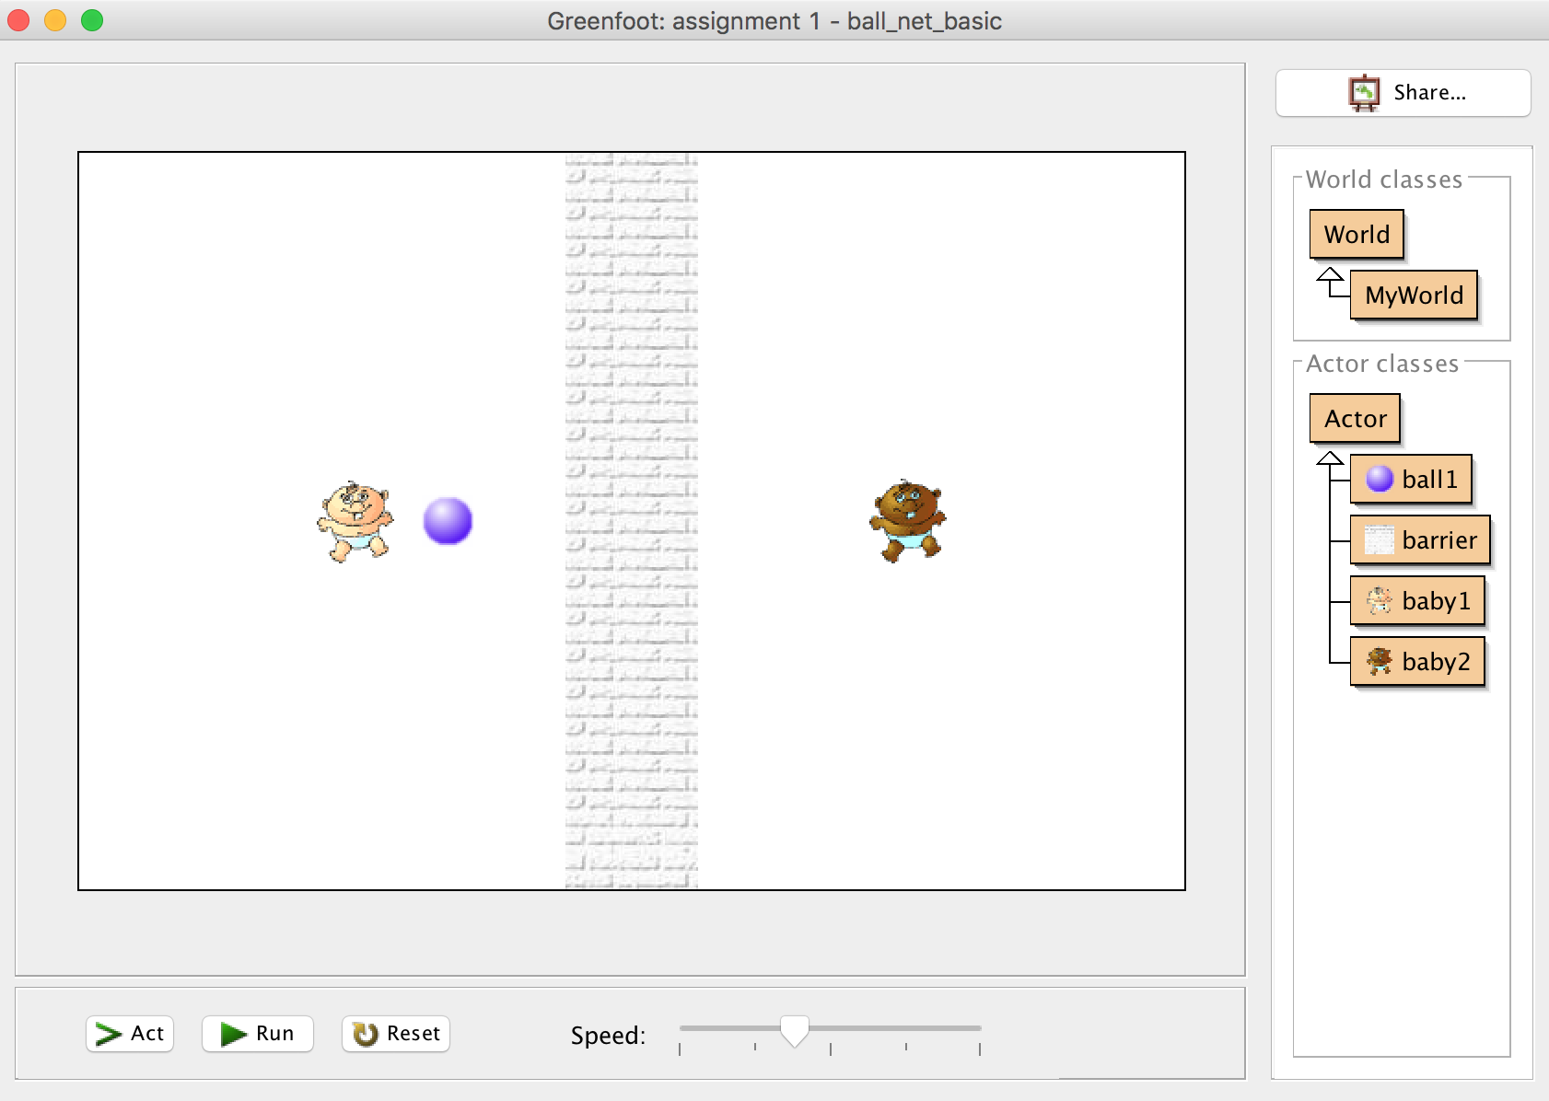

**Problem**

**A.Basic**

Alter the code in ball1 in the unmodified scenario to enable the ball to bounces between the two babies continuously. So must

* Cross the line in the middle of the screen;
* When the ball hits either baby it must rebound;
* If the babies are left in the unmodified codes starting position the ball would move between them continuously.

**B. Intermediate**

* Must have all the features of the basic above.
* The ball can bounce off a baby or babies in random direction.
* Two new ‘player’ babies are added to each side of the line, that move vertically towards the ball ready to potentially bounce the ball back.
* Add a scoring system for each side.

**C. Advanced**

Fully completed all the requirements for Intermediate. Now add extra features.

**What you must hand in.**

Two parts of this assignment

**Item 1 (submitted through ass1 video)**

Video, submitted through tha ass1 video link in submit your work, lasting no more than six minutes showing the solution you produced and showing a thorough testing of the solution (this means comments on what works, does not work and could be improved). There is a penalty of 5% for every 30 seconds over the limit. It must include a voice-over by you. (30%). See self-checklist on the next page for further guidance.

Checklist – self check

|  |  |  |
| --- | --- | --- |
| Level | Task requirements | Completed including testing (with %) |
| Basic | Cross the line in the middle of the screen; | 6 |
| When the ball hits either baby it must rebound; | 6 |
| If the babies are left in the unmodified codes starting position the ball would move between them continuously. | 6 |
| Intermediate | All of basic completed fully. If not then only a maximum of the scores for the Basic is allowed. | 0.5 if further features added |
| The ball can bounce off a baby or babies in random direction. | 1 |
| Two new ‘player’ babies are added to each side of the line, that move vertically towards the ball ready to potentially bounce the ball back. | 0.5 |
| Add a scoring system for each side | 1 |
|  |  |
| Advanced | All the requirements for the intermediate solutions are met | Up to 9 |

**Item 2 (submitted through turnitin)**

Only show work for the solution you finally present, please do not show earlier solutions just the final version.

Analysis (20%) for your solution must include inputs, outputs and rules/algorithms used;

Design (20%) for your solution either pseudocode or flowchart;

Code (20%) of the code produced must be clearly marked with what is your code and references to sources of other code. In other words there must be a Harvard reference list included as well. At least one reference to sources of code is required.

Conclusion (10%) Which solution did you completed and what is the evidence (clearly stated) that you meet this? How could your solution be improved?

|  |  |  |  |  |  |  |  |
| --- | --- | --- | --- | --- | --- | --- | --- |
|  | A | B | C | D | F+ | F- | G |
| Item 1 | All the advanced requirements are met.  Testing shows comments on what works, does not work and could be improved. | All the intermediate requirements are met.  Testing shows comments on what works, does not work and could be improved. | All the basic requirements are met.  Testing shows comments on what works, does not work and could be improved. | All basic requirements are met.  Testing shows what works only. | Only one of the basic requirements are missing | More than one of the basic requirements are missing | No creditable attempt |
| Analysis | Clearly written analysis of the advanced solution.  All elements are present | Clearly written analysis of the intermediate solution.  All elements are present | Clearly written analysis of the basic solution.  All elements are present | All requirements for the analysis of the basic solution are present but a basic level of analysis has been carried out. | One of the requirements for the analysis is missing | More than one of the requirements for the analysis is missing | No creditable attempt |
| Design | The design matches the advanced code without minor mistakes. | The design matches the intermediate code without minor mistakes. | The design matches the basic code without minor mistakes. | The design matches the code but includes minor mistakes or is not sufficiently clear, | The design mostly matches the code but there are elements in the design more provided in sufficient detail. | The design does not match the code. | No creditable attempt |
| Code | Both reference list included and in code references present.  Advanced solution code.  Referencing is Harvard (if not you will lose points) | Both reference list included and in code references present.  Intermediate solution code.  Referencing is Harvard (if not you will lose points) | Both reference list included and in code references present.  Basic solution code.  Referencing is Harvard. | Both reference list included and in code references present.  Basic solution code.  Reference is not Harvard. | Either  No reference list included or no in code references  AND  Referencing is not Harvard | No reference list included and no in code references | No creditable attempt |
| Conclusion | Well written and clear conclusions. All elements present. | | | Satisfactory attempt at a conclusion. | Limited attempt at a conclusions with only one element missing | Very limited attempt at a conclusions with elements missing | No creditable attempt |