NPI Links Analysis Readme

Instructions

1) Execute “mbx”, NPI_PolylineAttributeAssignV2.mbx. Either drag a drop in Mapinfo Application or double select.

2) NPI_Links title should appear in your Mapinfo Application, select from the drop down menu, NPI Links Analysis, see screenshots below.

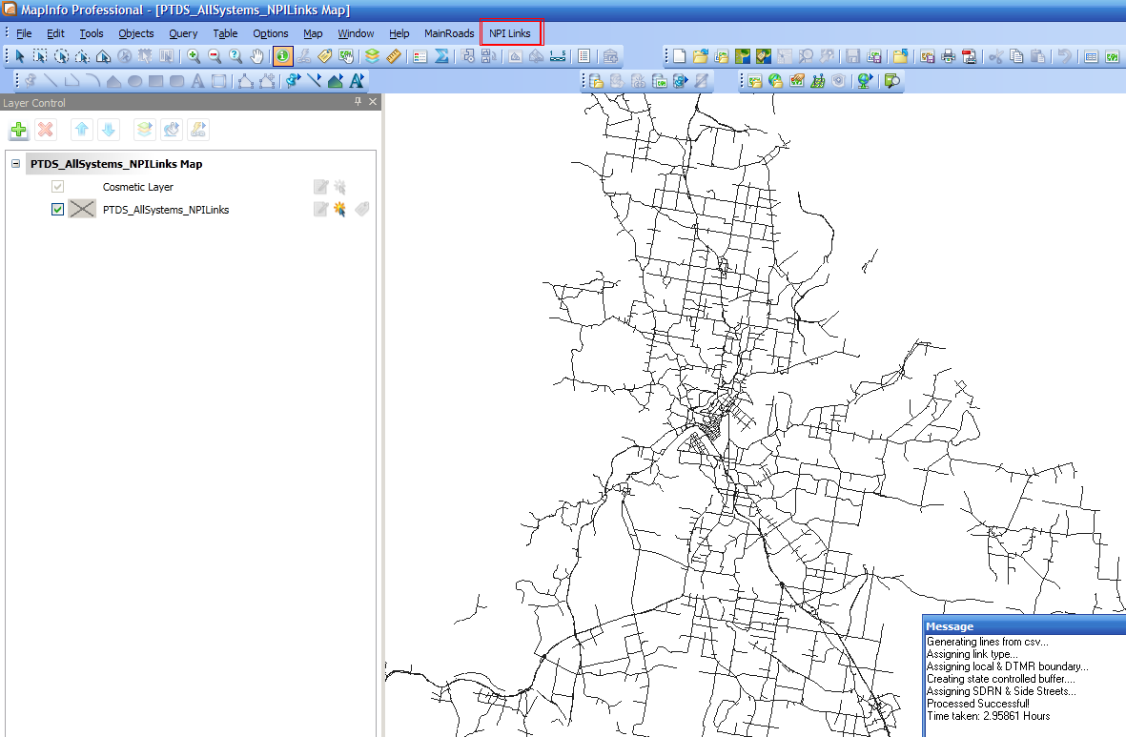

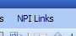

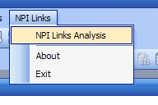
3) Navigate and select correct parameters. You will be prompted to select where to save the final dataset *.tab.

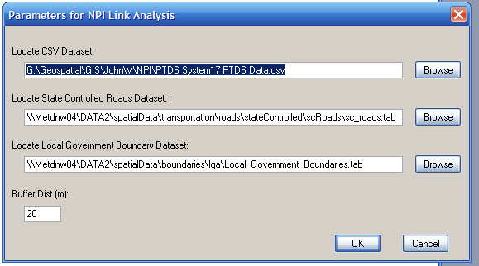

4) Please be patient, the algorithm may take awhile to complete. View message window to see how it is progressing. Previous runtimes are from 2-3 hours.

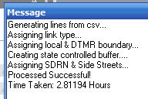

5) View final dataset – If there are any errors unexpected a log file will be generated.

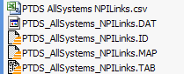
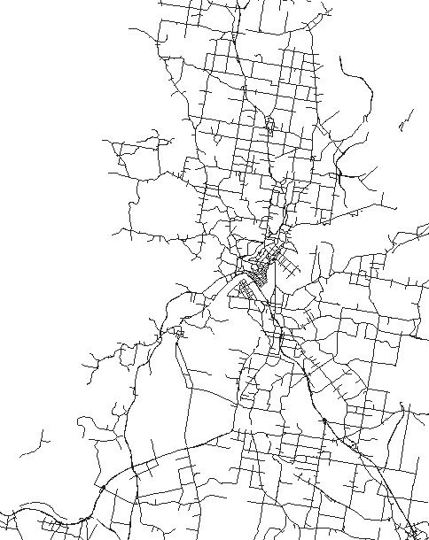

5) Any further issues please let me know.



