MUBASHIR ALI

AX-804

IOT( RUST )

SIR JAWWAD

CLASS ASSIGNMENT

- Store a string “PAKISTAN ZINDABAD” in a variable, also calculate the length of string and store it in a variable. Print both variables.
ANS.
CODE
fn main() {
let a="PAKISTAN ZINDABAD";
let len=a.len();

println!("{} LENGHT OF {} is {}",a,a,len);
}
Output

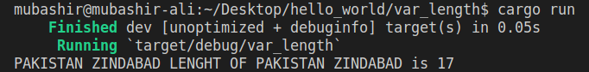

- Store 85 in a variable if it is an unsigned 64-bit number. Also store -550 in a variable if it is 16-bit integer. Print both variables.

ANS.
CODE
fn main() {
//int
let a:u64=85;
let :i16=-550;

println!("{} {}", a,b);
}

Output
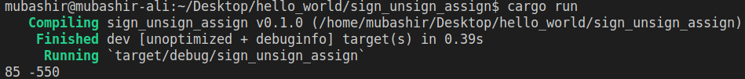

- Store a float 56.6 in a variable if it is a 32-bit float also print the variable.

ANS.
CODE
fn main() {
//float
let c:f32=56.6;

println!("{}",c);
}
Output
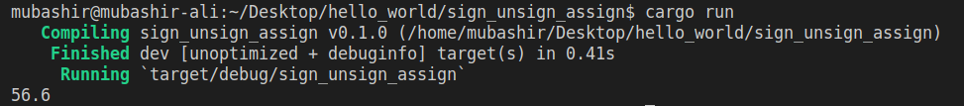

- Suppose there are two integer numbers 76 and 23. Store both of them in variables with any name and apply following operations on it.
● Addition
● Subtraction
● Multiplication
● Division
● Modulo

ANS.
CODE
fn main() {
let x:i32 = 76;
let y:i32= 23;
let sum = x+y;
let sub = x-y;
let div = x/y;
let mul = x*y;
let modulus =x%y;
println!("Addition : {}",sum);
println!("Subtraction : {}",sub);
println!("Division : {}",div);
println!("Multiplication : {}",mul);
println!("Modulus : {}",modulus);
}

Output
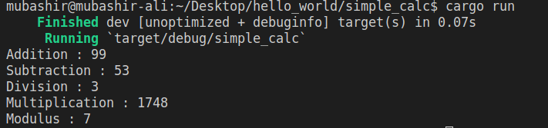

- Store following values in an array. Print the array and also print the values 150 and 250.
100, 150, 200, 250,300

ANS.
CODE
fn main() {
let array_list=[100,150,200,250,300];
println!("{:?}",array_list);
println!("{}",array_list[1]);
println!("{}",array_list[3]);
}

Output

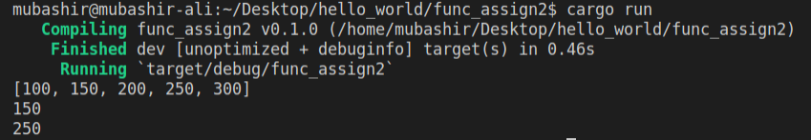

- Store following values in a tuple. Print the tuple and also print cloud, 8645 and 65.4. “IoT” , ”AI” , ”Cloud” ,500.65, 8645, 65.4

ANS.
CODE
fn main() {
let a=("IOT",8645,65.4,"Cloud","AI",500.65);

println!("{:?}",a);
println!("{}",a.3);
println!("{}",a.1);
println!("{}",a.2);
}

Output

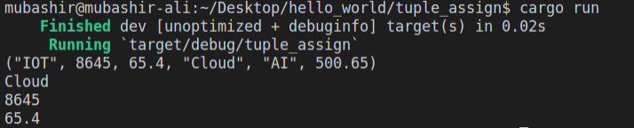

- Write a function that can take 3 integer numbers as argument/parameter and prints the sum of them. Hint: when we call the function add(10,20,30) like this, it prints the sum.

ANS.
CODE
fn main() {
another_func(10, 20, 30);
}
fn another_func(x:i32,y:i32,z:i32)
{
let sum =x+y+z;
println!("sum = {}",sum);
}

Output

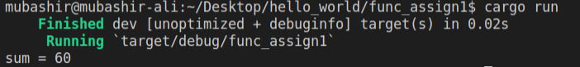

- What a function that can take 3 float numbers as argument/parameter and returns the multiplication result of them. Hint: when we call the function multiply(5.6,2.4,10.2) like this, it returns the result. Save that result in a variable and print it.

ANS.
CODE
fn main() {
let result=another_func(5.6,2.4,10.2);
println!("result = {}",result);
}
fn another_func(x:f64,y:f64,z:f64) ->f64{
let product=x*y*z;
product
}

Output

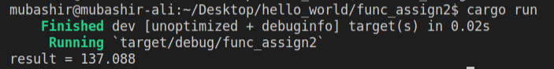

- Store marks in a variable and print the Grade of student. Marks Range:
Greater than 80 - Grade A+ Between 70 and 80 - Grade A Between 60 and 70 - Grade B Between 50 and 60 - Grade C Between 40 and 50 - Grade D Below 40 - Grade F Change value in marks variable to 95, 32 and 62 and show the output.

ANS.
CODE
fn main() {
let marks =92;
if marks >=80 && marks<=100{
println!("A1 grade");
}else if marks >=70 && marks<80{
println!("A grade");
}else if marks >=60 && marks<70{
println!("B grade");
}else if marks >=50 && marks<60{
println!("C grade");
}else if marks >=40 && marks<50{
println!("D grade");
}else if marks >=0 && marks<40{
println!("Failed");
}else{
println!("Invalid marks given");
}
}

Output

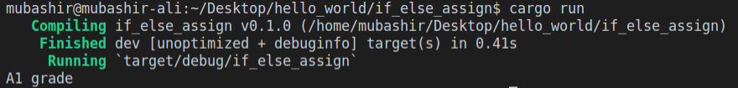

- Store year in variable like this (let year = 2019;) and check if the year is leap or not. Hint: Leap Year is exactly divisible by 4.

ANS.
CODE
fn main() {
let year = 2019;
if year%4==0{
println!("Leap");
}else{
println!("Not a leap");
}
}

Output

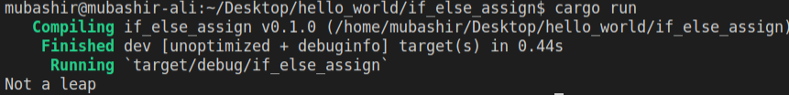

- Print even numbers using for loop.
Output:
2,4,6,8,10,12,.…

ANS.
CODE
fn main() {
let mut even:i8=2;
for _ in 2..{
println!("{}",even);
even+=2;
}
}

Output

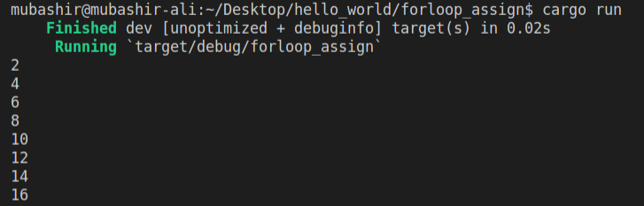

- Print odd numbers using while loop.
Output:
1,3,5,7,9,11,...…

ANS.
CODE
fn main() {
let mut num =1;
while num<=12 {
println!("{}",num);
num=num+2;
}
}

Output

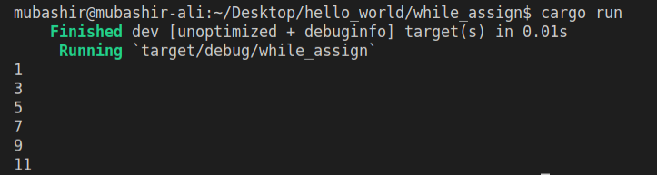

- Store an integer (any value) in a variable and print the table of that
number using any loop.
Output:
5 * 1 = 5 5 * 2 = 10 5 * 3 = 15 5 * 4 = 20 5 * 5 = 25 5 * 6 = 30 5 * 7 = 35 5 * 8 = 40
5 * 9 = 45 5 * 10 = 50

ANS.
CODE
fn main() {
let mut num=1;
let tab=5;
while num<=10{
println!("{} * {} = {}",tab,num,tab*num);
num+=1;
}
}

Output

