Installation of Laravel

Lab 07

8/13/2015

Jawwad Bin Sarfraz

Reg no 1087

Installation Composer

1. I have run this in my terminal to have the latest composer version

curl -sS https://getcomposer.org/installer

1. I used C:\Program Files\wamp\www option and provided a target directory to install composer to a specific directory. I appended option to – so that PHP ignores them, like C:\Program Files\wamp\www\bin
2. I installed composer to a specific release by using the --version option and providing a target release.

For example: https://getcomposer.org/installer

1. The installer downloaded composer and set up my PATH environment variable so I can simply call composer from any directory
2. I downloaded and run Composer-Setup.exe - it installed the latest composer version in my **php.exe**

Below are the steps I needed to follow for installation of laravel on wamp server.

1. I required installing Larvel Framework on windows that required PHP.

2. I downloaded the laravel from github from the link https://github.com/laravel/laravel/archive/master.zip and extract laravel into wamp www folder.

3. I downloaded composer from https://getcomposer.org/Composer-Setup.exe for windows.

This showed me .exe file download that I needed to save that file.

4. I needed to php_openssl extension in C:\wamp\bin\php\php5.3\php.ini. I tried finding extension=php_openssl.dll and remove ; from beginning of this.

Similarly you need to follow C:\wamp\bin\apache\apache2.2.22\bin\php.ini fle and try finding extension=php_openssl.dll and remove ; from beginning of this.

and these will make openssl enable.

Note: I have wamp installed in c:\ (path depends upon the folder in which laravel is installed)

5. Install composer setup:- You need to install Composer into same directory where php.exe is located.

How to find php.exe file path:- open command prompt and type in C:\>where php.exe , will show you php.exe file location.

6. Enable extensions php_openssl, php_curl, php_socket by clicking on wamp > php > php extensions.

7. Now again open command propmpt and change to directory where laravel is extracted like cd C:\wamp\www\laravel.

8. Here you need to type command composer install and press enter.

9. Copy all file from public folder .htaccess, index.php ,favicon.ico from C:\wamp\www\laravel\public folder to C:\wamp\www\laravel .

Now open index.php and change

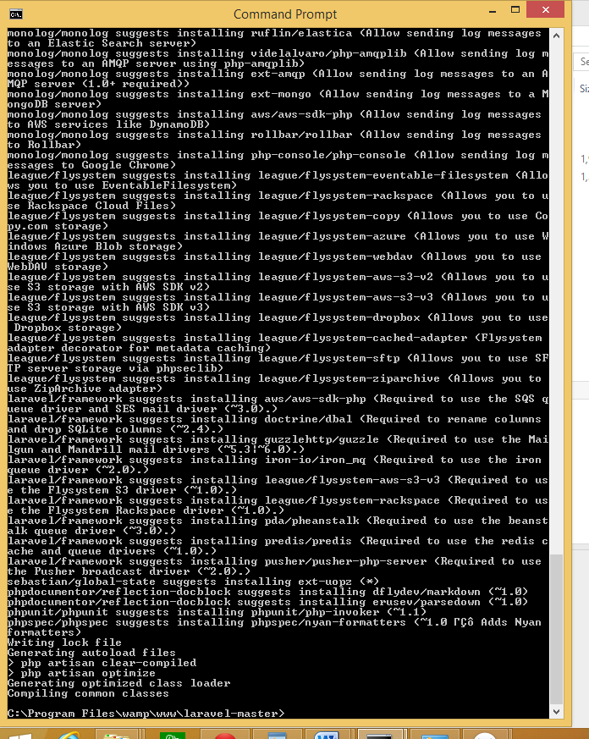

This is complete installation

And the output I get is 